Choose and write.
will
won’t
I
Then

1 | 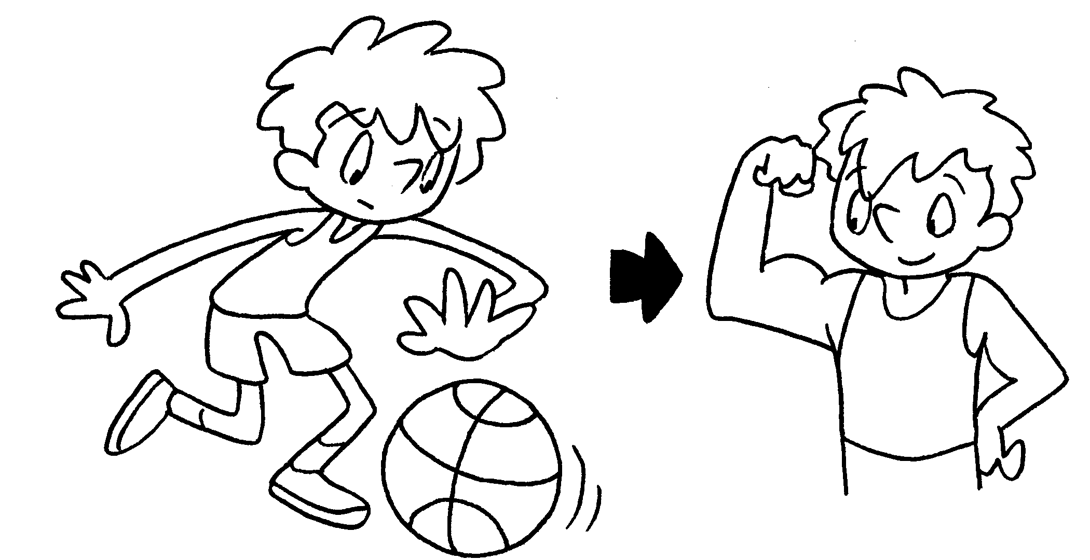 | I am going to play basketball every  day.  Then I be strong.
2 | 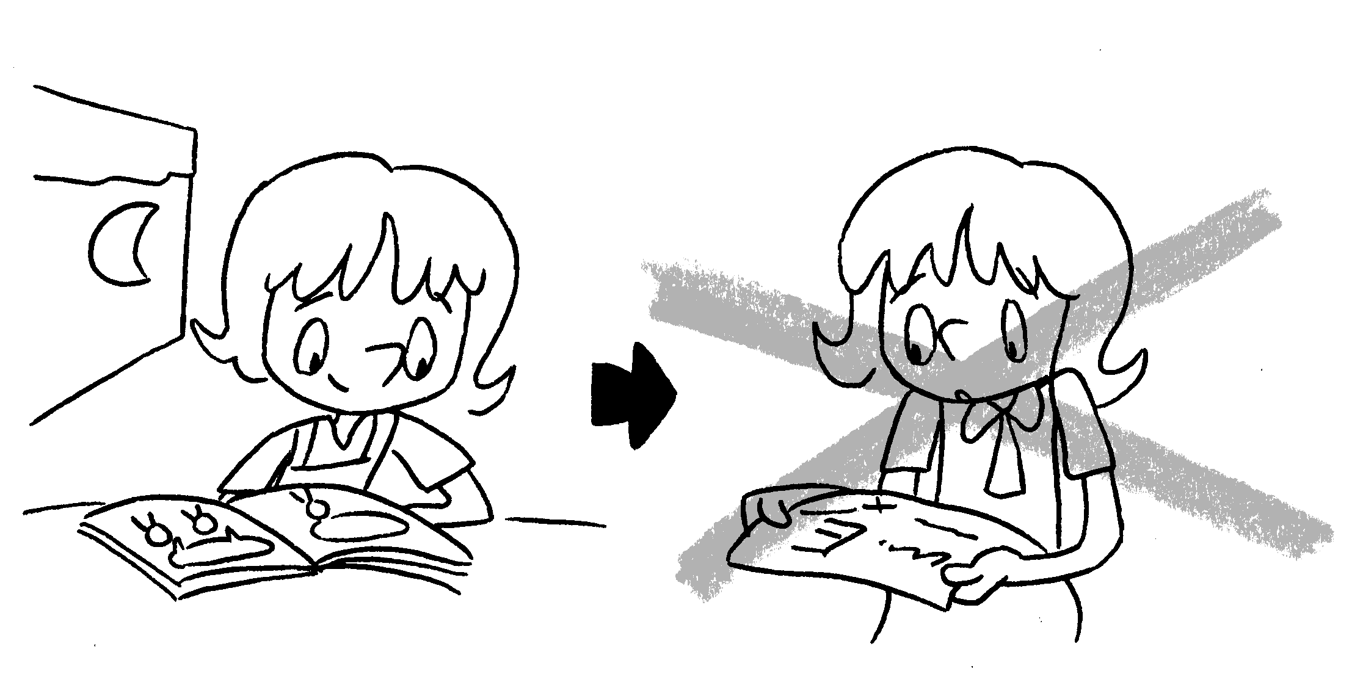 | I am going to do revision every day.  Then fail my exam.
3 | 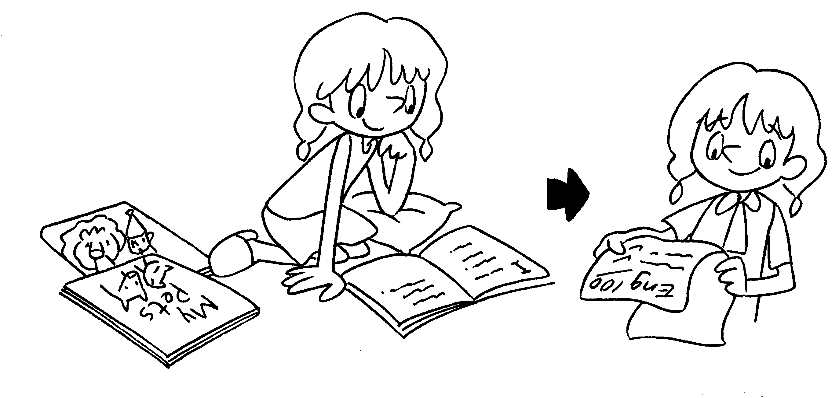 | I am going to read English books every day.  Then be good at English.
4 | 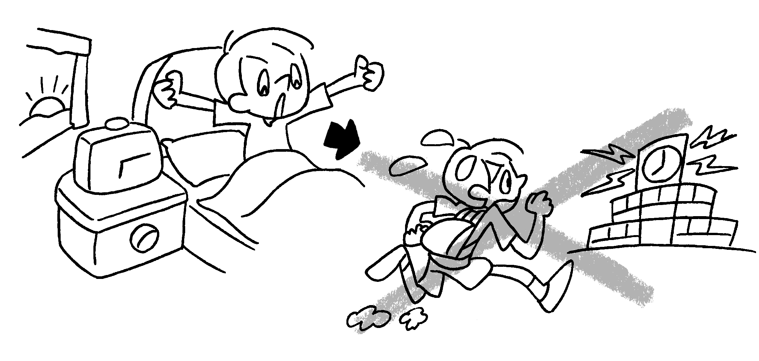 | I am going to get up early every day.  be late for school.
5 | 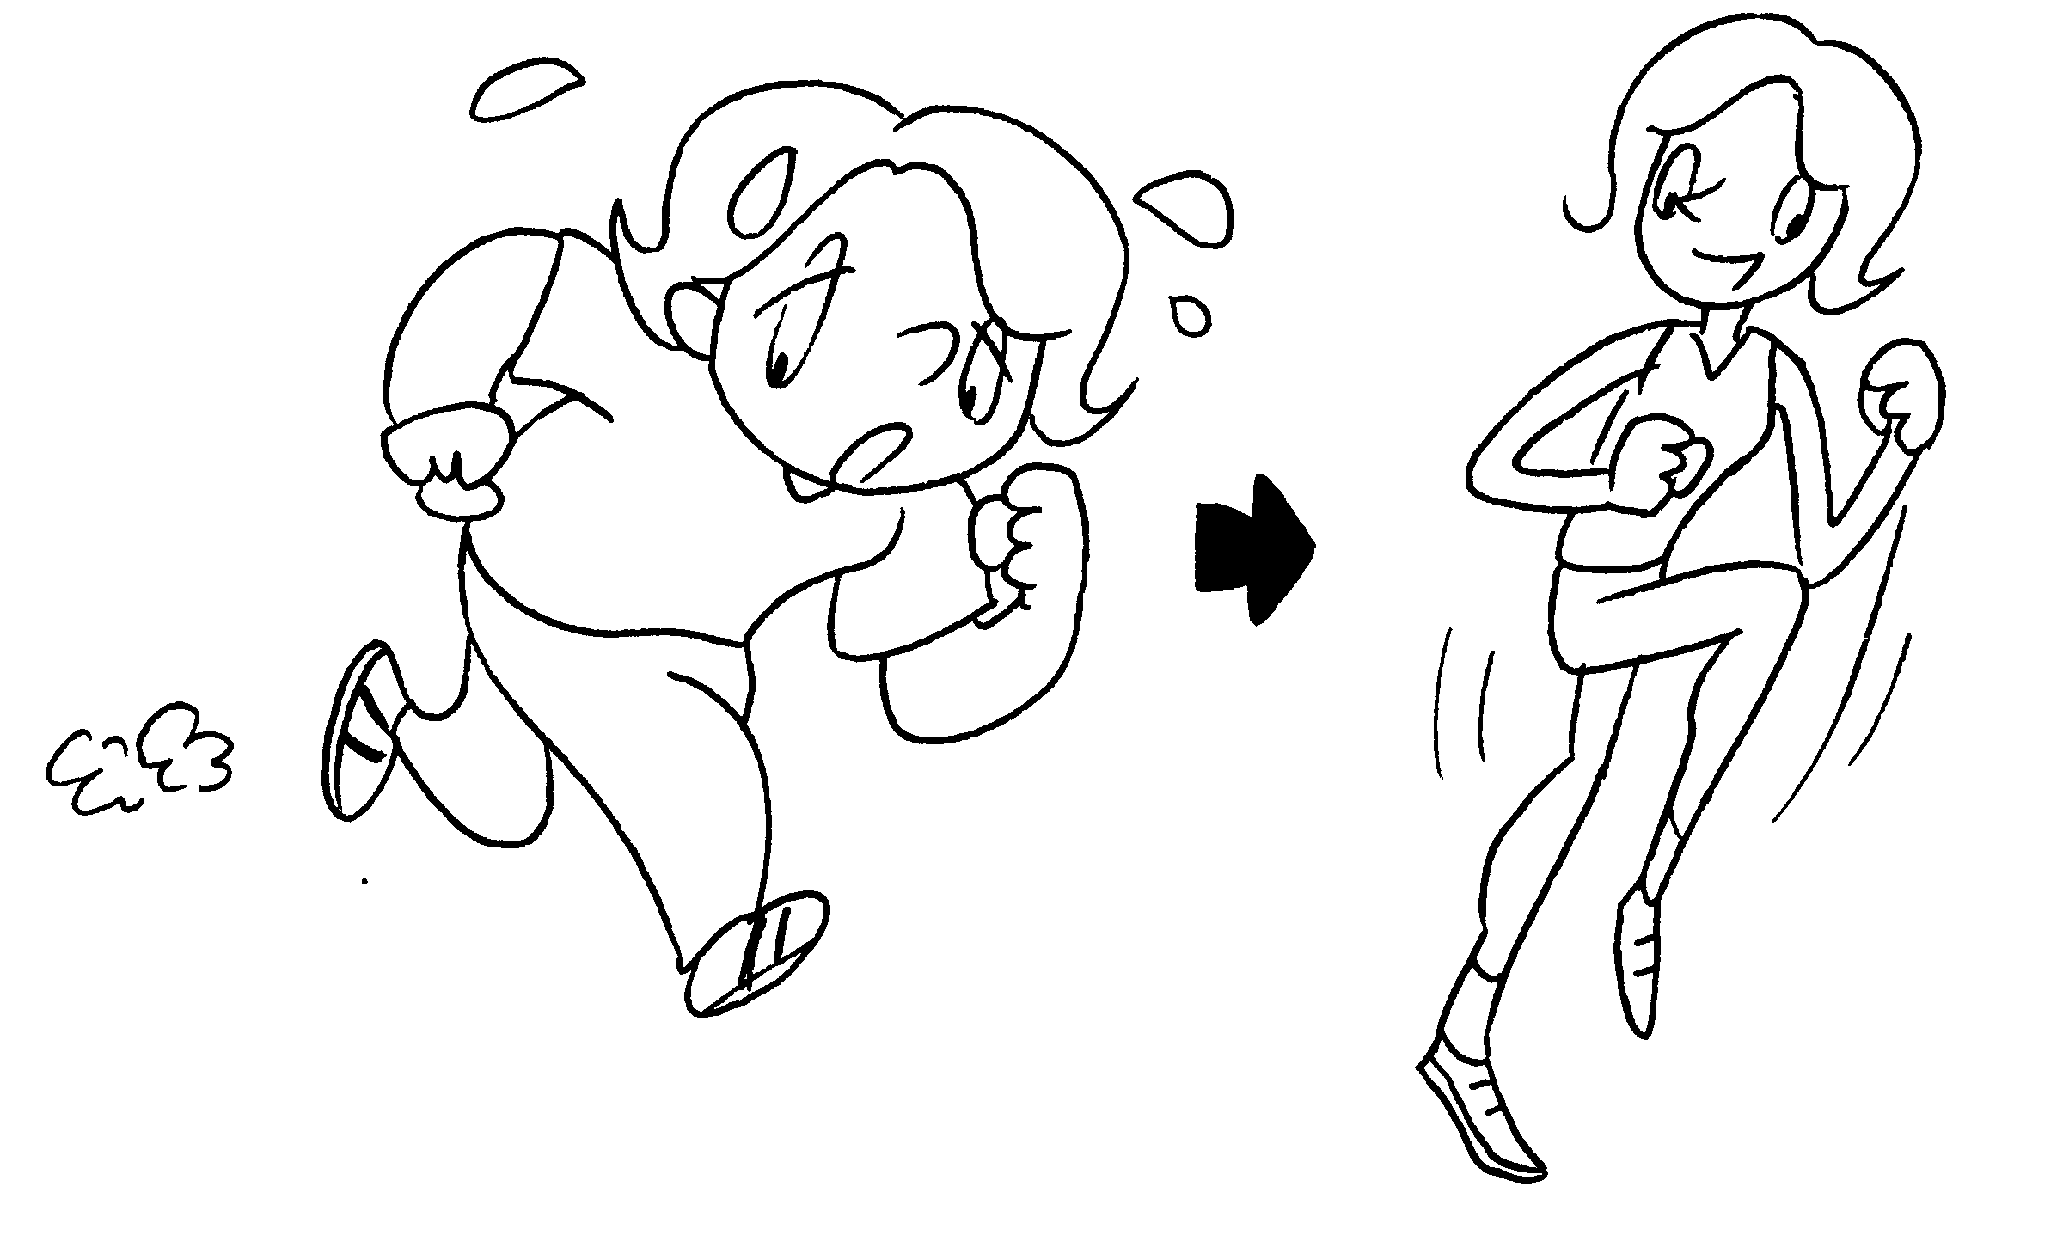 | I am going to go running every day.  be fit.


Book 4B Chapter 5 Graded Worksheets
Worksheet 3⬇
- will
- I won’t
- I will
- Then I won’t
- Then I will

