What are they going to do? What do they think will / won’t happen? Finish the sentences.
late
good at
fail
fit
strong

1 | 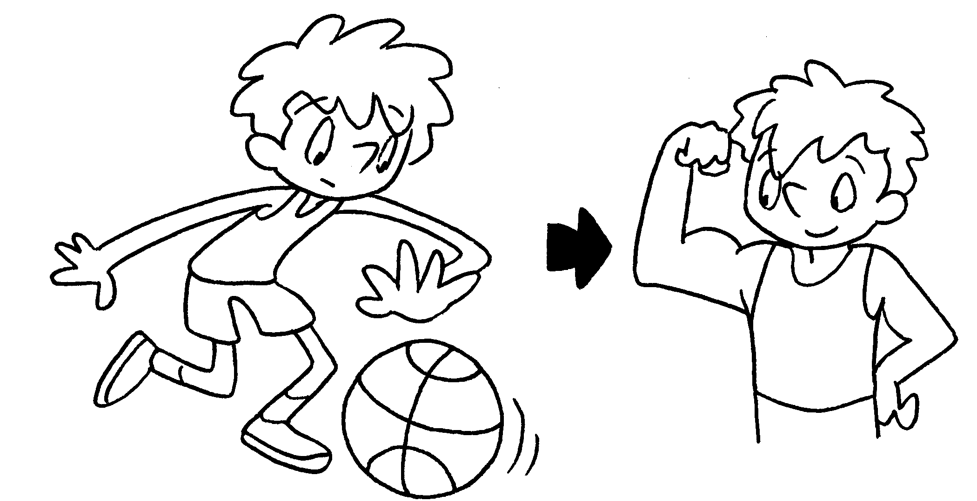 | I am going to play basketball every  day.  Then I will be .
2 | 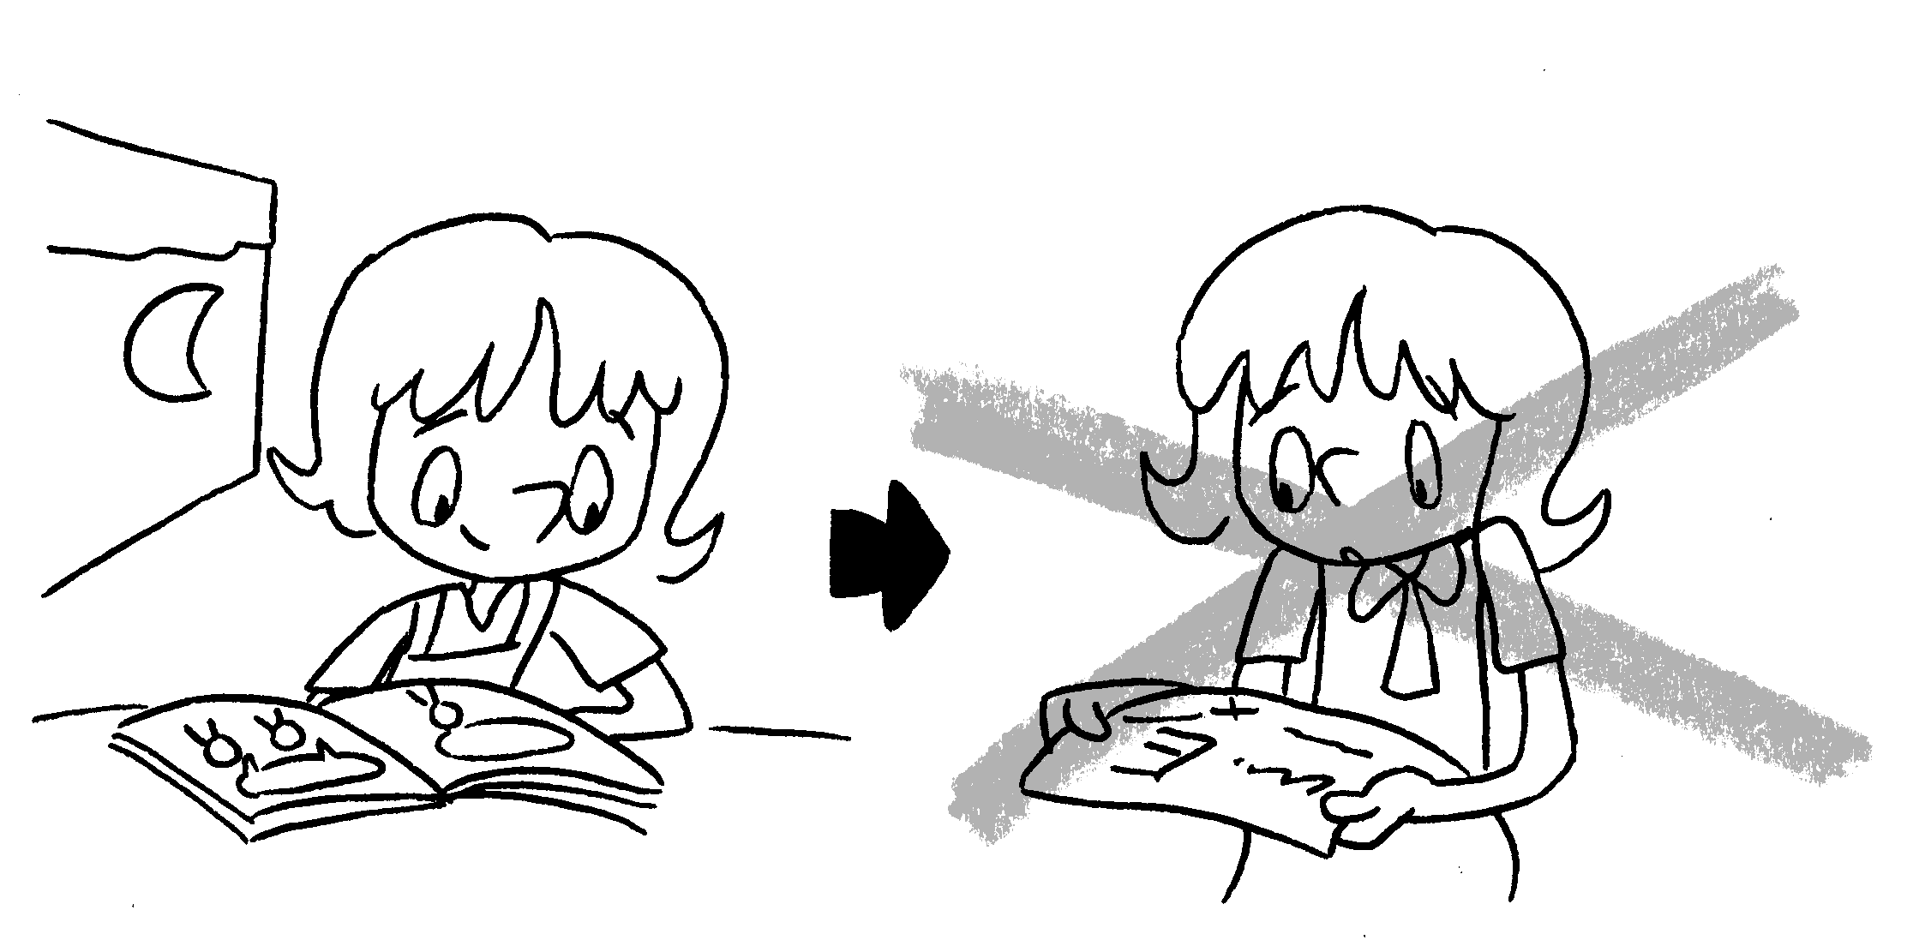 | I am going to do revision every day.  Then I my exam.
3 | 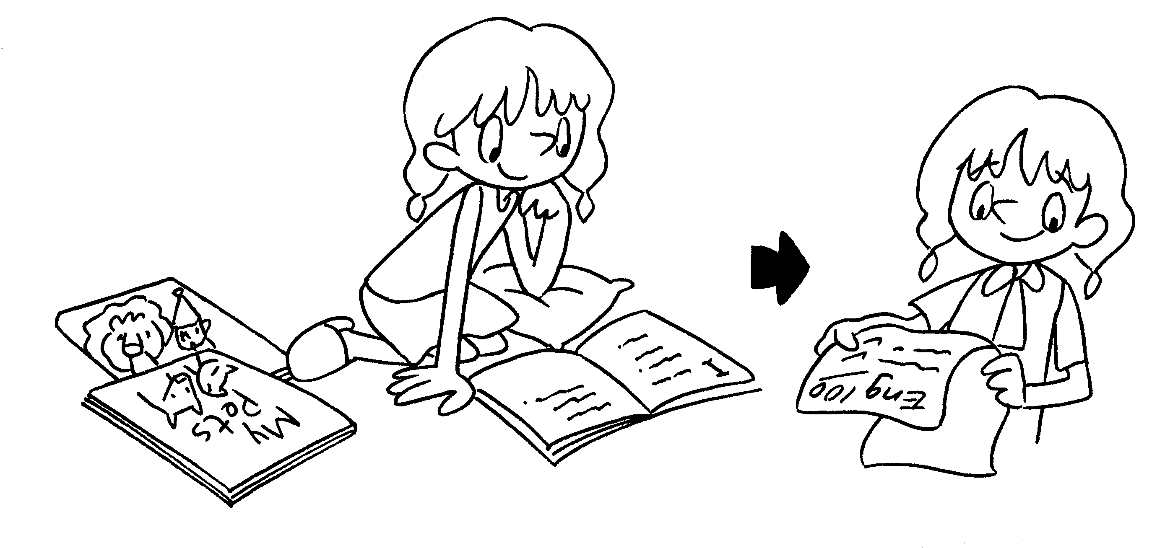 | I am going to read English books every day.  Then English.
4 | 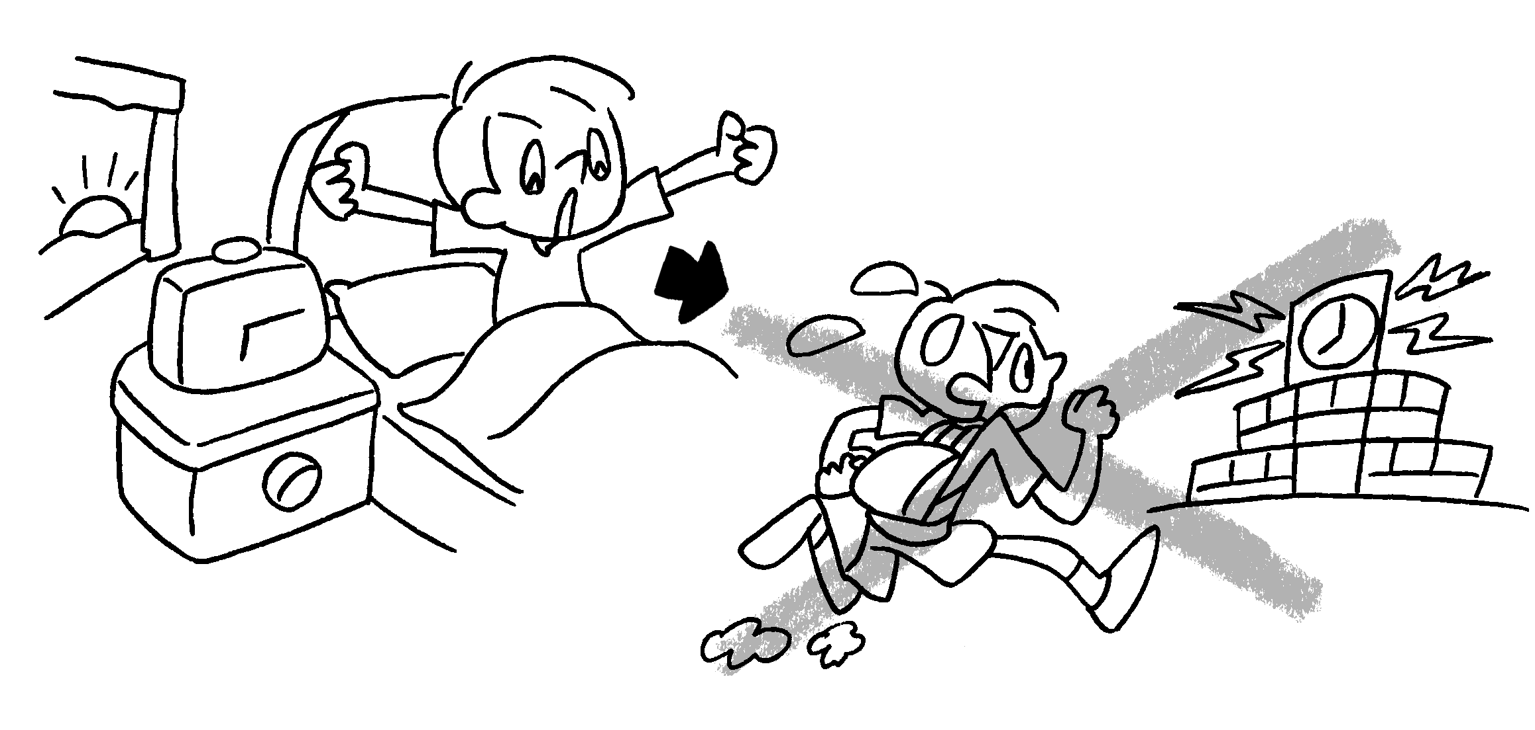 | I am going to get up early every day.  for school.
5 | 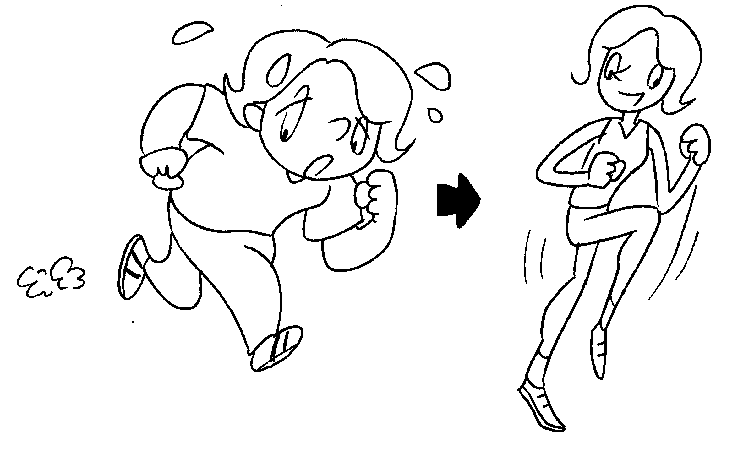 | I am going to go running every day.


Book 4B Chapter 5 Graded Worksheets
Worksheet 3⬇⬇
- strong
- won’t fail
- I will be good at
- Then I won’t be late
- Then I will be fit.

