What are they going to do? What do they think will / won’t happen? Finish the sentences.
late
good at
fail
fit
strong

1 | 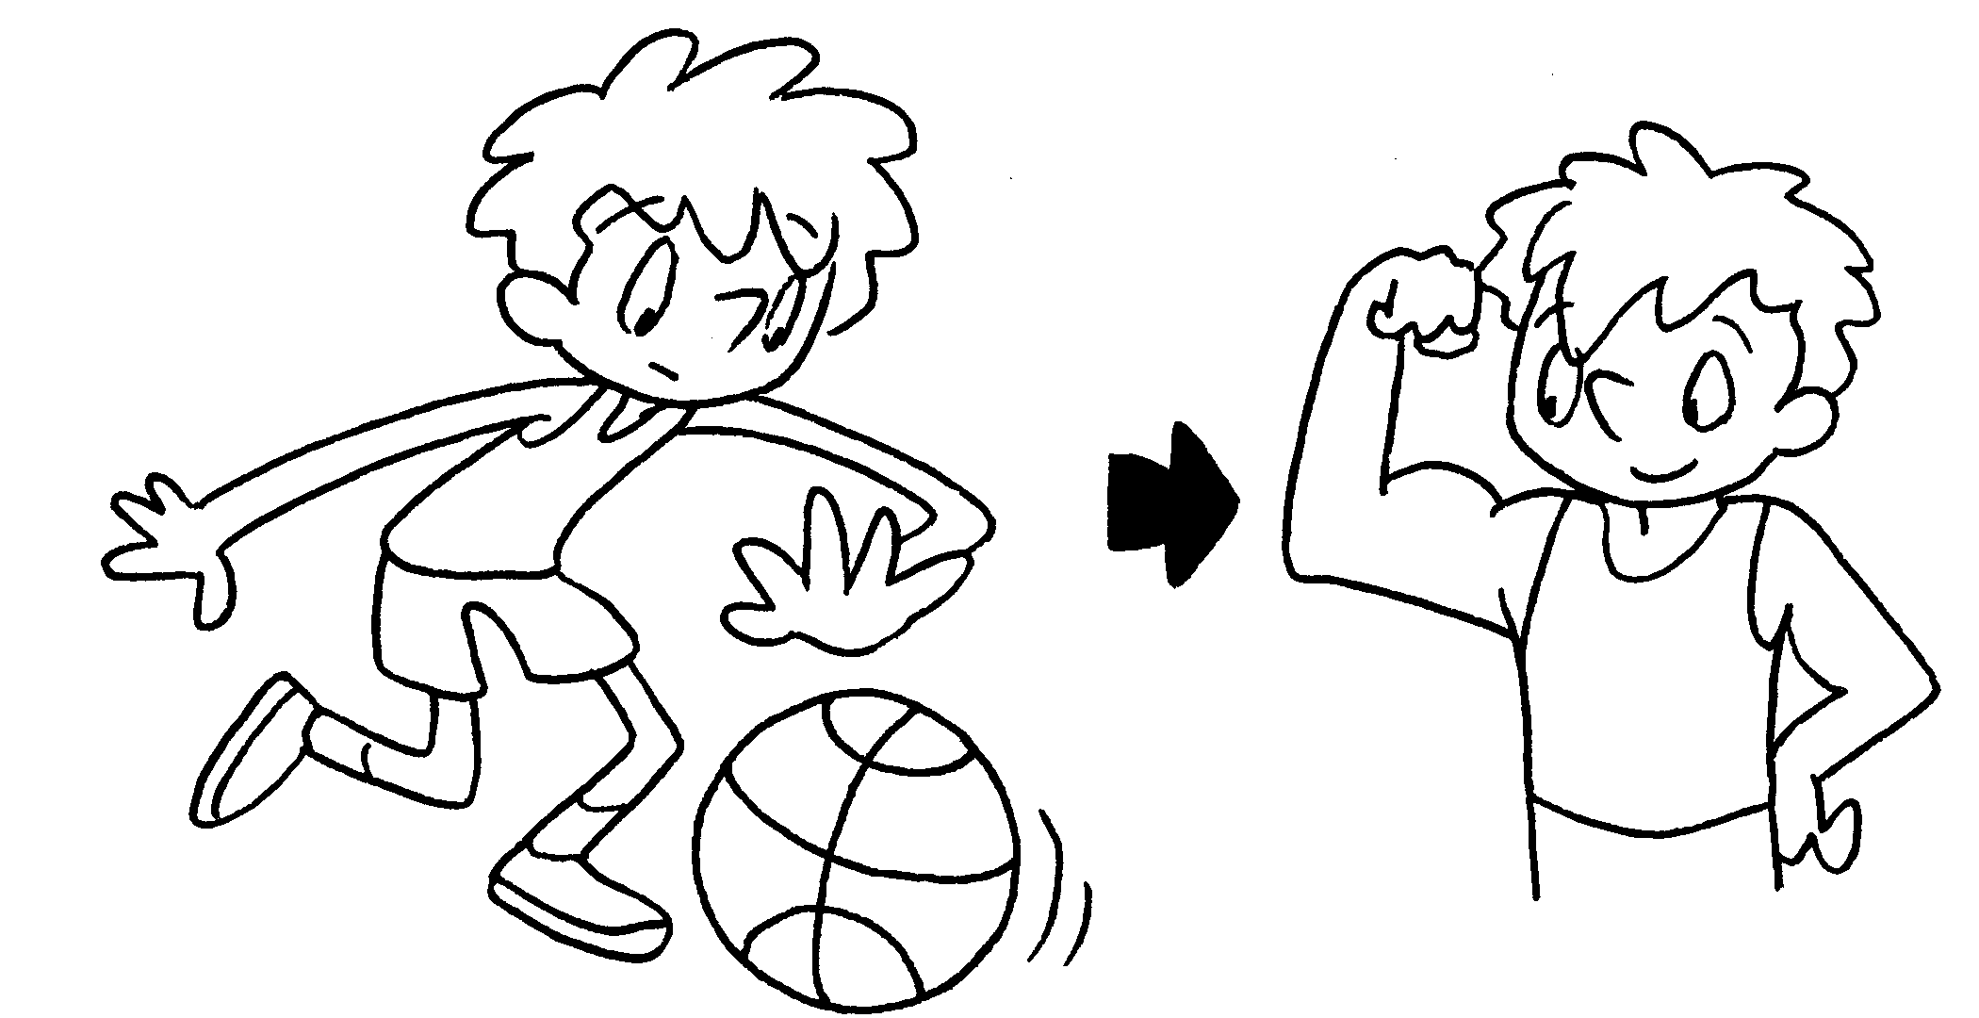  (play) | I am going to basketball  every day.  Then I will be .
2 | 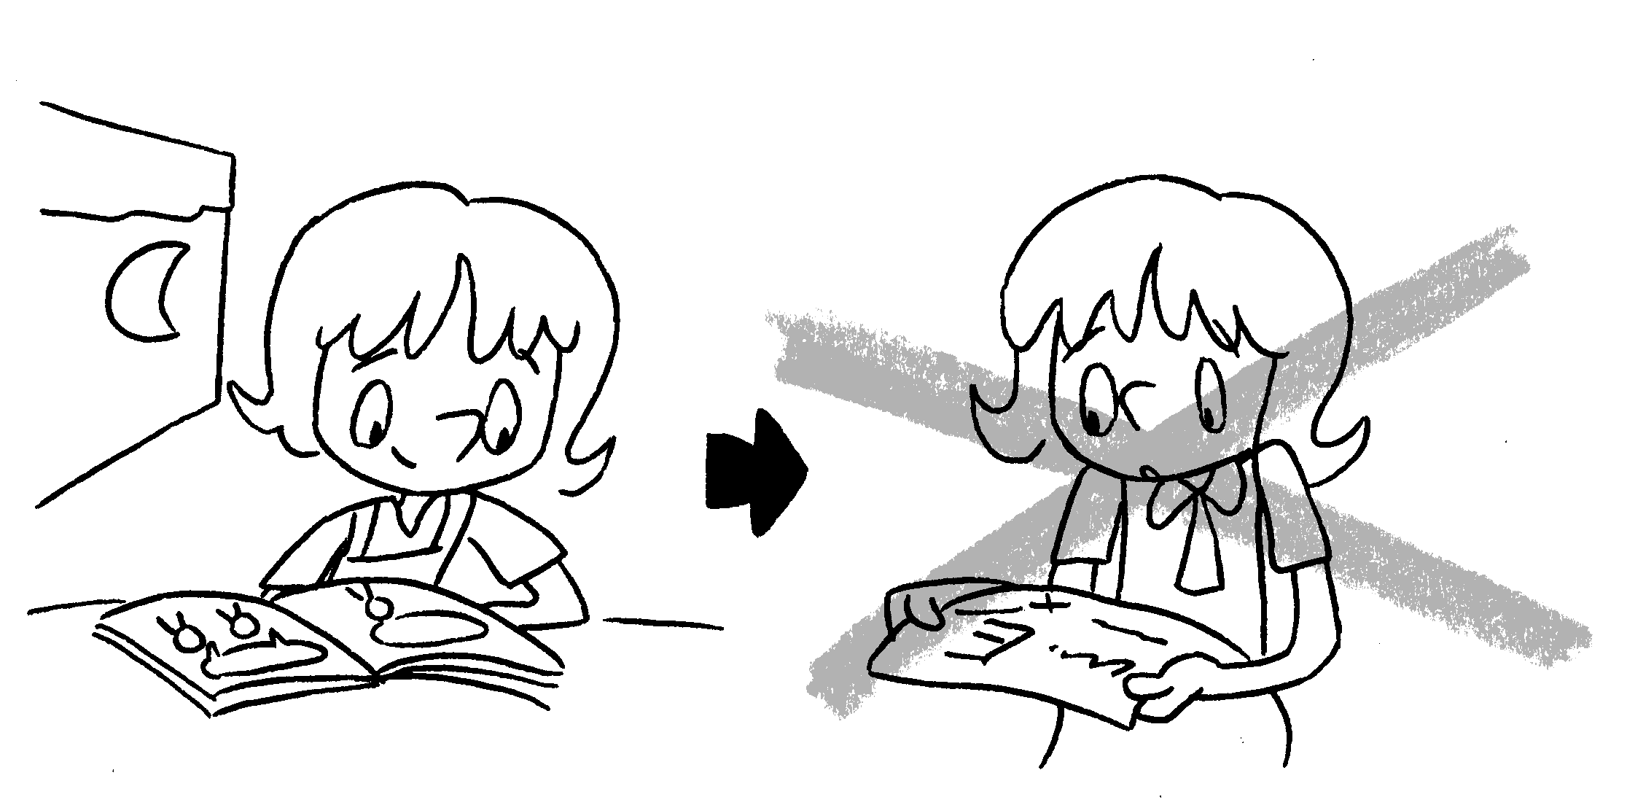  ( do ) | I am going to  every day.  Then I my exam.
3 | 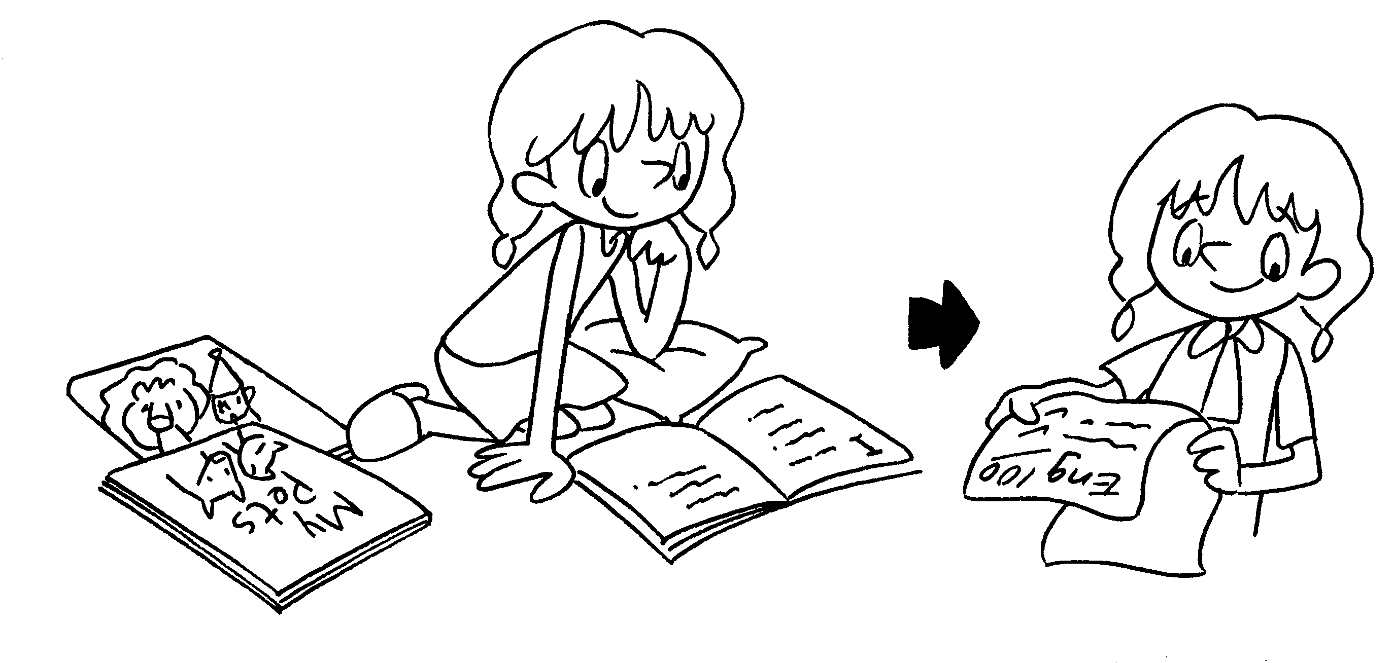  ( read ) | I am  English books every day.  Then English.
4 | 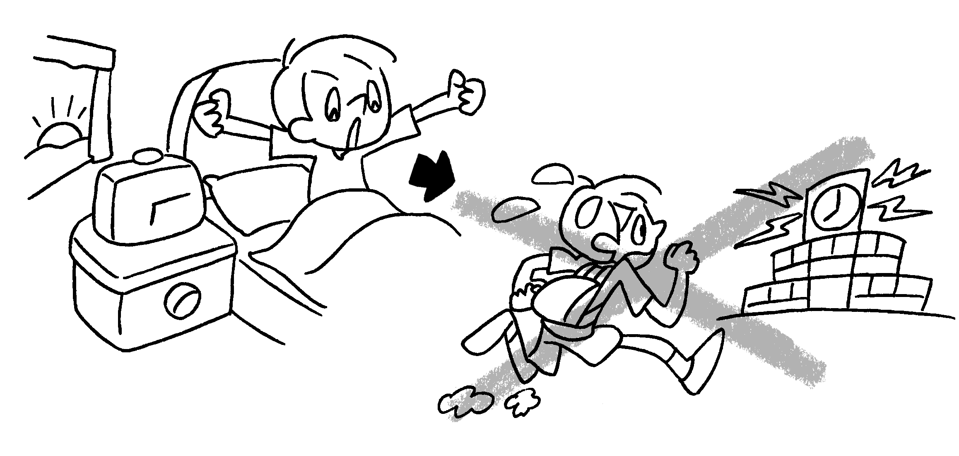  ( get up ) | I am  every day.  for school.
5 | 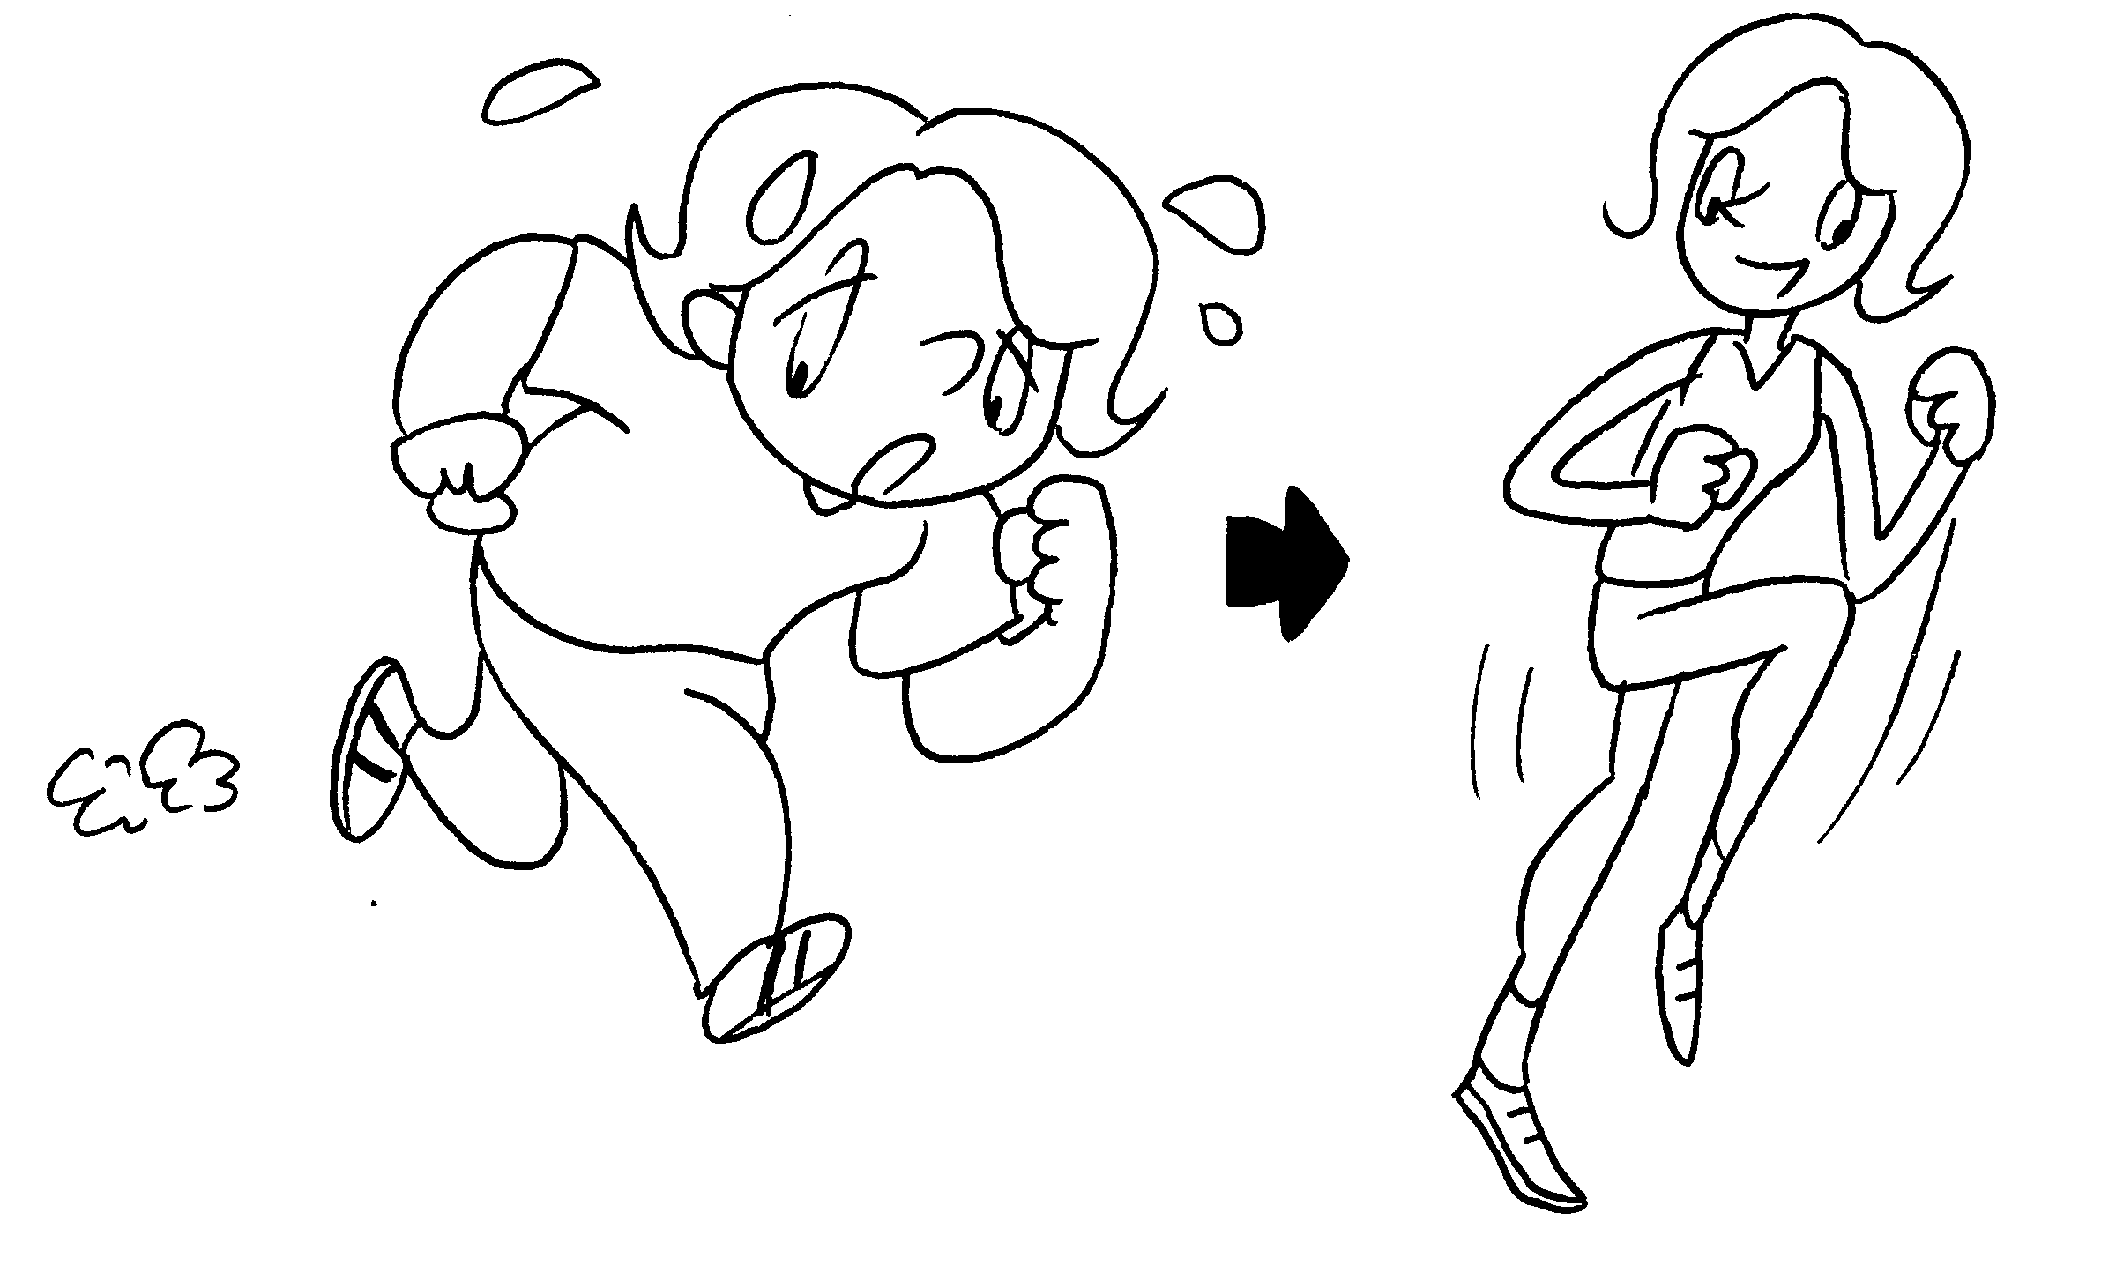  ( go ) | every day.


Book 4B Chapter 5 Graded Worksheets
Worksheet 3⬇⬇⬇
- play
strong
- do revision
won’t fail
- going to read
I will be good at
- going to get up early
Then I won’t be late
- I am going to go running
Then I will be fit.
(Accept any reasonable answers.)
 Primary Longman Elect 4B © Pearson Education Asia Limited 2009

