Choose and write.
change my faceclothchange my sockschange my uniformcut my fingernailshelp with the houseworkgo to the dentistwash my hairwash my sports shoes

1 | 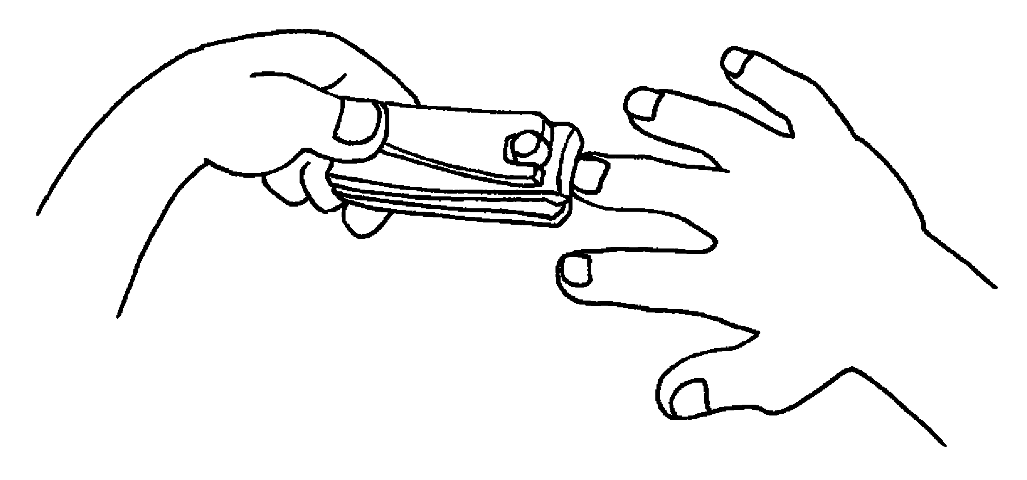 | 2 | 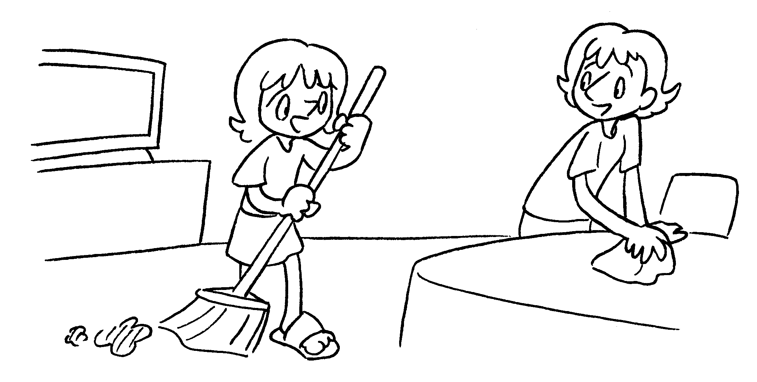
3 | 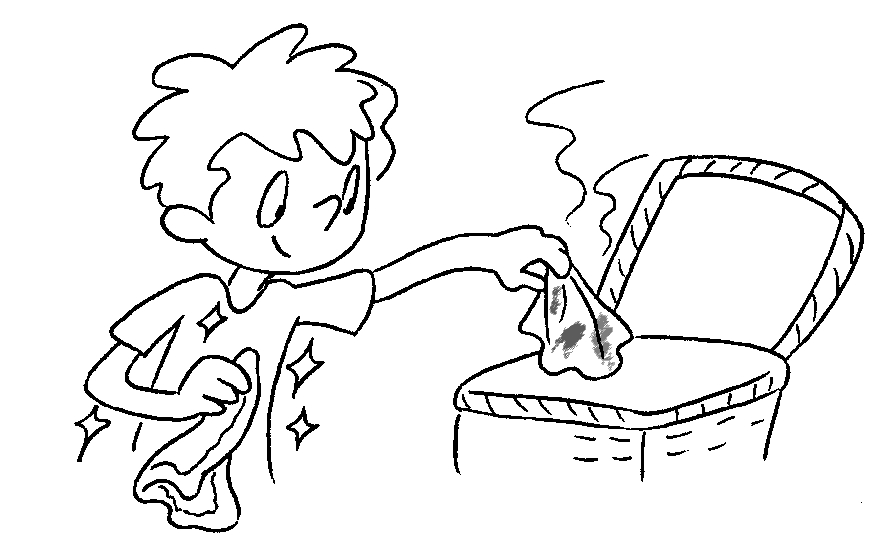 | 4 | 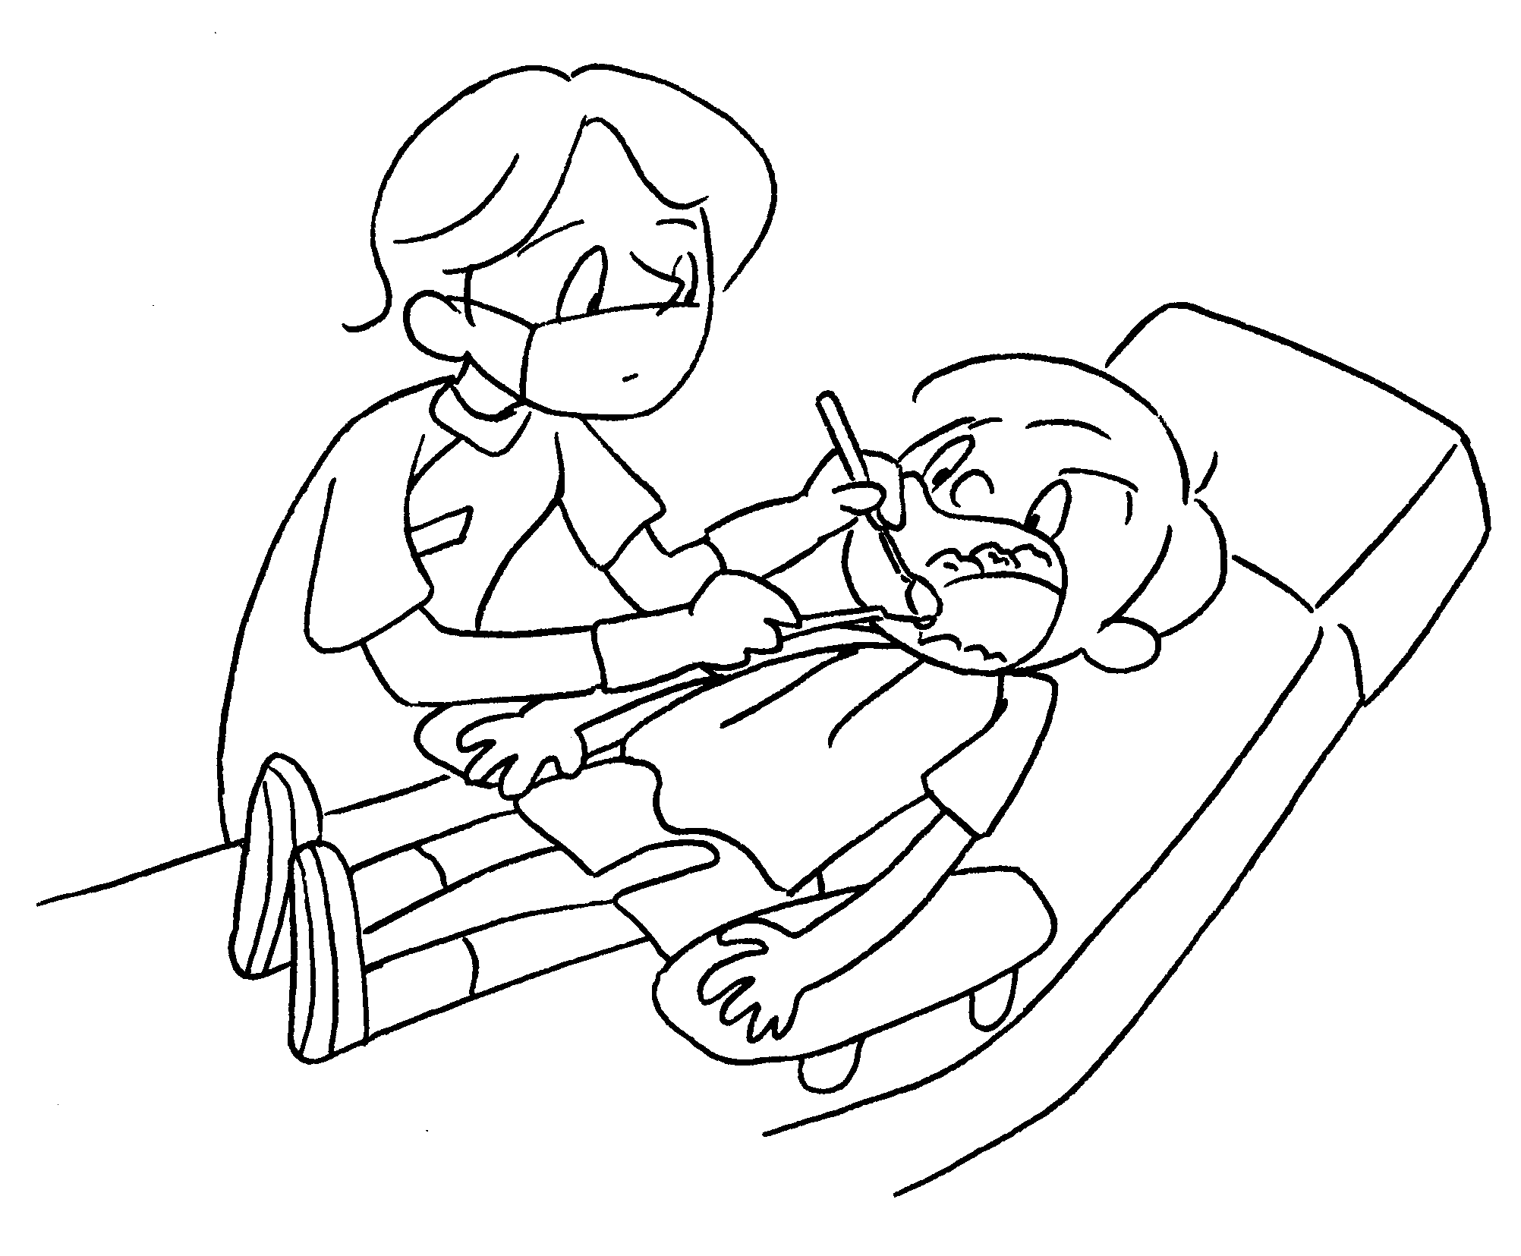
5 | 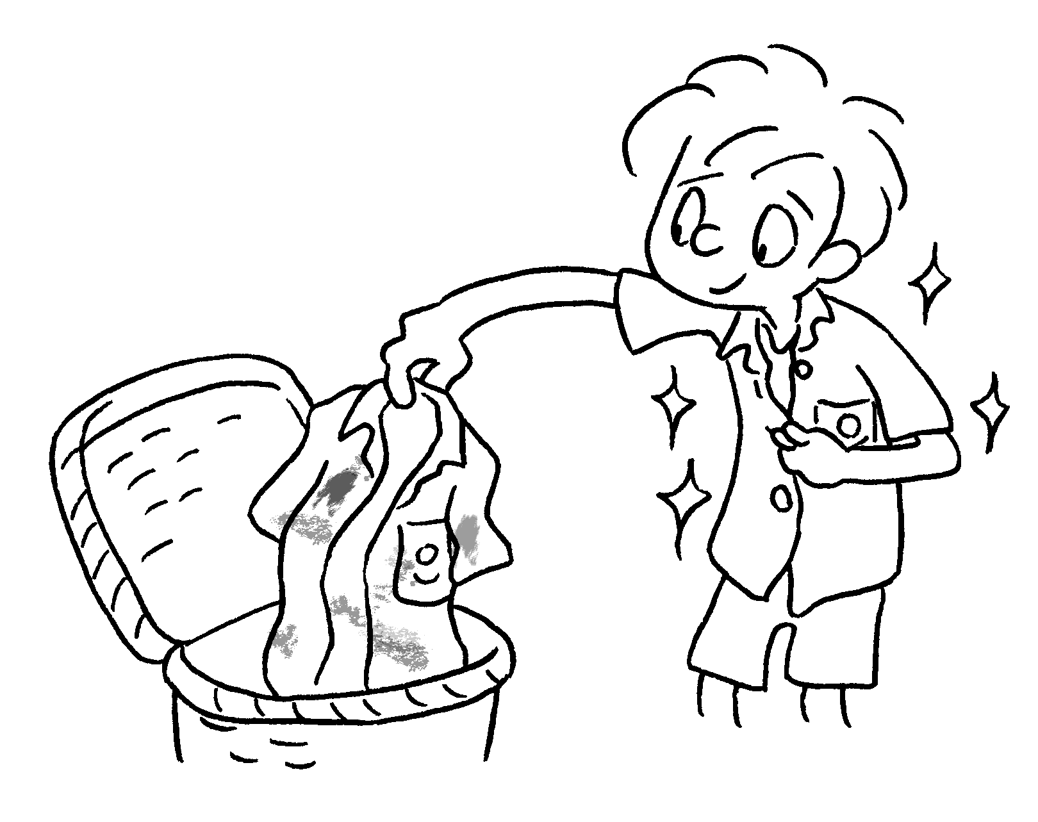 | 6 | 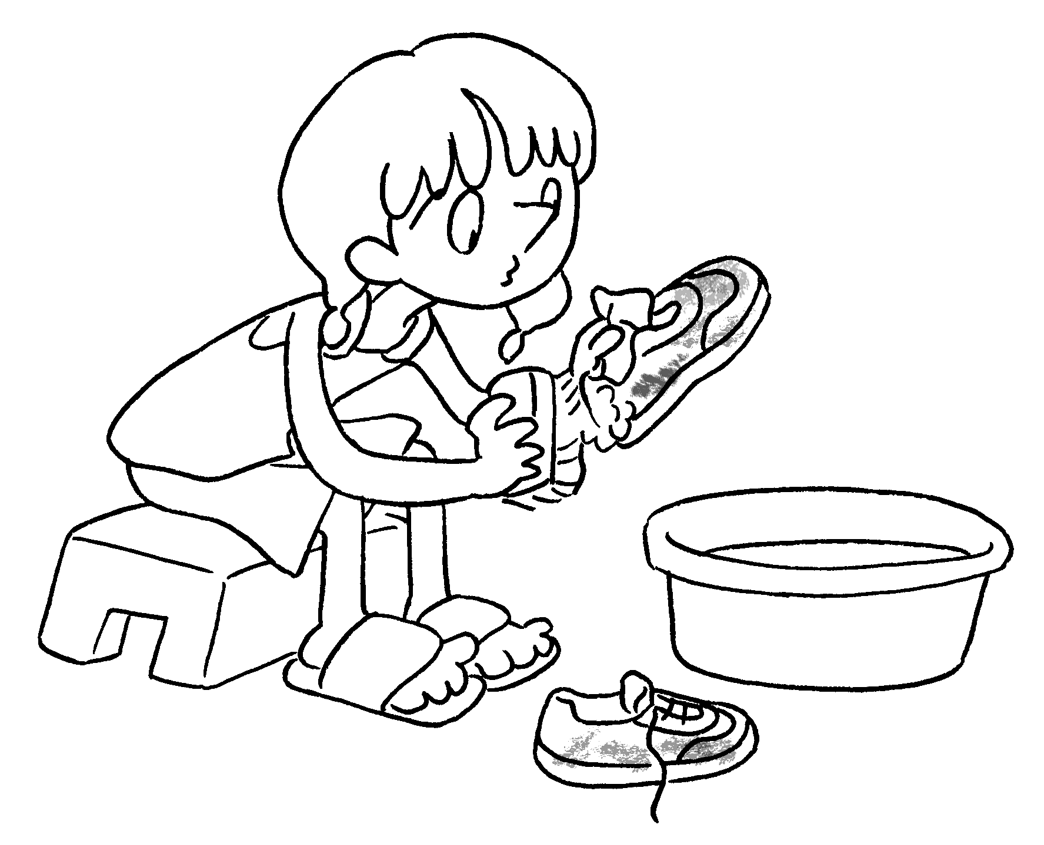
7 | 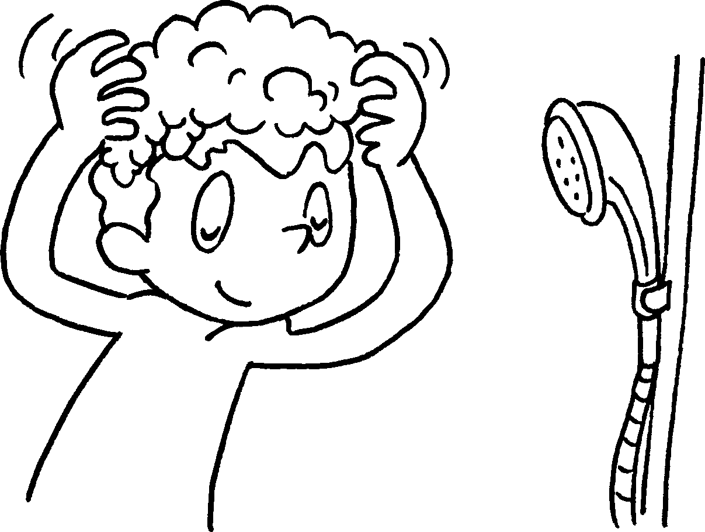 | 8 | 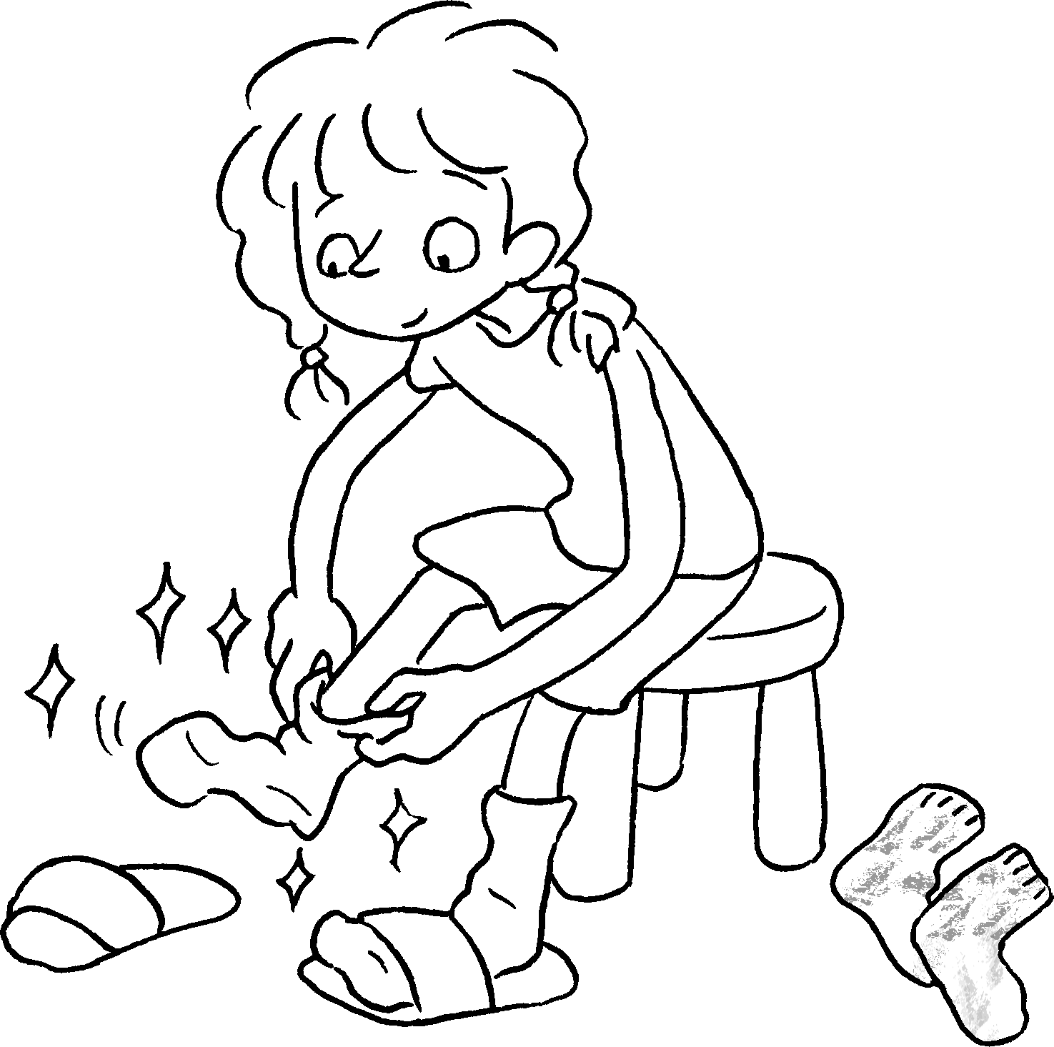


Book 4B Chapter 6 Graded Worksheets
Worksheet 1⬇
- cut my fingernails 2 help with the housework
3 change my facecloth 4 go to the dentist
5 change my uniform 6 wash my sports shoes
7 wash my hair 8 change my socks

