Fill in the blanks.

change cut go to uniform dentist facecloth housework
wash help with sports shoes fingernails socks hair

1 | 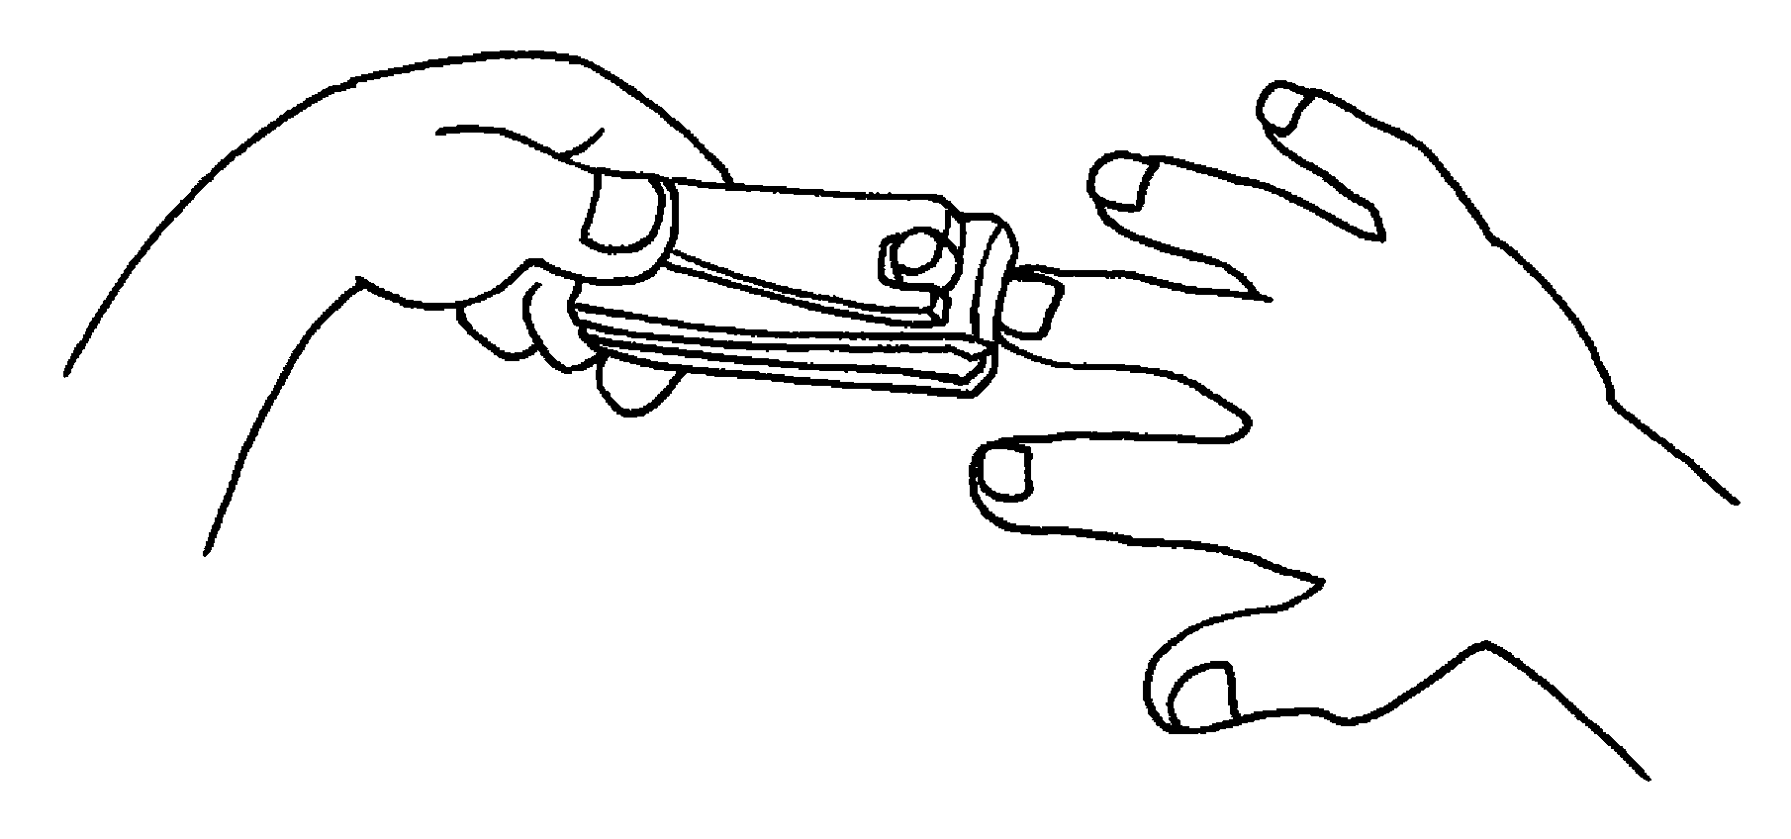  I _________ my _________________  once a week. | 2 | 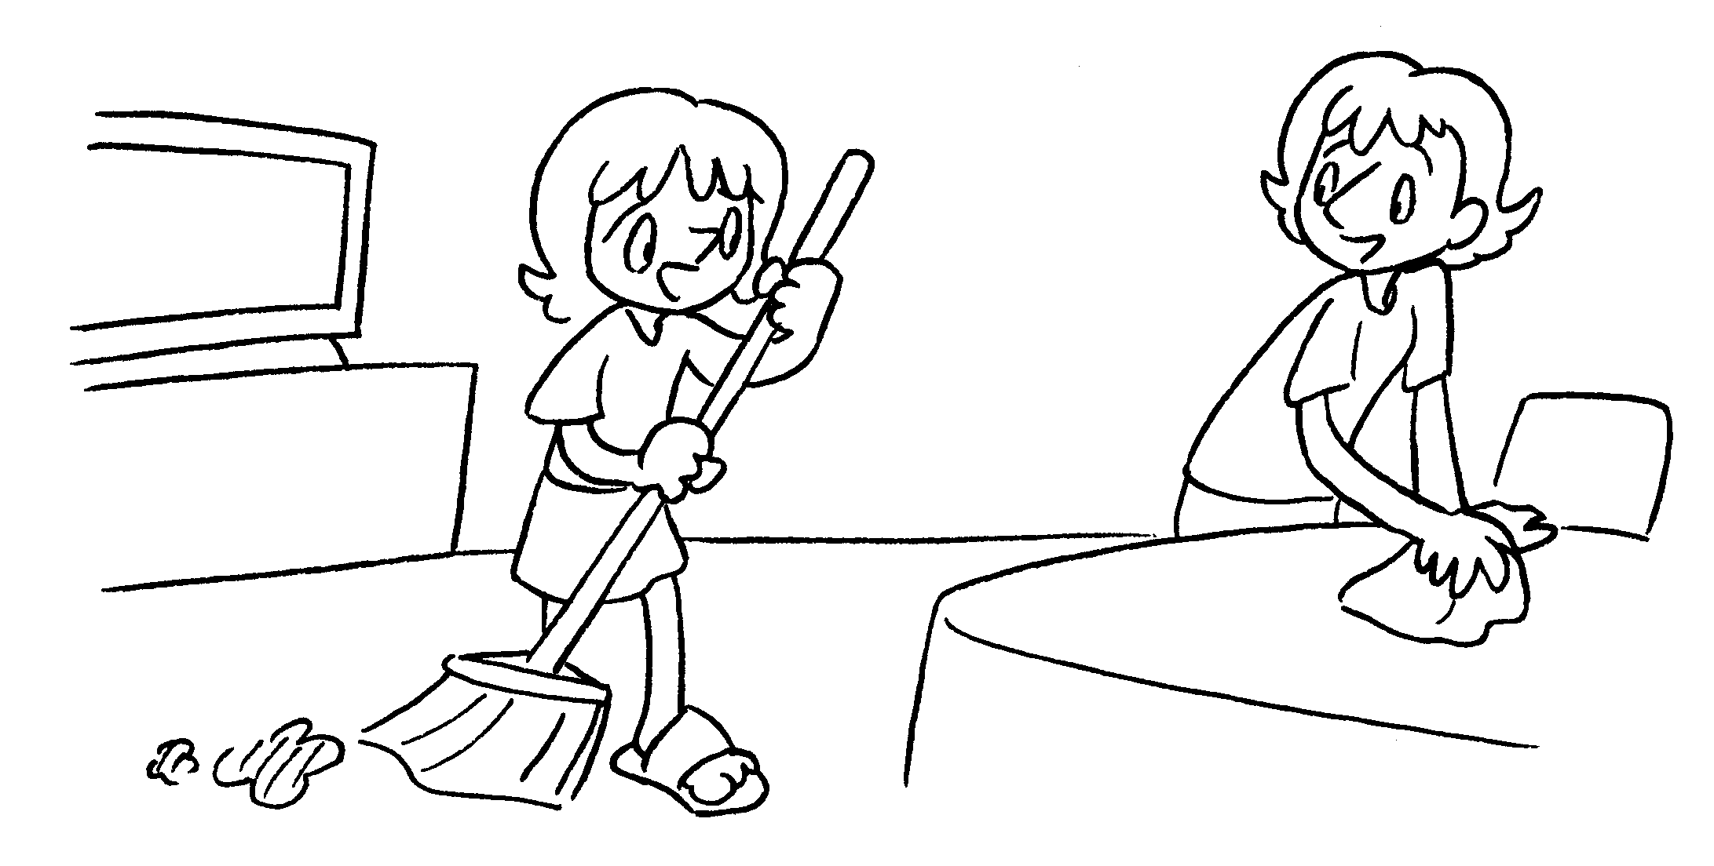  I ____________________ the  ________________ twice a week.
3 | 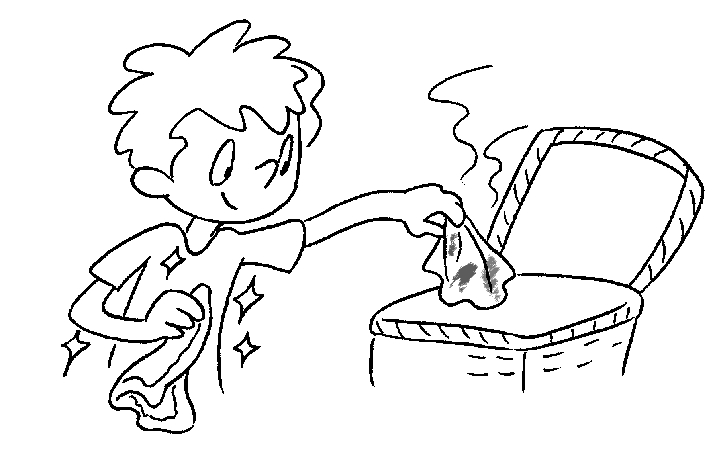  I _____________ my _____________  every day. | 4 | 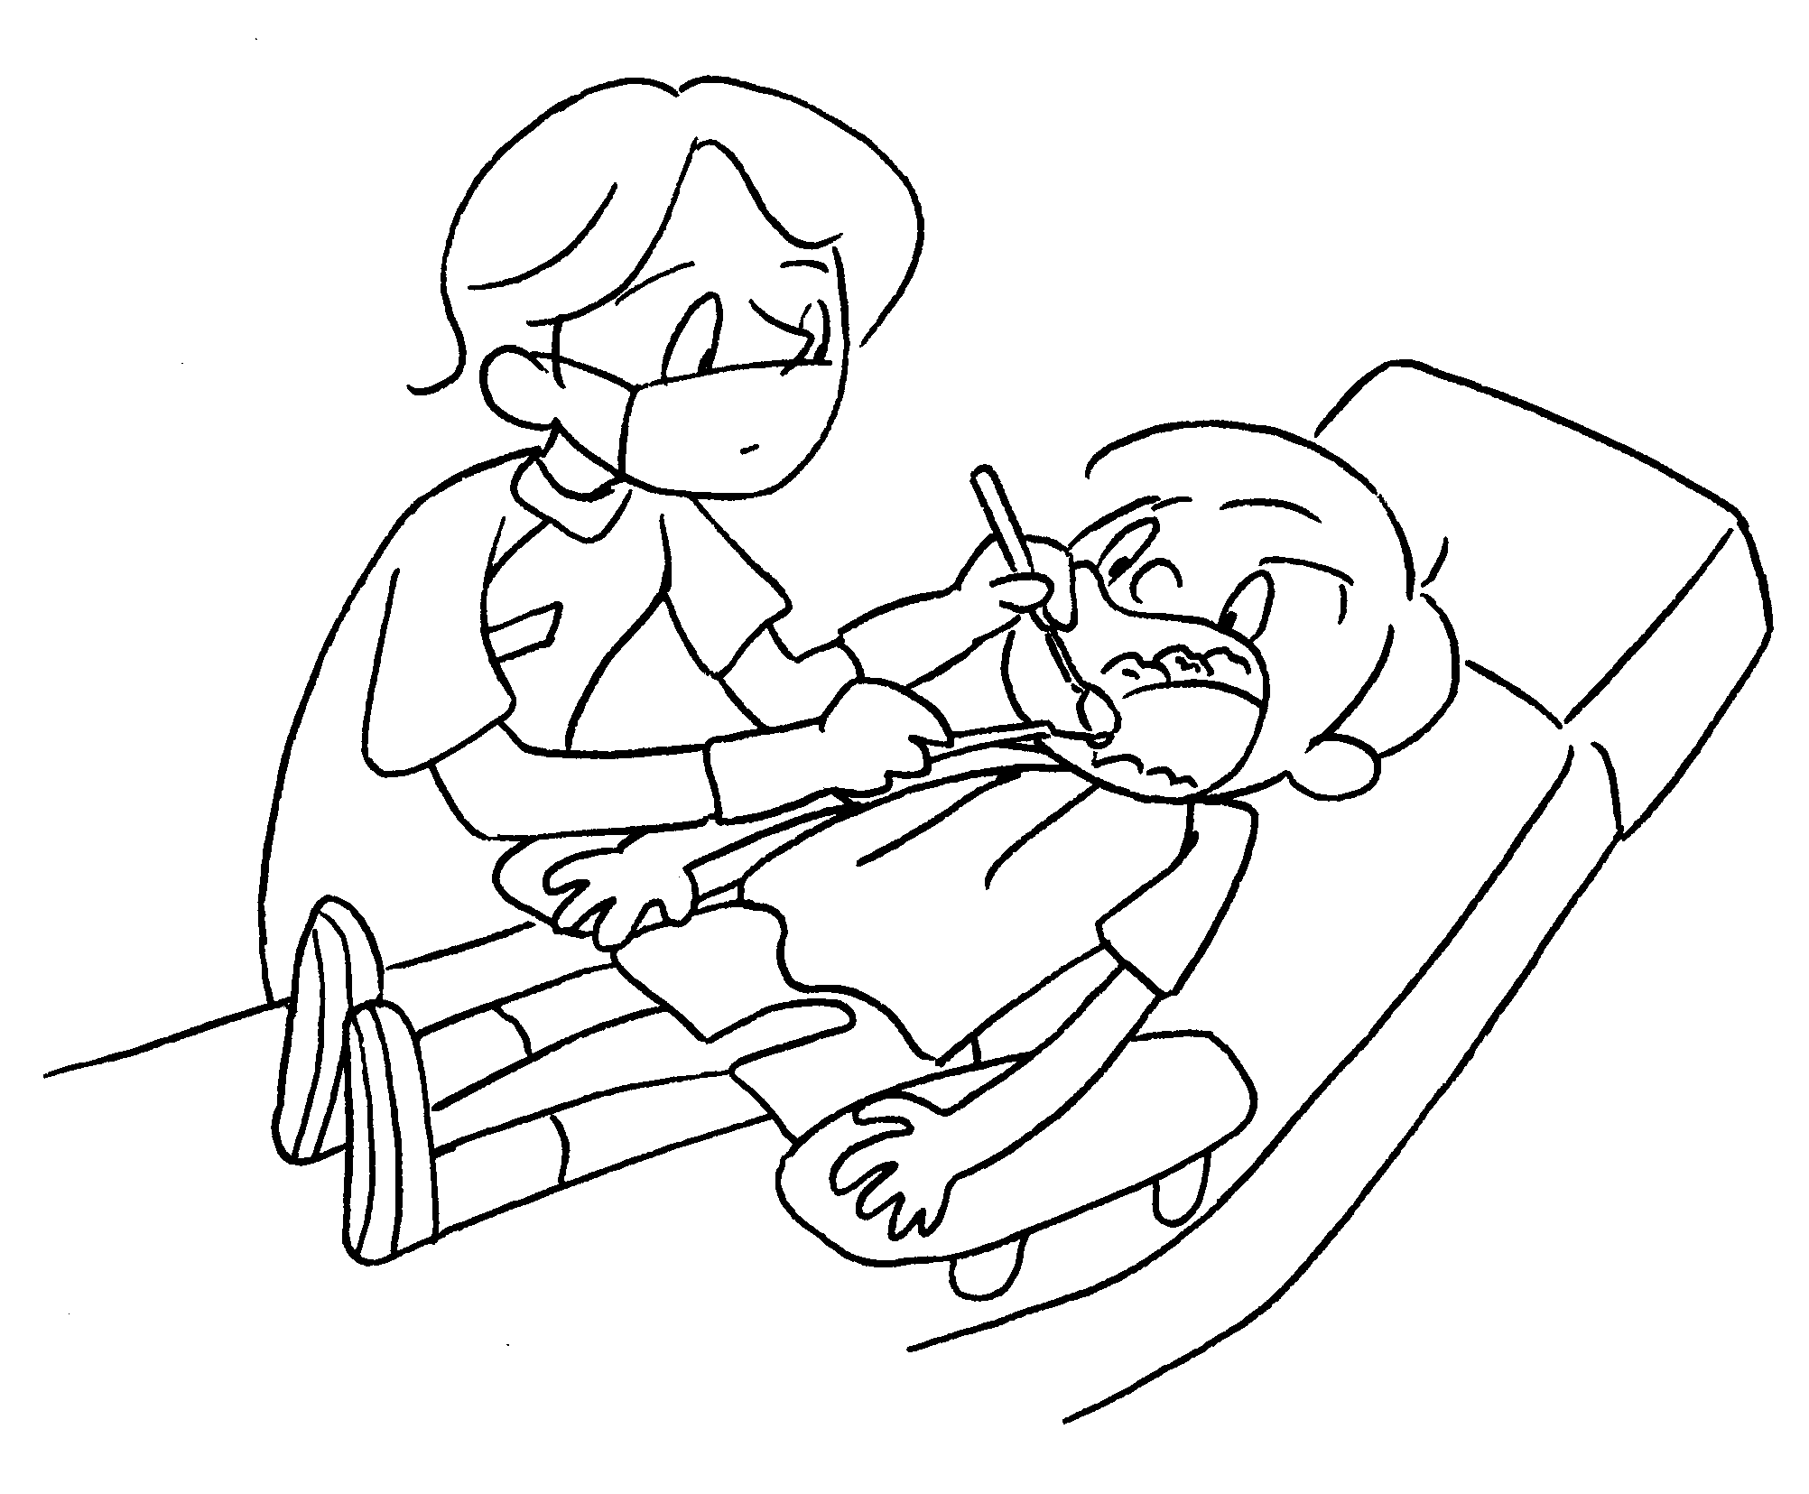  I ______________________________  once a year.
5 | 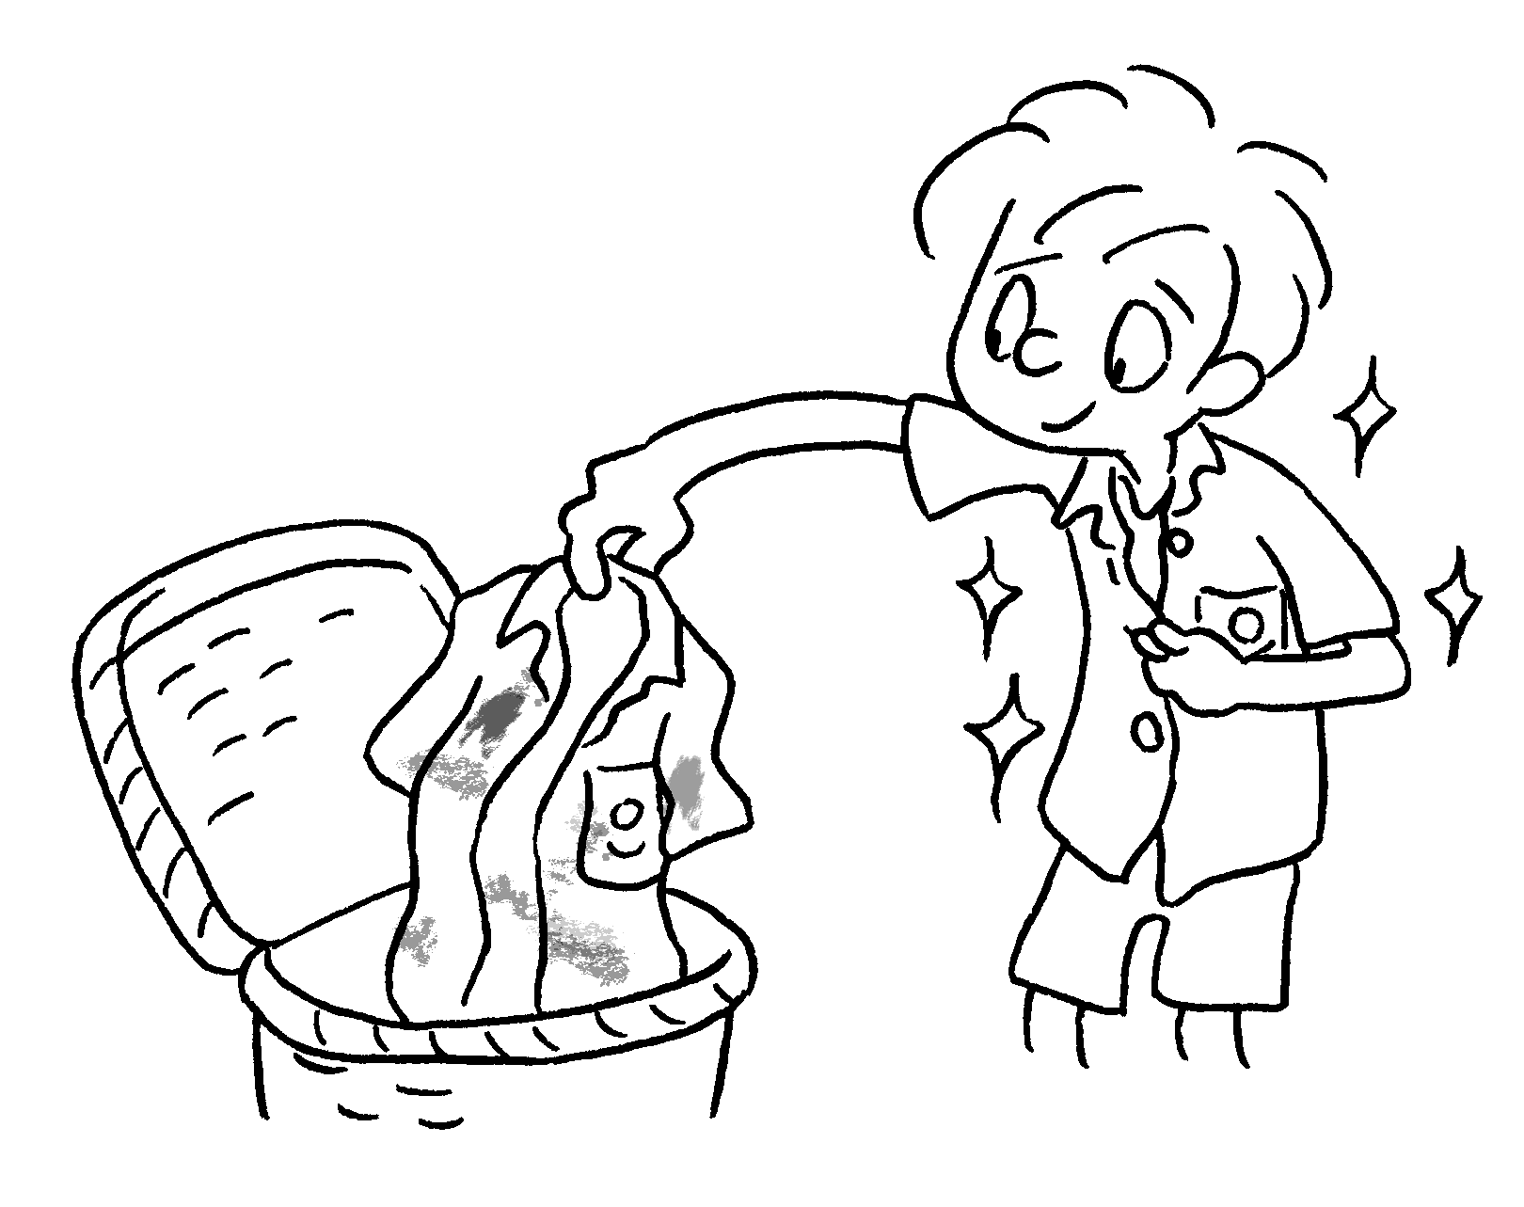  I _______________________________  every day. | 6 | 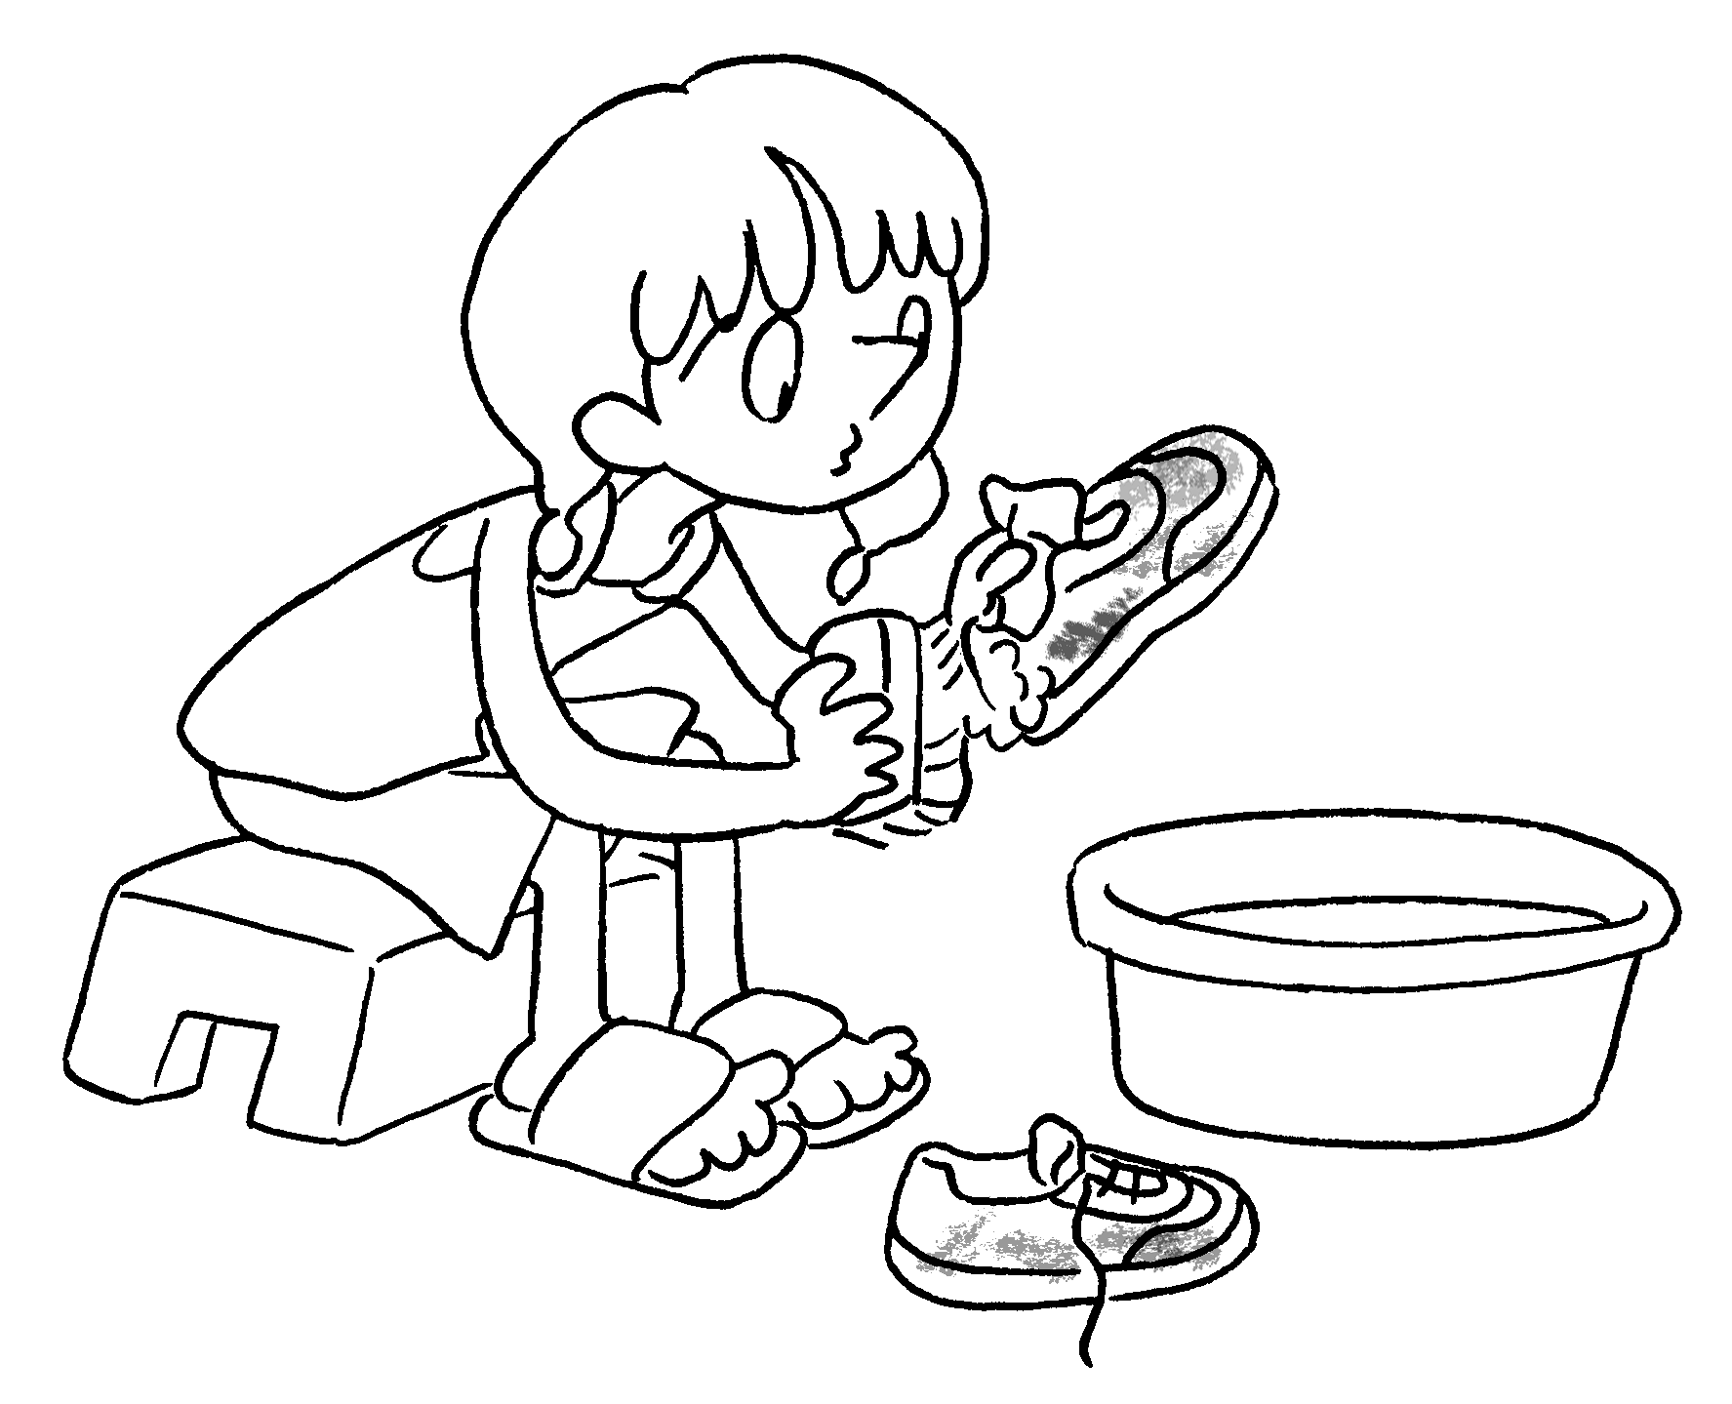  I ______________________________  once a week.
7 | 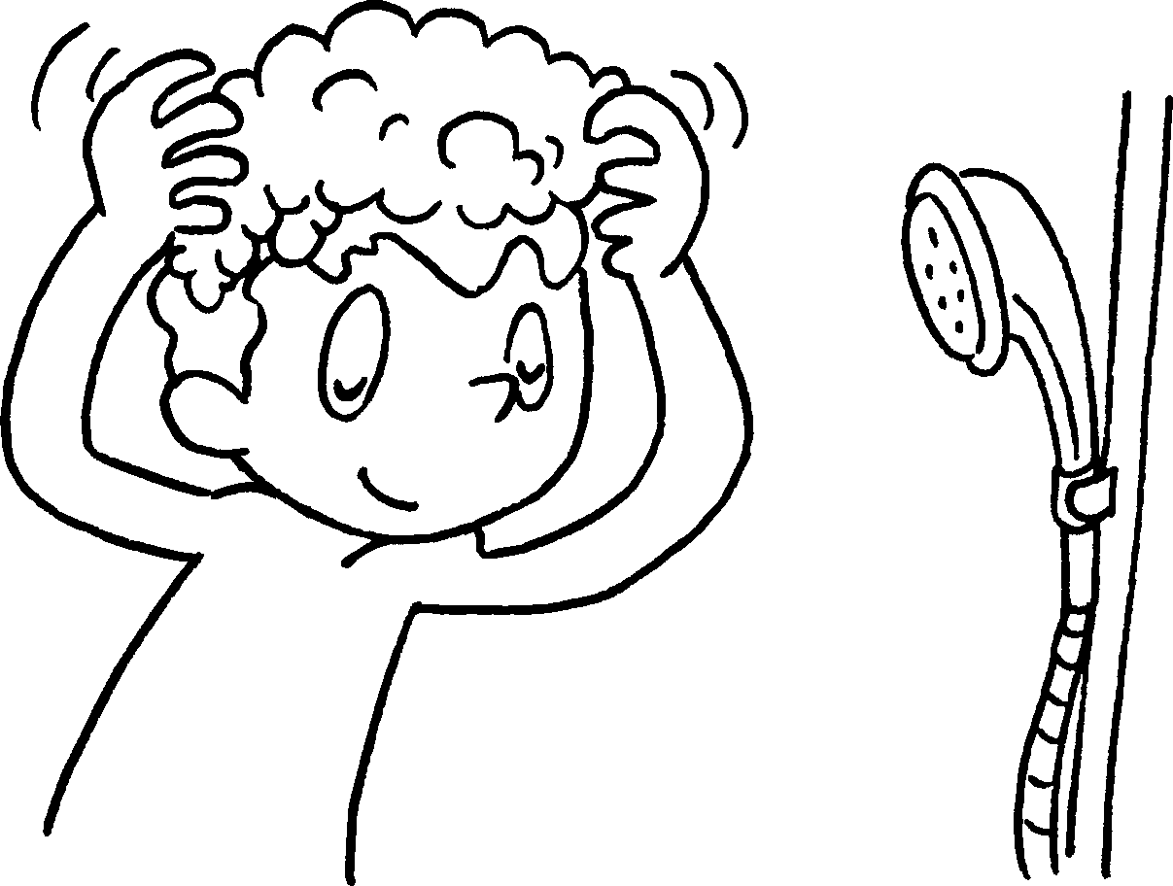  I _______________________________  three times a week. | 8 | 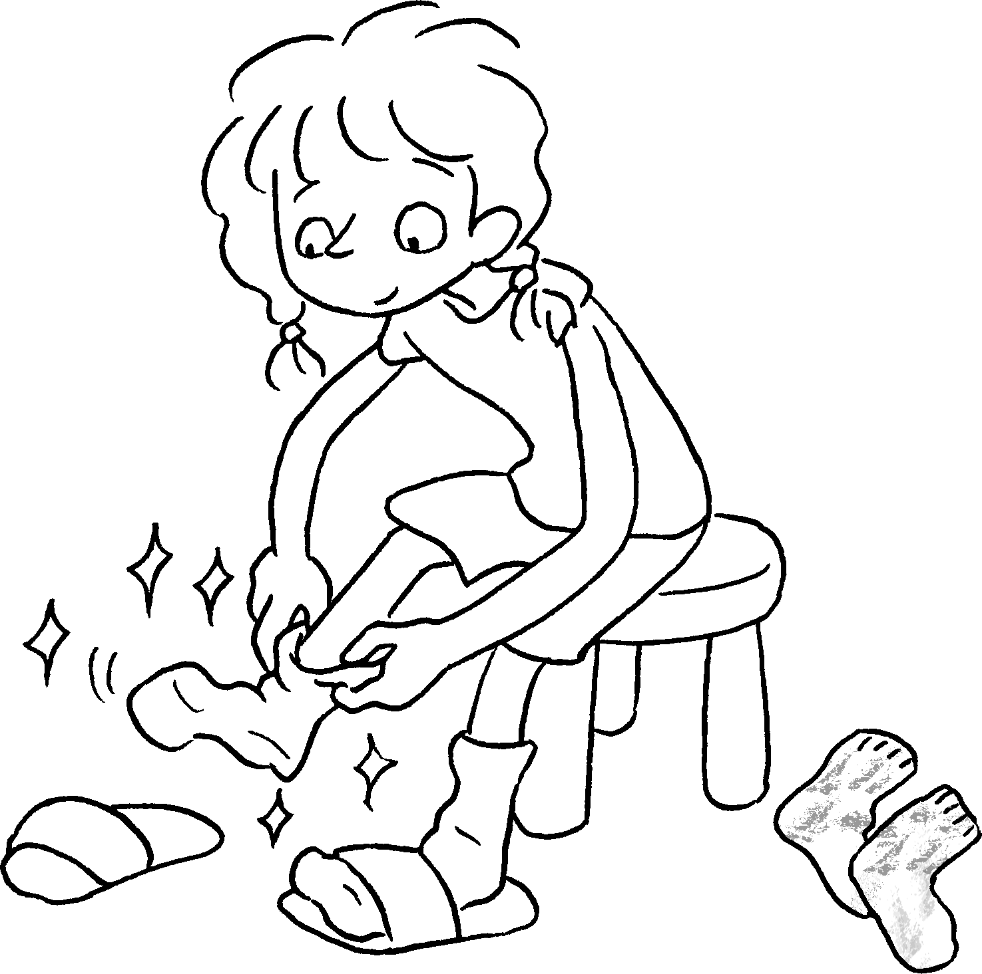  I ______________________________  every day.


Book 4B Chapter 6 Graded Worksheets
Worksheet 1⬇⬇
- cut fingernails 2 help with housework
3 change facecloth 4 go to the dentist
5 change my uniform 6 wash my sports shoes
7 wash my hair 8 change my socks

