Choose and write.
How often
oncetwicethree times
1  1 / week  B  A | 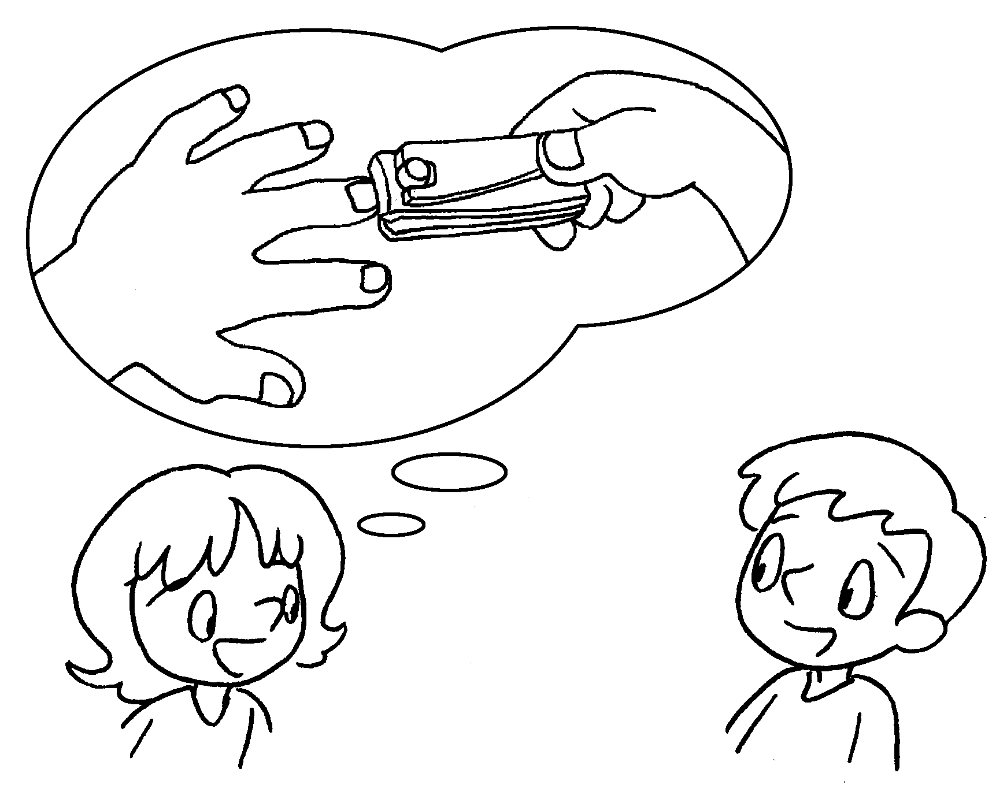 | A : How often do you cut your fingernails?  B : I cut my fingernails  a week.
2  2 / day  B  A | 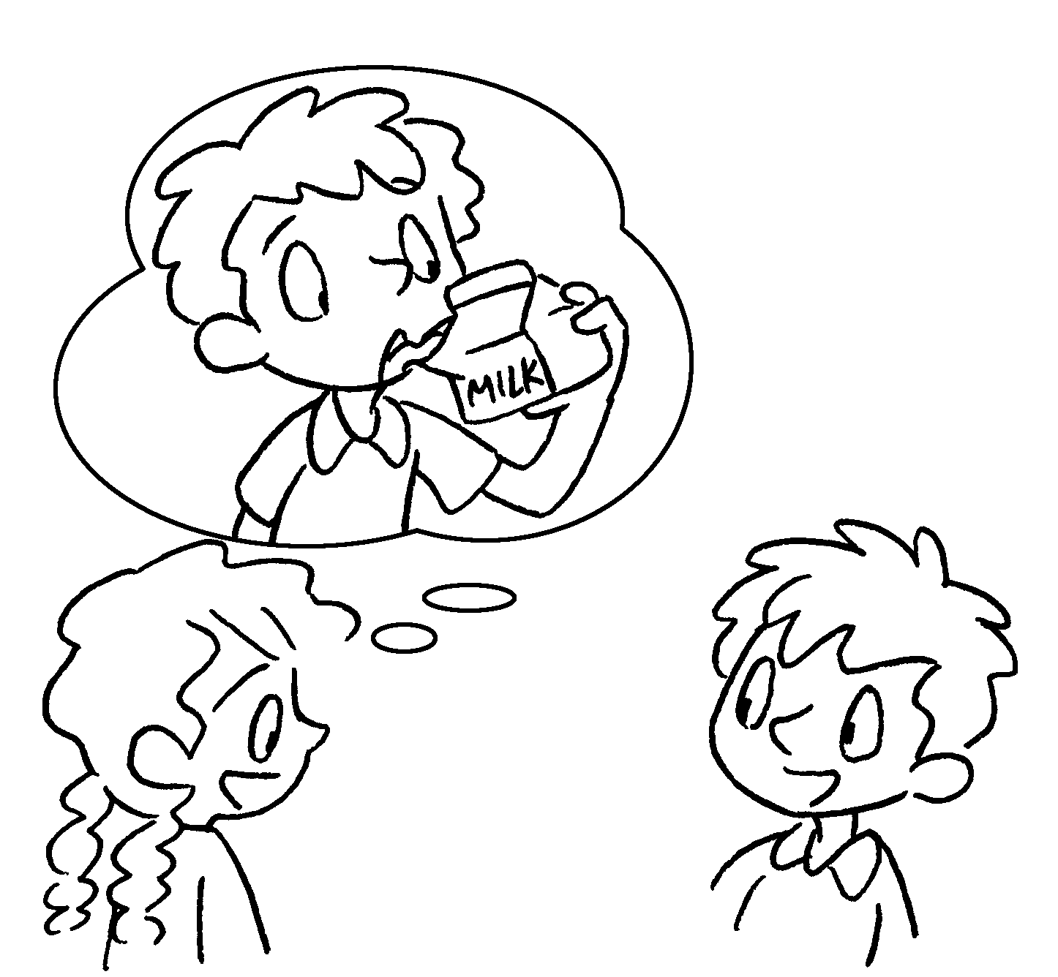  B | A : How often do you drink milk?  B : I drink milk a day.
3 | 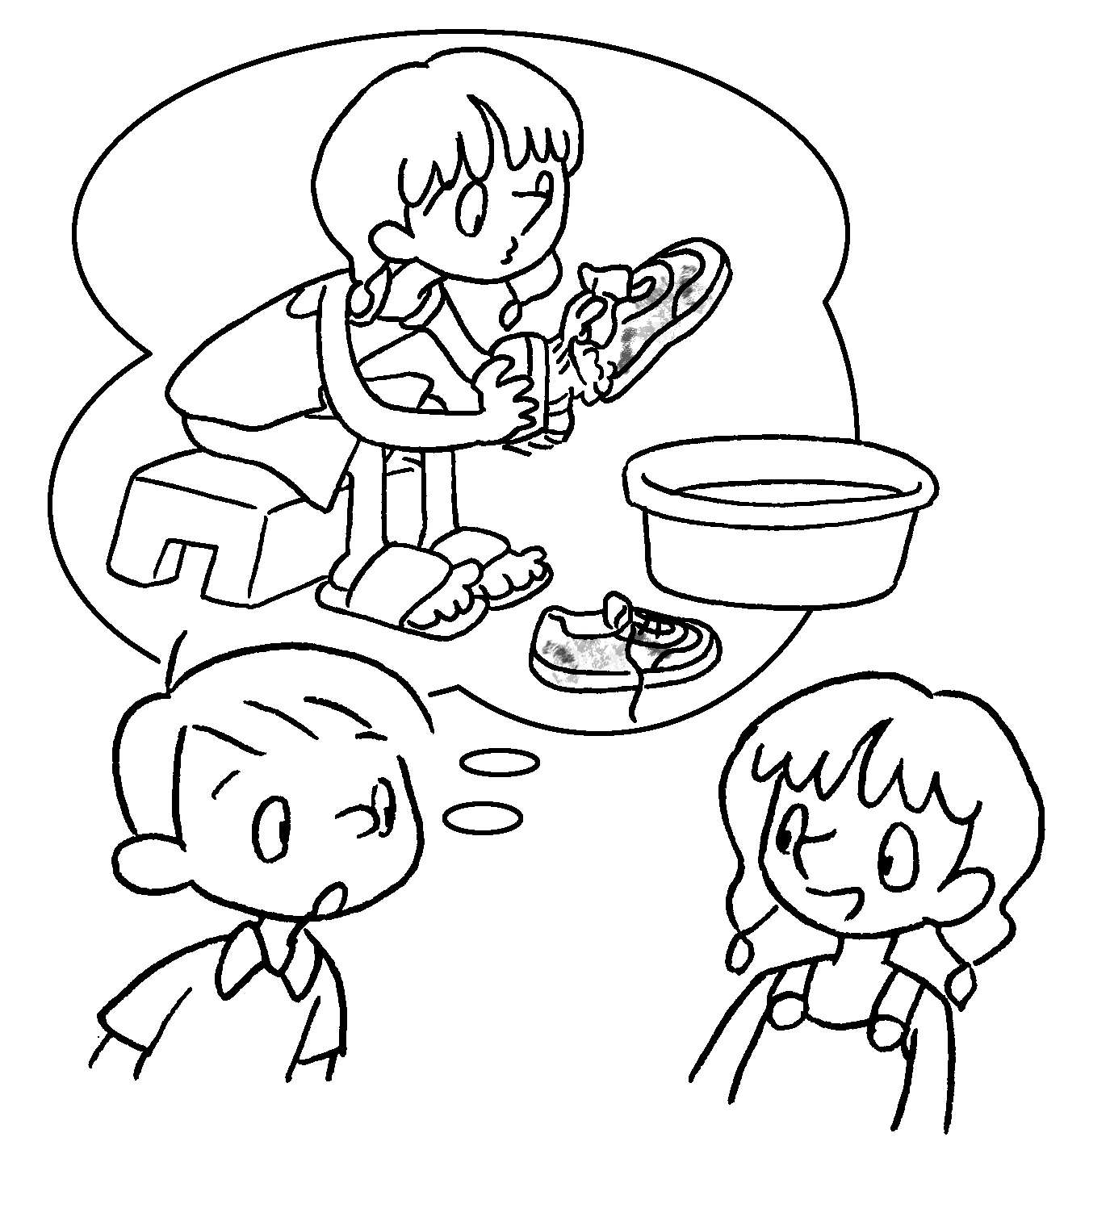  1 / month  A | A : do you wash  your sports shoes?  B : I wash my sports shoes  a month.
4  2 / year  B  A | 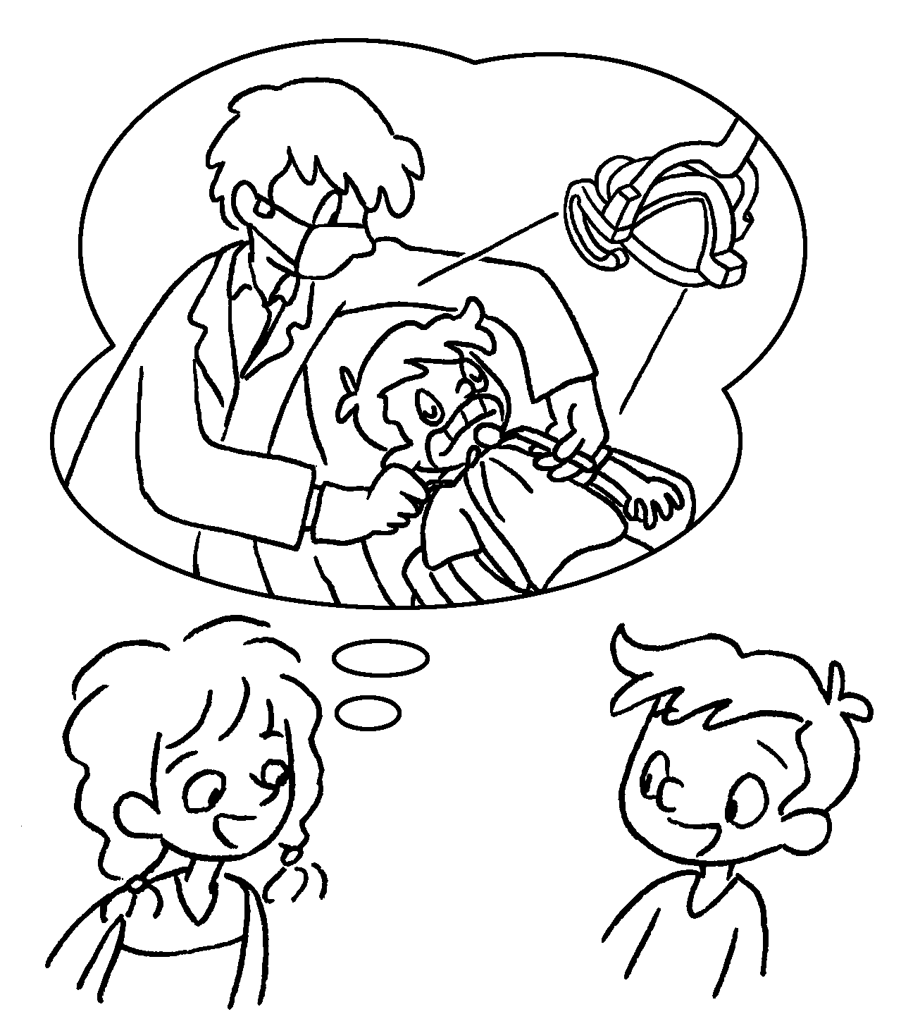 | A : do you go to  the dentist?  B : I go to the dentist  a year.
5  3 / week  B  A | 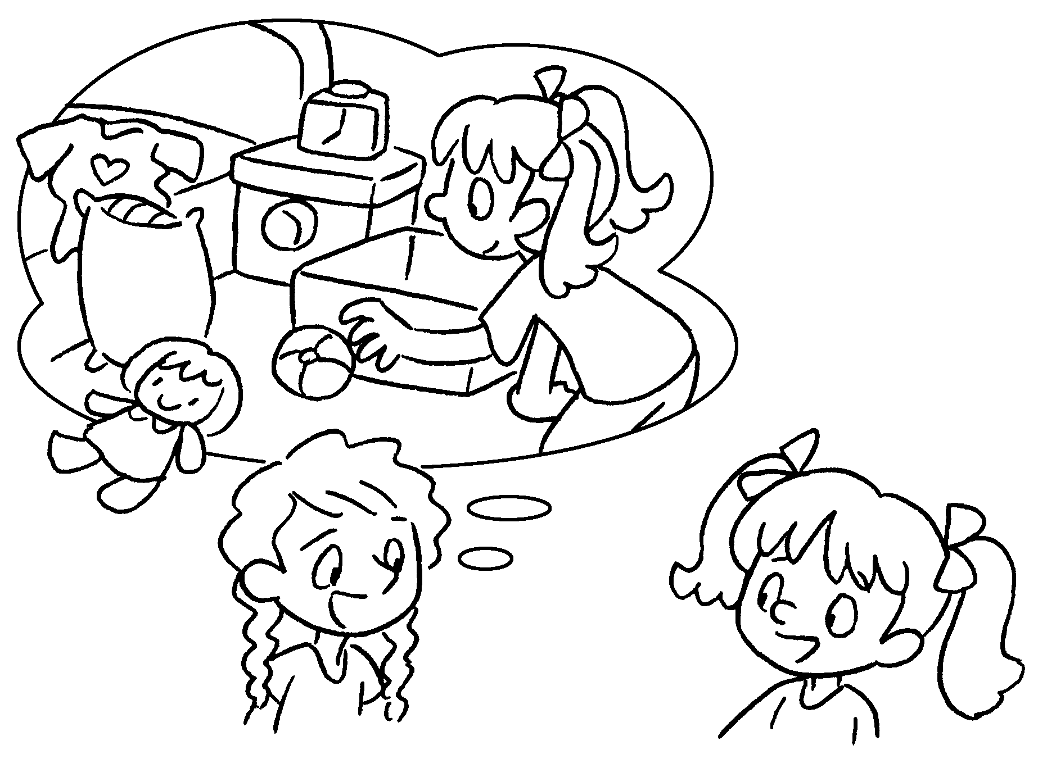 | A : do you tidy your  room?  B : I tidy my room  a week.


Book 4B Chapter 6 Graded Worksheets
Worksheet 2⬇
- once
- twice
- How often
once
- How often
twice
- How often
three times

