Finish the questions and answers.
washgo todrinktidy
1  1 / week  B  A | 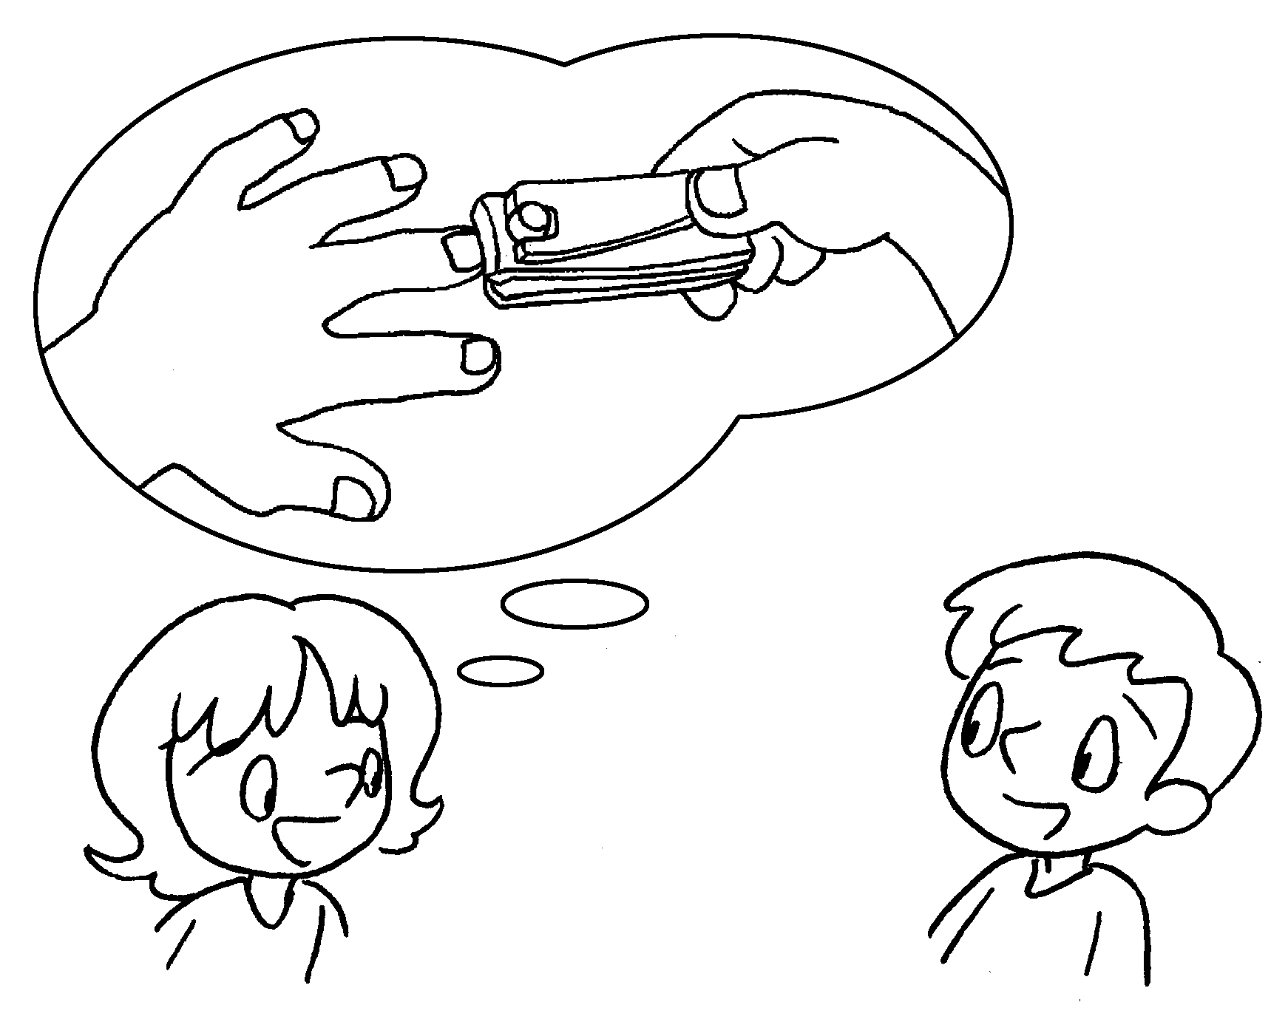 | A : How often do you cut your fingernails?  B : I cut my fingernails ___________________  a week.
2  2 / day  B  A | 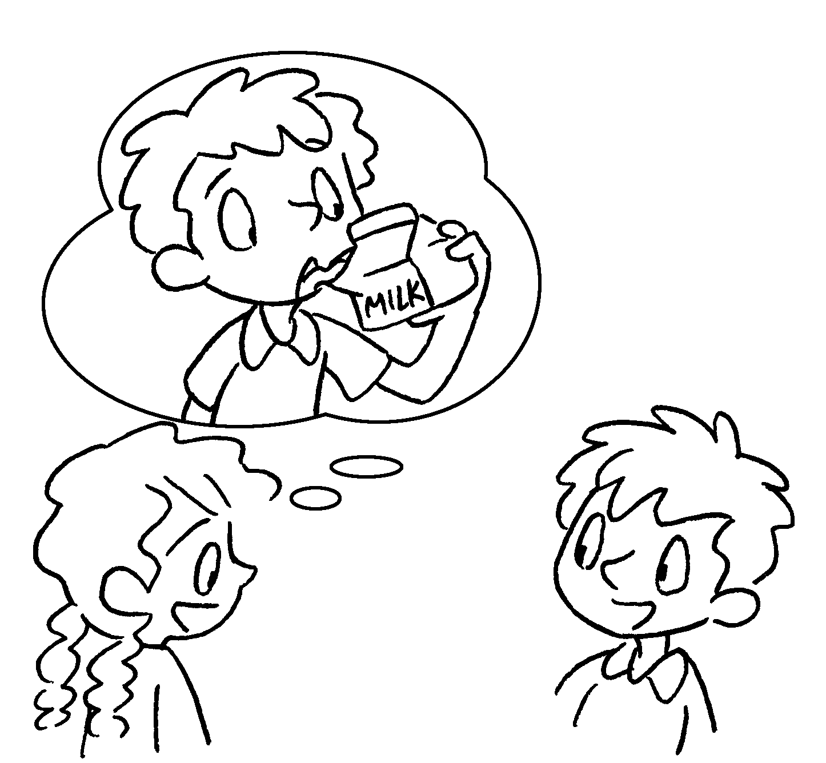  B | A : How often do you _____________ milk?  B : I ________________ milk _______________  a day.
3 | 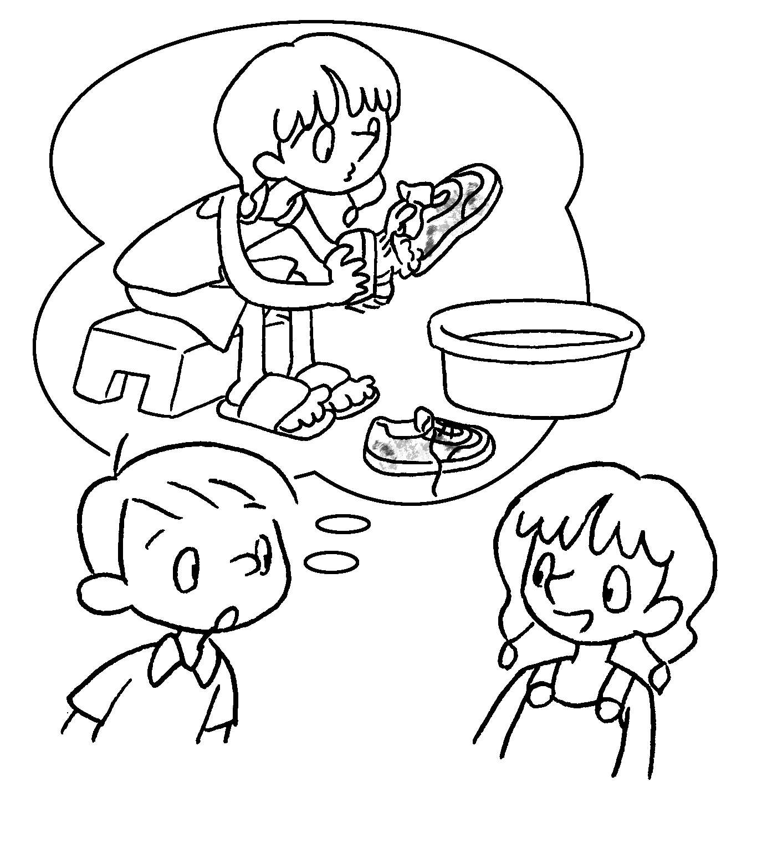  1 / month  A | A : _________________________ do you  ______________ your sports shoes?  B : I ____________________________________  ____________________________________ .
4  2 / year  B  A | 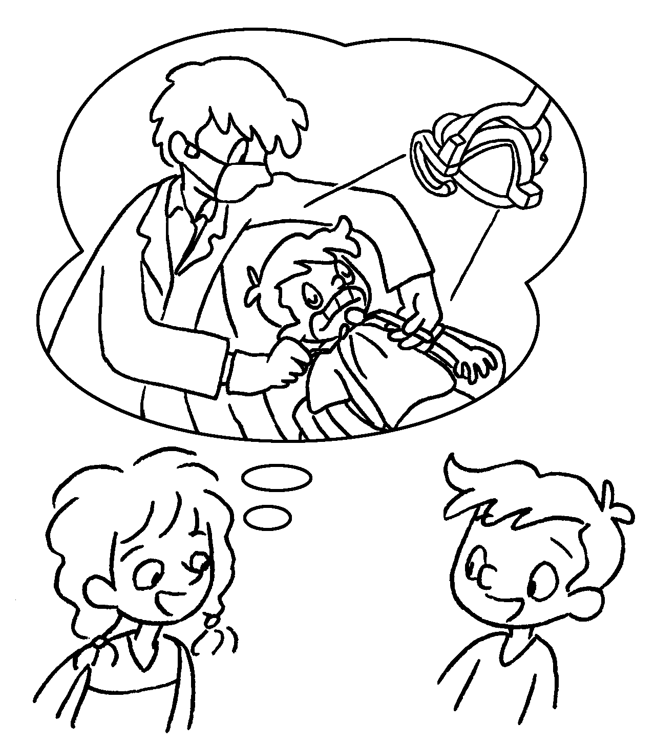 | A : _____________________________________  the dentist?  B : _____________________________________  _____________________________________
5  3 / week  B  A | 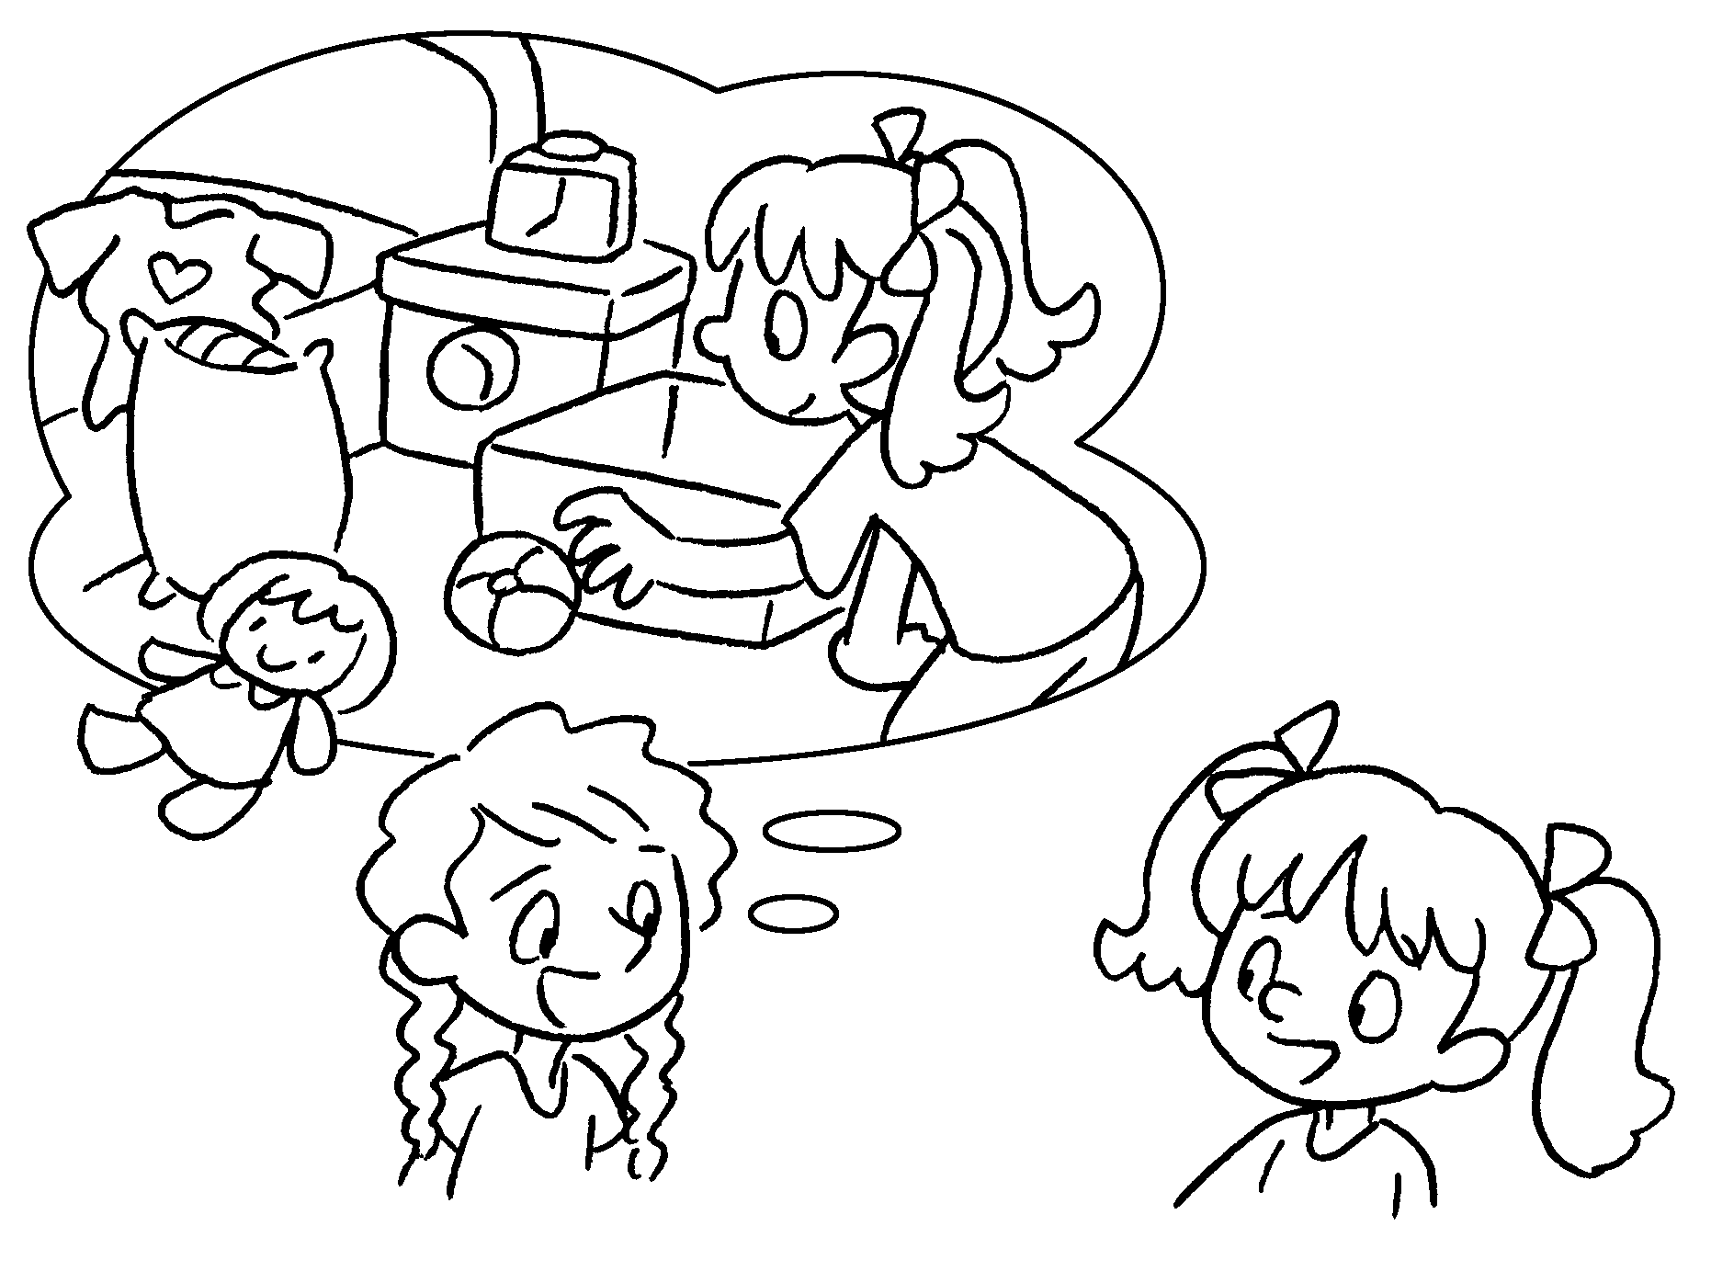 | A : _____________________________________  _____________________________________  B : _____________________________________  _____________________________________


Book 4B Chapter 6 Graded Worksheets
Worksheet 2⬇⬇⬇
- once
- drink
drink twice
- How often wash
wash my sports shoes once a month
- How often do you go to
I go to the dentist twice a year.
- How often do you tidy your room?
I tidy my room three times a week.
(Accept any reasonable answers.)

