Finish the sentences using ‘ought to’.
1 | 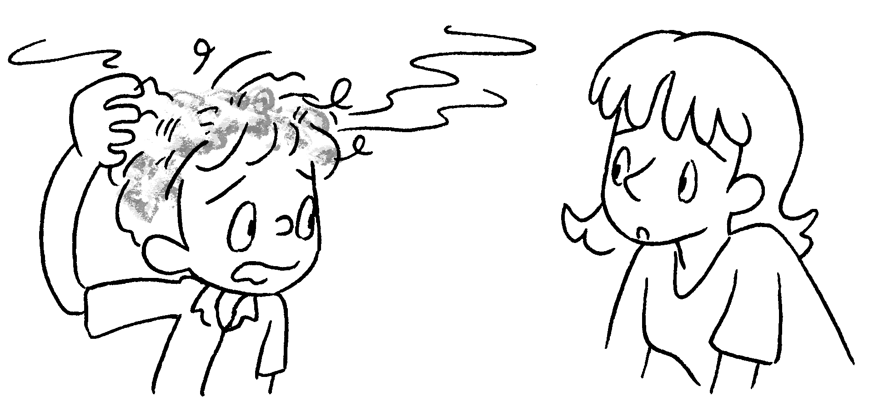 | You wash  your hair three times a week.
2 | 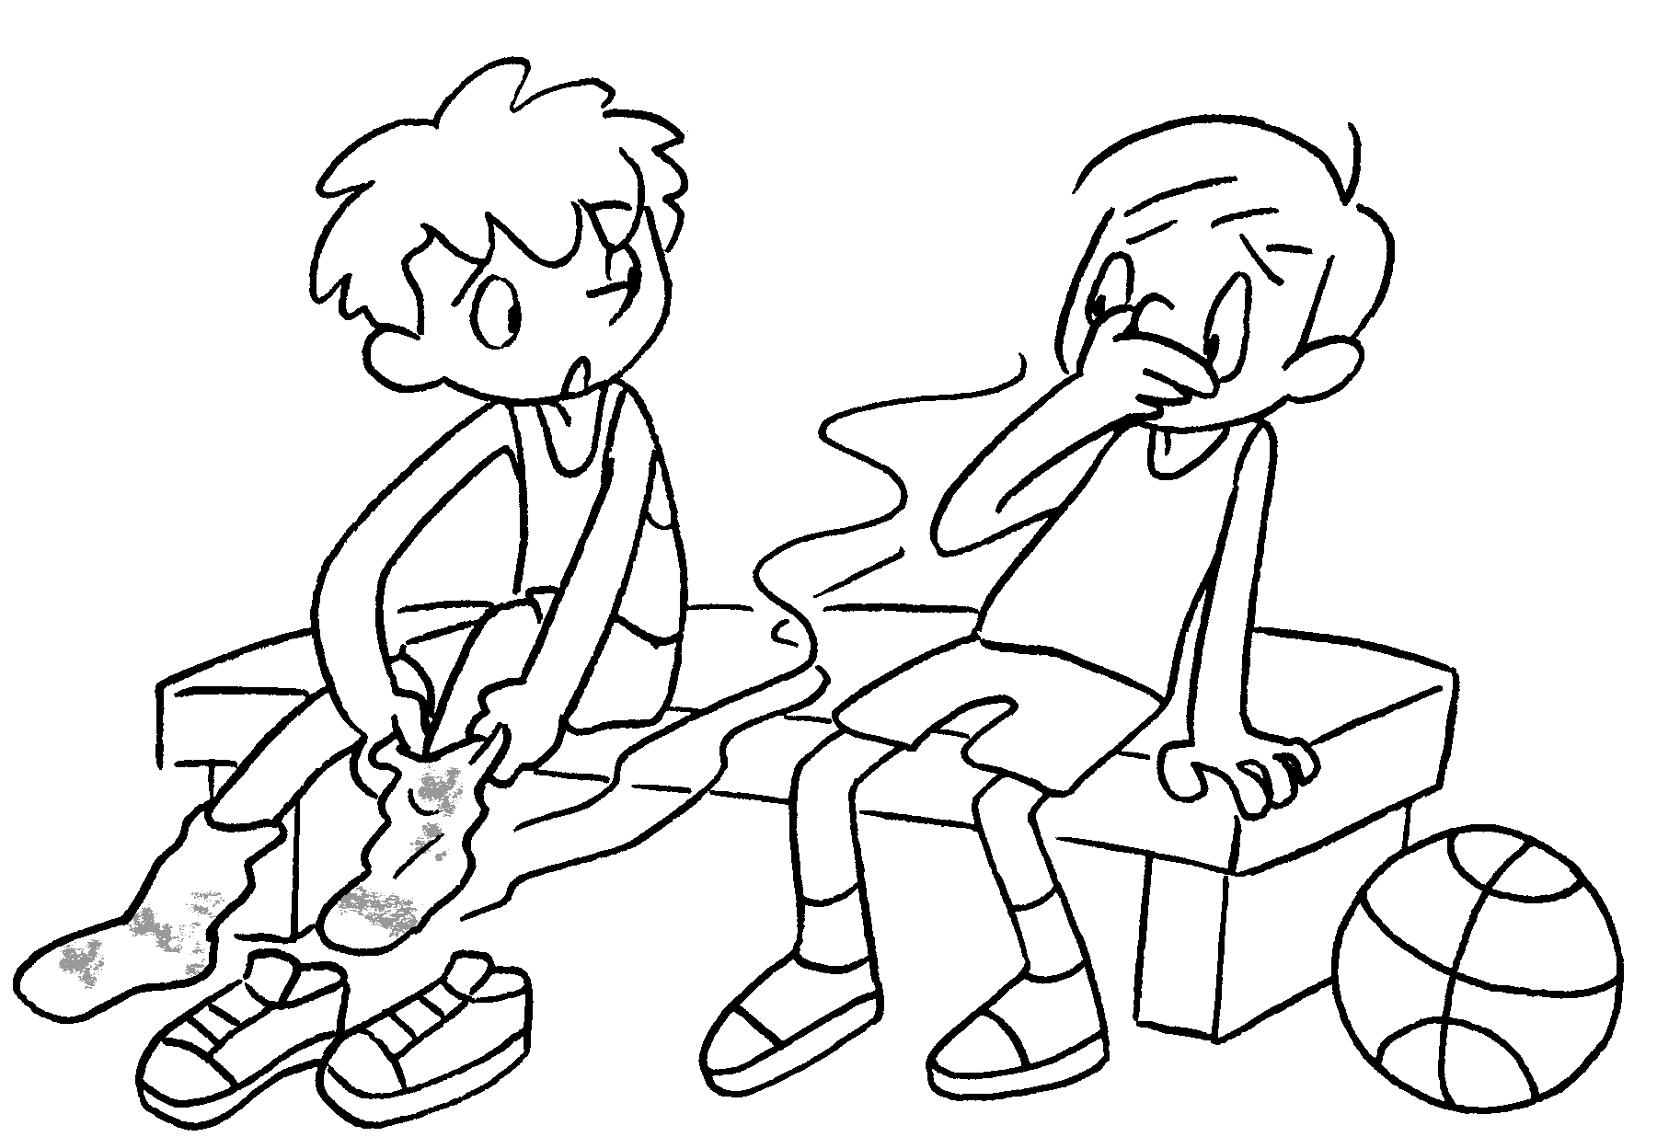 | You change  your socks once a day.
3  ( cut ) | 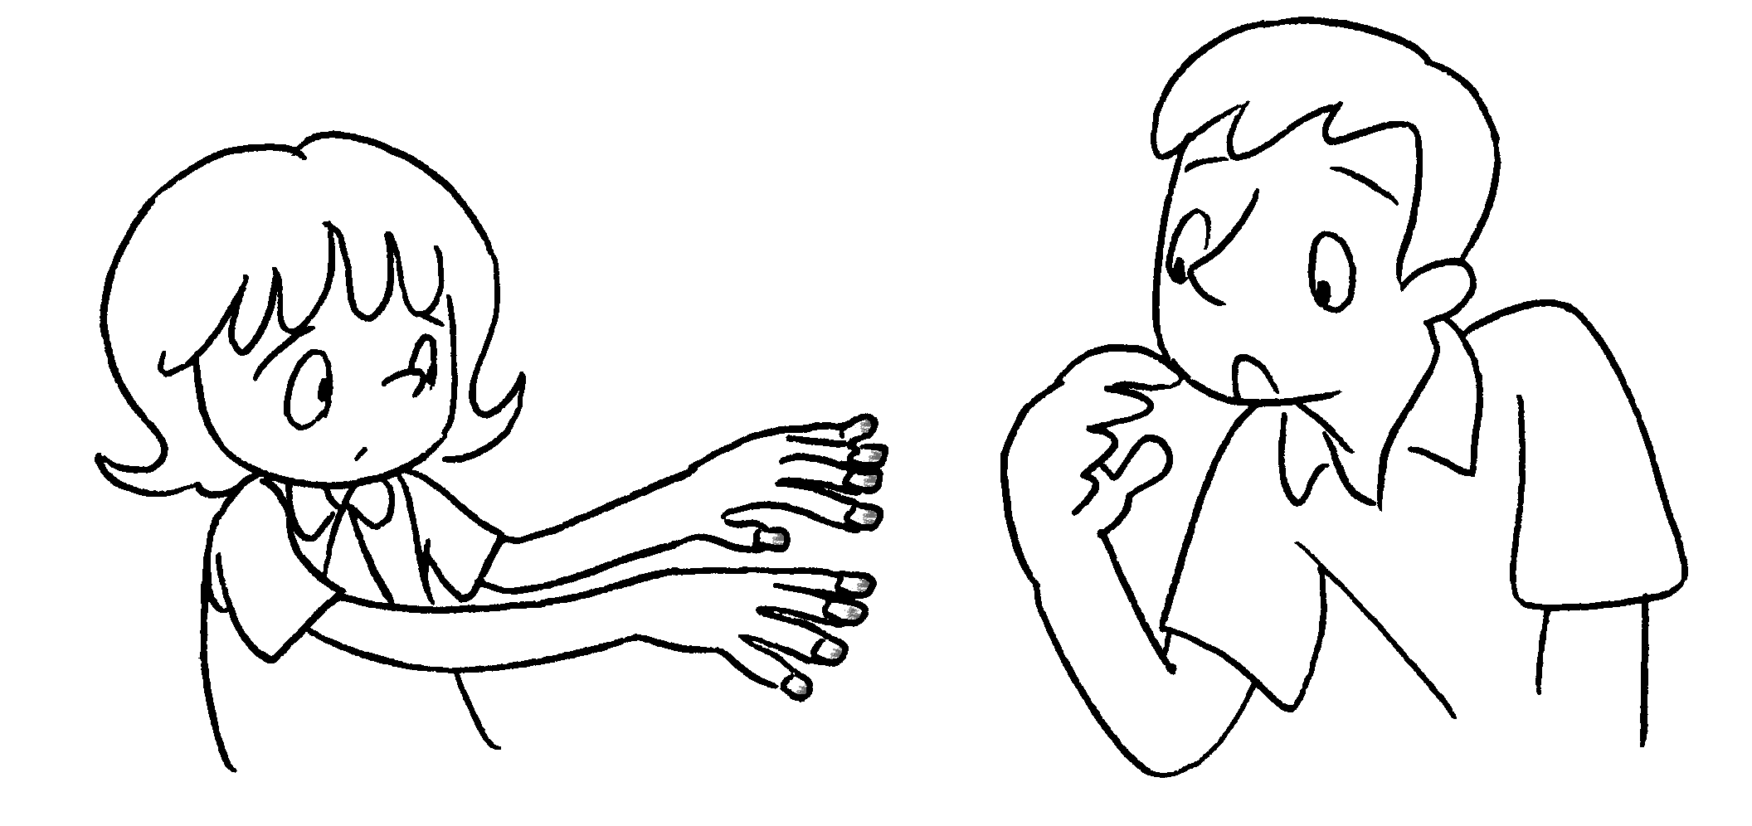 | You  your fingernails once a week.
4  ( brush ) | 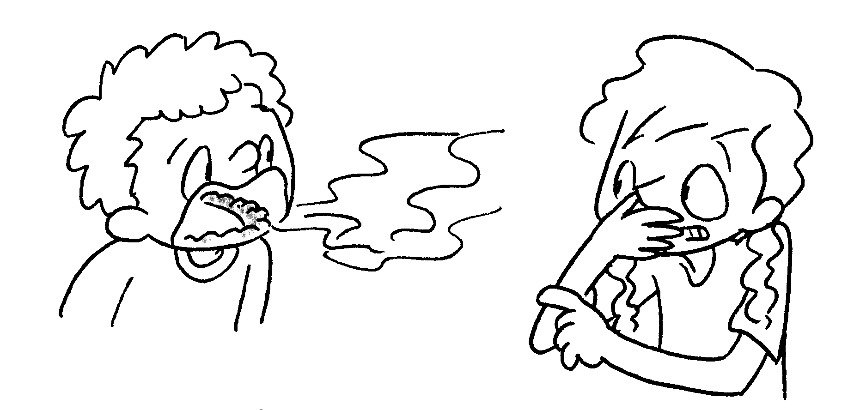 | You  your teeth twice a day.
5  ( wash ) | 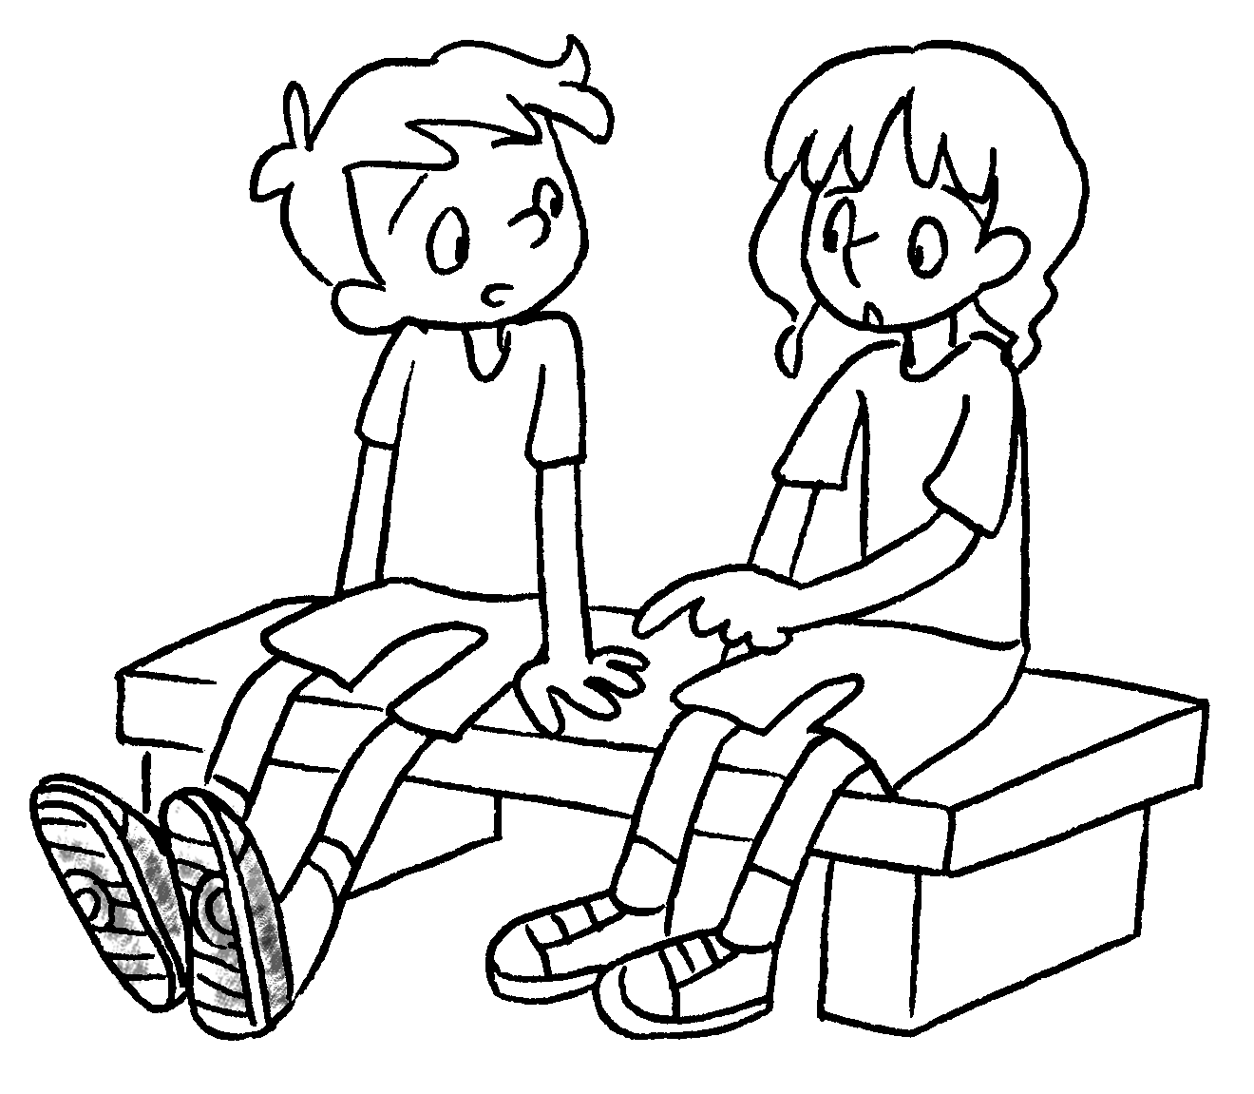 | You  your sports shoes once a month.
6  ( change ) | 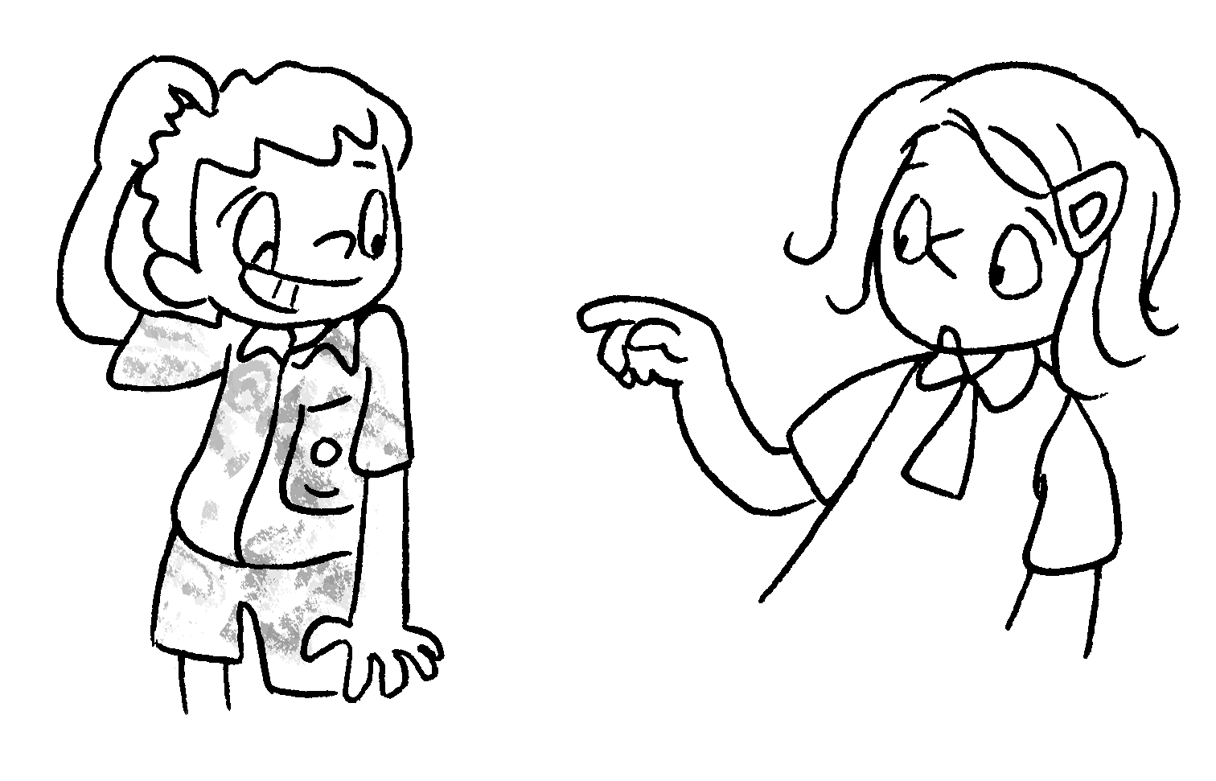 | You  your uniform three times a week.


Book 4B Chapter 6 Graded Worksheets
Worksheet 3⬇
- ought to
- ought to
- ought to cut
- ought to brush
- ought to wash
- ought to change

