Finish the sentences using ‘ought to’.

brush wash fingernails hair teeth
change cut sports shoes uniform socks

1 | 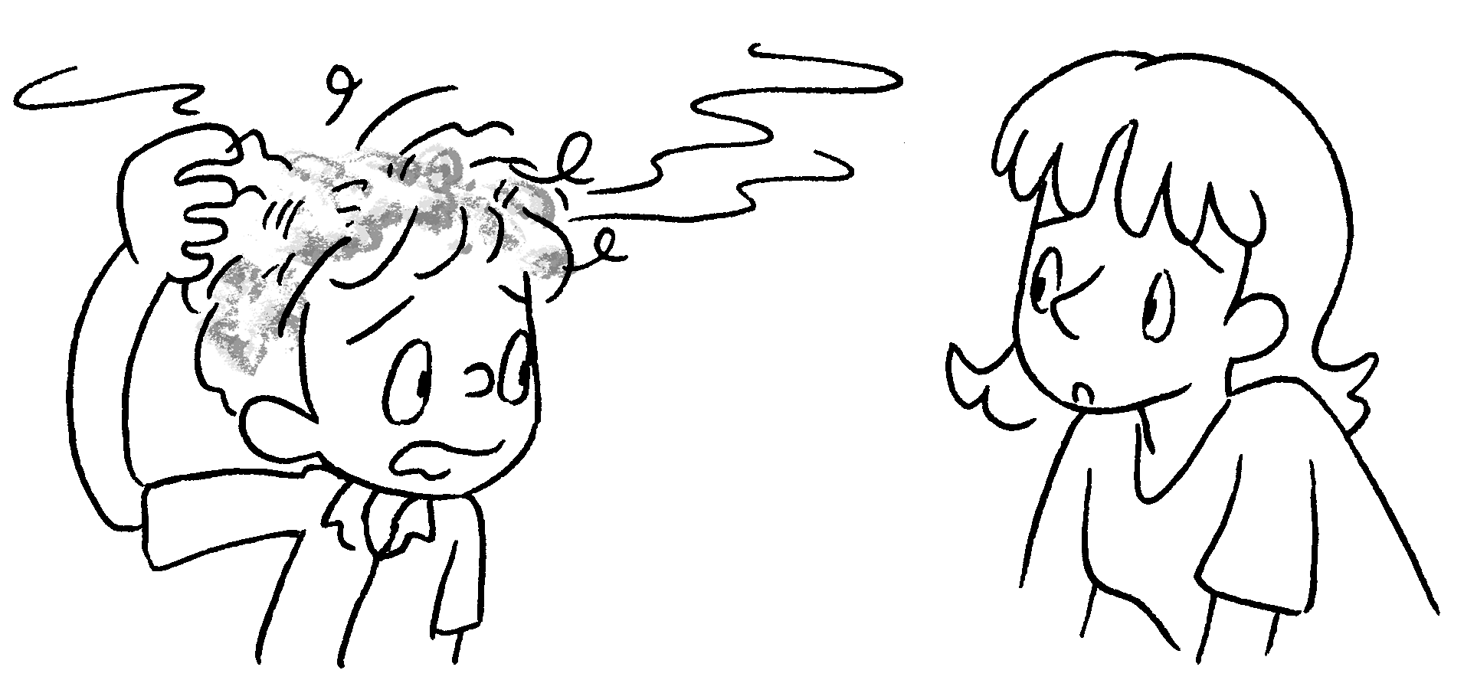 | You wash  your three times a week.
2 | 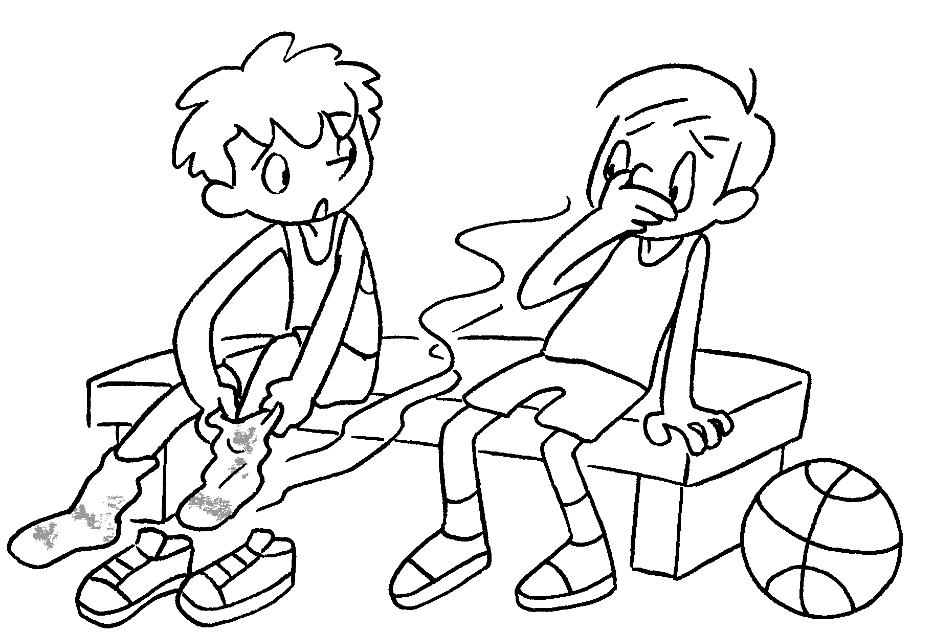 | You  your once a day.
3 | 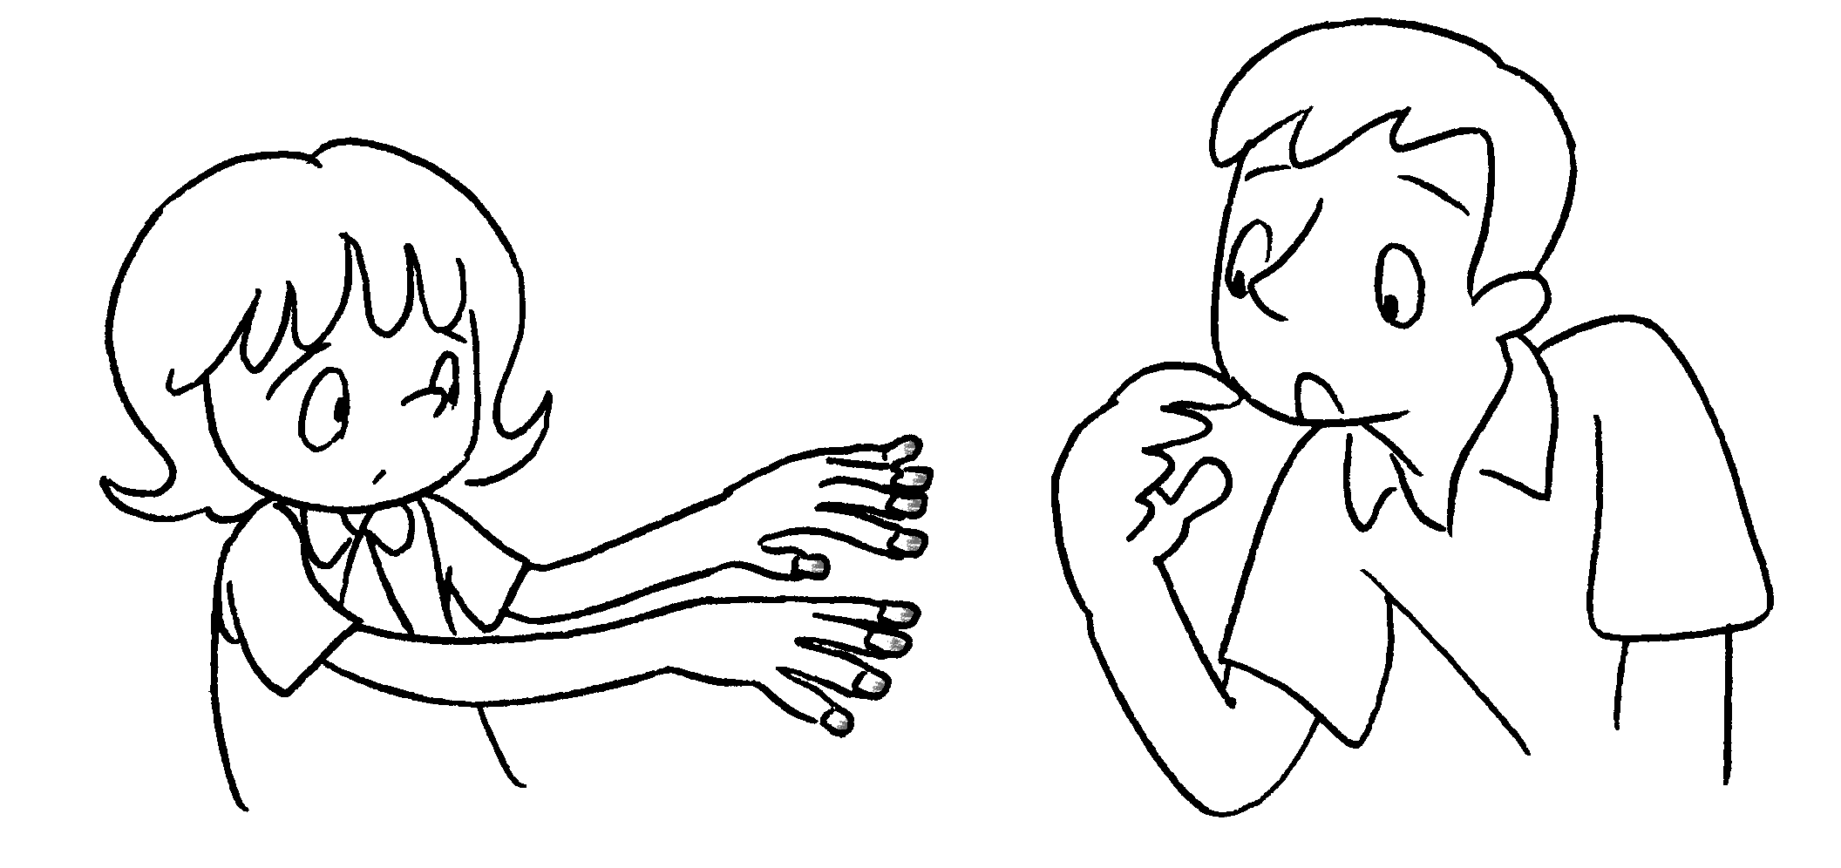 | You  once a week.
4 | 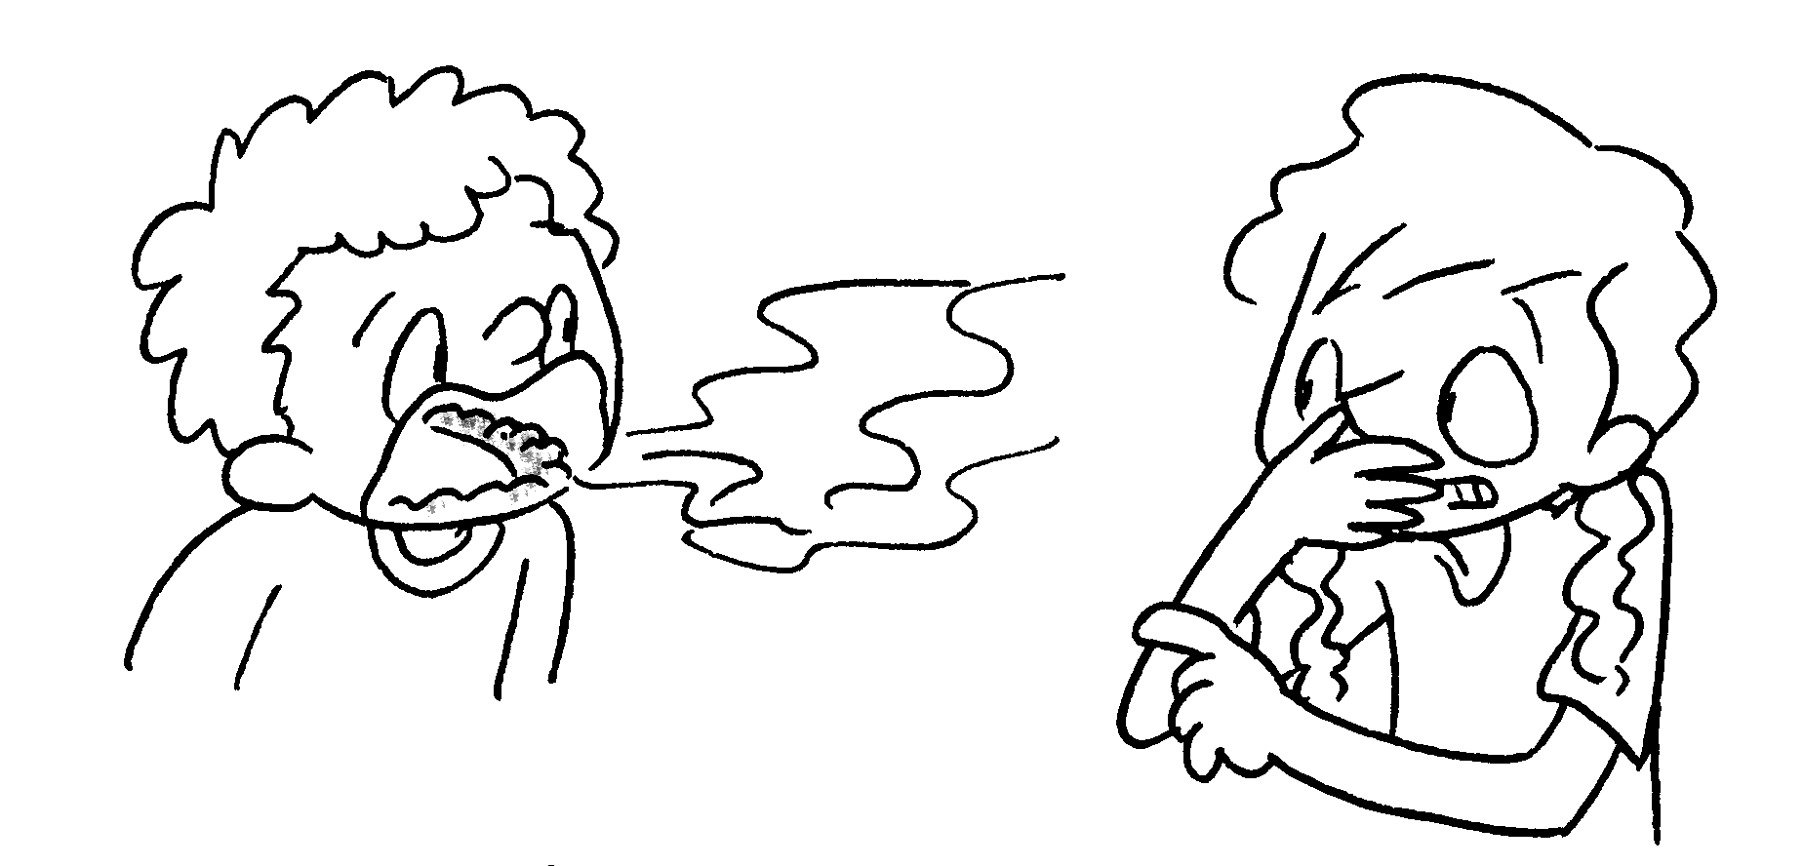 | You  twice a day.
5 | 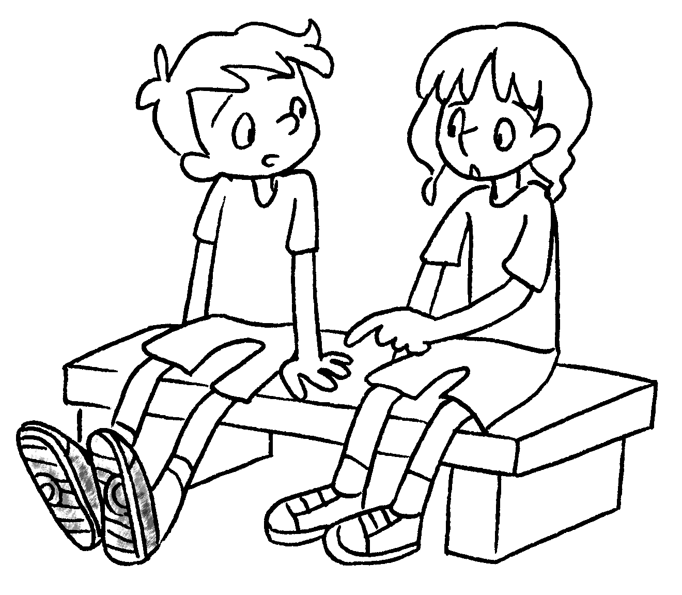 | You  once a month.
6 | 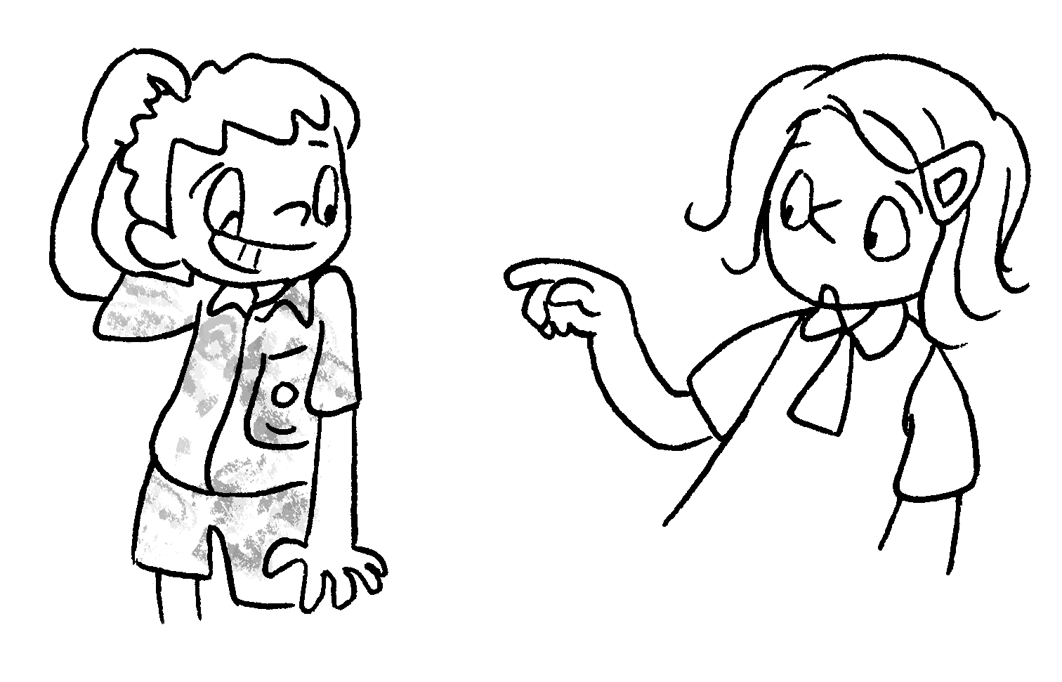 | You  three times a week.


Book 4B Chapter 6 Graded Worksheets
Worksheet 3⬇⬇
- ought to hair
- ought to change socks
- ought to cut your fingernails
- ought to brush your teeth
- ought to wash your sports shoes
- ought to change your uniform

