Finish the sentences using ‘ought to’.

fingernails hair sports shoes socks teeth uniform

1 | 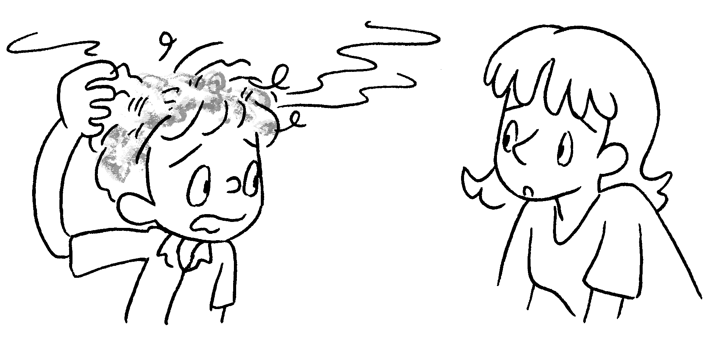 | You wash  your three times a week.
2 | 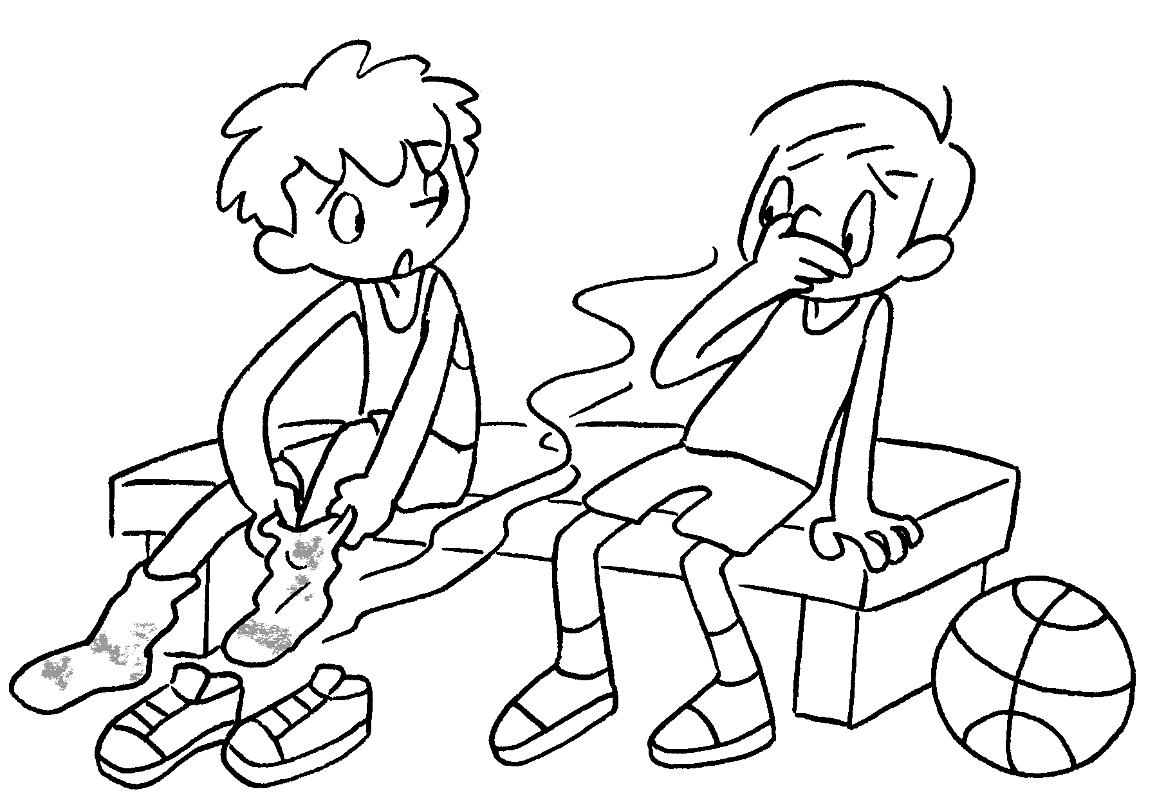 | You change  your once a day.
3 | 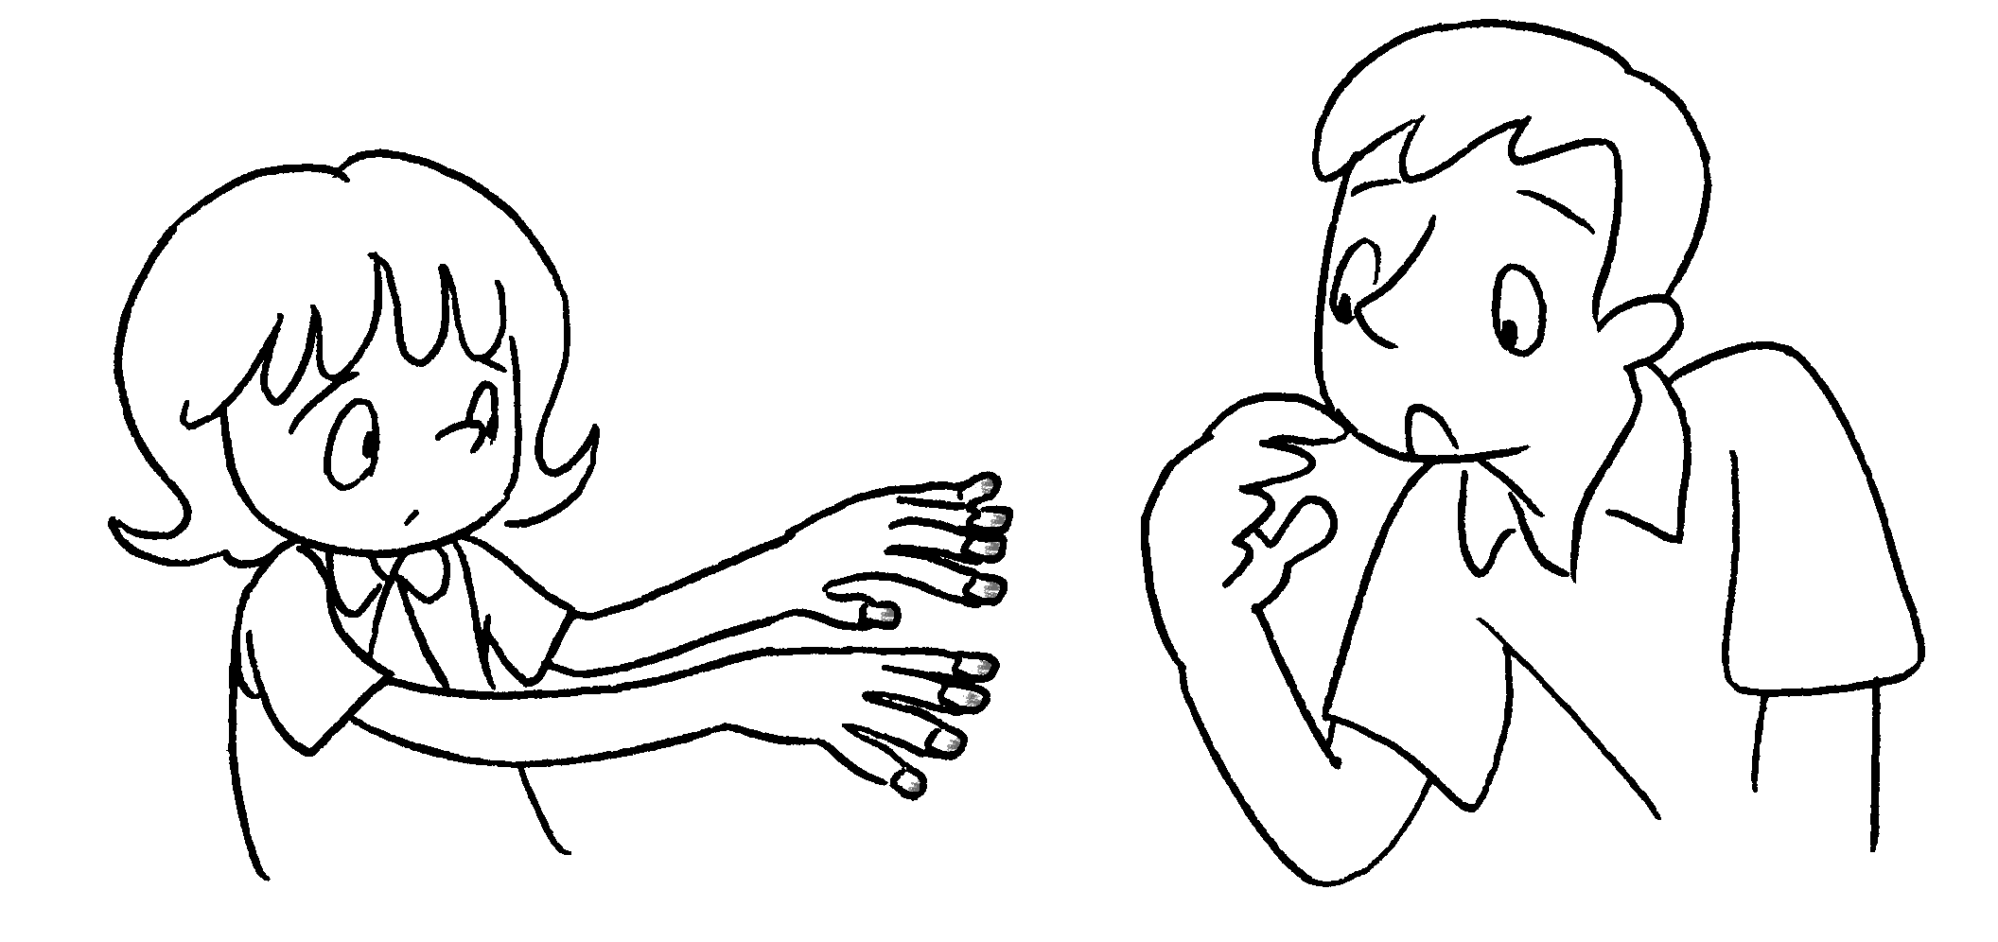 | You  once a week.
4 | 2 / day  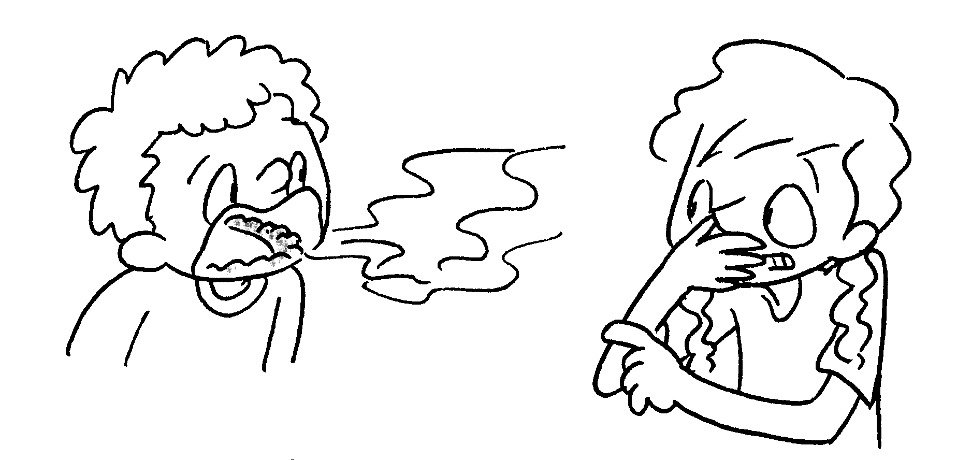 | You  .
5 | 1 / month  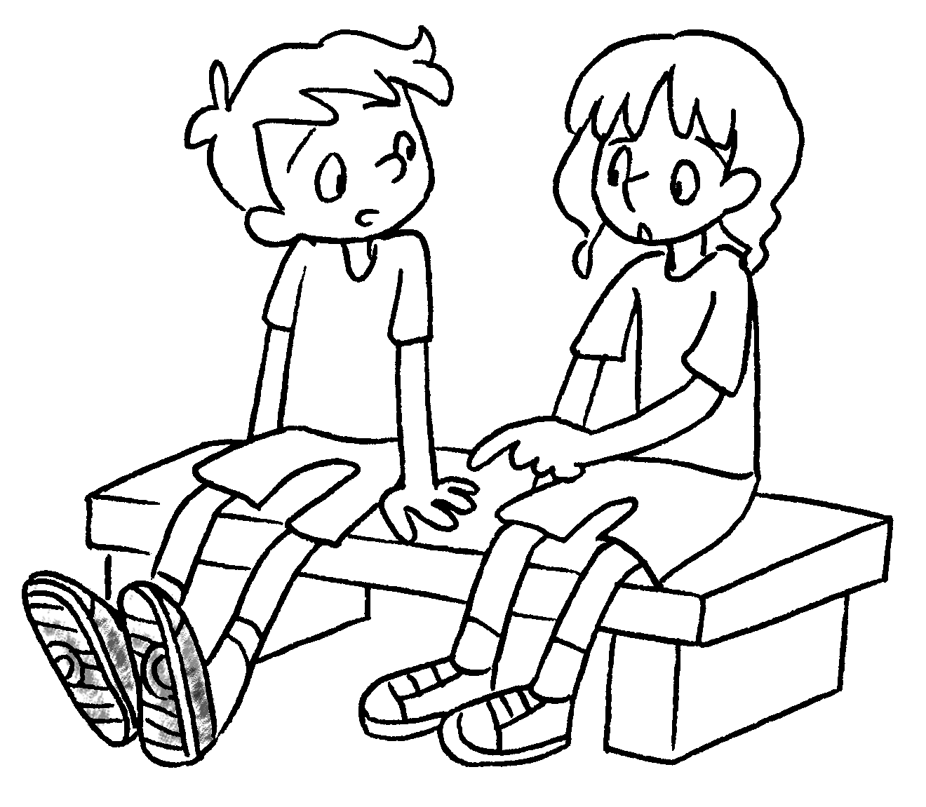  3 / week | You  .
6 | 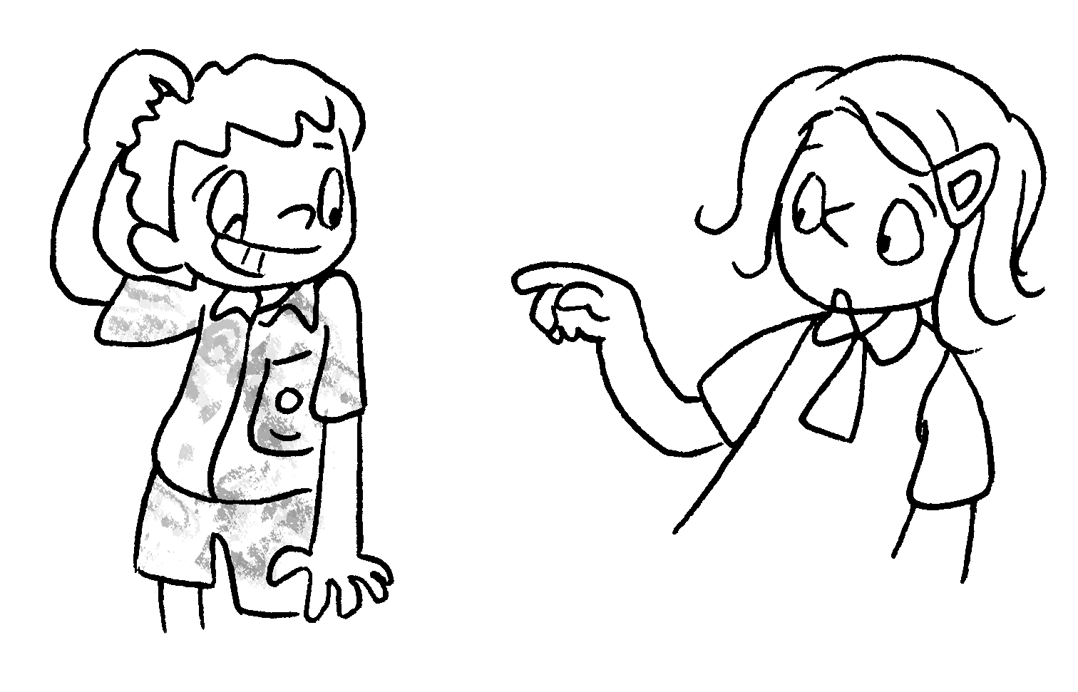 | You  .


Book 4B Chapter 6 Graded Worksheets
Worksheet 3⬇⬇⬇
- ought to hair
- ought to socks
- ought to cut your fingernails
- ought to brush your teeth twice a day
- ought to wash your sports shoes once a month
- ought to change your uniform three times a week

 Primary Longman Elect 4B © Pearson Education Asia Limited 2009

