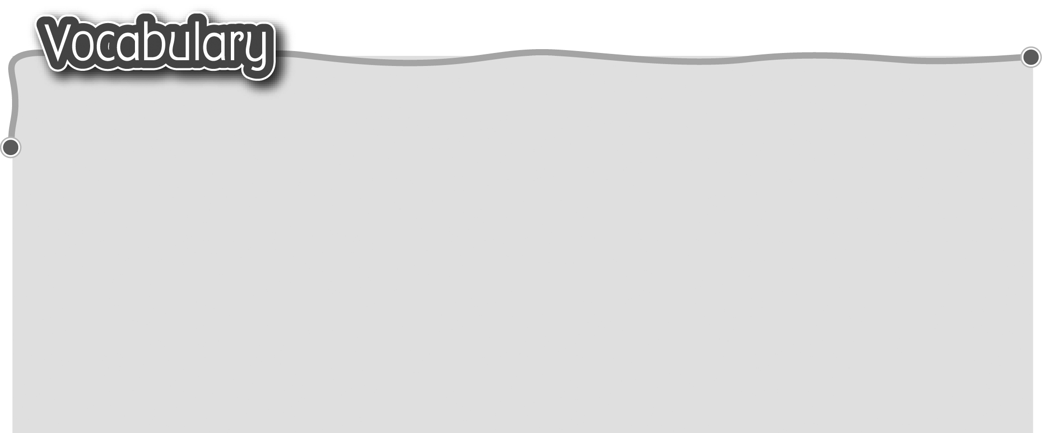
1 good habit 良好習慣 6 cut my fingernails 剪指甲
2 change my facecloth 7 wash my hair 洗頭髮
更換小毛巾 8 go to the dentist 看牙醫
3 change my socks 更換襪子 9 help with the housework
4 change my uniform 更換校服 幫忙做家務
5 wash my sports shoes
洗運動鞋
The words marked with * have different meanings in other
contexts. You can look up those meanings in a dictionary.
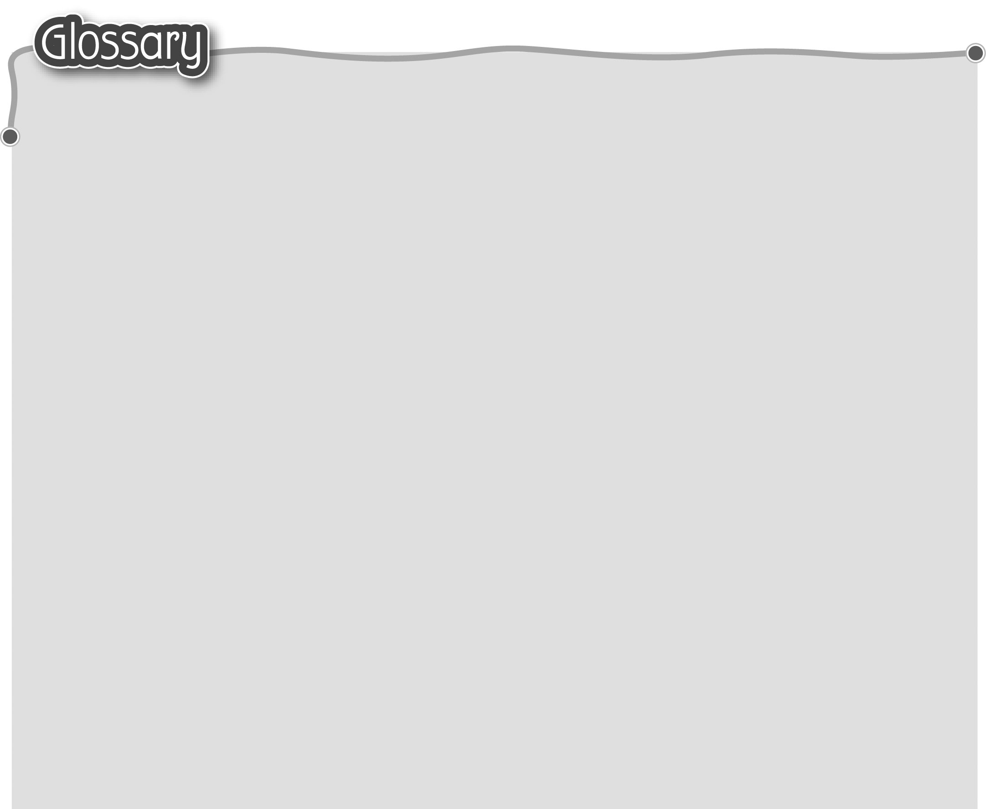
1 once upon a time (p.46) 從前 14 again (p.46) 再次
2 witch (p.46) 女巫 15 handsome* (p.46) 漂亮
3 tower* (p.46) 塔 16 smell awful (p.46) 發出臭味
4 shook (shake)* (p.46) 17 … times* (p.47) ……次
擺動（動詞） 18 replied (reply)* (p.47) 回答（動詞）
5 rescue (p.46) 拯救（動詞） 19 already (p.47) 已經
6 how often (p.46) 多久 20 ran (run) … through (p.47) 撥弄
7 (be) surprised (p.46) 感到意外 21 shiny (p.47) 閃亮
8 once (p.46) 一次 22 start* (p.47) 開始（說）（動詞）
9 put … over (p.46) 用……掩着 23 quiz* (p.51) 測驗
10 ought to (p.46) 應該 24 complete (p.51) 完成
11 twice (p.46) 兩次 25 improve (p.51) 改善
12 in a week’s time (p.46) 26 hunter (p.52) 獵人
在一星期之後 27 soldier (p.52) 士兵
13 the next week (p.46) 28 towards (p.53) 朝着
下一個星期 29 bossy (p.53) 愛發號施令

