RP no: Century Gothic 15pt
(所有圈號用15pt)
Choose and write.
bridgedesertescalatorlakemountainrivertower

1 | 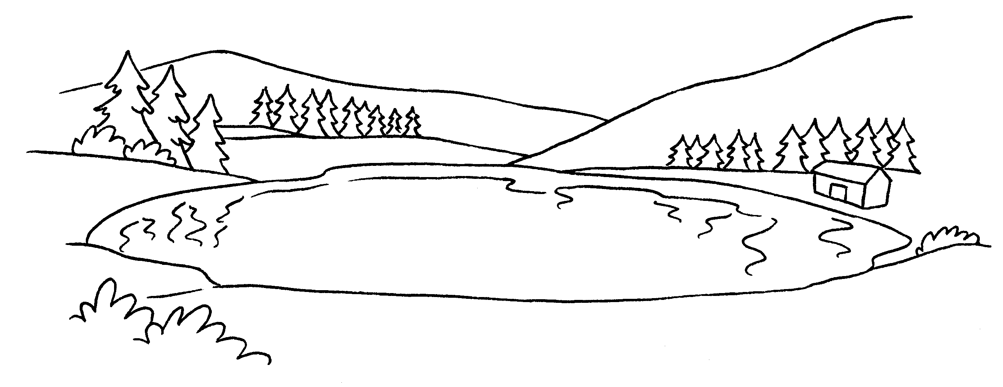  2  a |  |  | 2 | 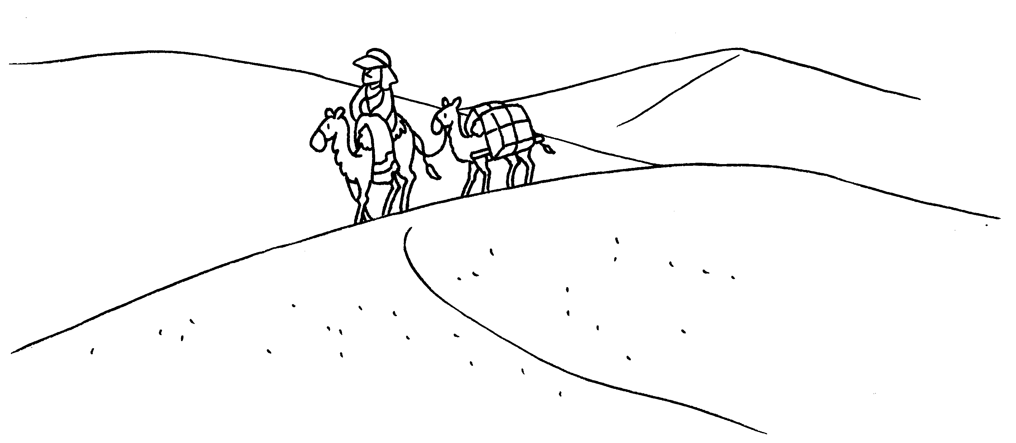  a
3 | 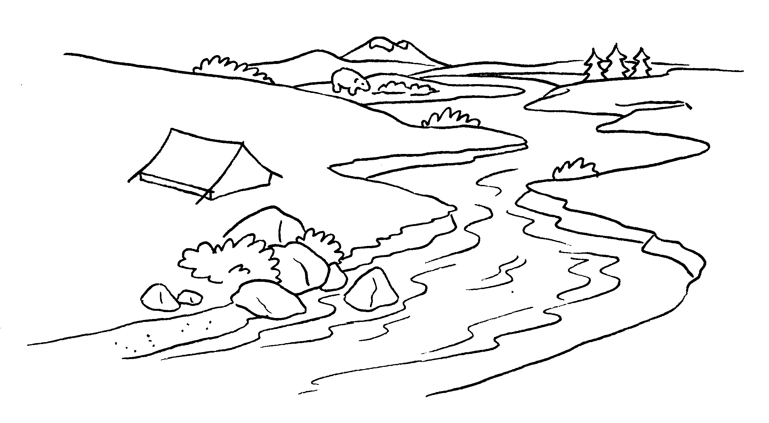  4  a |  |  |  | 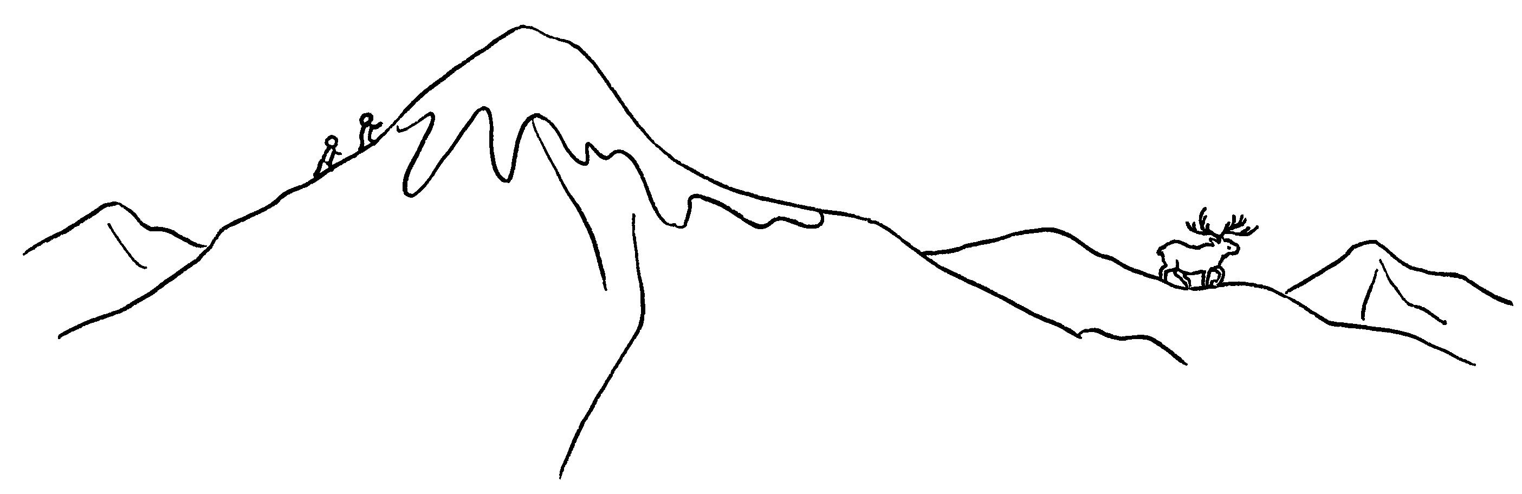  a
5 | 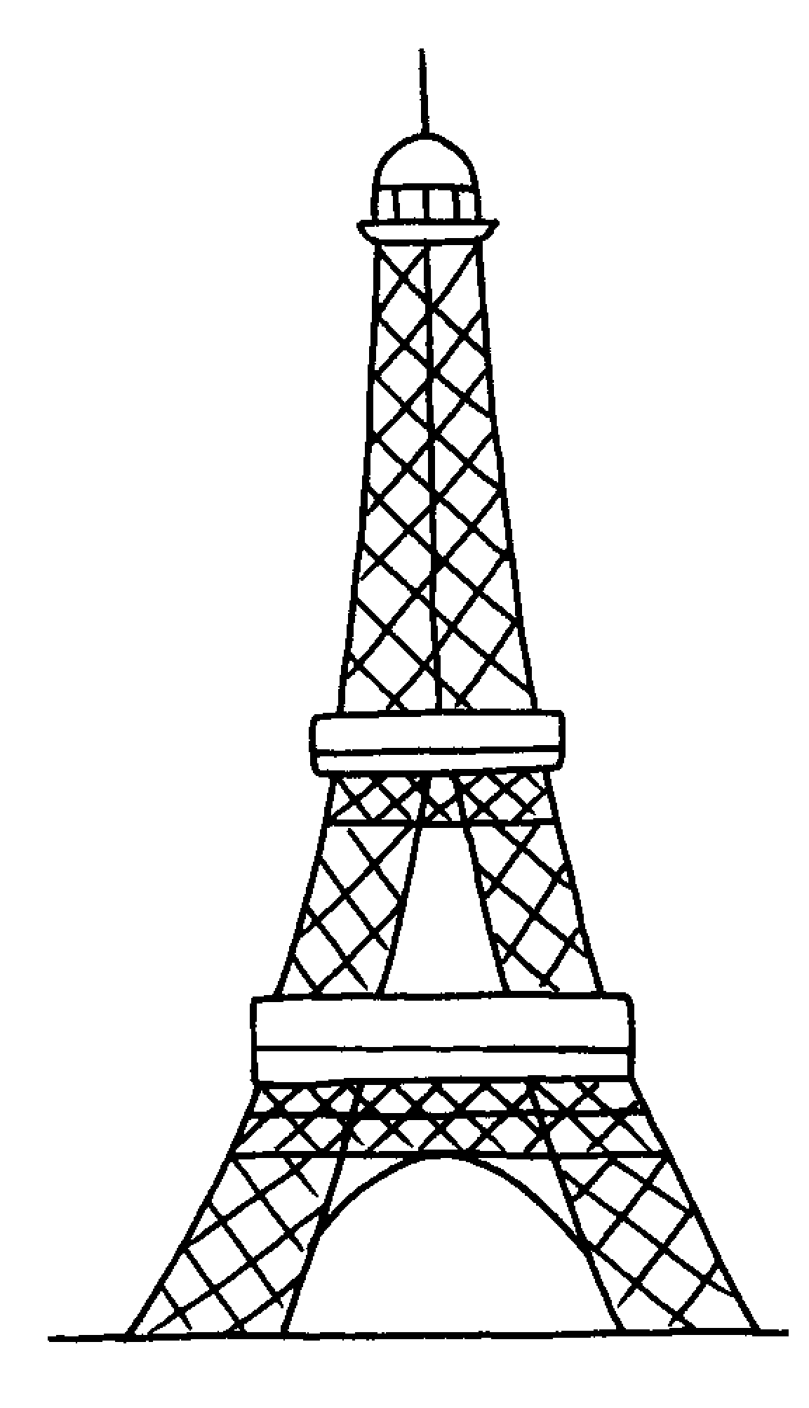  6  a |  |  |  | 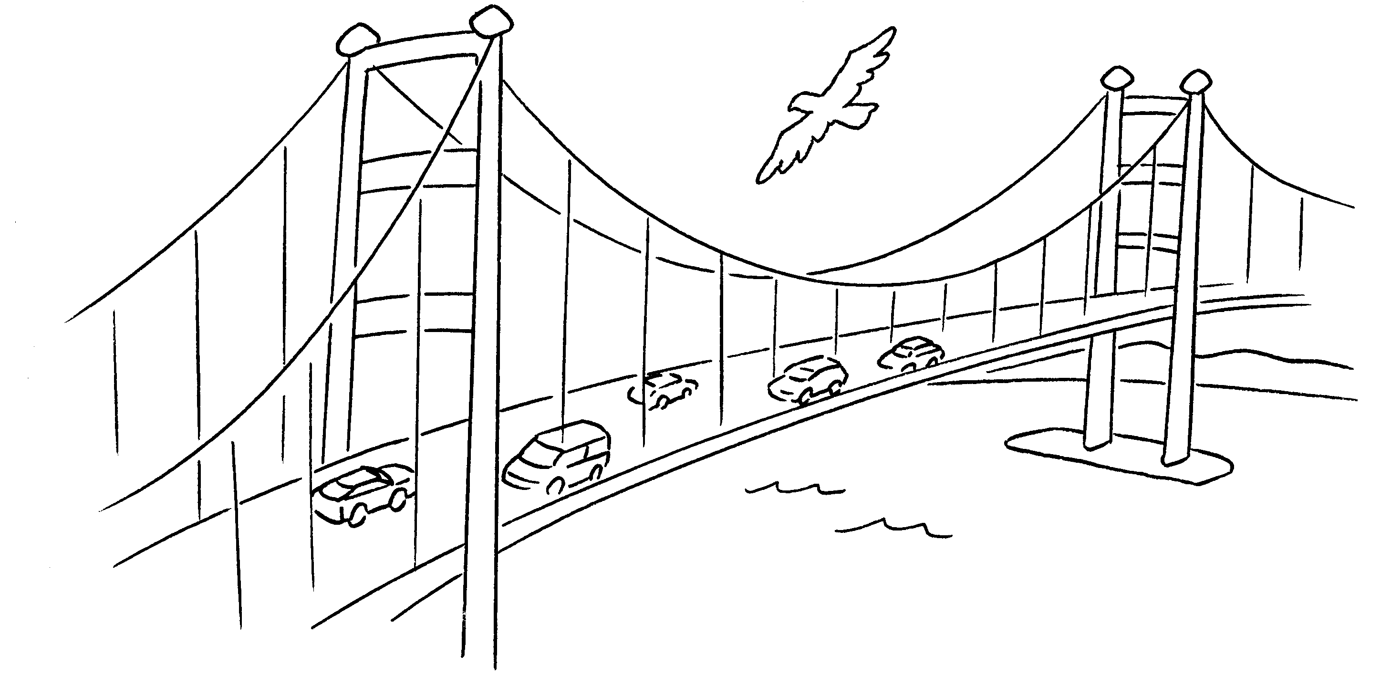  a
7 |  |  | 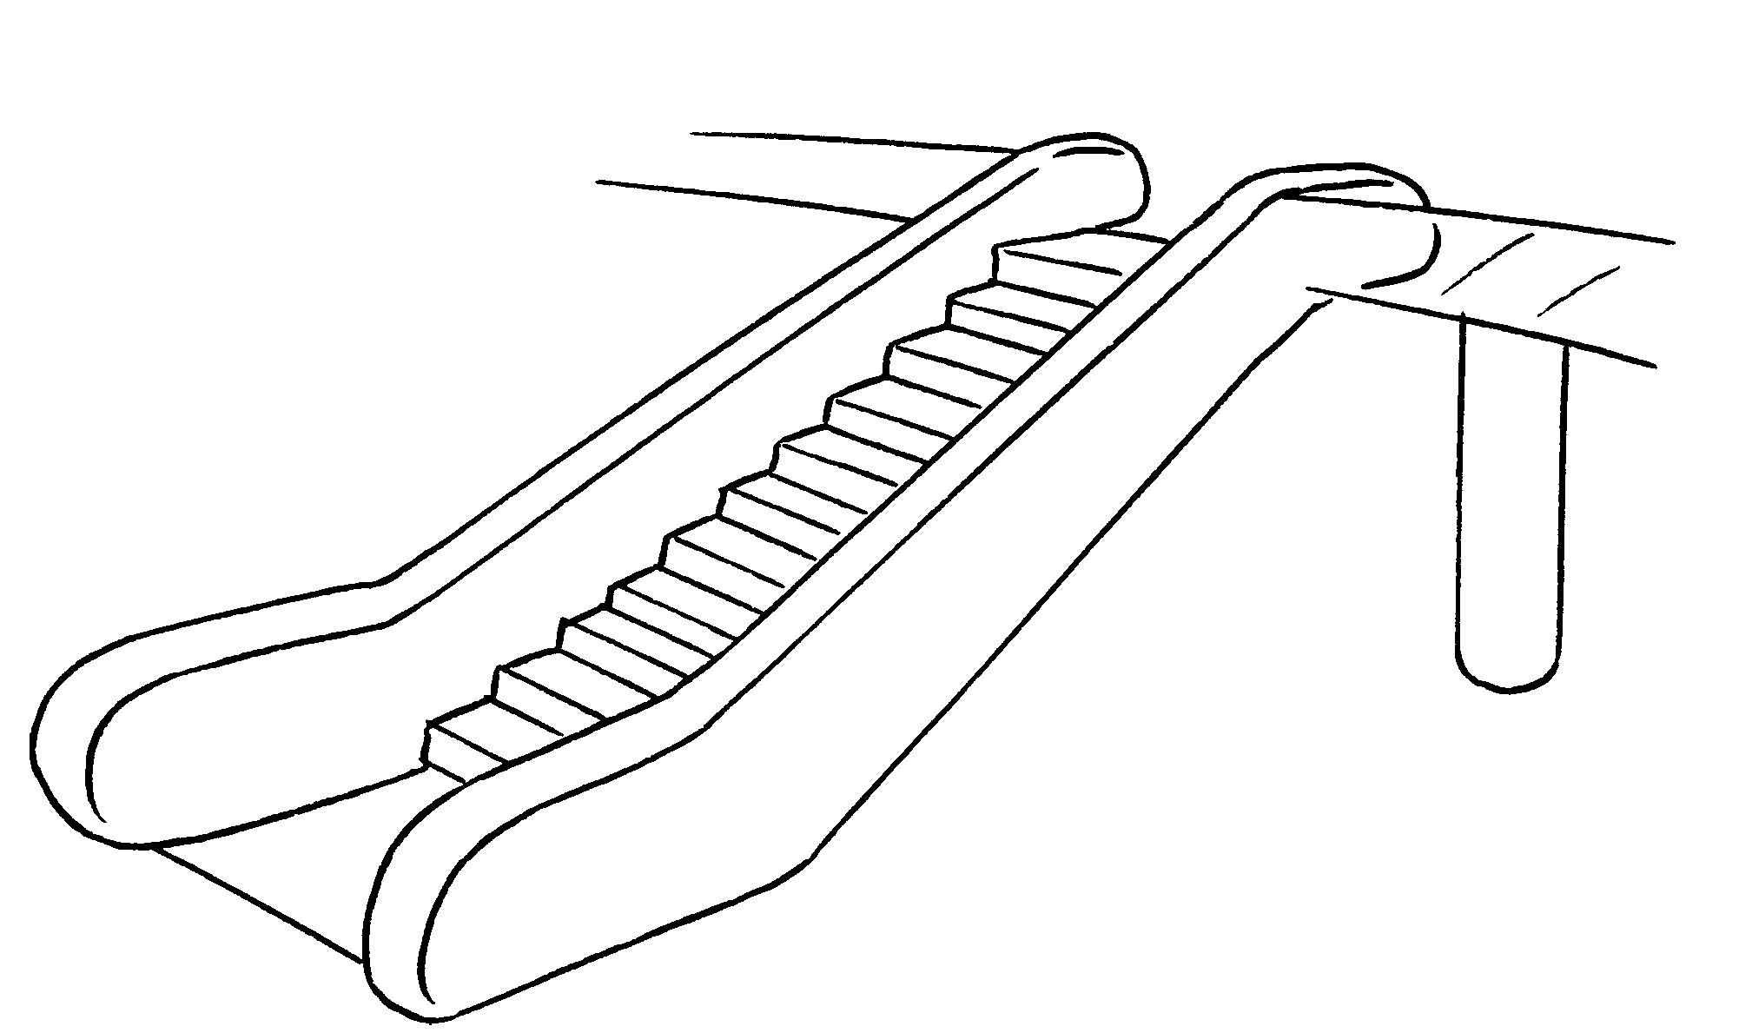  an


Book 4B Chapter 7 Graded Worksheets
Worksheet 1⬇
- lake 2 desert
3 river 4 mountain
5 tower 6 bridge
7 escalator

