RP no: Century Gothic 15pt
(所有圈號用15pt)
What are they? Write.

1 | 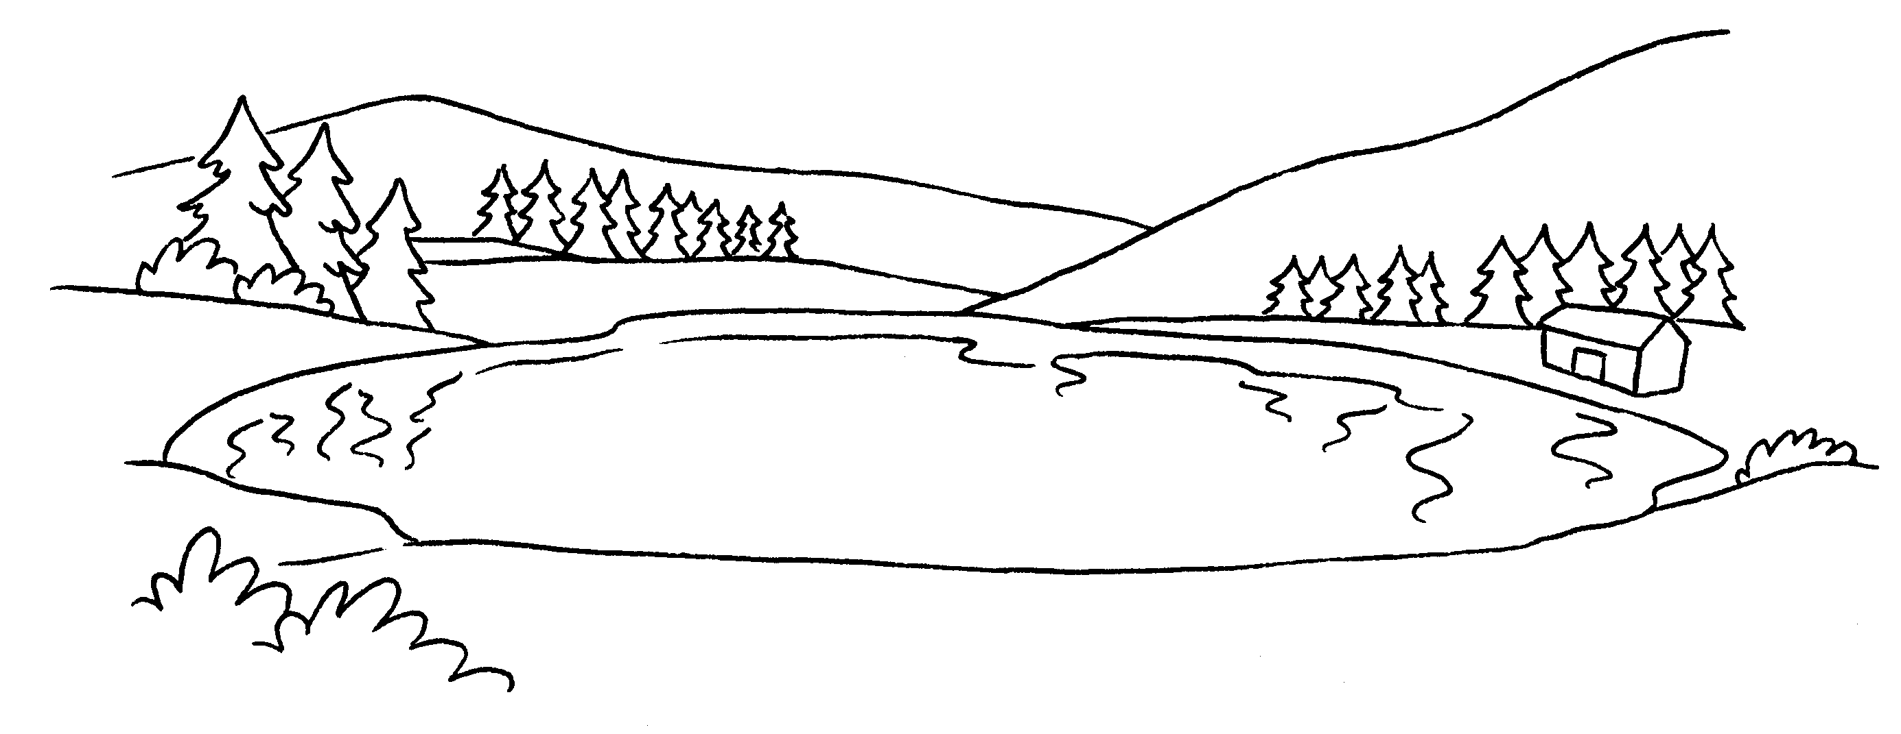  2  a l | 2 | 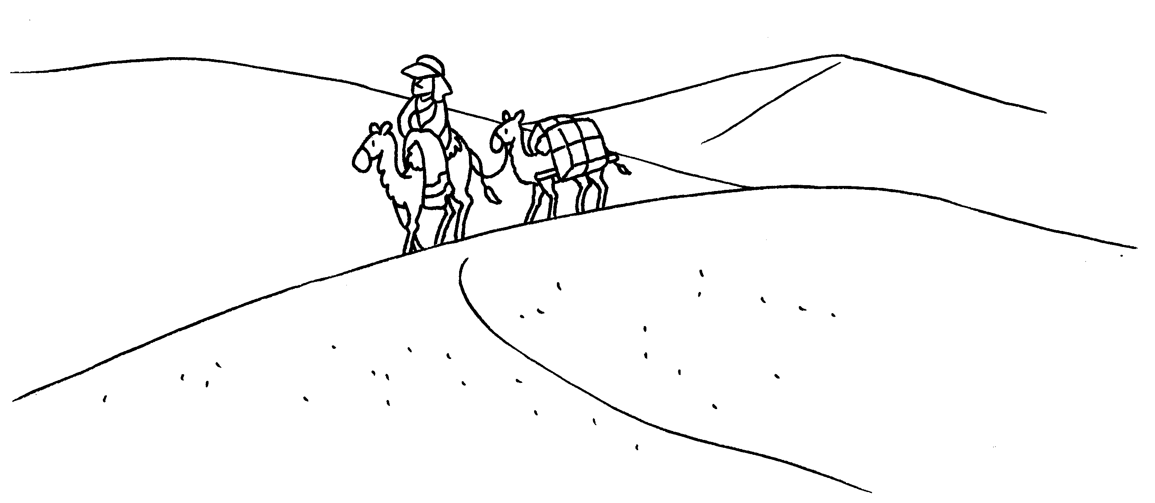  a d

3 | 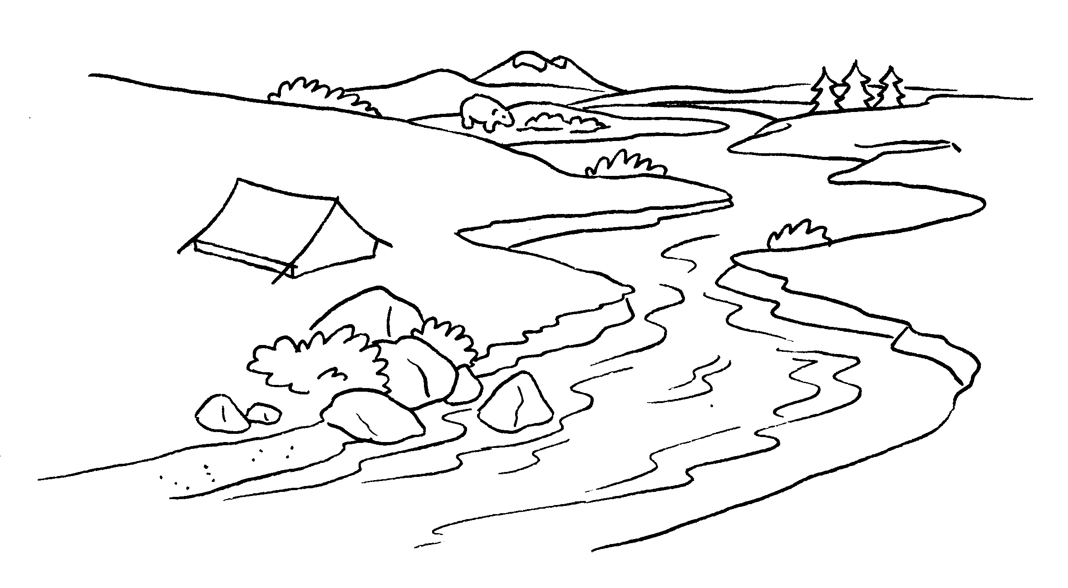  4  a r |  | 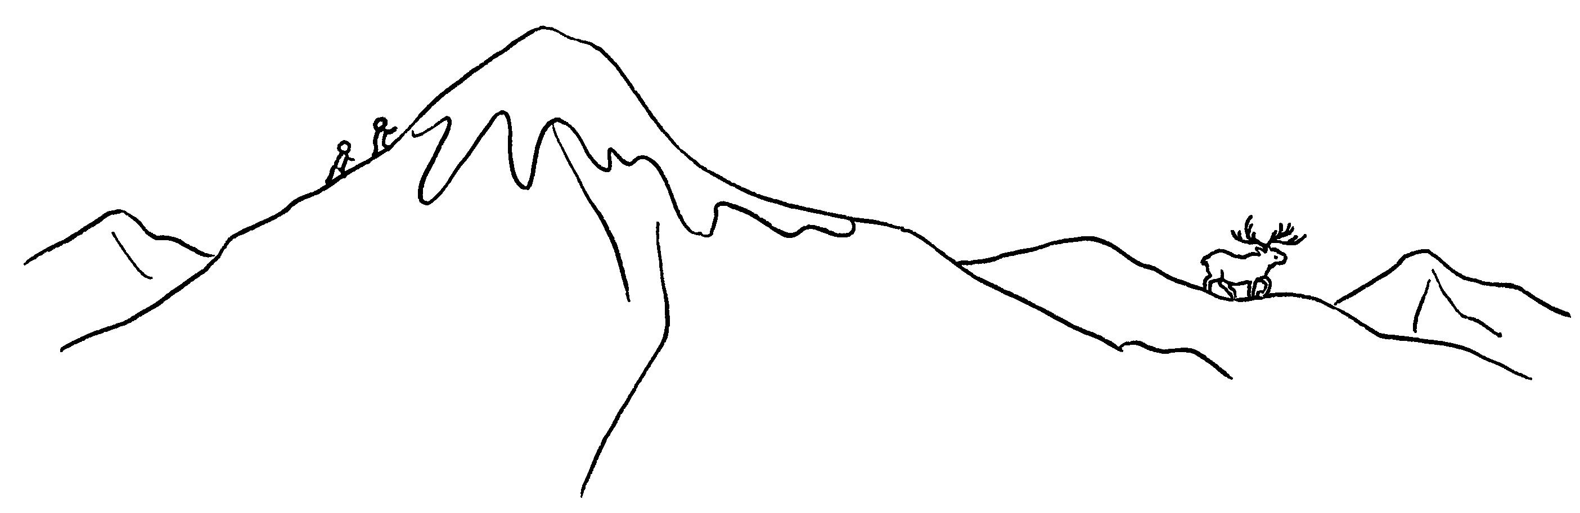  a m

5 | 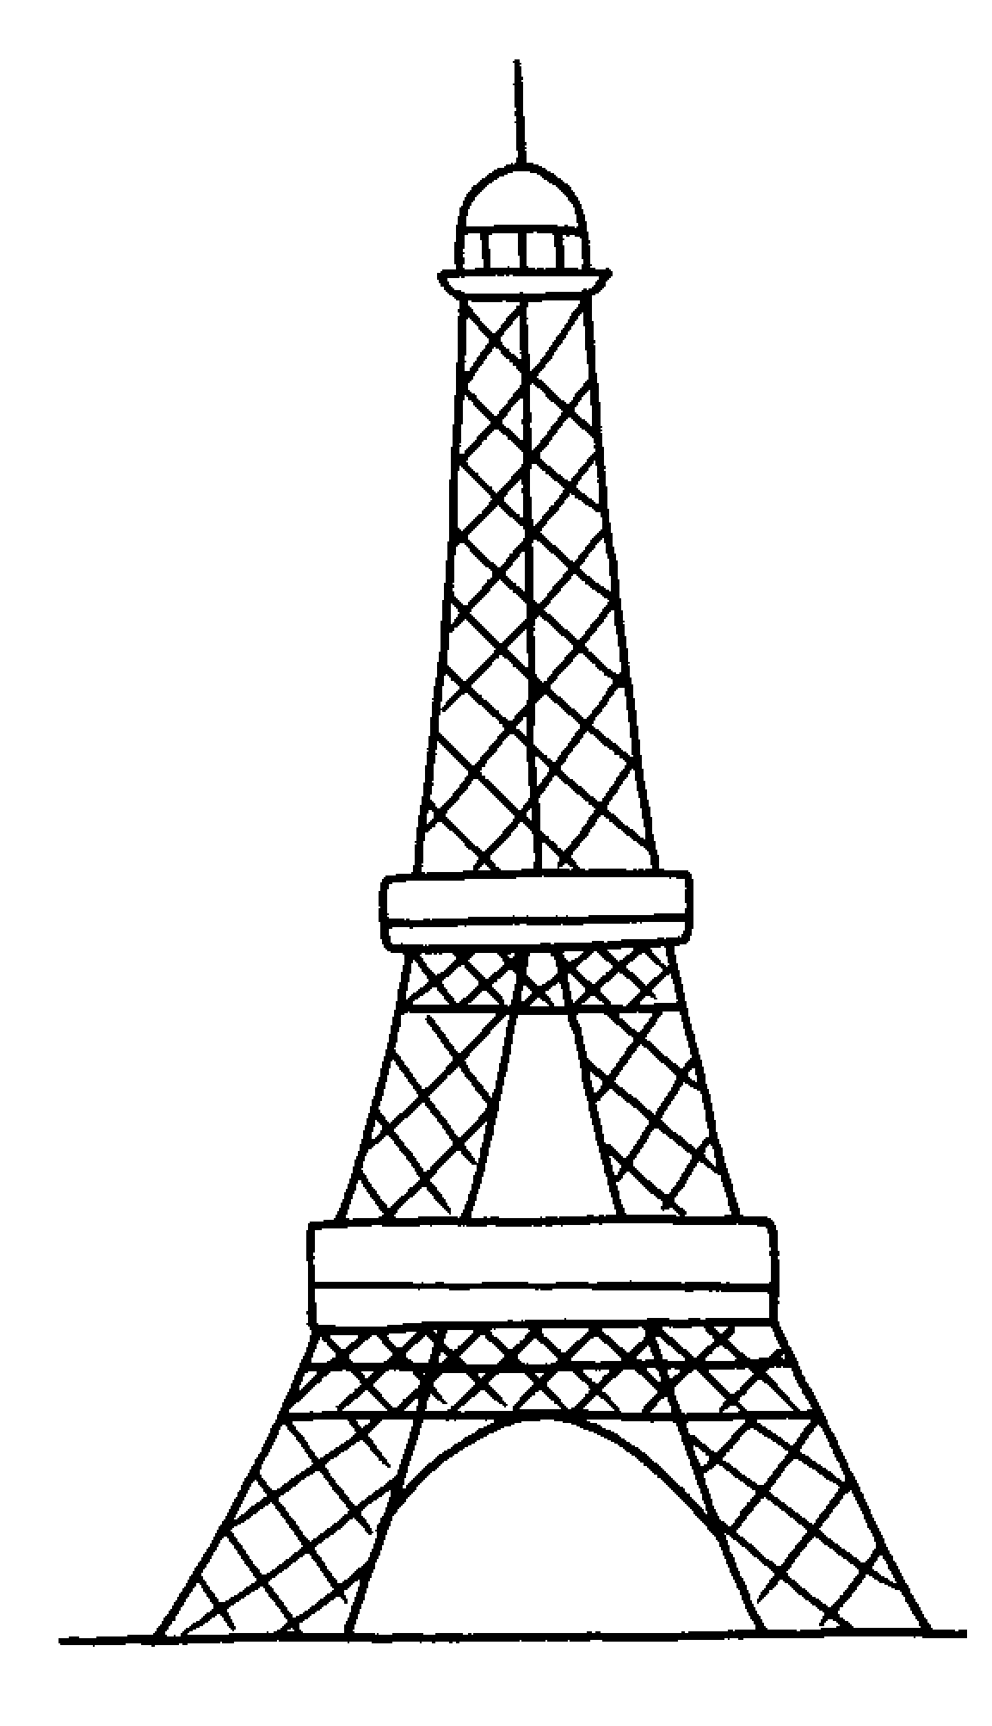  6  a t |  | 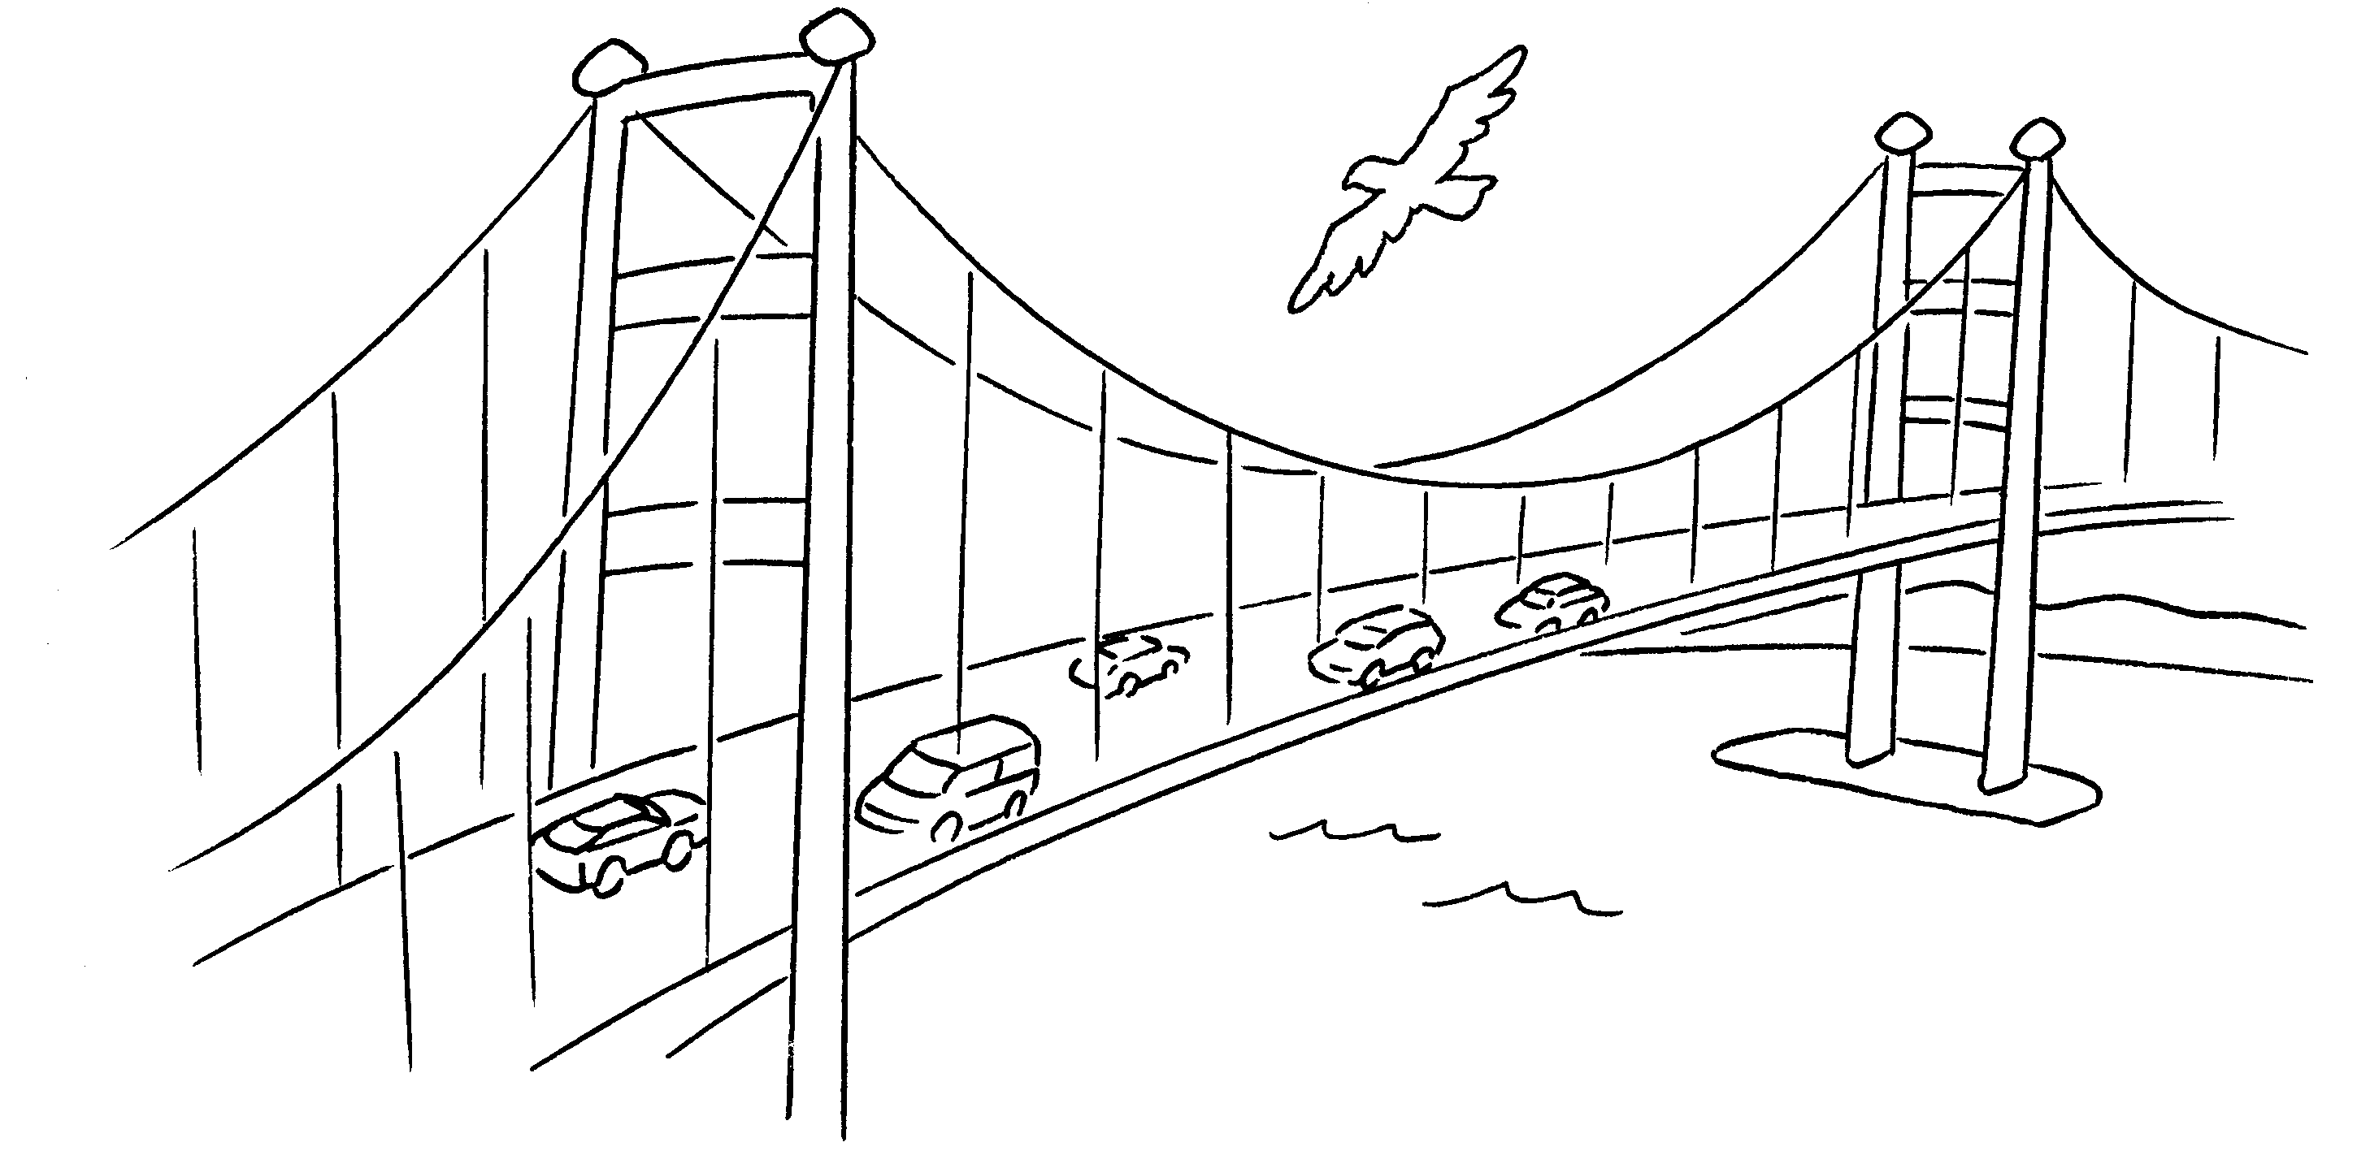  a b

7 |  | 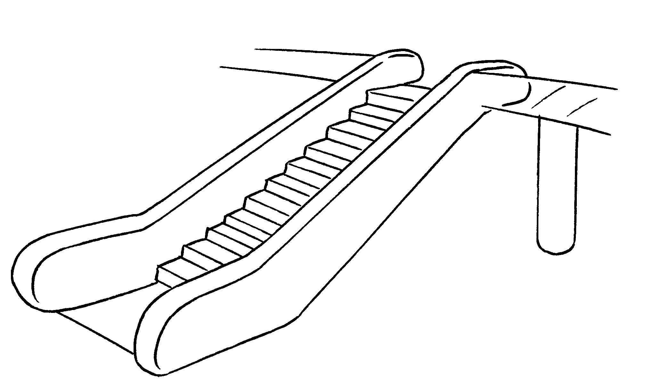  an e


Book 4B Chapter 7 Graded Worksheets
Worksheet 1⬇⬇
- lake 2 desert
3 river 4 mountain
5 tower 6 bridge
7 escalator

