What are they? Write.
RP no: Century Gothic 15pt
(所有圈號用15pt)

1 | 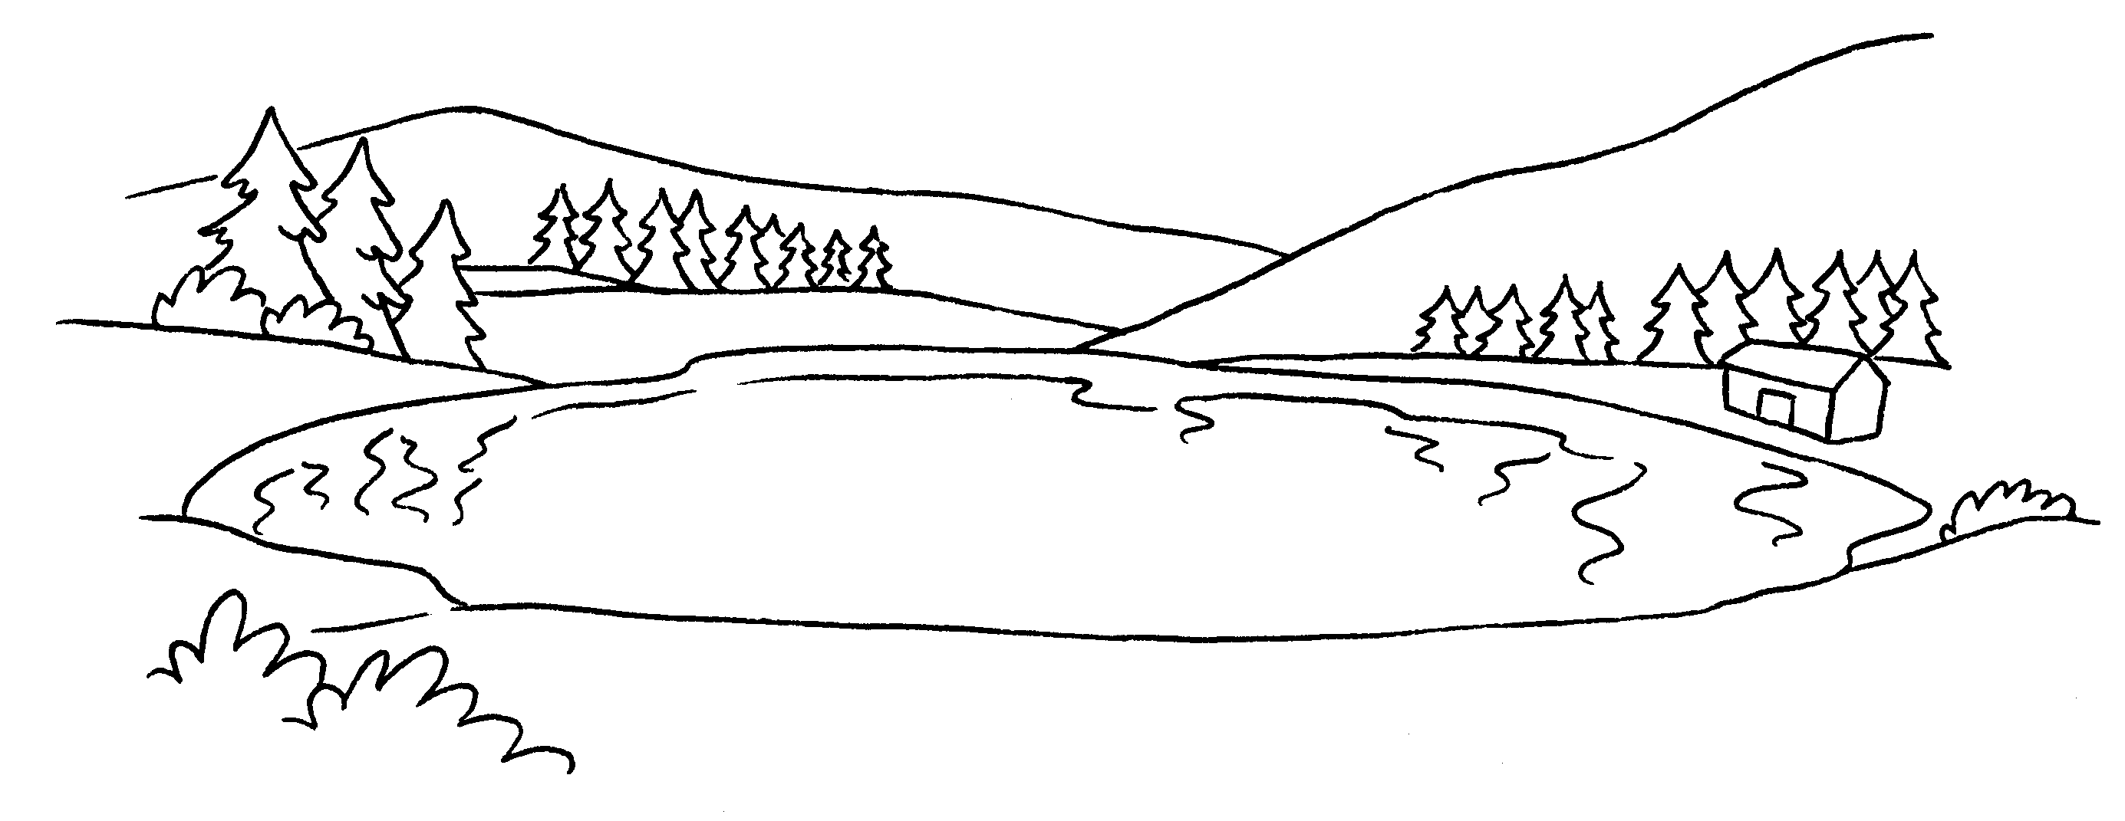  2  a | 2 | 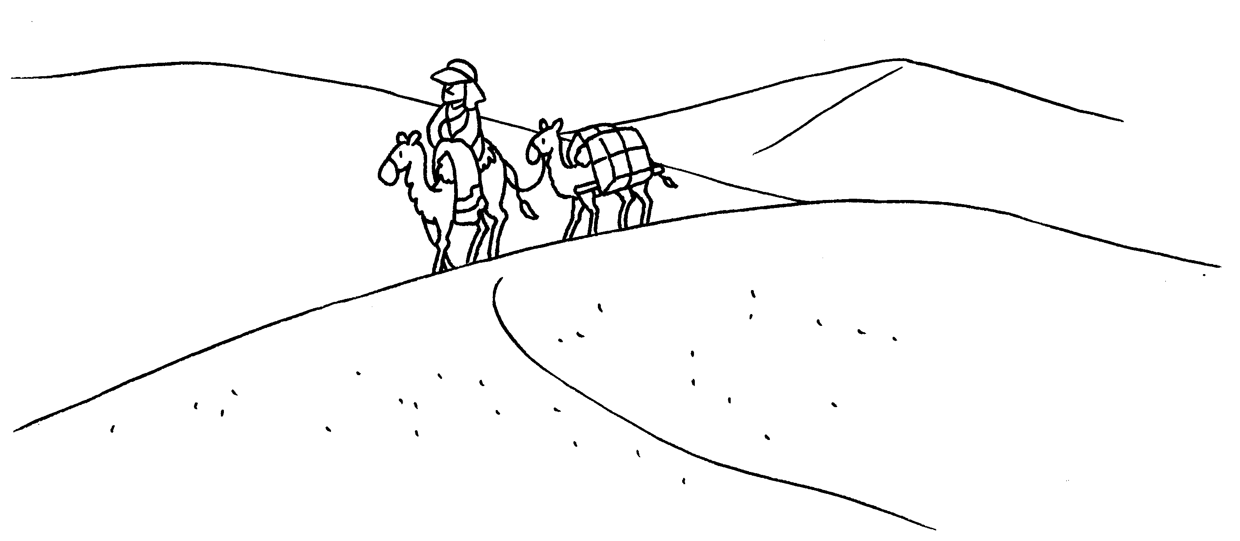  a

3 | 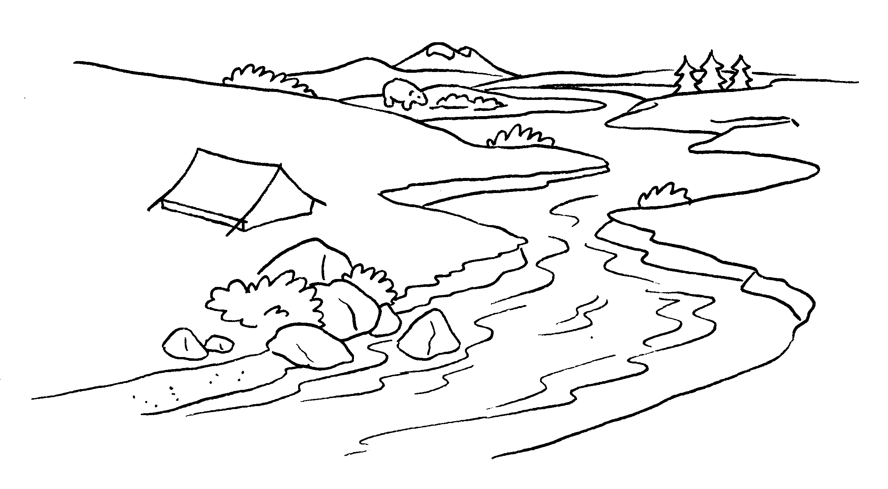  4 |  | 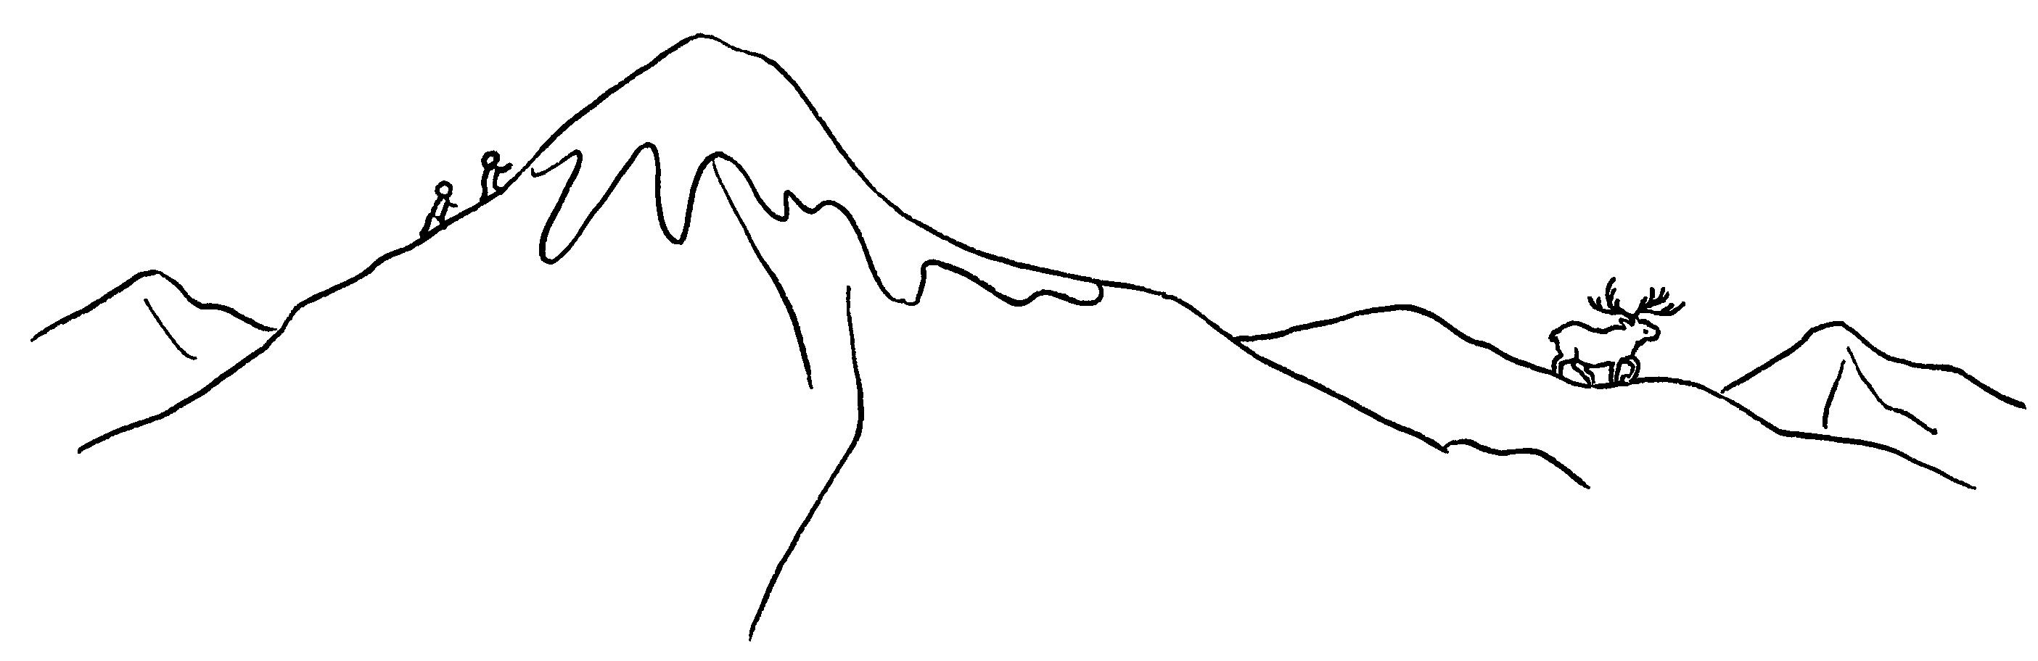

5 | 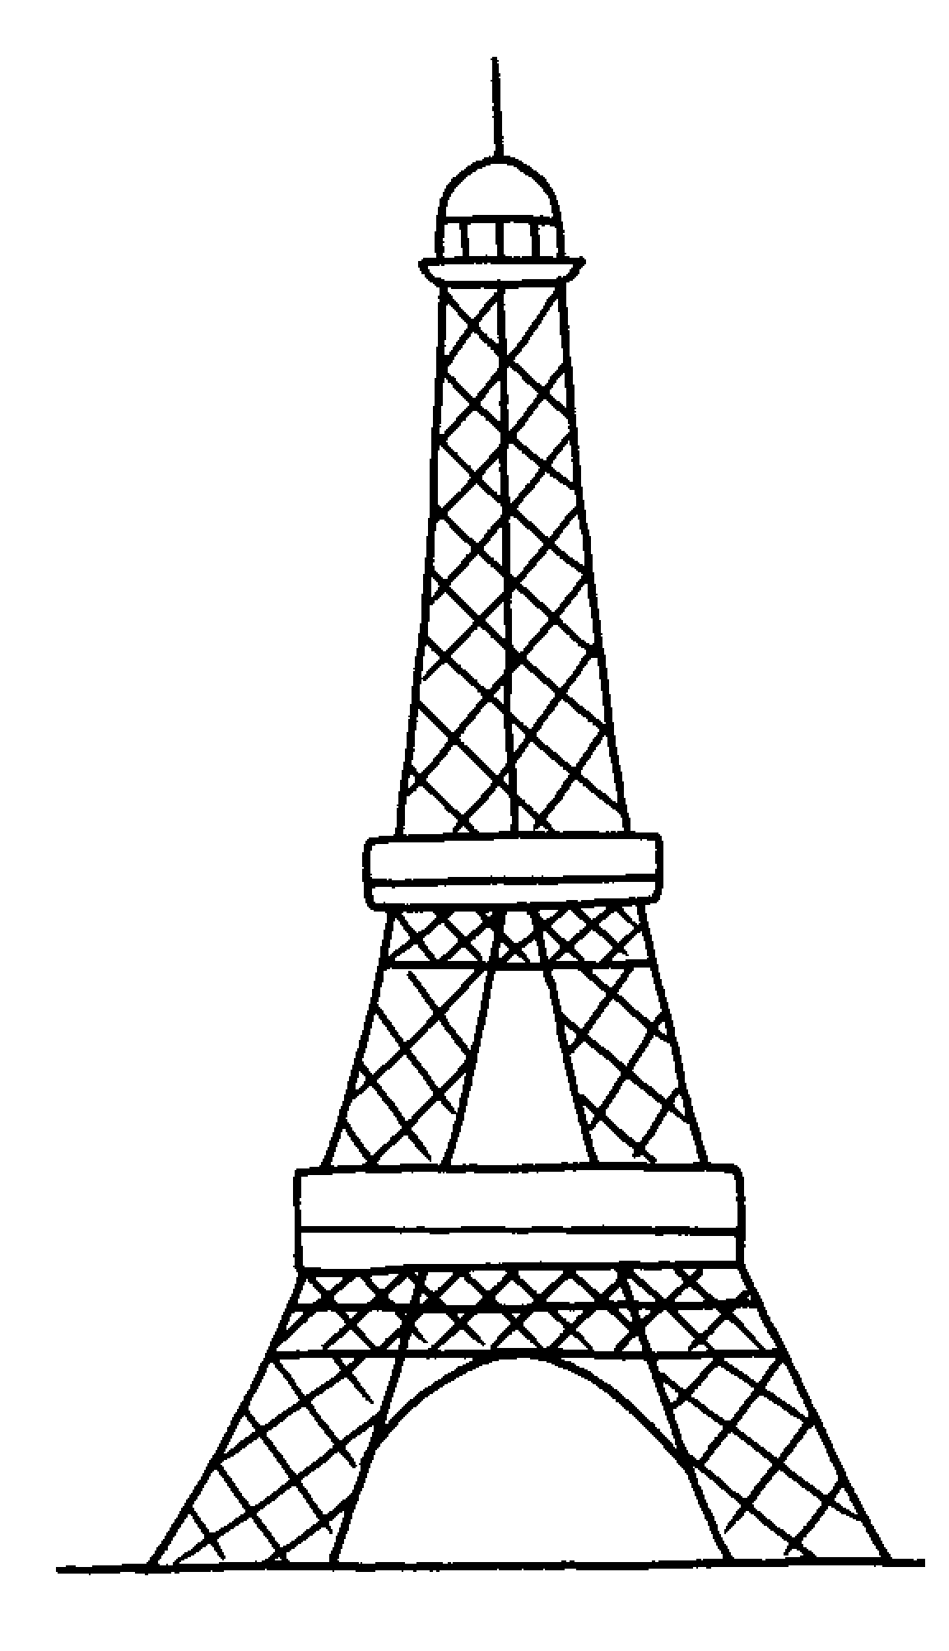  6 |  | 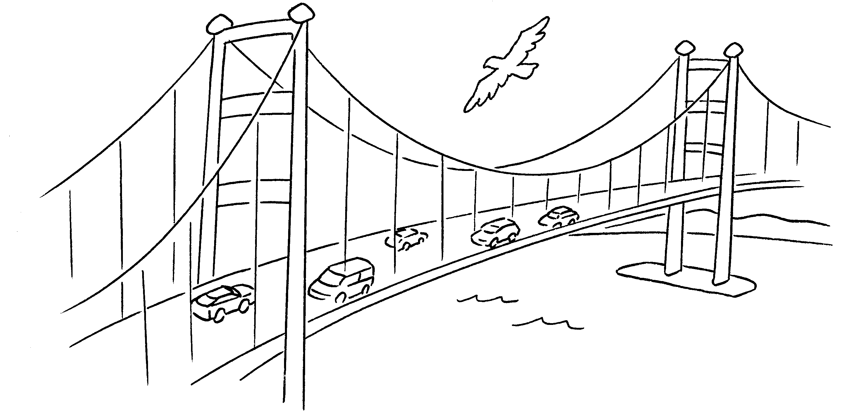

7 |  | 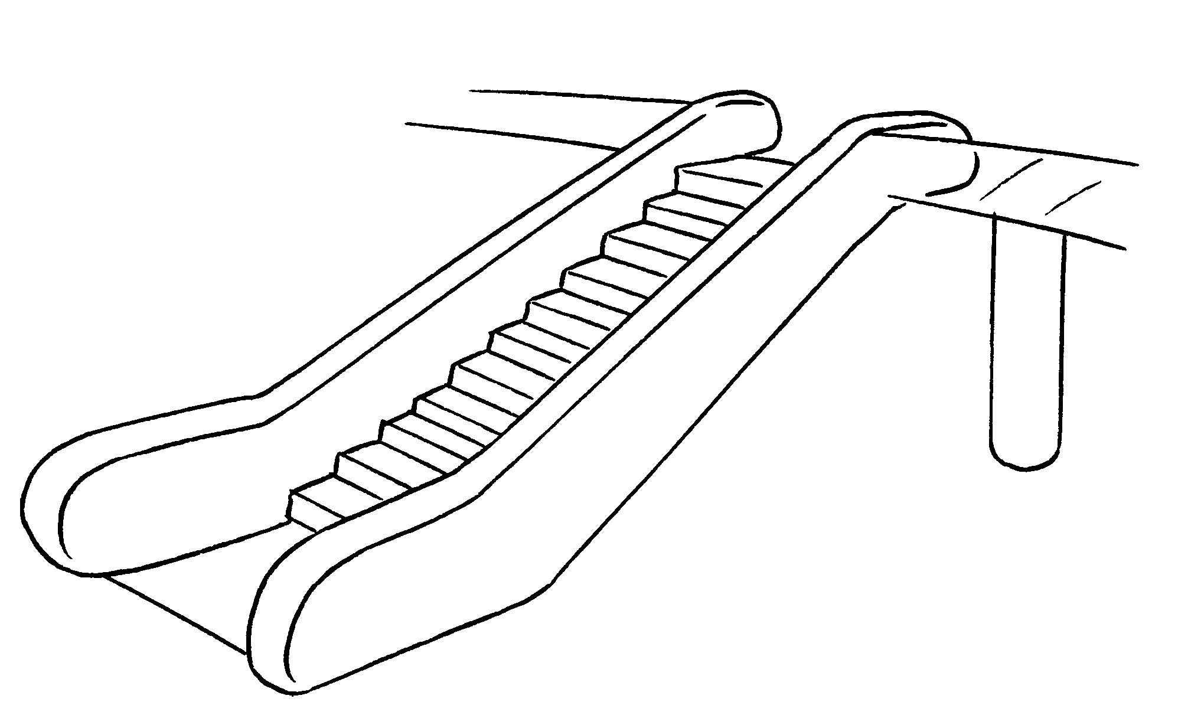


Book 4B Chapter 7 Graded Worksheets
Worksheet 1⬇⬇⬇
- lake 2 desert
3 a river 4 a mountain
5 a tower 6 a bridge
7 an escalator

