RP no: Century Gothic 15pt
(所有圈號用15pt)

Finish the questions and answers.
metres
centimetres
1  A  B | 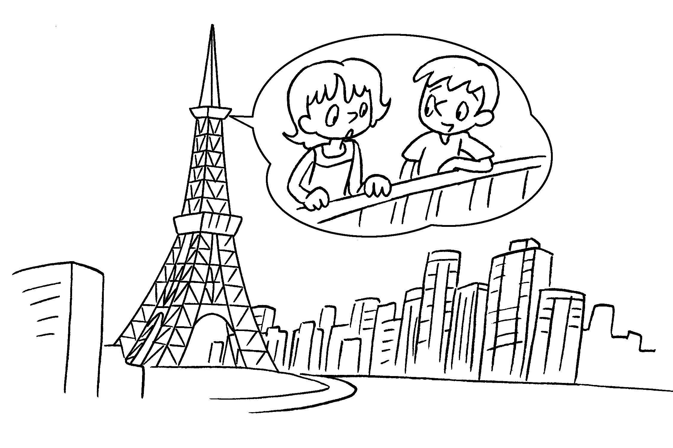 | A : How is this tower?  B : It’s 321 metres.
2  A  B | 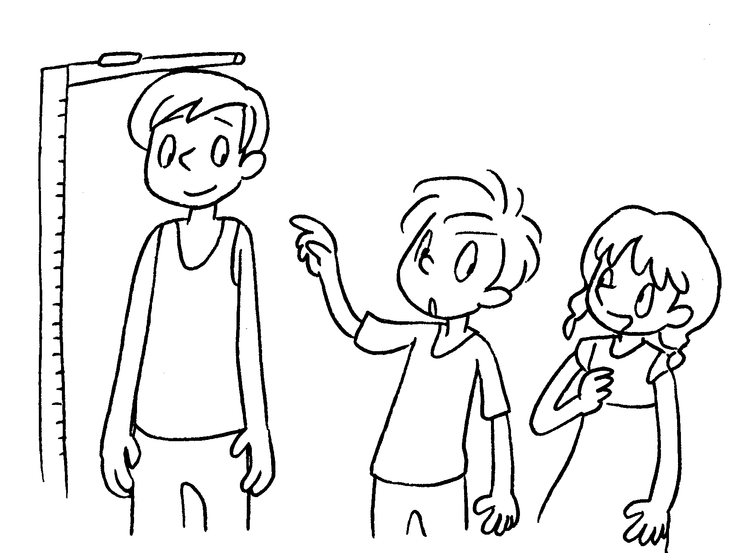 | A : tall is Sam?  B : He’s 160 .
3  A  B | 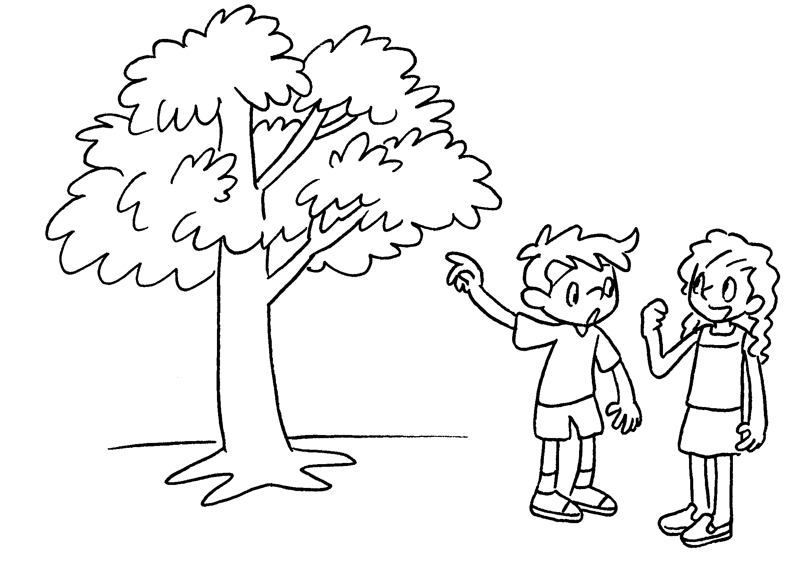 | A : this tree?  B : It’s 2.16 .
4  A  B | 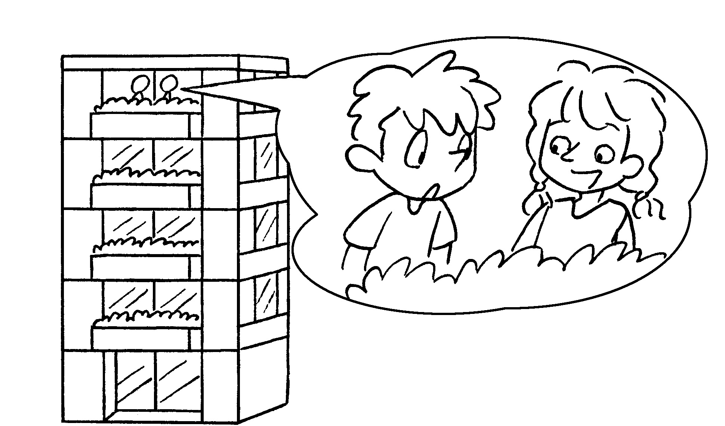  ( building ) | A :  B : It’s 21 .
5  A  B | 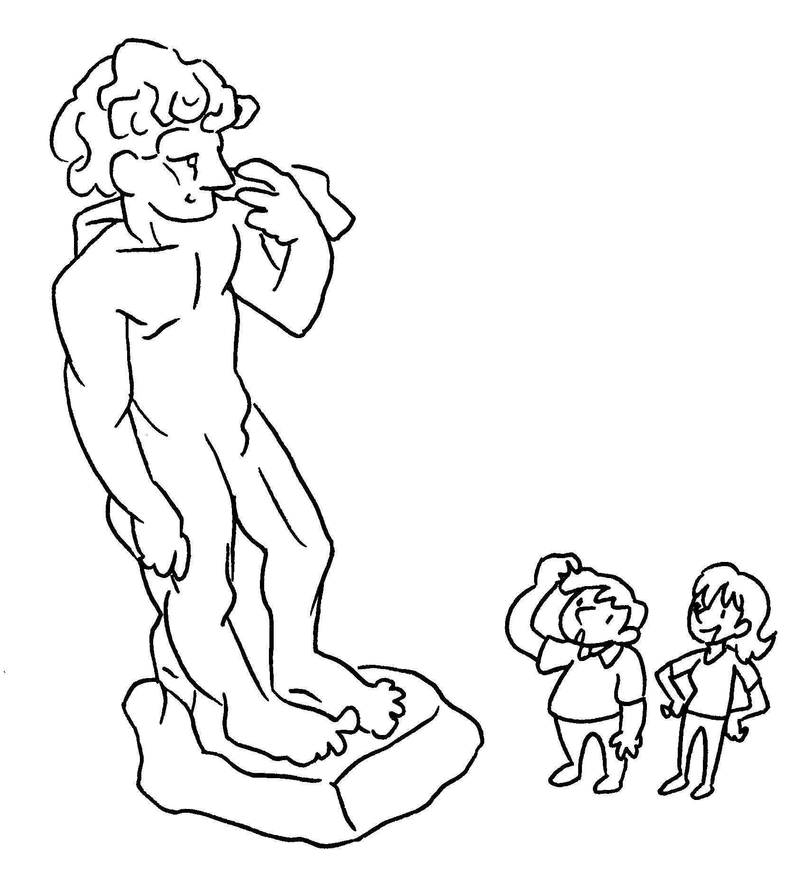  ( statue ) | A :  B : It’s 11 .


Book 4B Chapter 7 Graded Worksheets
Worksheet 2⬇⬇
- tall
- How
centimetres
- How tall is
metres
- How tall is this building?
metres
- How tall is this statue?
metres

