Finish the questions and answers.
metres
centimetres
1  A  B | 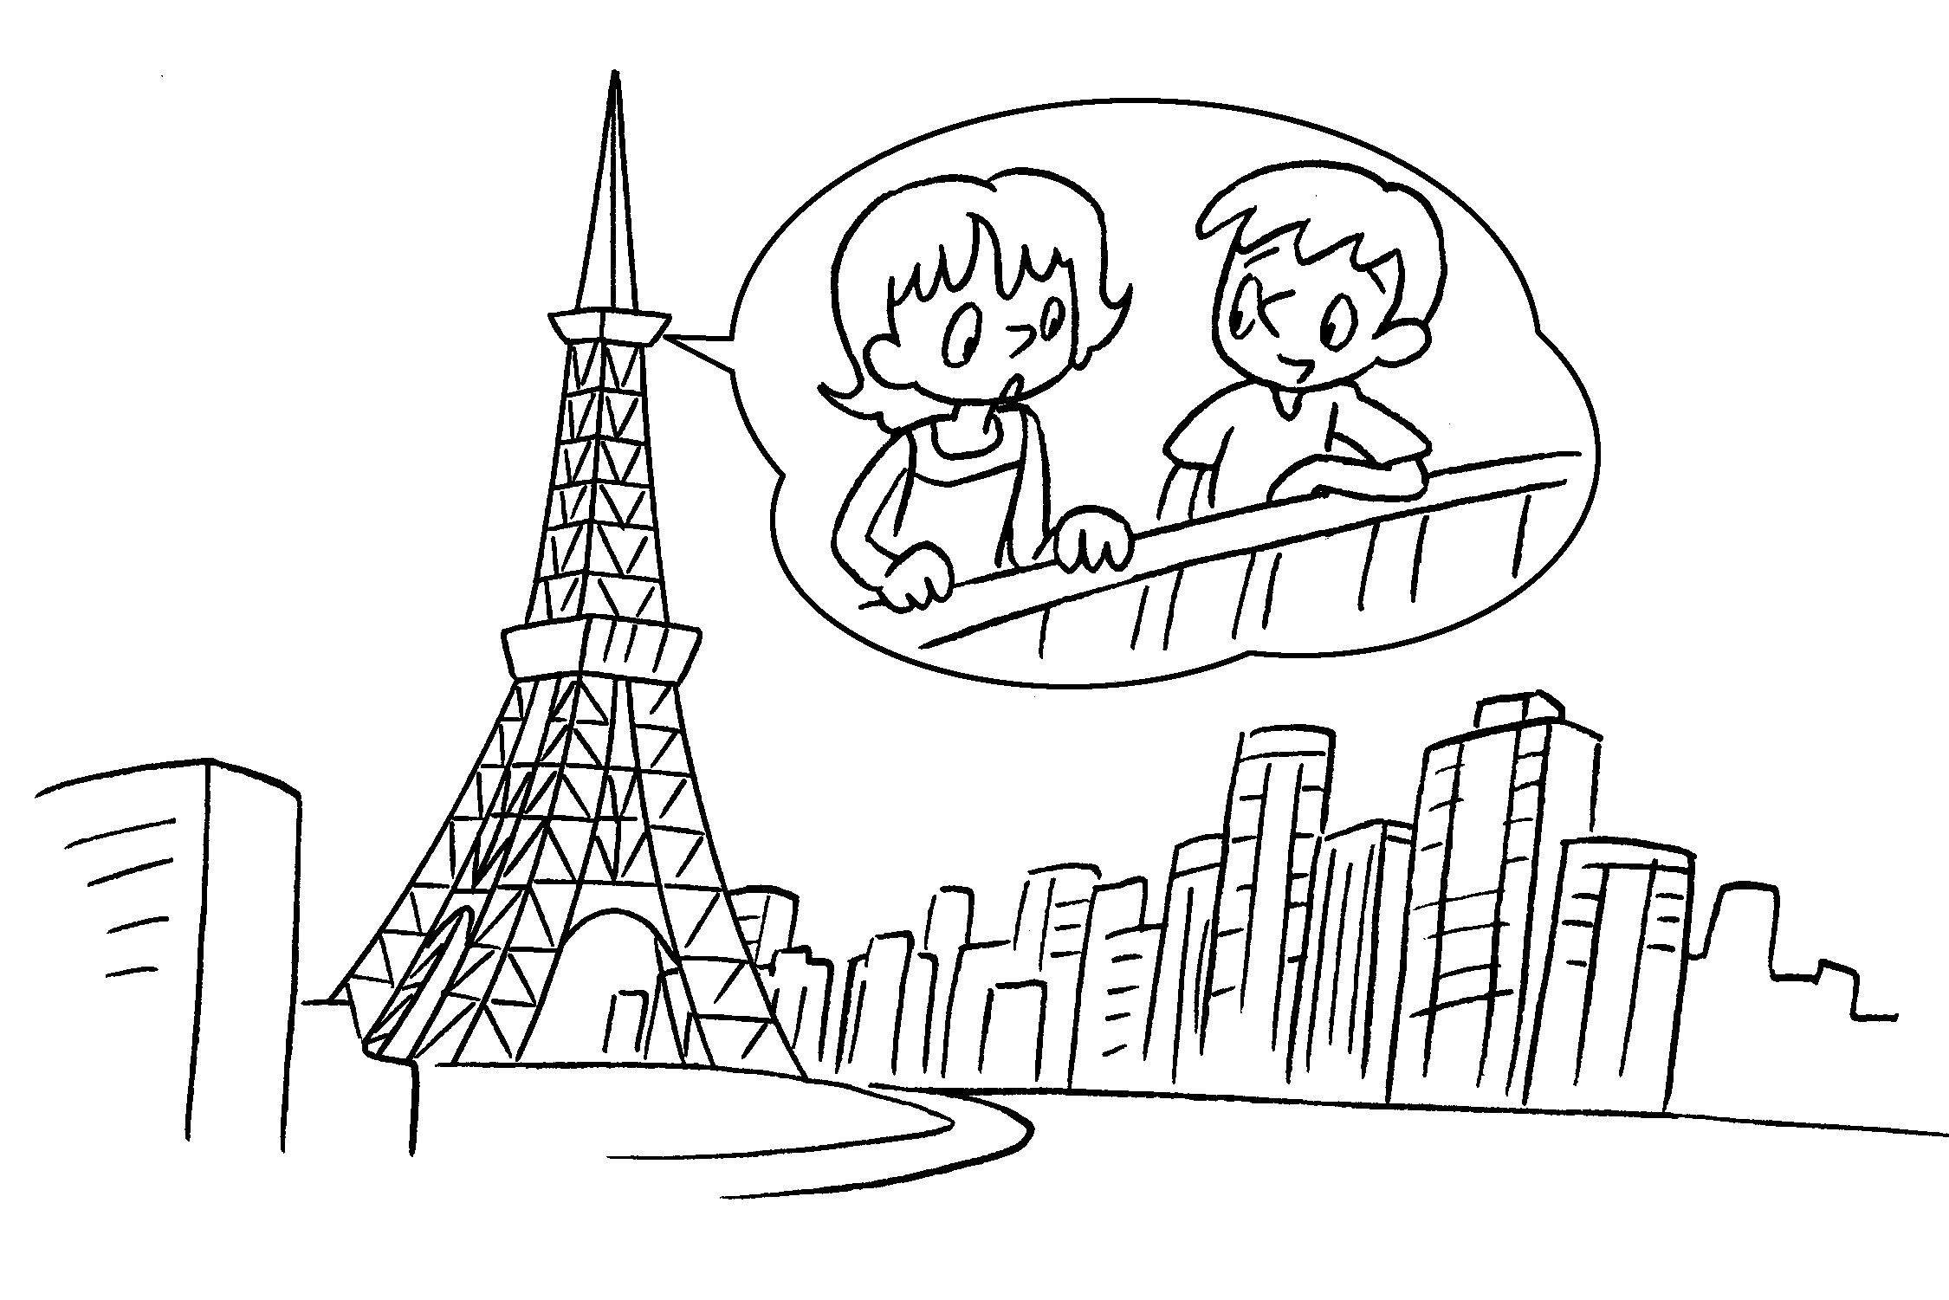 | A : How is this tower?  B : It’s 321 metres.
2  A  B | 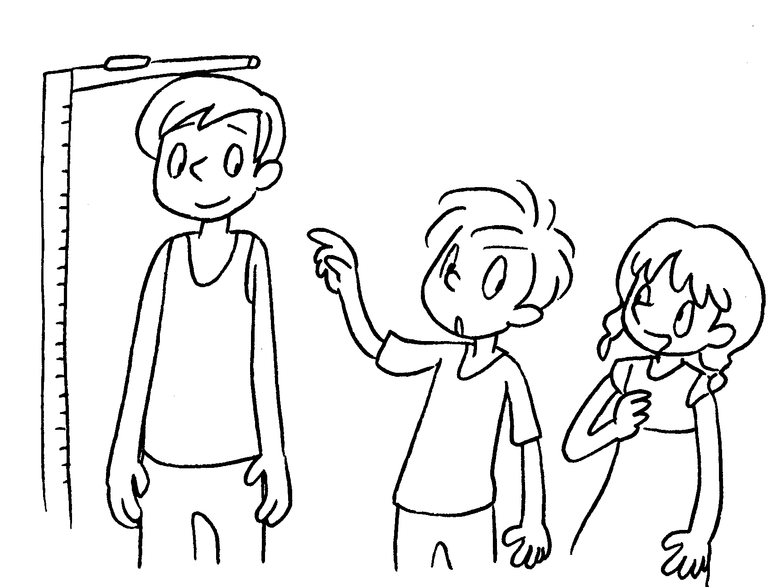 | A : tall is Sam?  B : He’s 160 .
3  2.16 m  A  B | 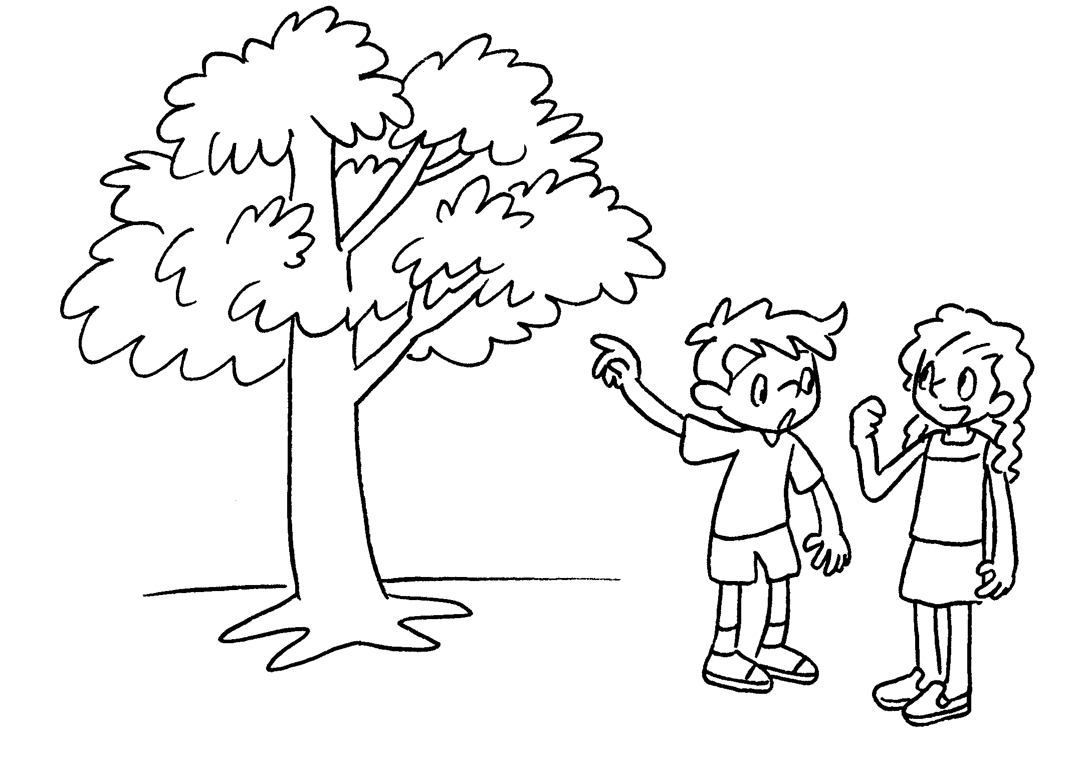 | A : this tree?  B : It’s .
4  21 m  A  B | 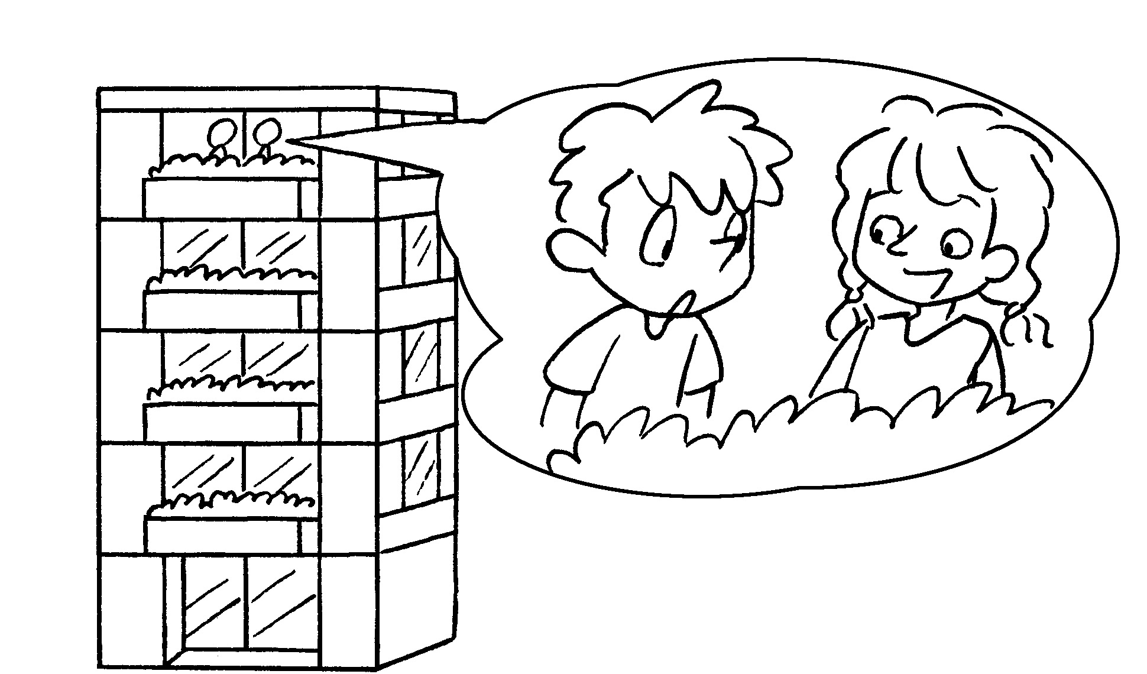 | A :  B :
5  11 m  A  B | 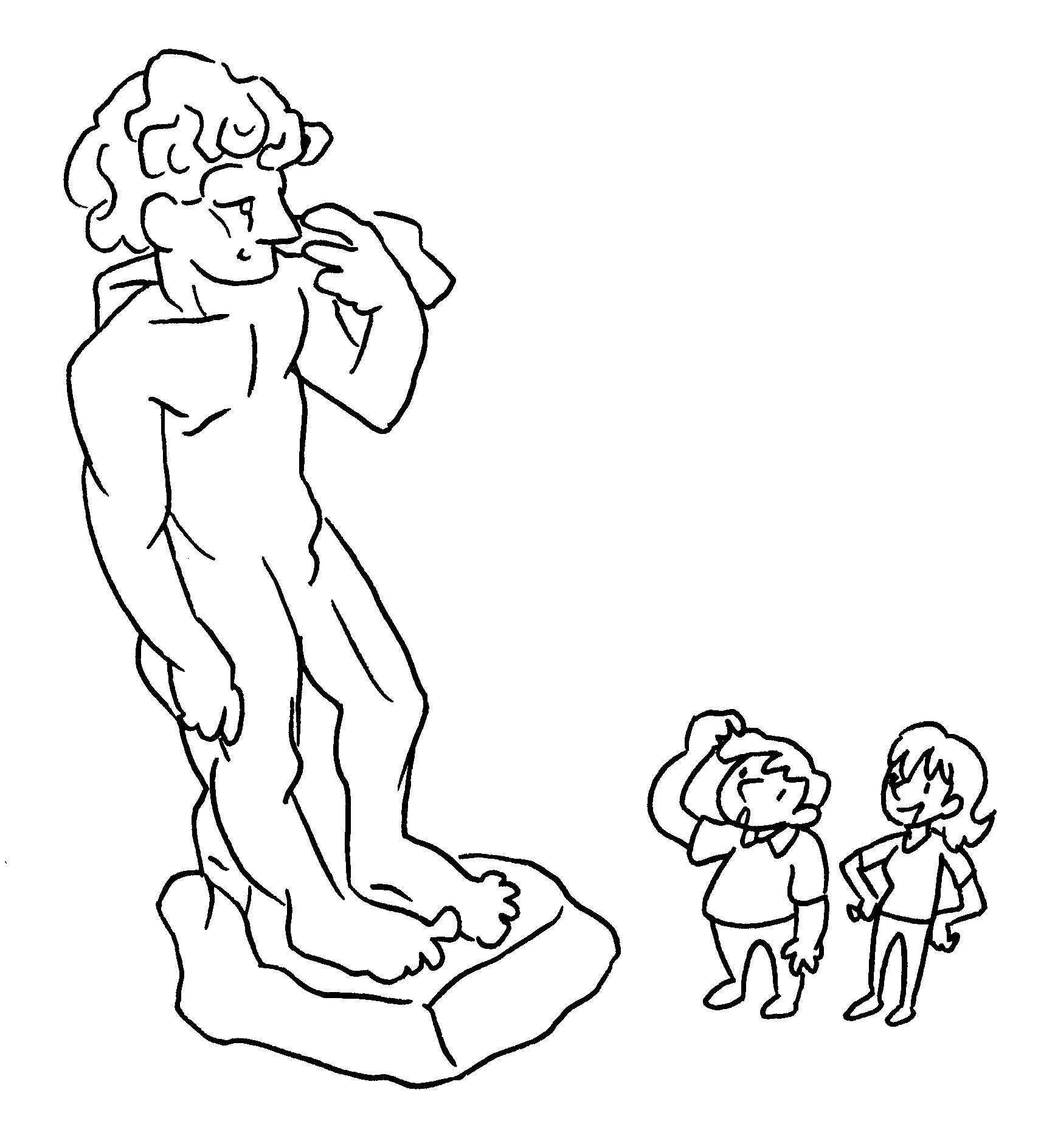 | A :  B :


Book 4B Chapter 7 Graded Worksheets
Worksheet 2⬇⬇⬇
- tall
- How
centimetres
- How tall is
2.16 metres
- How tall is this building?
It’s 21 metres.
- How tall is this statue?
It’s 11 metres.

