Choose and write.
heavy
high
long

1  A  B | 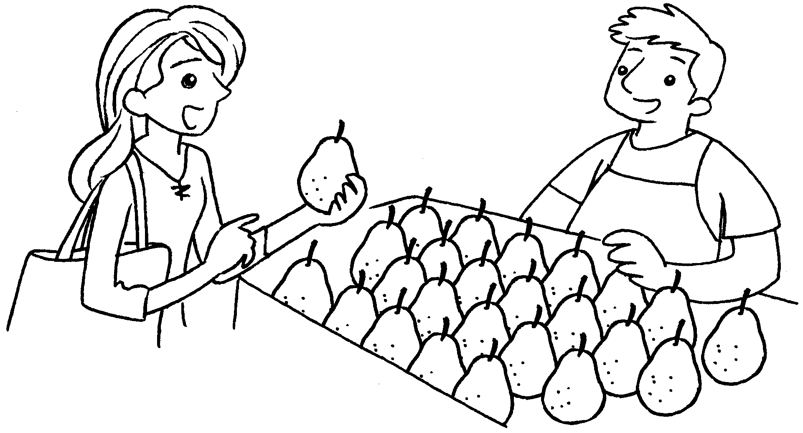 | A : How is this pear?  B : It’s 140 grams.
2  A  B | 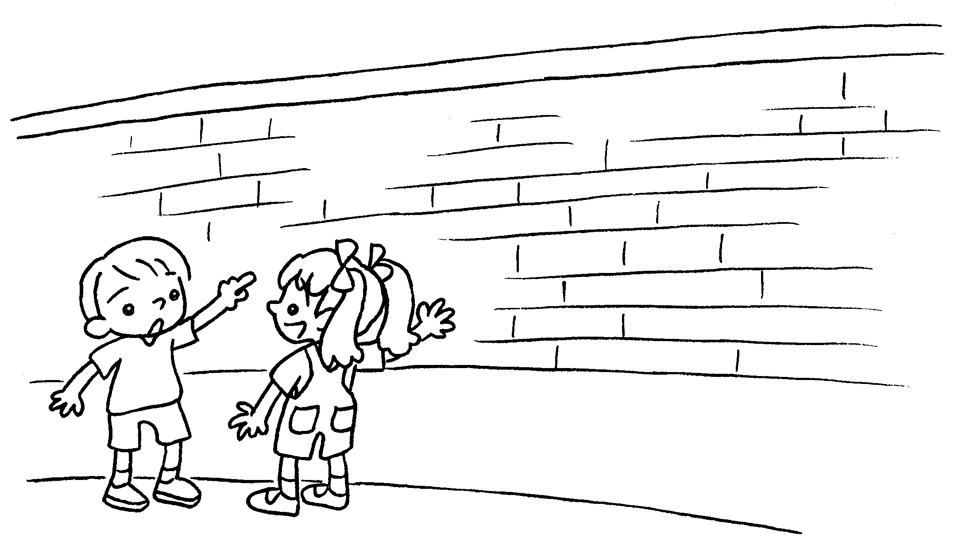 | A : How is this wall?  B : It’s 210 centimetres .
3  A  B | 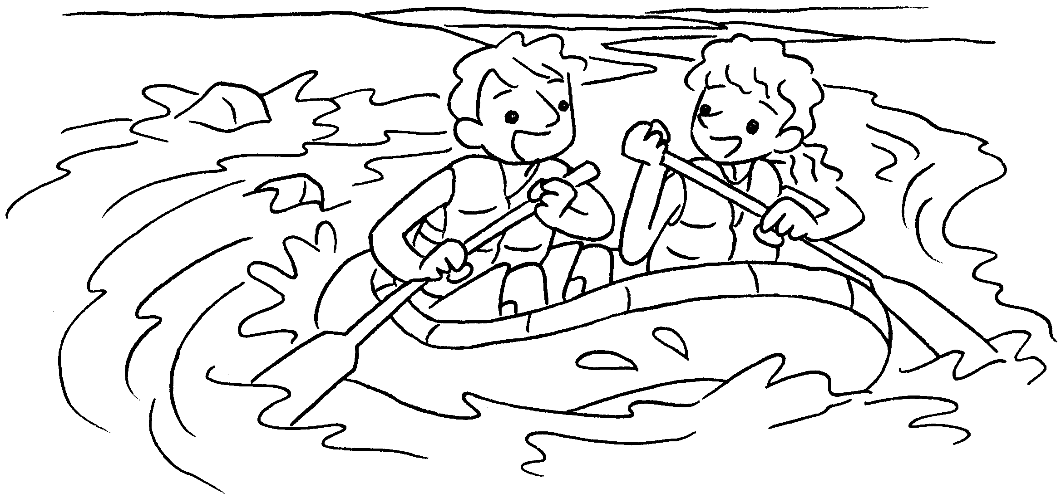 | A : How is this river?  B : It’s 2 kilometres .
4  A  B | 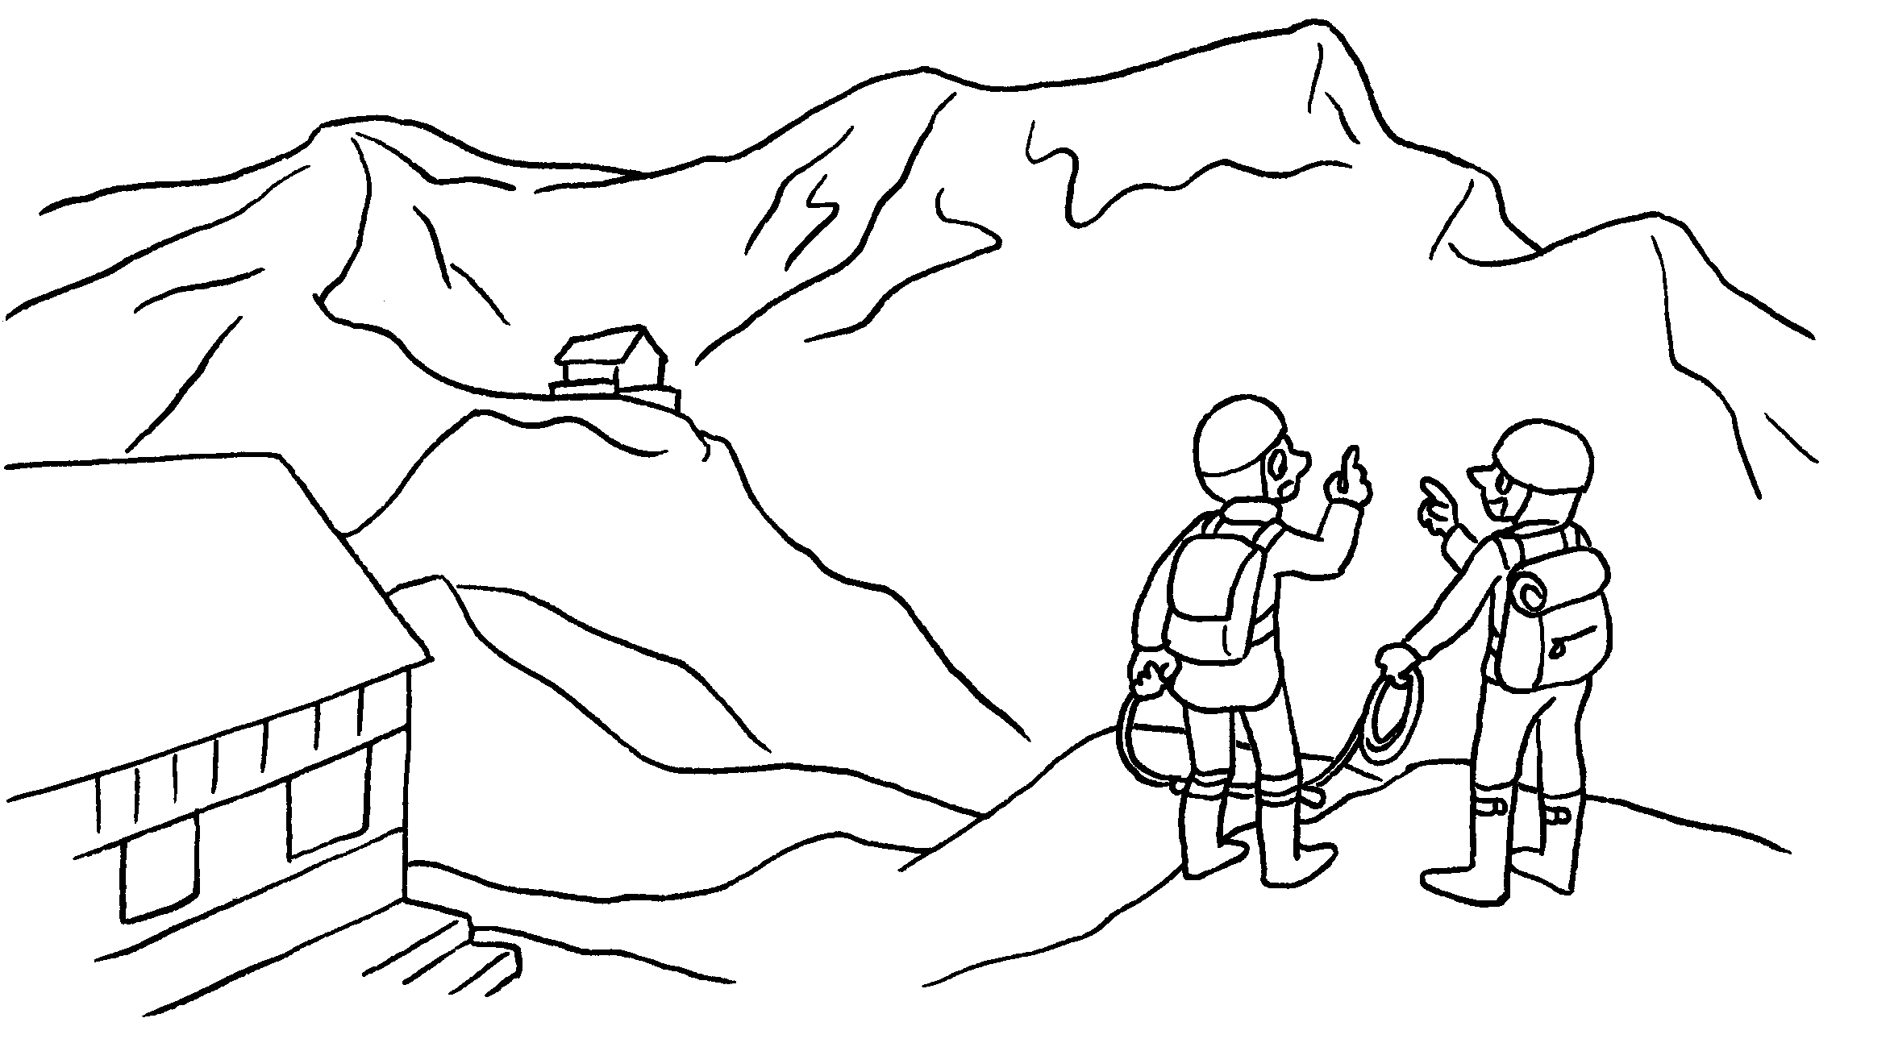 | A : How is that  mountain?  B : It’s 5,260 metres .


Book 4B Chapter 7 Graded Worksheets
Worksheet 3⬇
- heavy
- high
high
- long
long
- high
high

