Finish the questions and answers.
heavy
high
long

1  A  B | 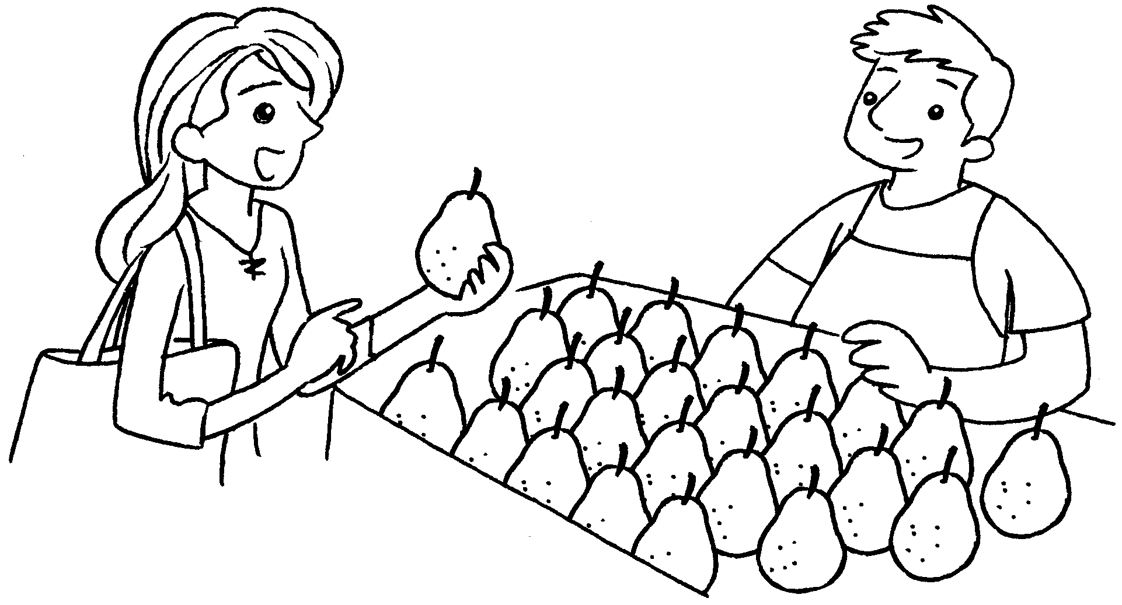 | A : How is this pear?  B : It’s 140 grams.
2  A  B | 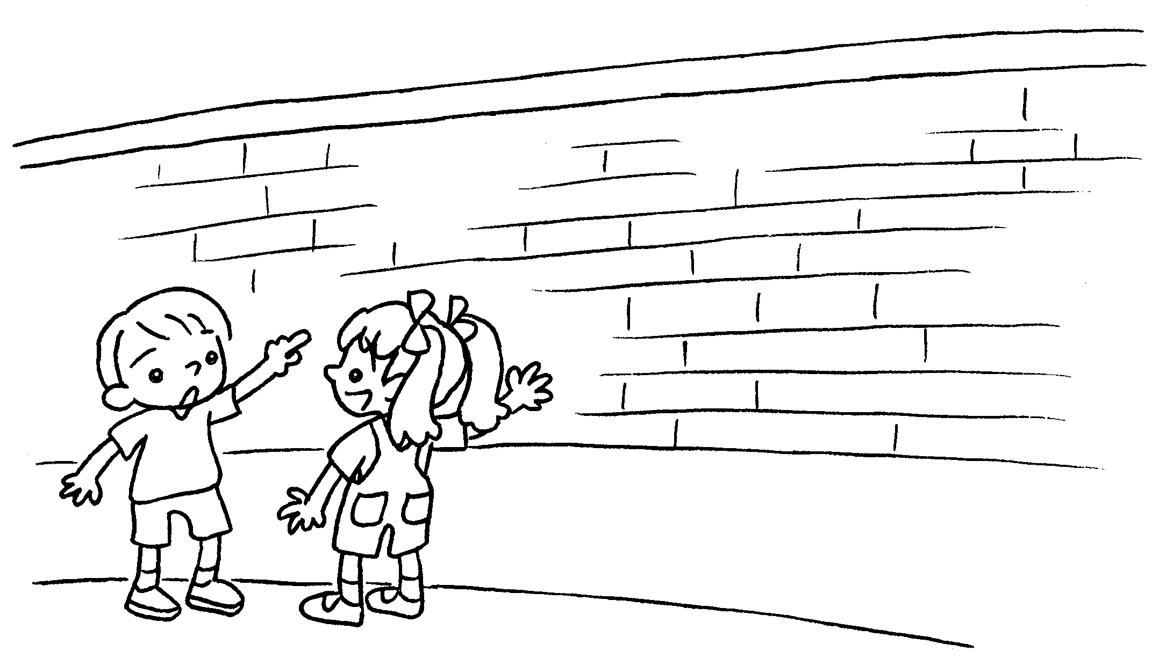 | A : is this wall?  B : It’s 210 centimetres .
3  A  B | 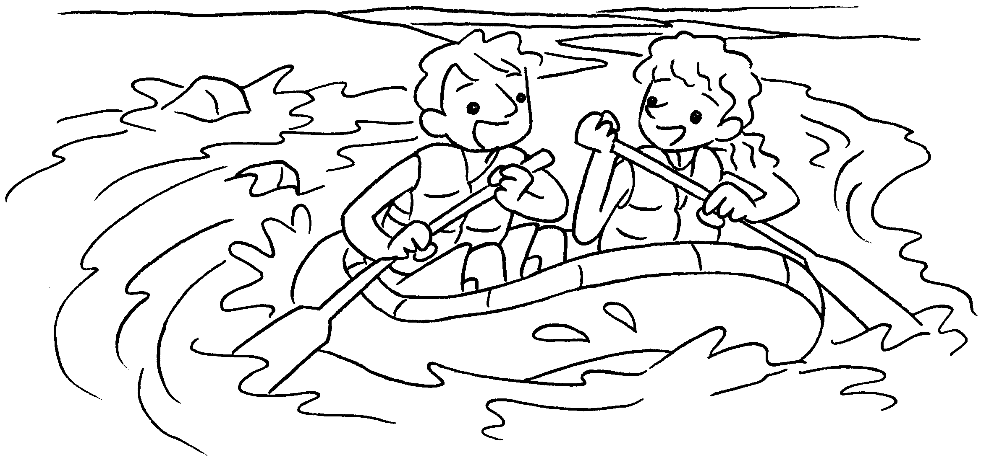  ( river ) | A : this  ?  B : It’s 2 kilometres .
4  A  B | 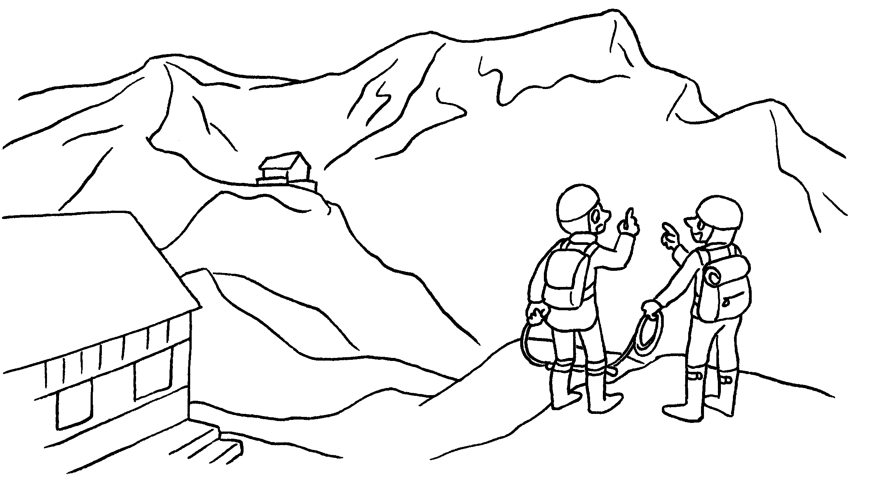  ( mountain ) | A : that  ?  B : It’s 5,260 metres .


Book 4B Chapter 7 Graded Worksheets
Worksheet 3⬇⬇
- heavy
- How high
high
- How long is river
long
- How high is mountain
high

