Finish the questions and answers.

1  A  B | 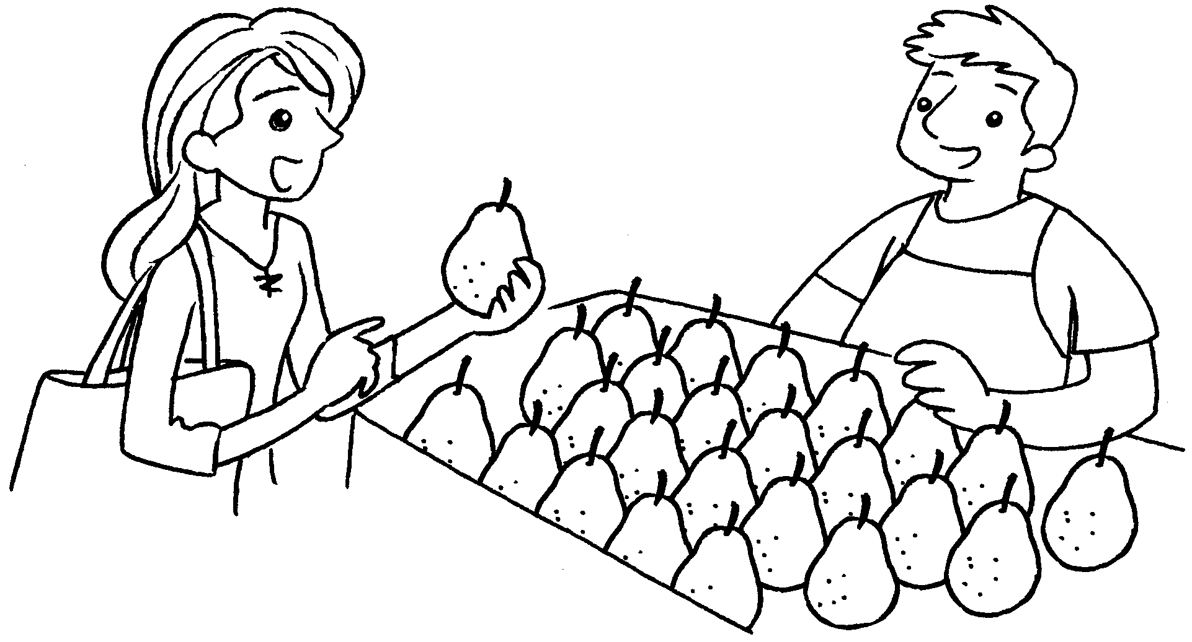 | A : How is this pear?  B : It’s 140 grams.
2  A  B | 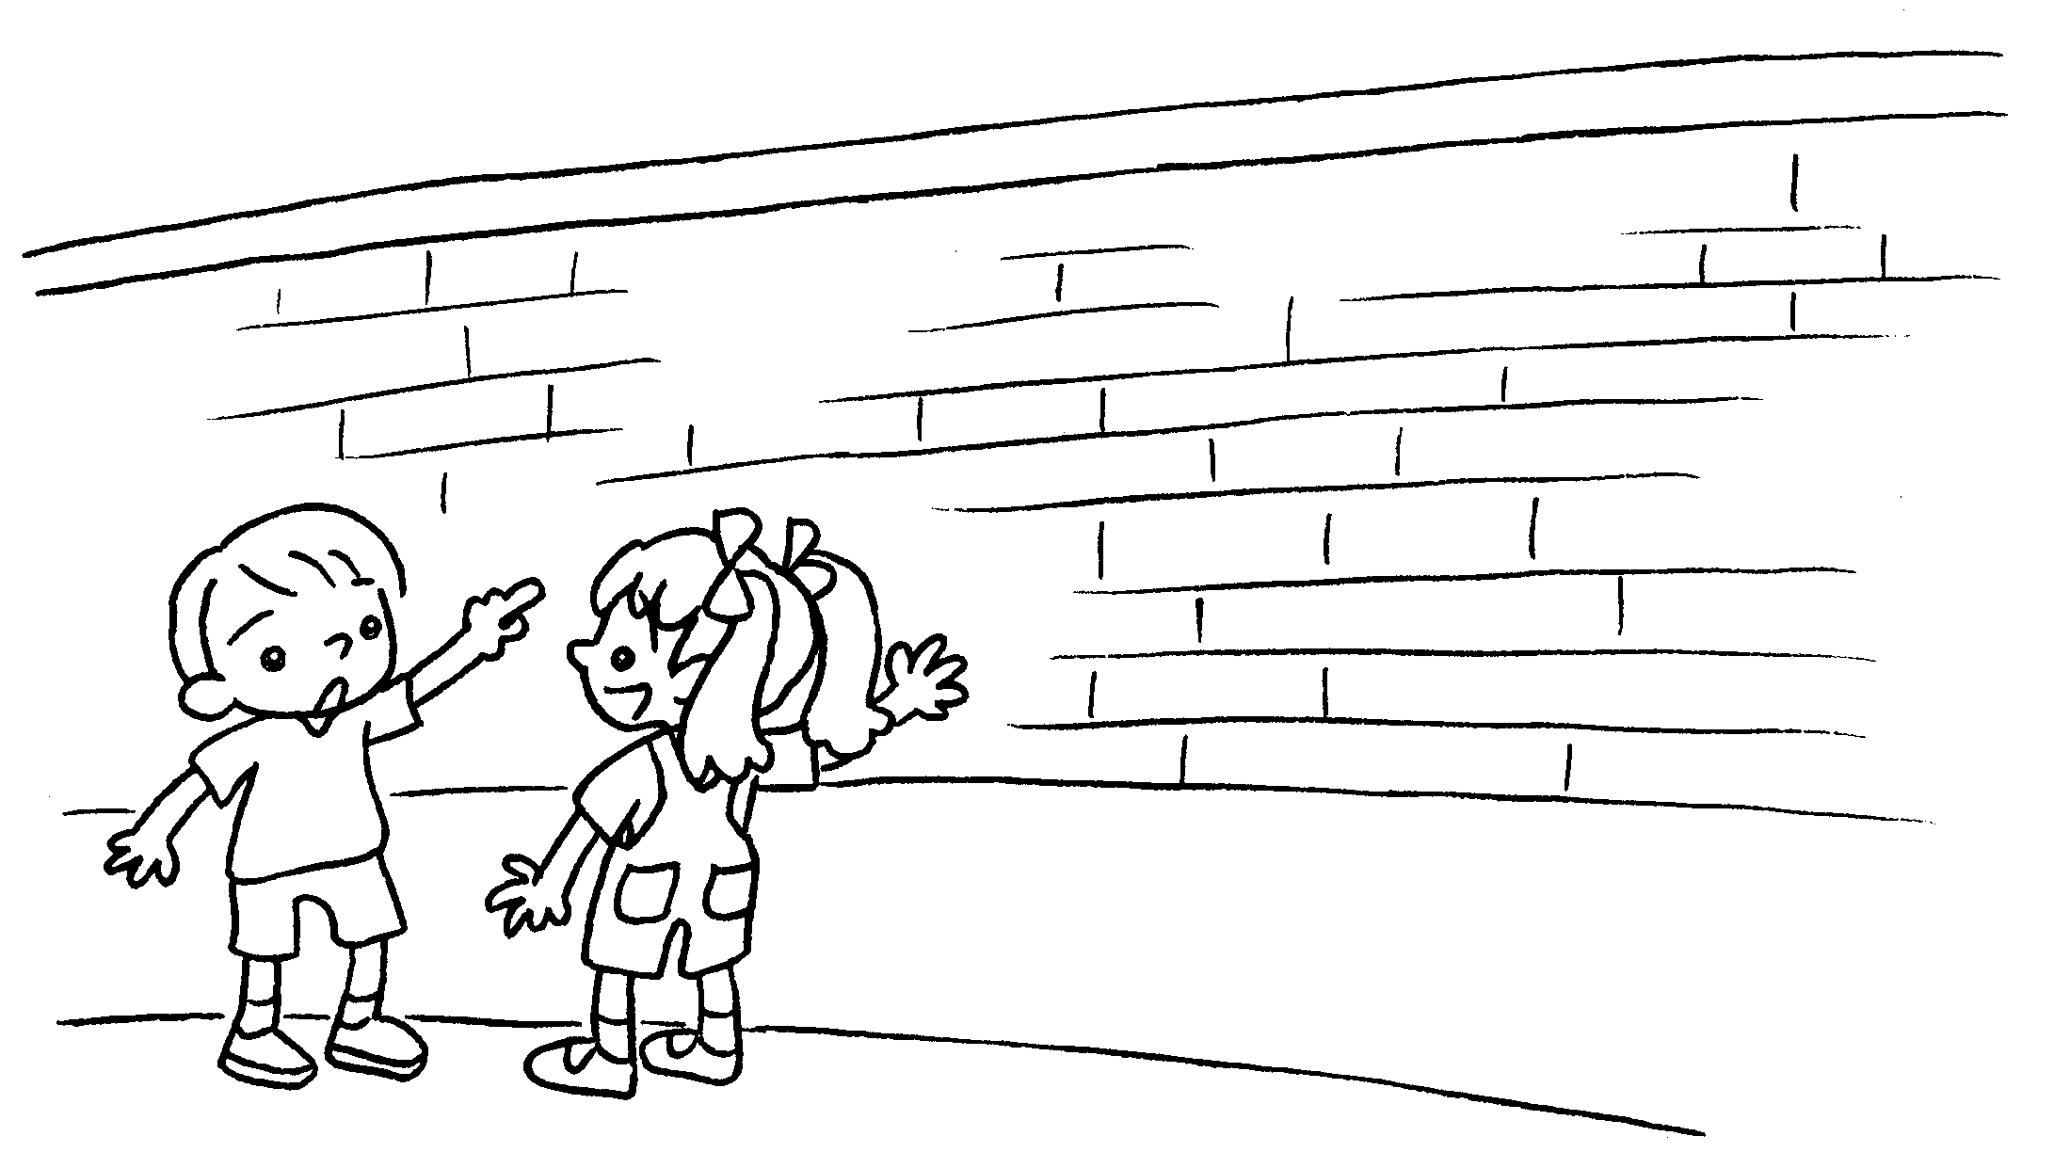 | A : How is this wall?  B : It’s 210 centimetres .
3  A  B | 2 km  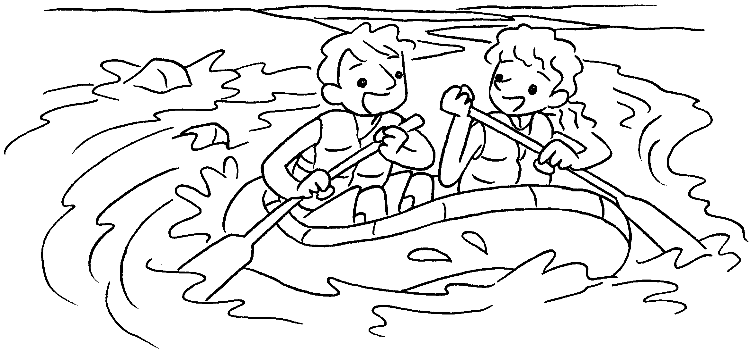 | A : this  ?  B : It’s .
4  A  B | 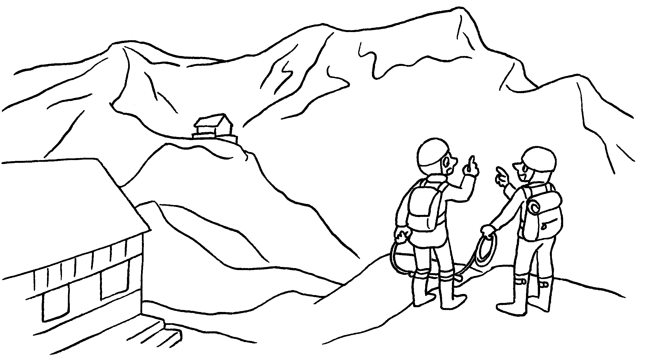  5,260 m | A : that  ?  B :


Book 4B Chapter 7 Graded Worksheets
Worksheet 3⬇⬇⬇
- heavy
- high
high
- How long is river
2 kilometres (long)
- How high is mountain
It’s 5,260 metres (high).

