RP no: Century Gothic 15pt
(所有圈號用15pt)
Choose and write.

earlypolitelypatientlyquietlysoftlylaterudelyimpatientlynoisilyloudly

1 | 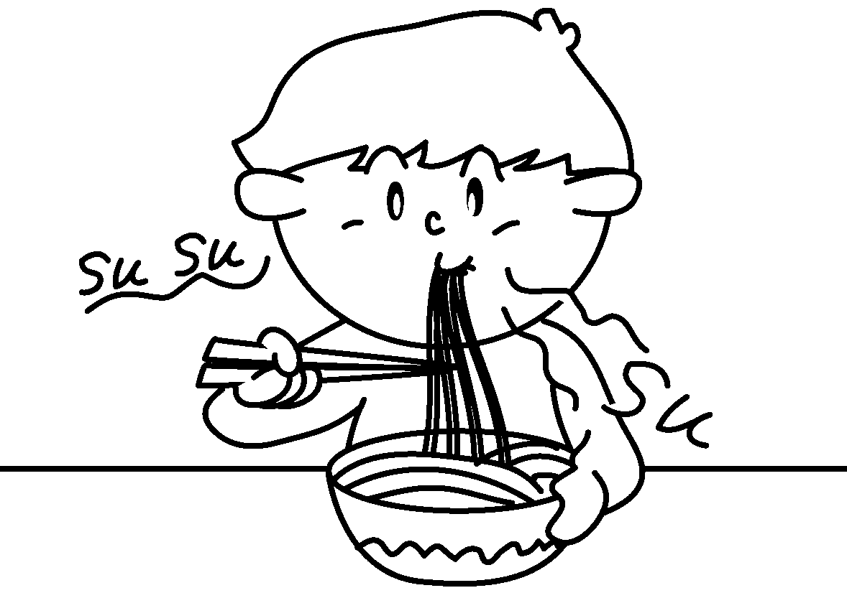 | eat  n |  |  | eat  q
2 | 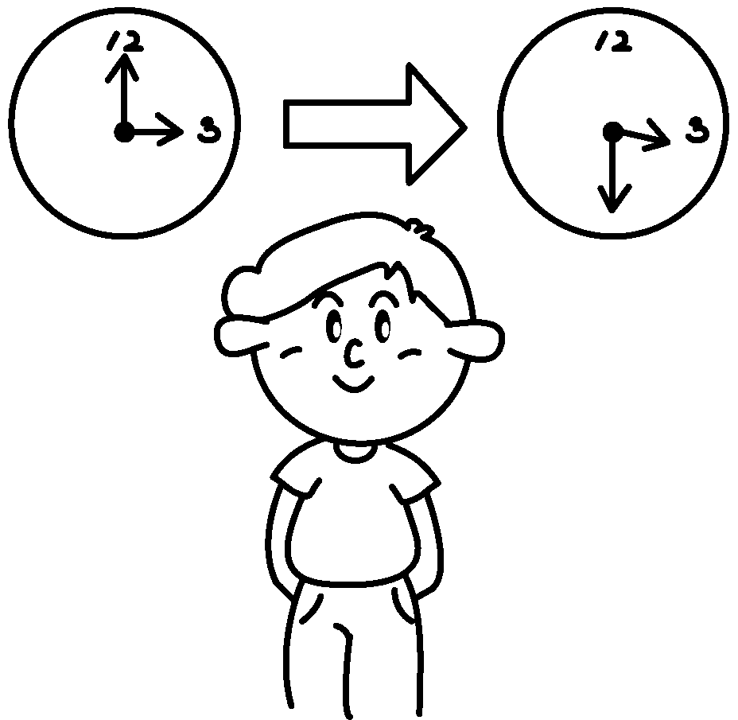 | wait |  | 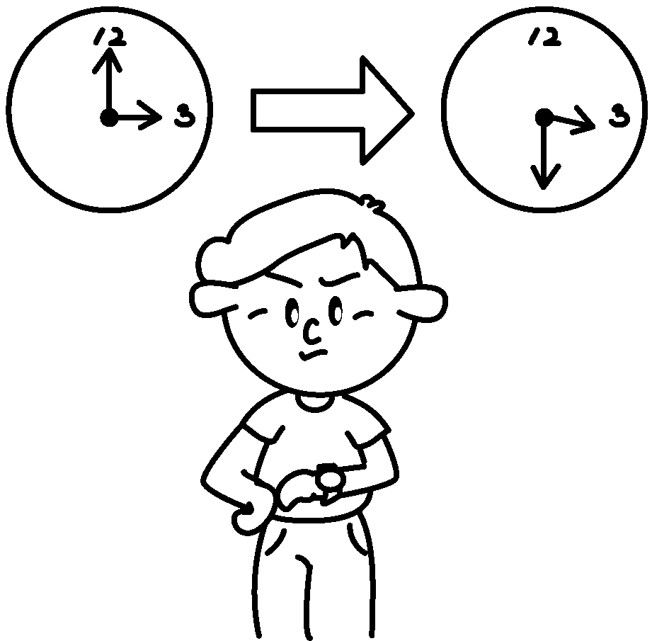 | wait
3 |  | speak |  |  | speak
4  May I borrow  your pencil? | 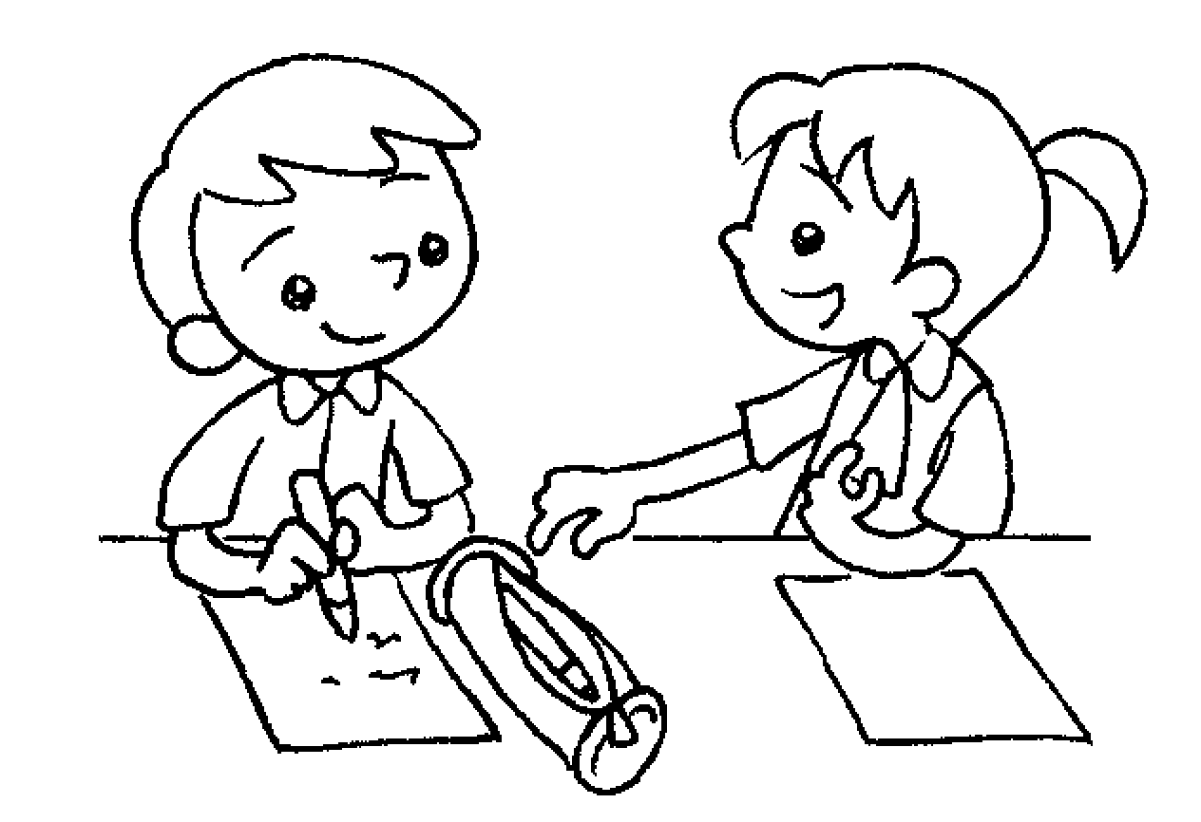 | talk | Give me your pencil! | 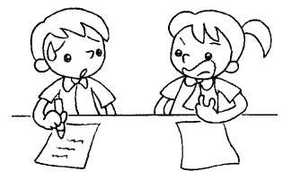 | talk
5 | 8:45 | arrive |  | 7:00 | arrive

RP no: Century Gothic 15pt
(所有圈號用15pt)


Book 5A Chapter 1 Graded Worksheets
Worksheet 1⬇
- noisily quietly
- patiently impatiently
- loudly softly
- politely rudely
- late early

