RP no: Century Gothic 15pt
(所有圈號用15pt)
RP no: Century Gothic 15pt
(所有圈號用15pt)
Fill in the blanks with the correct adverbs.

1 |  | eat  n |  |  | eat  q
2 | 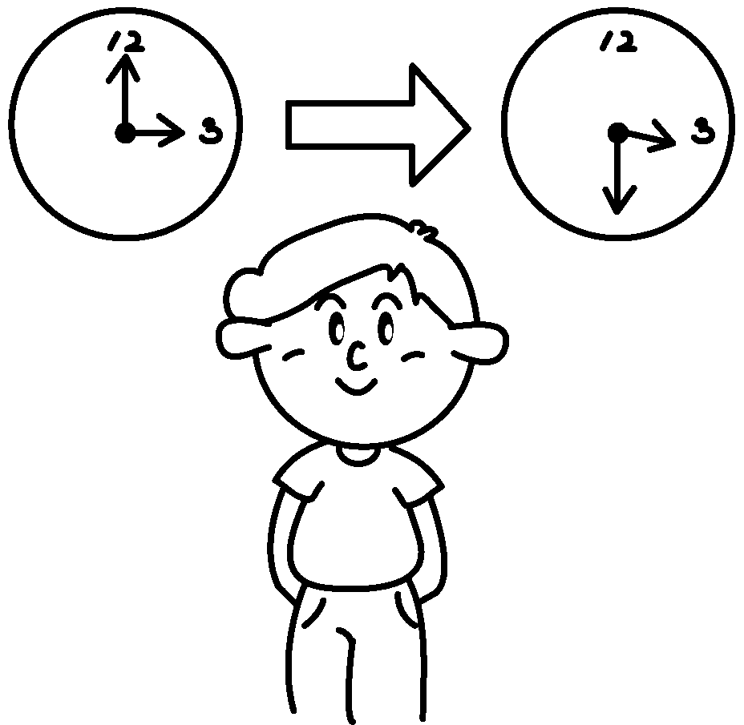 | wait  p |  | 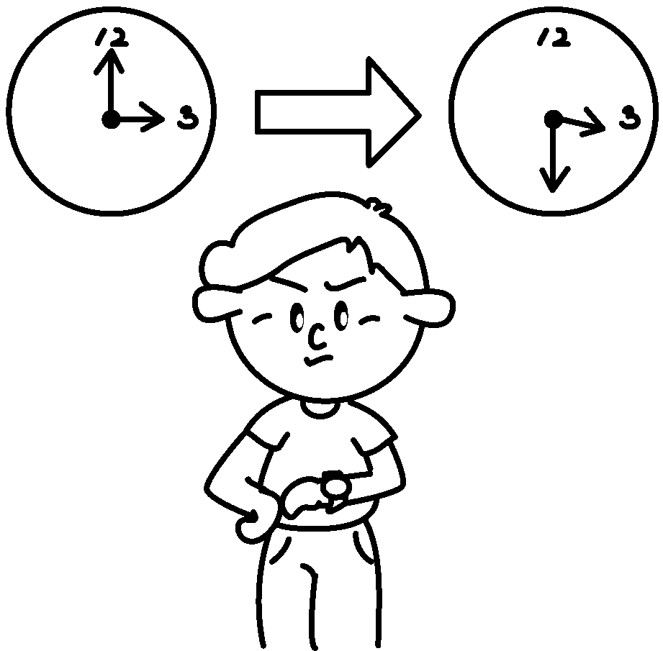 | wait  i
3 |  | speak  l |  |  | speak  s
4  May I borrow  your pencil? | 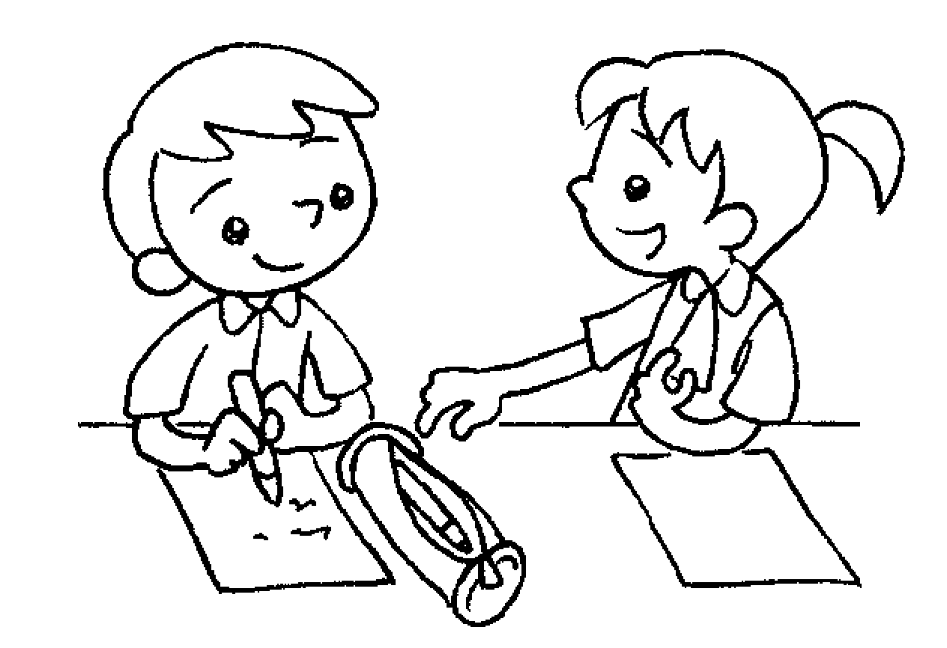 | talk  p | Give me your pencil! | 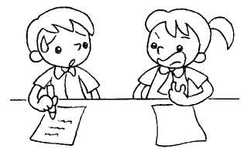 | talk  r
5 | 8:45 | arrive  l |  | 7:00 | arrive  e

RP no: Century Gothic 15pt
(所有圈號用15pt)


Book 5A Chapter 1 Graded Worksheets
Worksheet 1⬇⬇
- noisily quietly
- patiently impatiently
- loudly softly
- politely rudely
- late early

