RP no: Century Gothic 15pt
(所有圈號用15pt)

Fill in the blanks with the correct form of the words.

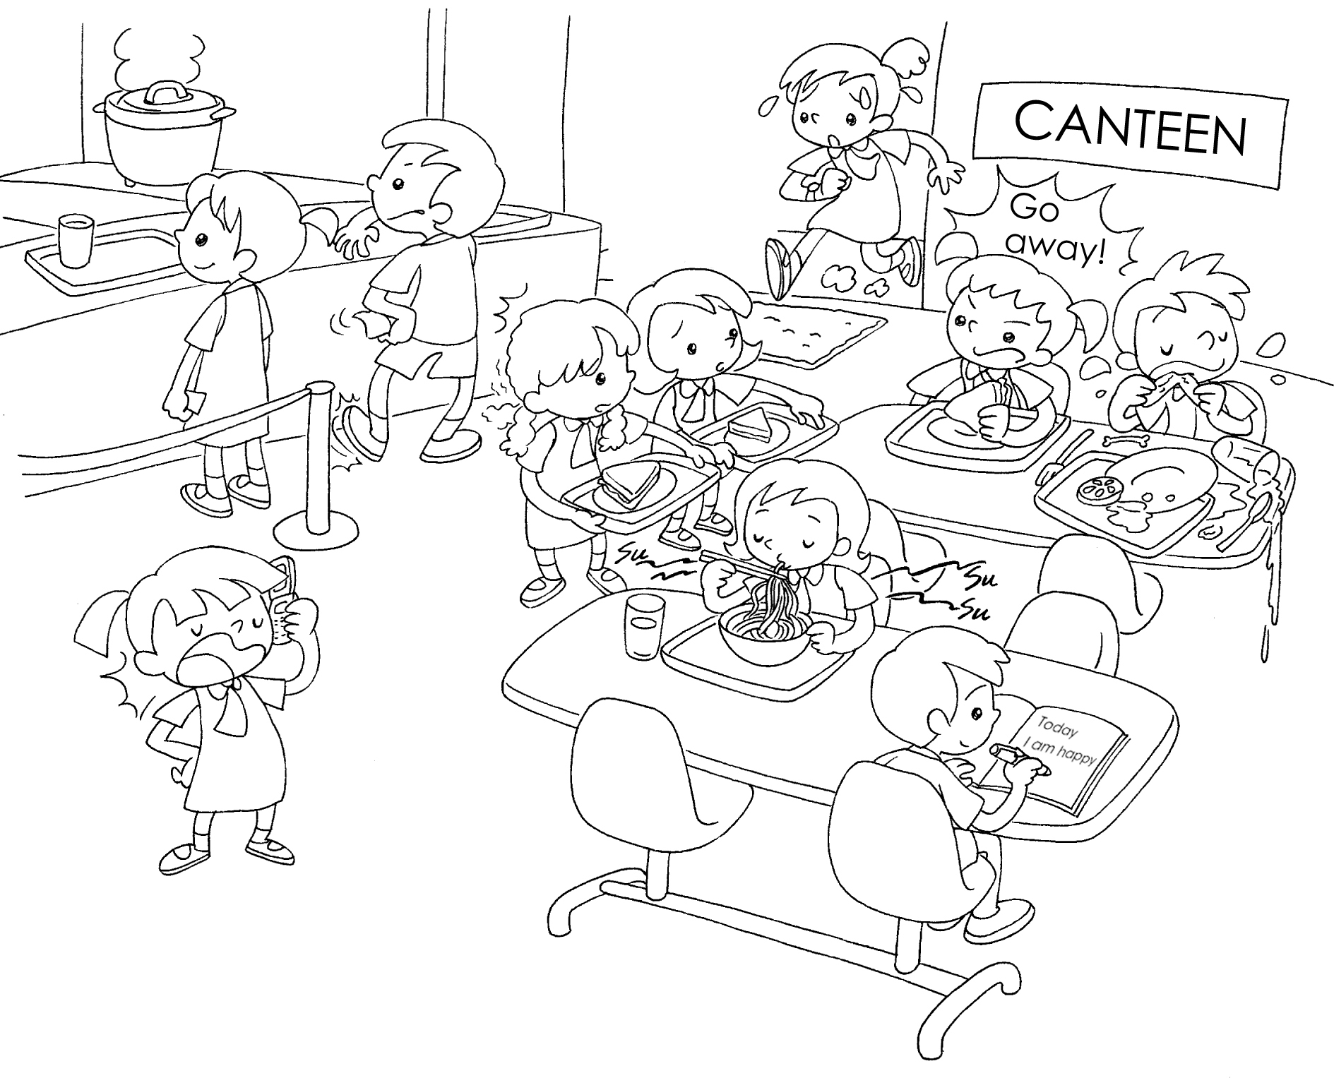
Jane
John
Sandy
Mary
Penny
Susan
1 | Susan arrives ( late ).
2 | Jane is talking ( loud ) on the phone.
3 | Penny is waiting ( patient ) for the food.
4 | John is waiting ( impatient ) for the food.
5 | Mary is talking ( rude ) to her schoolmates.
6 | Sandy is eating noodles ( noisy ).


Book 5A Chapter 1 Graded Worksheets
Worksheet 2⬇
- late
- loudly
- patiently
- impatiently
- rudely
- noisily

