RP no: Century Gothic 15pt
(所有圈號用15pt)

Fill in the blanks with the correct adverbs.
RP no: Century Gothic 15pt
(所有圈號用15pt)

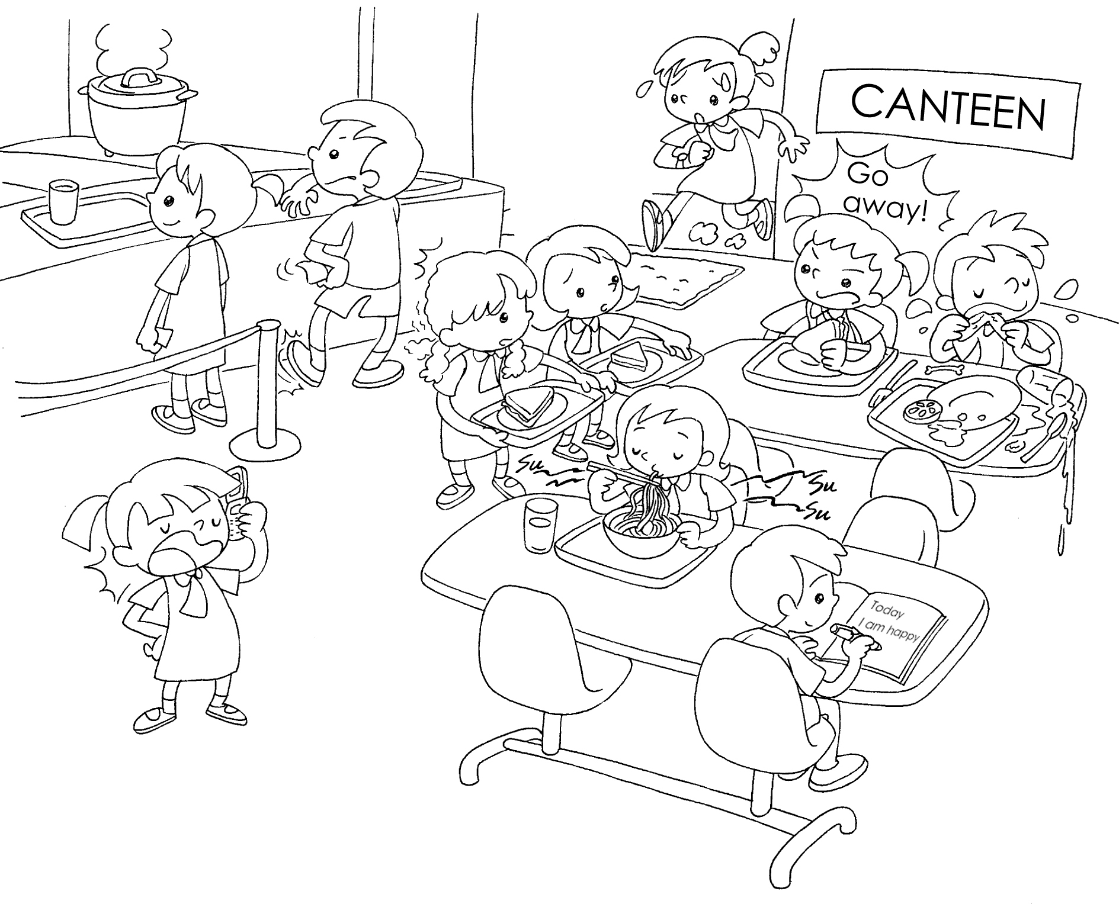
Jane
John
Sandy
Mary
Penny
Susan
1 | Susan arrives .
2 | Jane is talking on the phone.
3 | Penny is waiting for the food.
4 | John is waiting for the food.
5 | Mary is talking to her schoolmates.
6 | Sandy is eating noodles .

RP no: Century Gothic 15pt
(所有圈號用15pt)

Book 5A Chapter 1 Graded Worksheets
Worksheet 2⬇⬇
- late
- loudly
- patiently
- impatiently
- rudely
- noisily
(Accept any reasonable answers.)

