RP no: Century Gothic 15pt
(所有圈號用15pt)

Fill in the blanks with the correct verbs and adverbs.

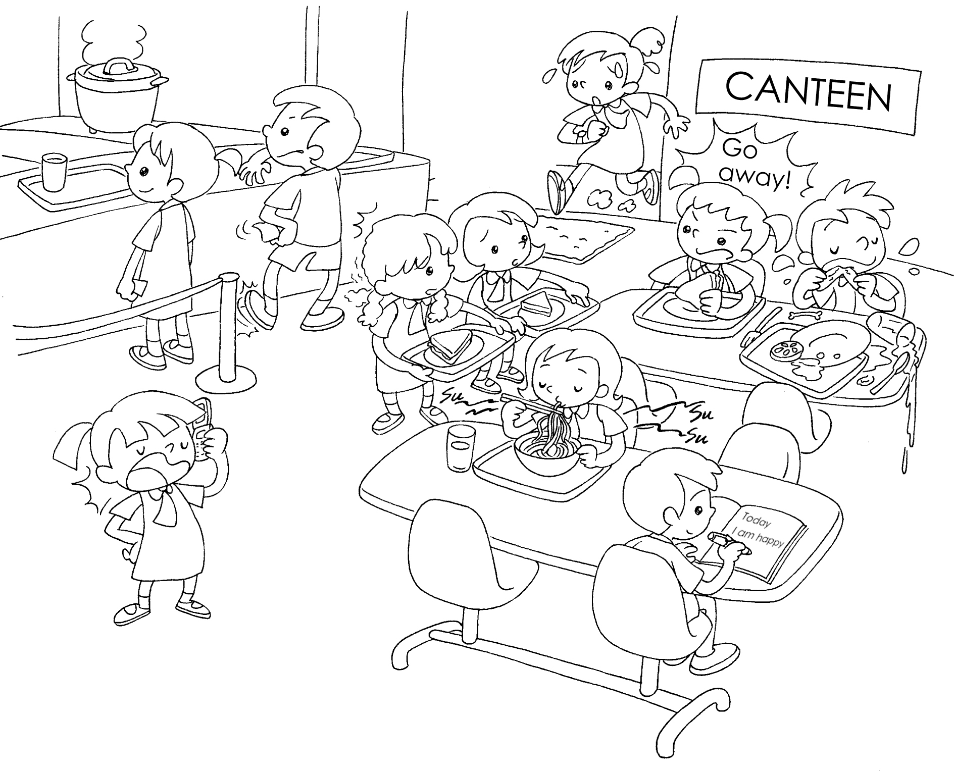
Jane
John
Sandy
Mary
Penny
Susan
1 | Susan arrives .
2 | Jane is talking on the phone.
3 | Penny is for the food.
4 | John is for the food.
5 | Mary is to her schoolmates.
6 | Sandy is noodles .


Book 5A Chapter 1 Graded Worksheets
Worksheet 2⬇⬇⬇
- late
- loudly
- waiting patiently
- waiting impatiently
- talking rudely
- eating noisily
(Accept any reasonable answers.)
RP no: Century Gothic 15pt
(所有圈號用15pt)
RP no: Century Gothic 15pt
(所有圈號用15pt)

