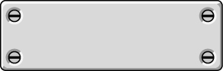
Choose and write.
should shouldn’t

1 | 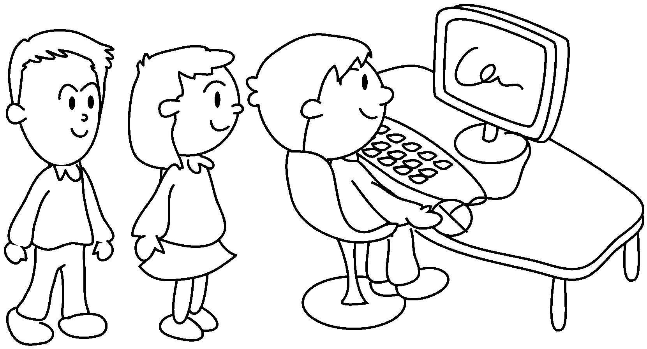 | 2 | 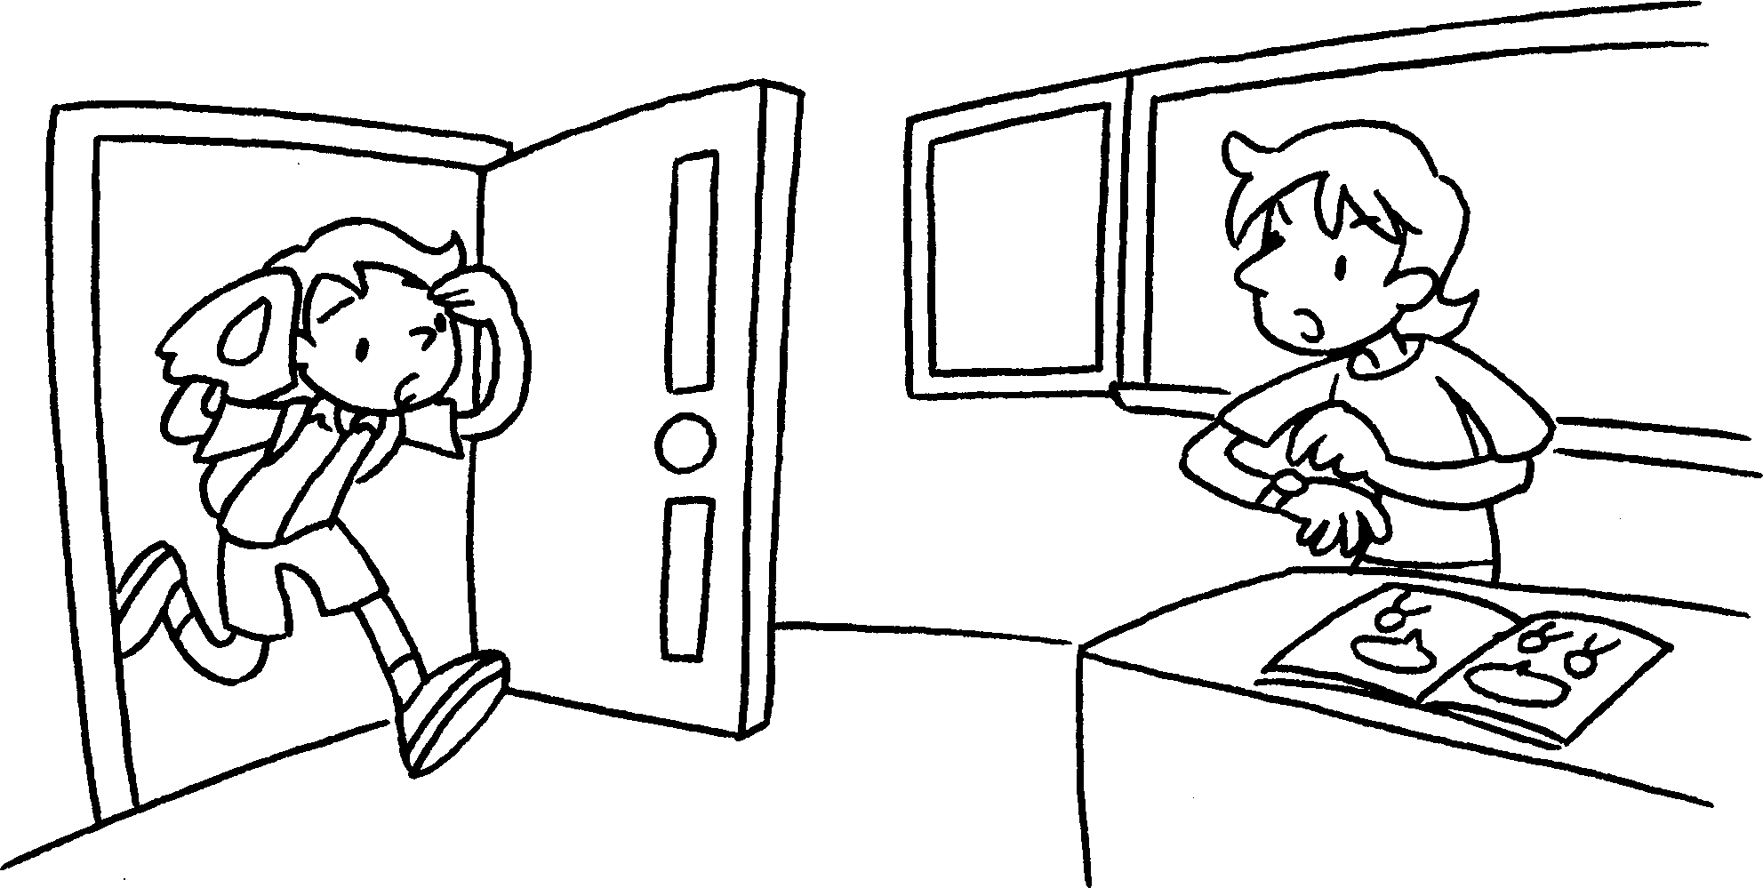
Give me your eraser! | We wait  patiently in the computer room. |  | We arrive late for school.
3 | 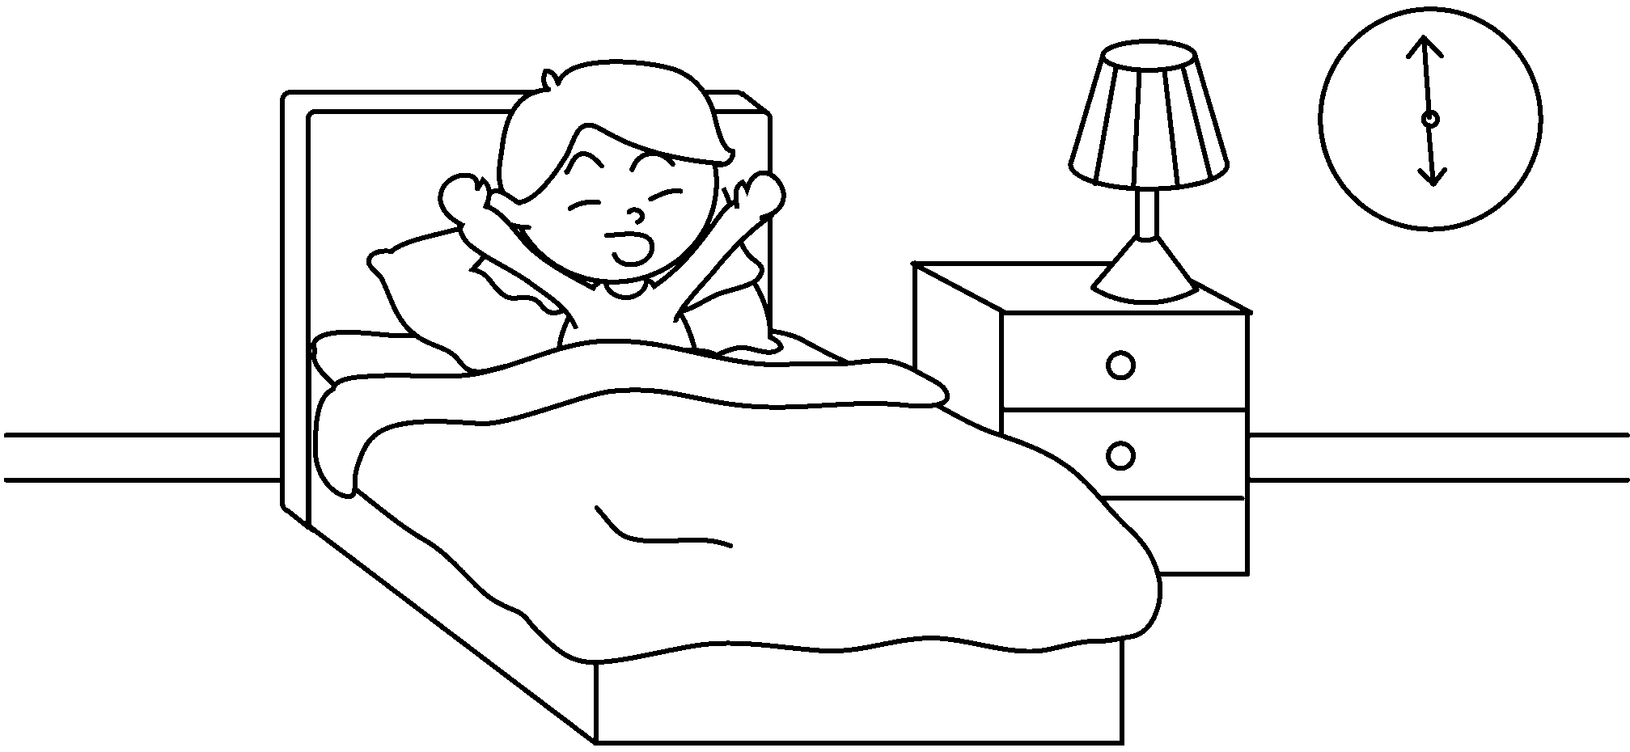 | 4 | 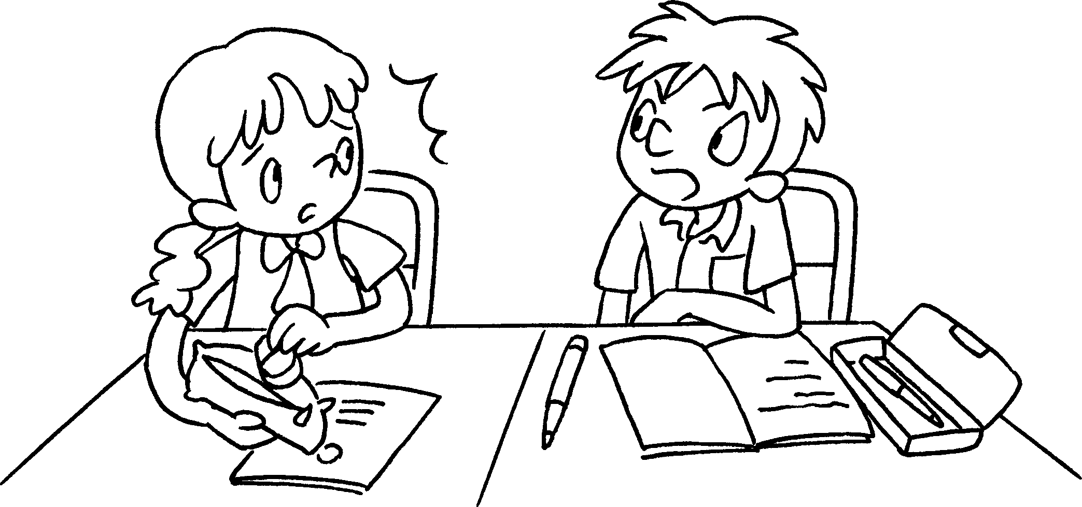
 | We wake up early in the morning. |  | We talk rudely to our friends.
5 | 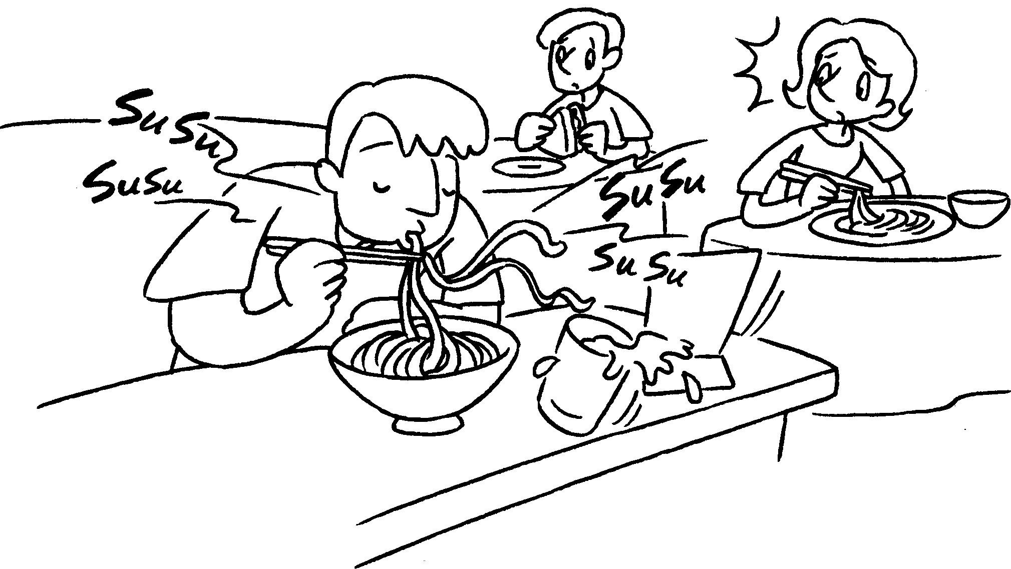 | 6 | 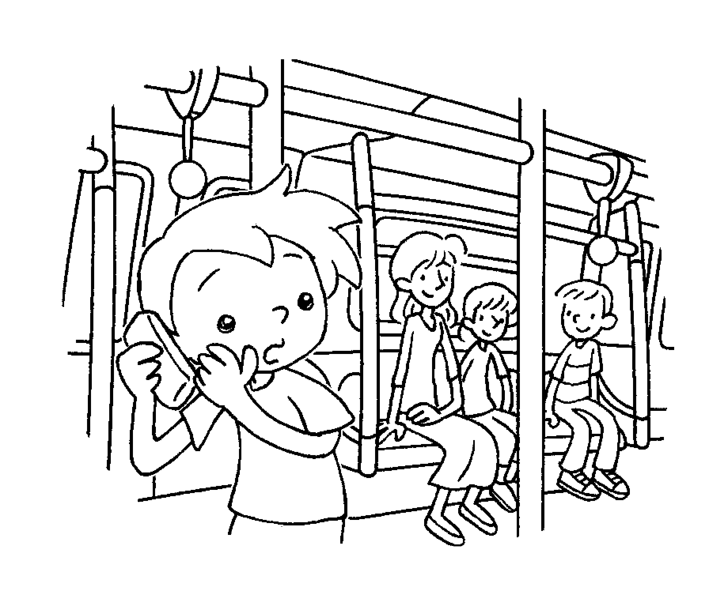
 | We eat noisily in the restaurant. |  | We talk softly on the phone.


Book 5A Chapter 1 Graded Worksheets
Worksheet 3⬇
- should
- shouldn’t
- should
- shouldn’t
- shouldn’t
- should

