What should / shouldn’t we do? Finish the sentences.

early late patient soft rude noisy

1 | 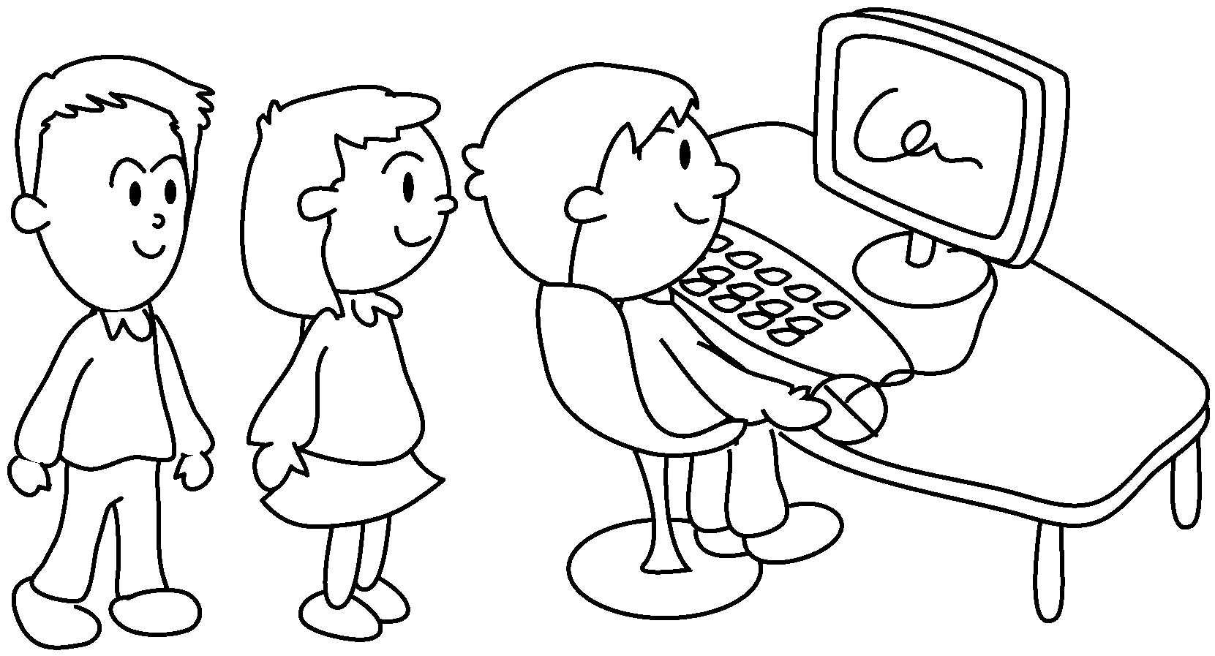 | 2 | 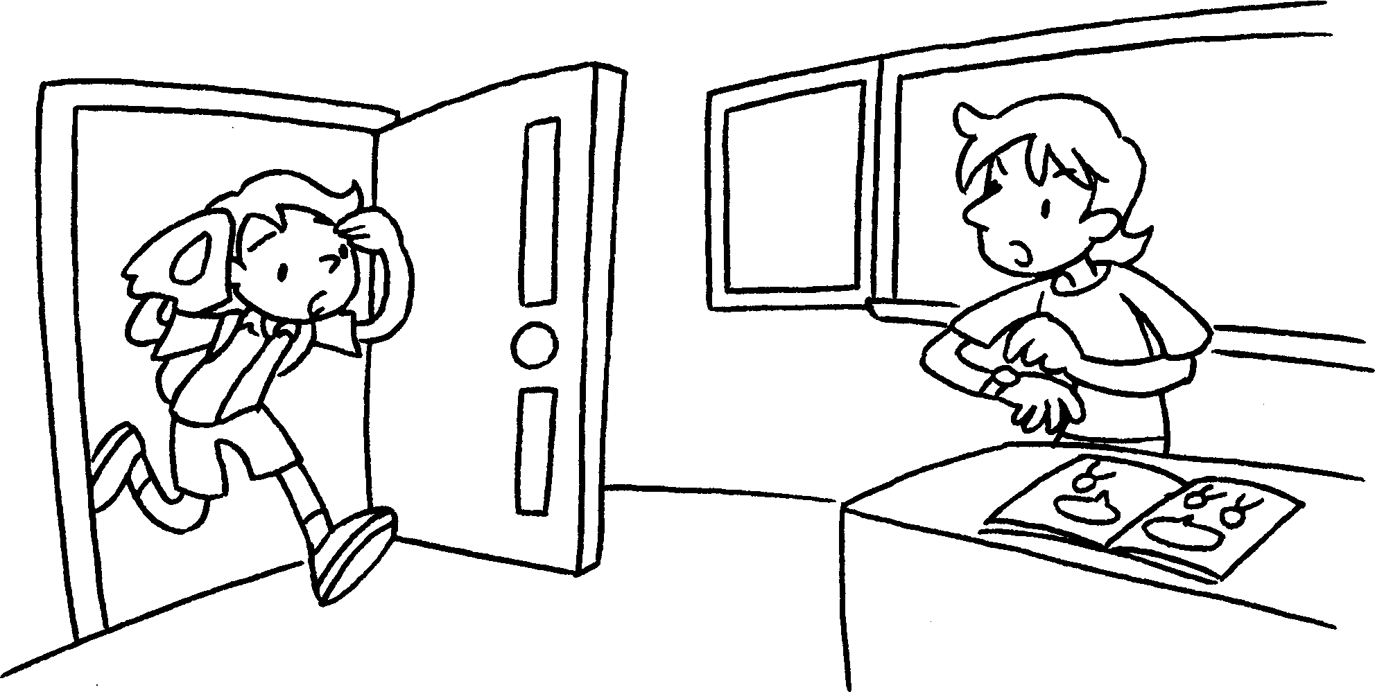  
Give me your eraser! | We should wait in the computer room. |  | We arrive  for school.
3 | 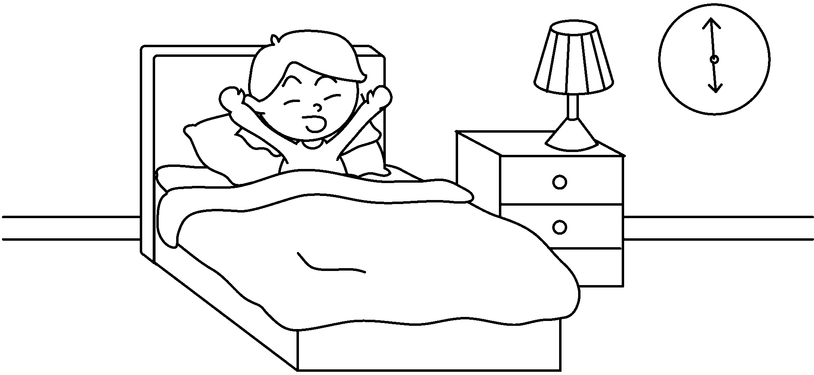 | 4 | 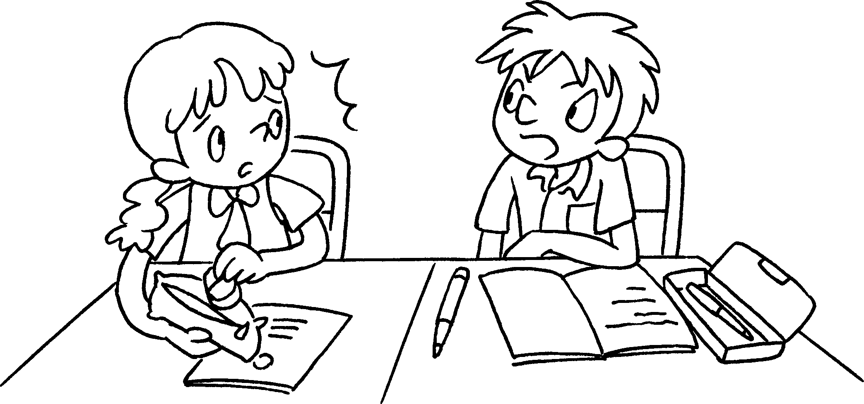
 | We wake  up in the morning. |  | We talk  to our friends.
5 | 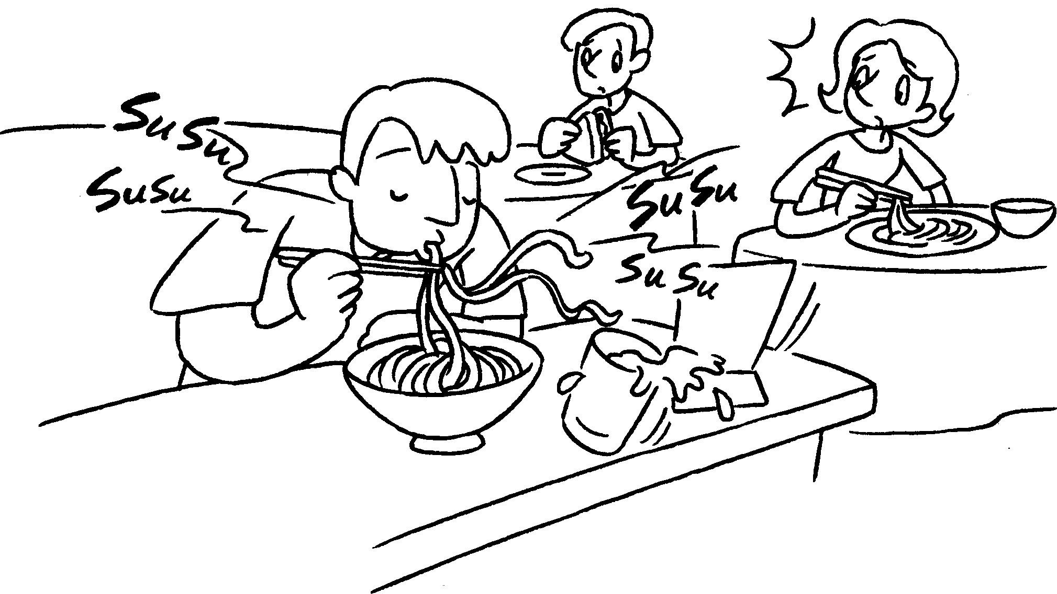 | 6 | 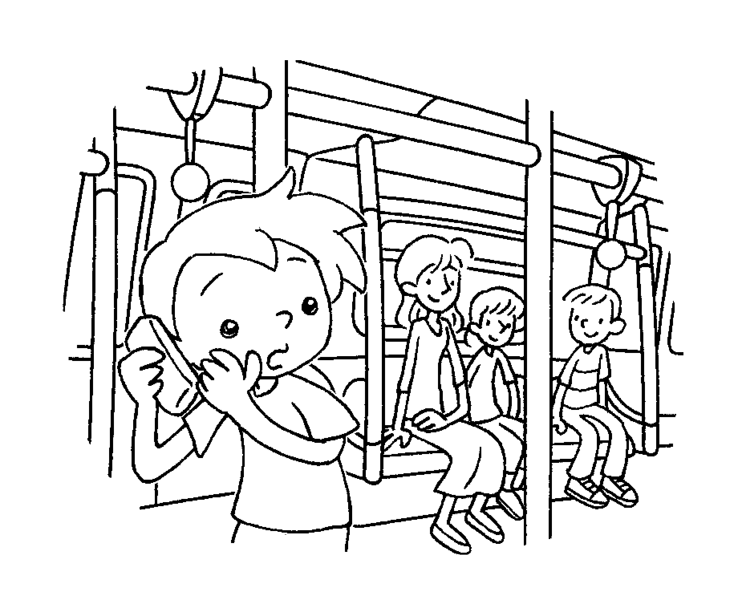
 | We eat  in the  restaurant. |  | We talk  on the phone.


Book 5A Chapter 1 Graded Worksheets
Worksheet 3⬇⬇
- patiently
- shouldn’t late
- should early
- shouldn’t rudely
- shouldn’t noisily
- should softly

