What should / shouldn’t we do? Finish the sentences.

1 | 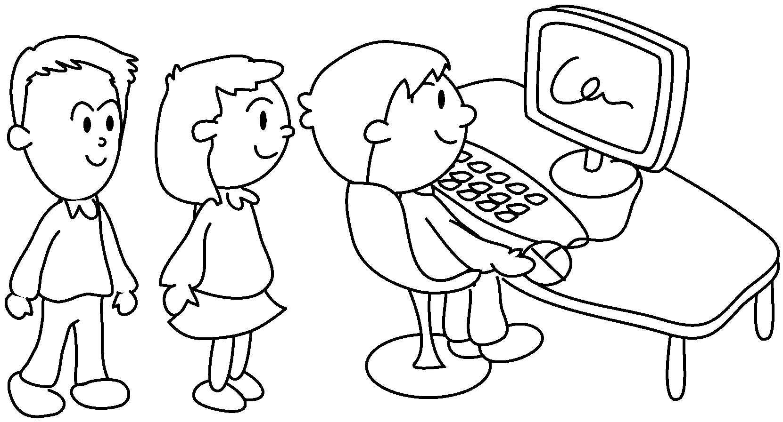 | 2 | 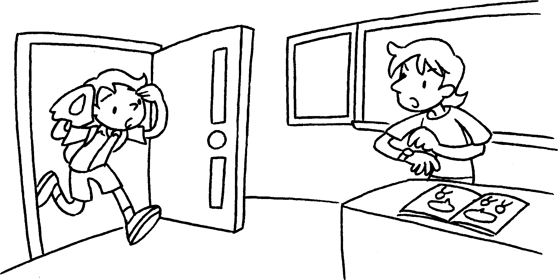  
Give me your eraser! | We should wait p in the computer room. |  | We arrive  for school.
3 | 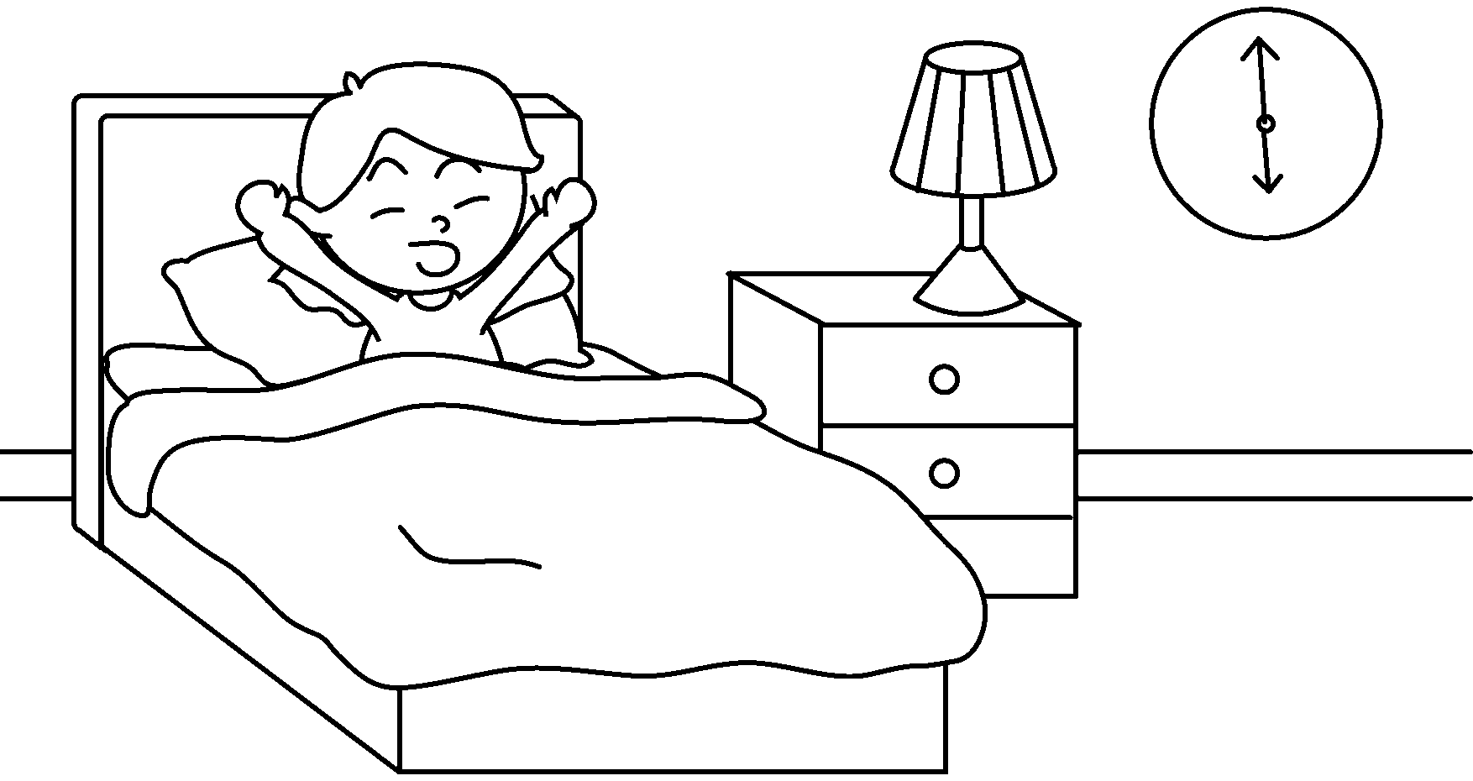 | 4 | 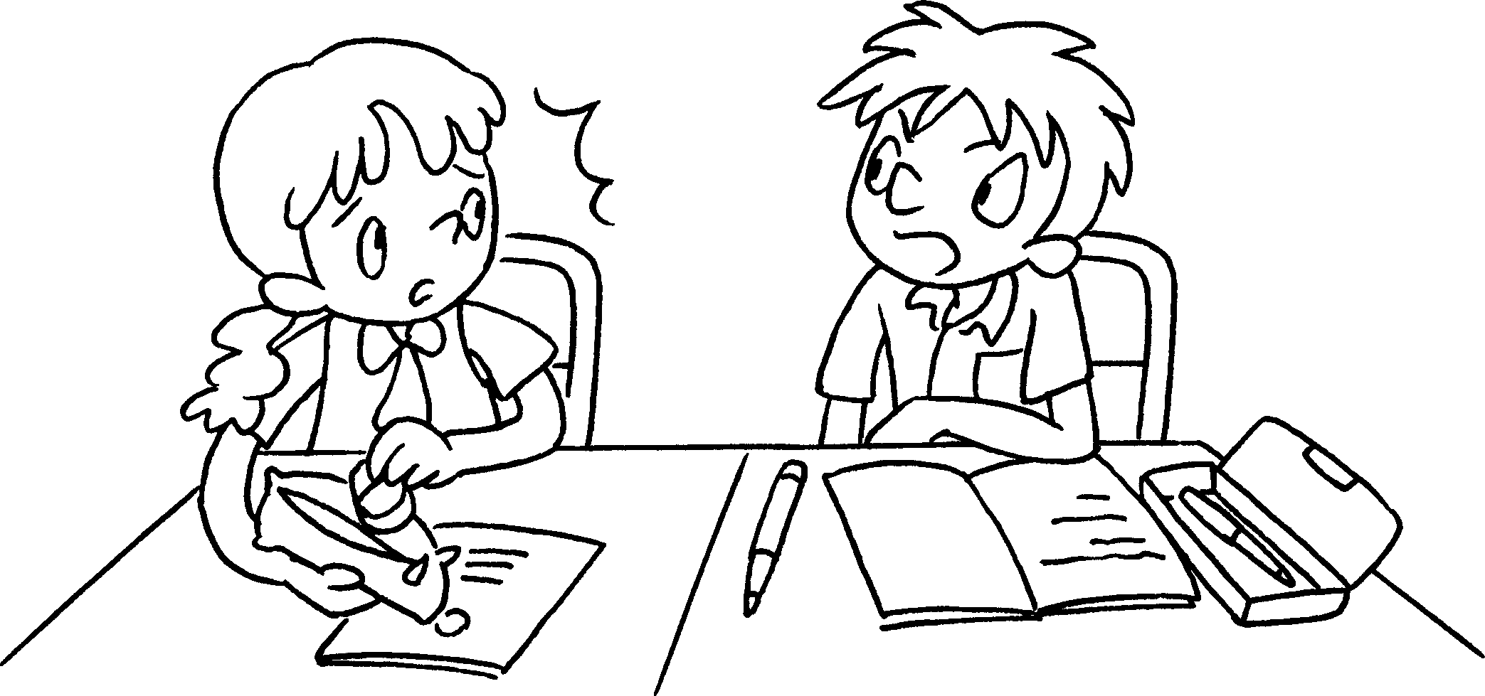
 | We wake  up in the  morning. |  | We  to our  friends.
5 | 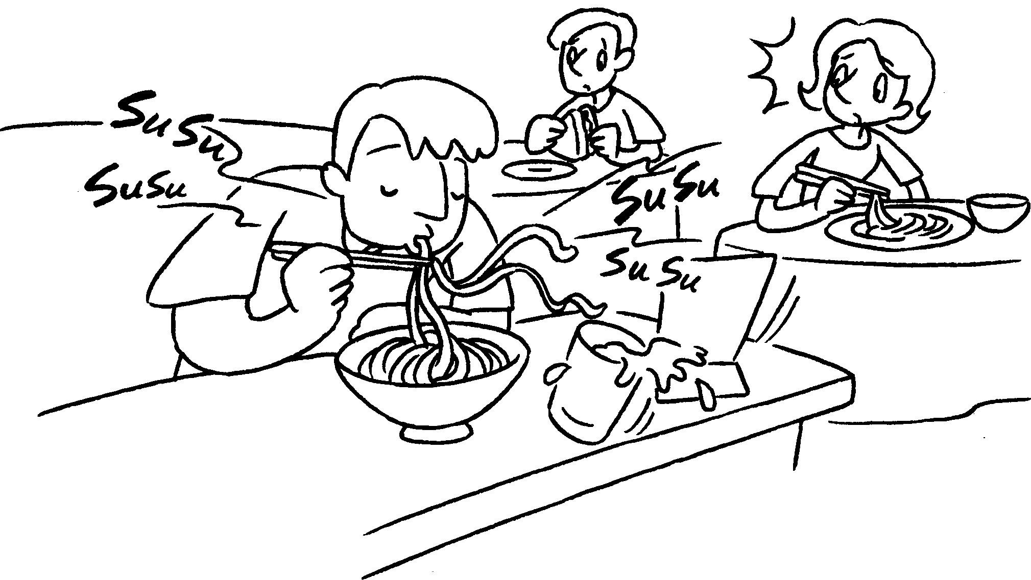 | 6 | 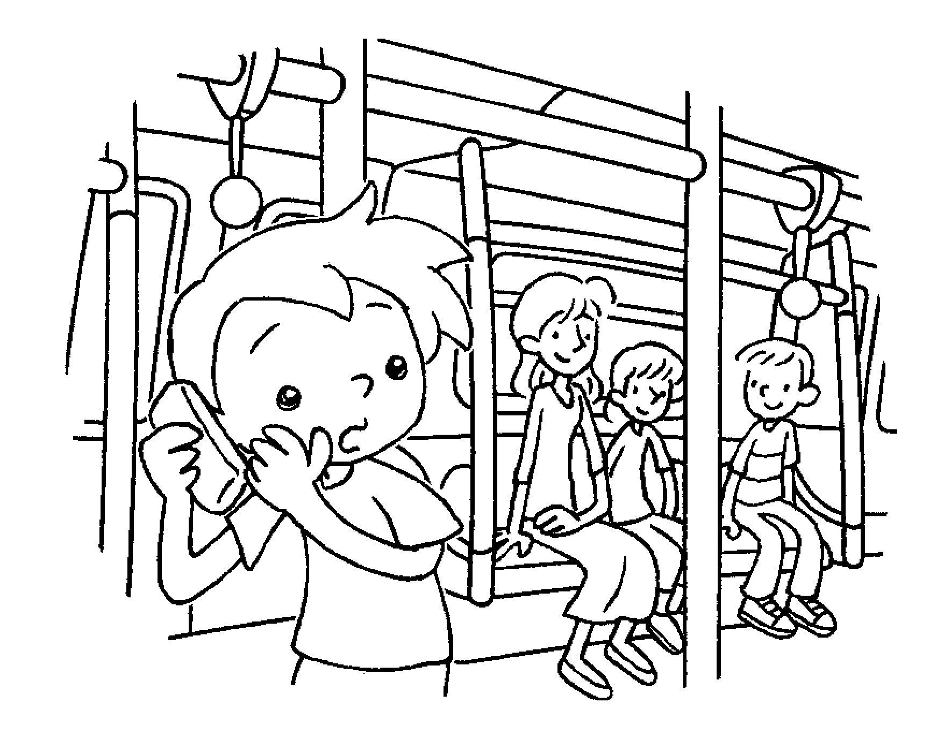
 | We  in the  restaurant. |  | We  on the  phone.


Book 5A Chapter 1 Graded Worksheets
Worksheet 3⬇⬇⬇
- patiently
- shouldn’t late
- should early
- shouldn’t talk rudely
- shouldn’t eat noisily
- should talk softly
(Accept any reasonable answers.)

