Circle the correct answers.

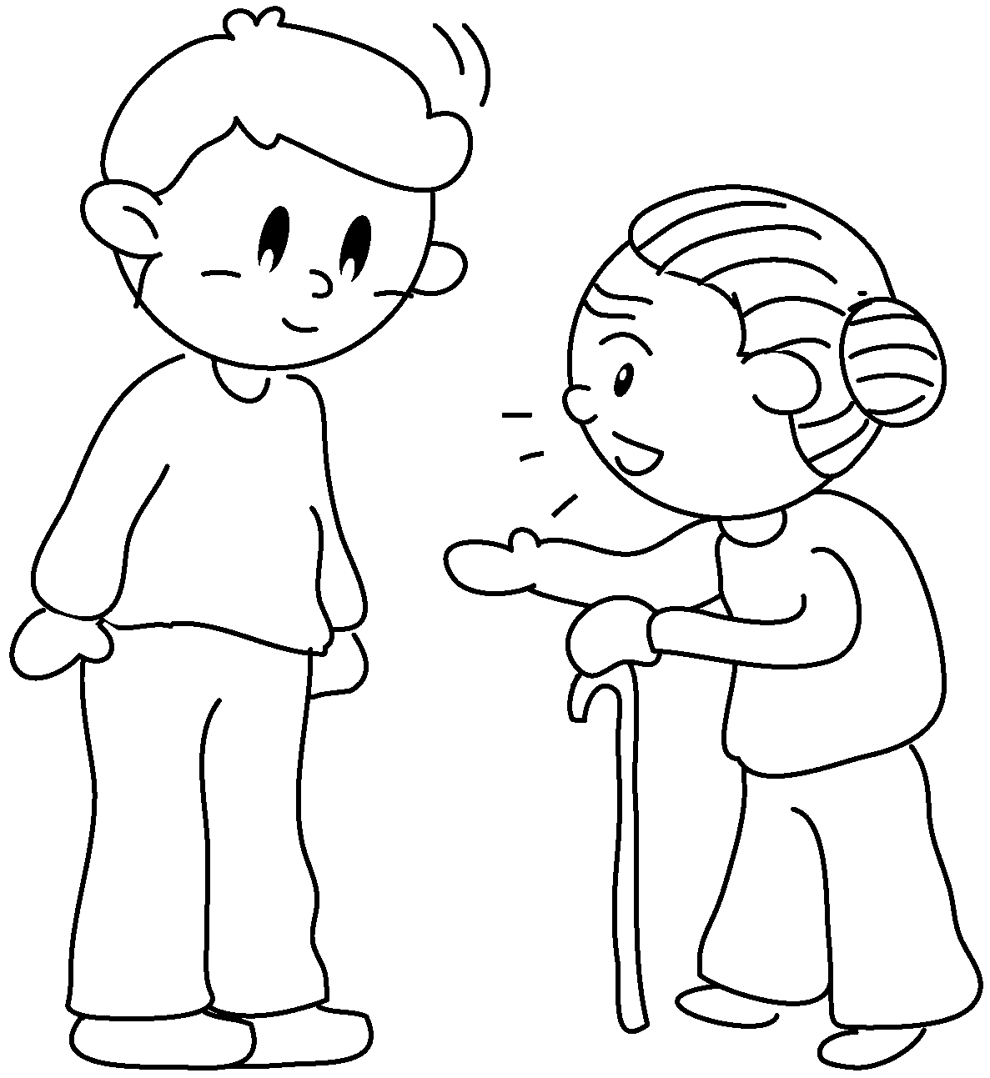  1 | 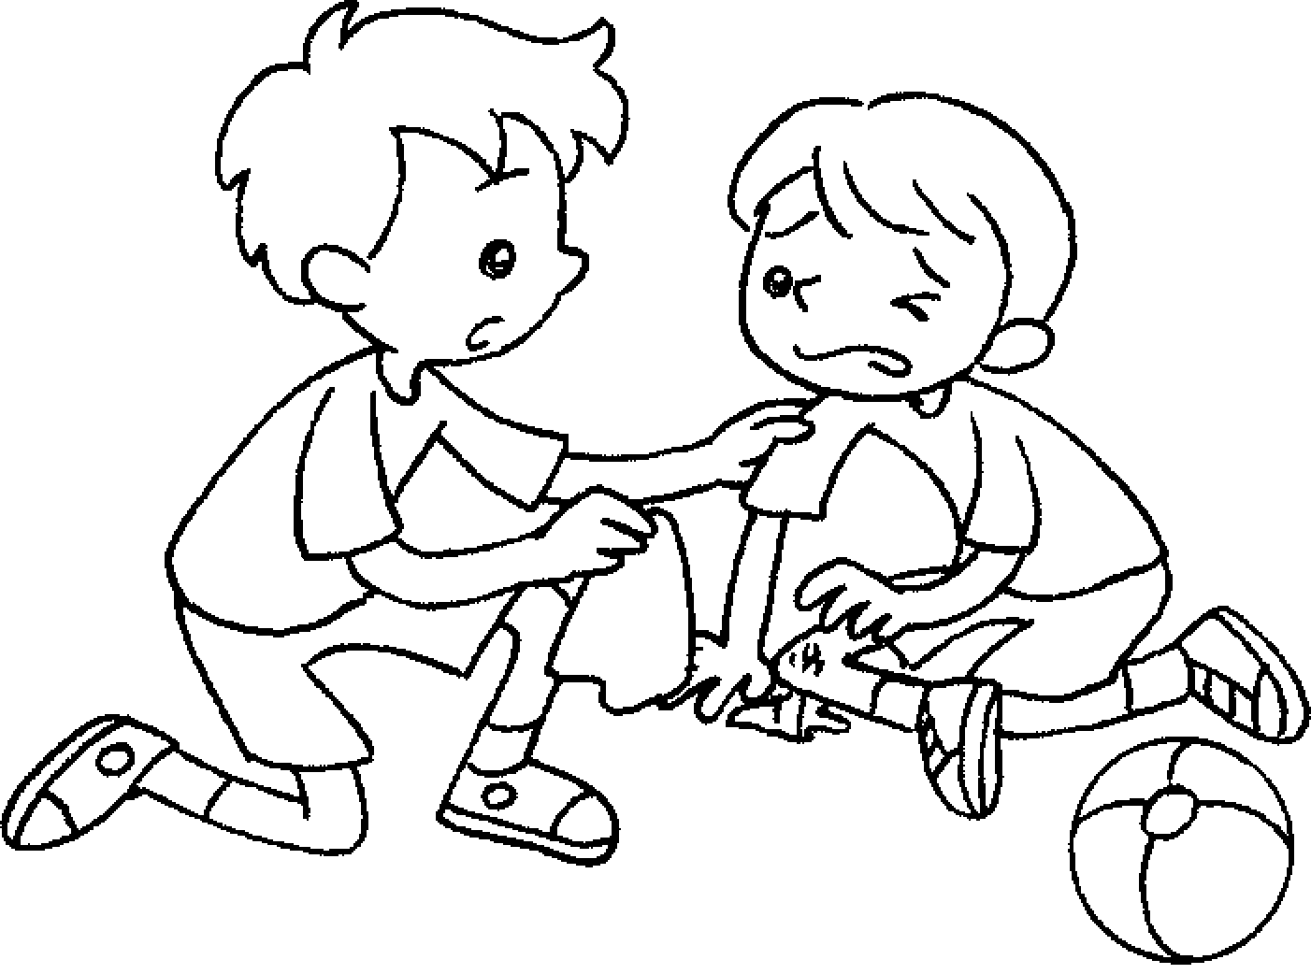  2 | 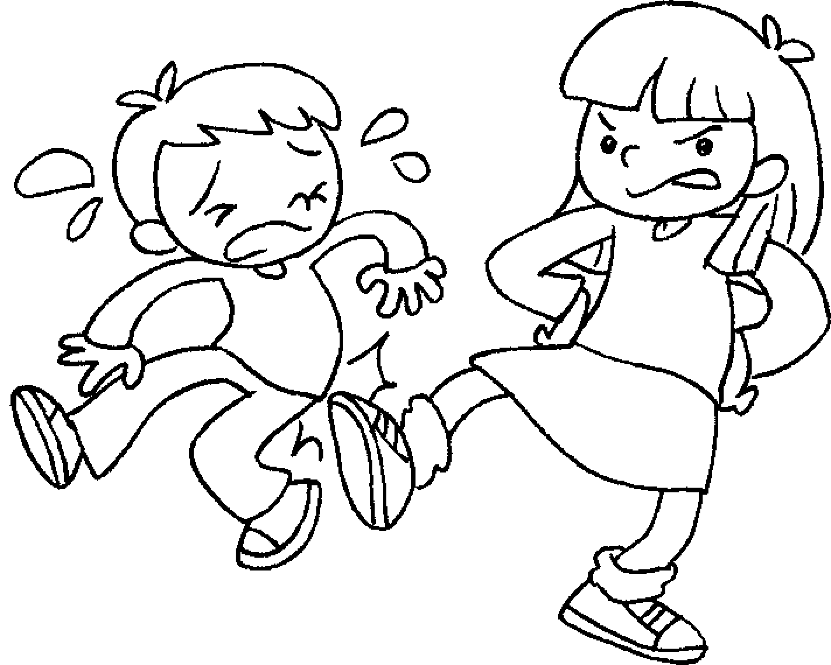  3 | 4
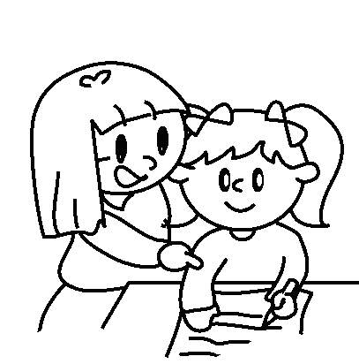  5 | 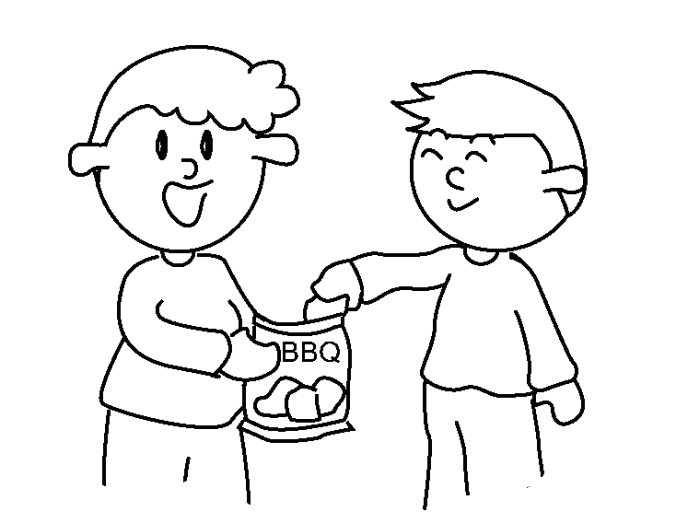  6 | 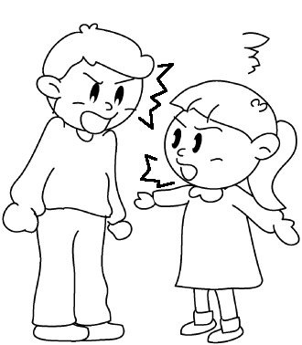  7 | 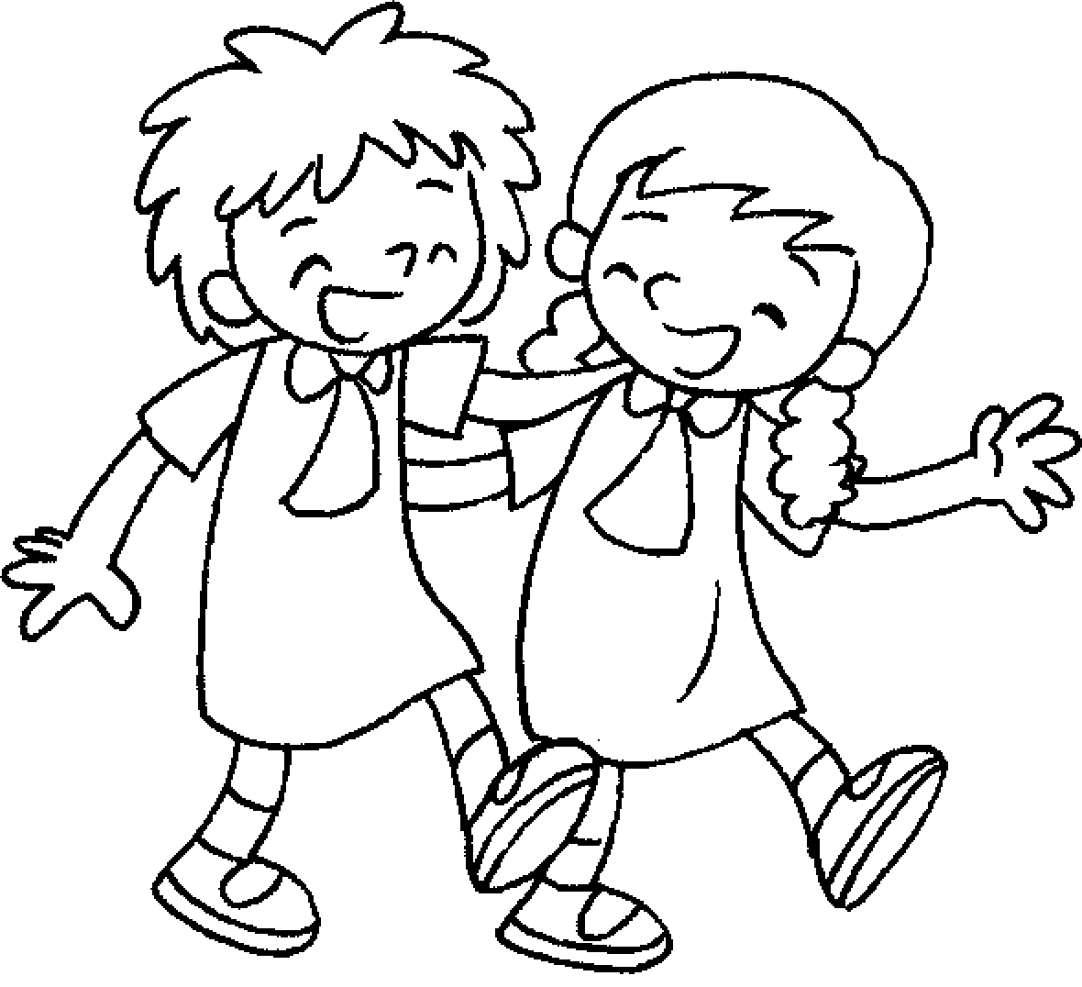  8
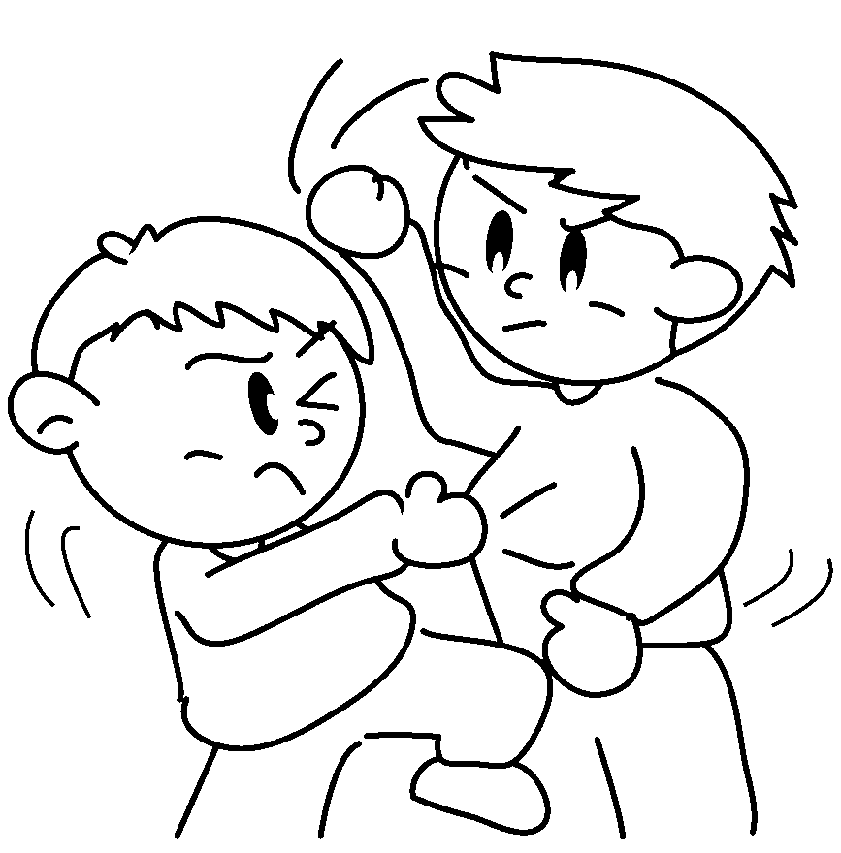  9 | 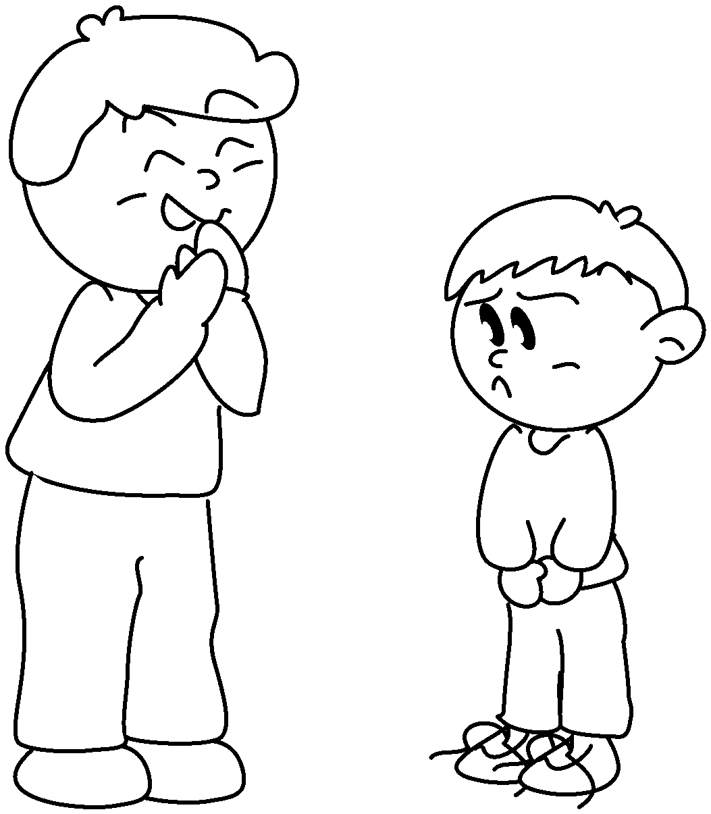  10 | 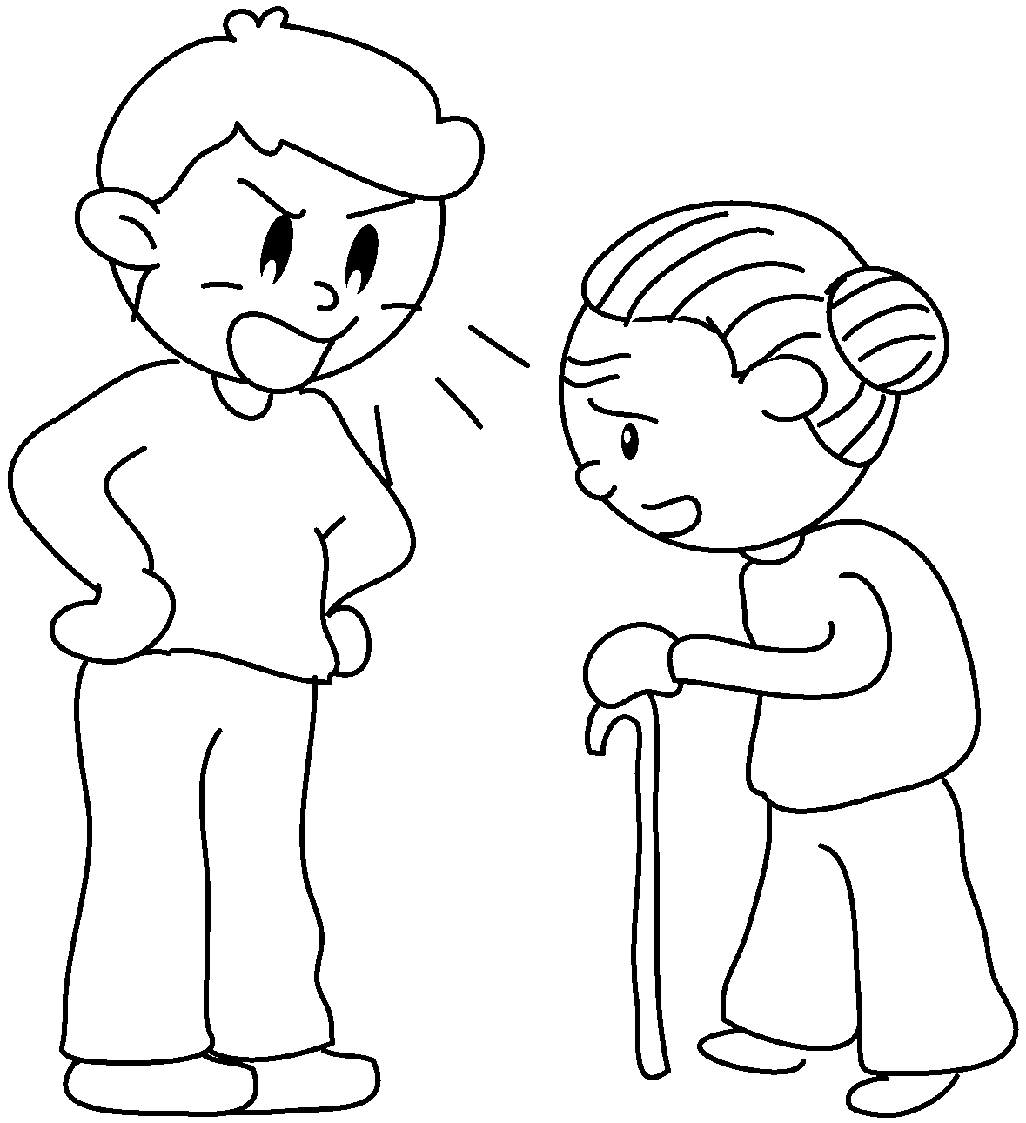  11 | 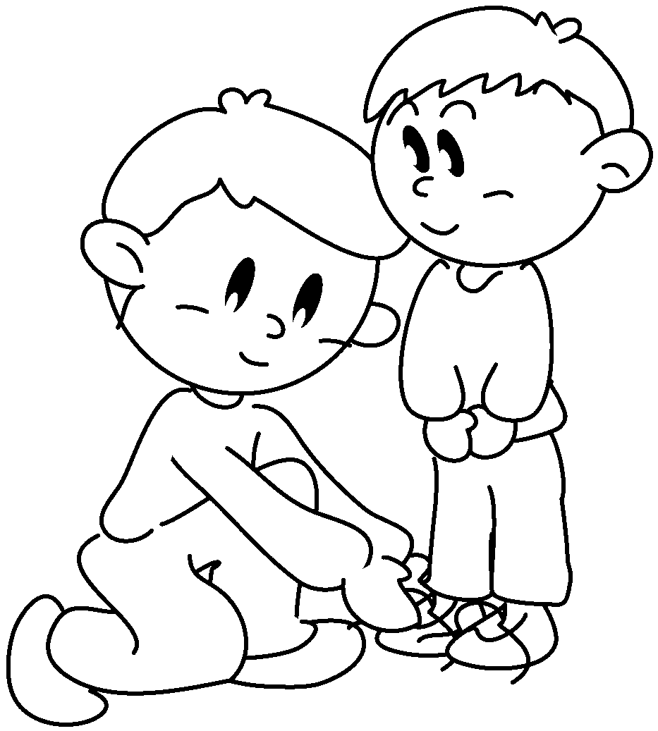  12

1 | ( listen / talk ) to | 2 | ( be nice / get on ) to
3 | ( be mean / share ) to | 4 | ( listen / quarrel ) to
5 | ( shout / help ) with | 6 | ( laugh / share ) with
7 | ( quarrel / help ) with | 8 | ( take care / get on ) with
9 | ( fight / shout ) with | 10 | ( laugh / listen ) at
11 | ( be mean / shout ) at | 12 | ( take care / talk ) of


Book 5A Chapter 2 Graded Worksheets
Worksheet 1⬇
1 ( listen / talk ) 2 ( be nice / get on )
3 ( be mean / share ) 4 ( listen / quarrel )
5 ( shout / help ) 6 ( laugh / share )
7 ( quarrel / help ) 8 ( take care / get on )
9 ( fight / shout ) 10 ( laugh / listen )
11 ( be mean / shout ) 12 ( take care / talk )

