Choose and write.

take care get on help share be nice listen
talk shout fight laugh be mean quarrel

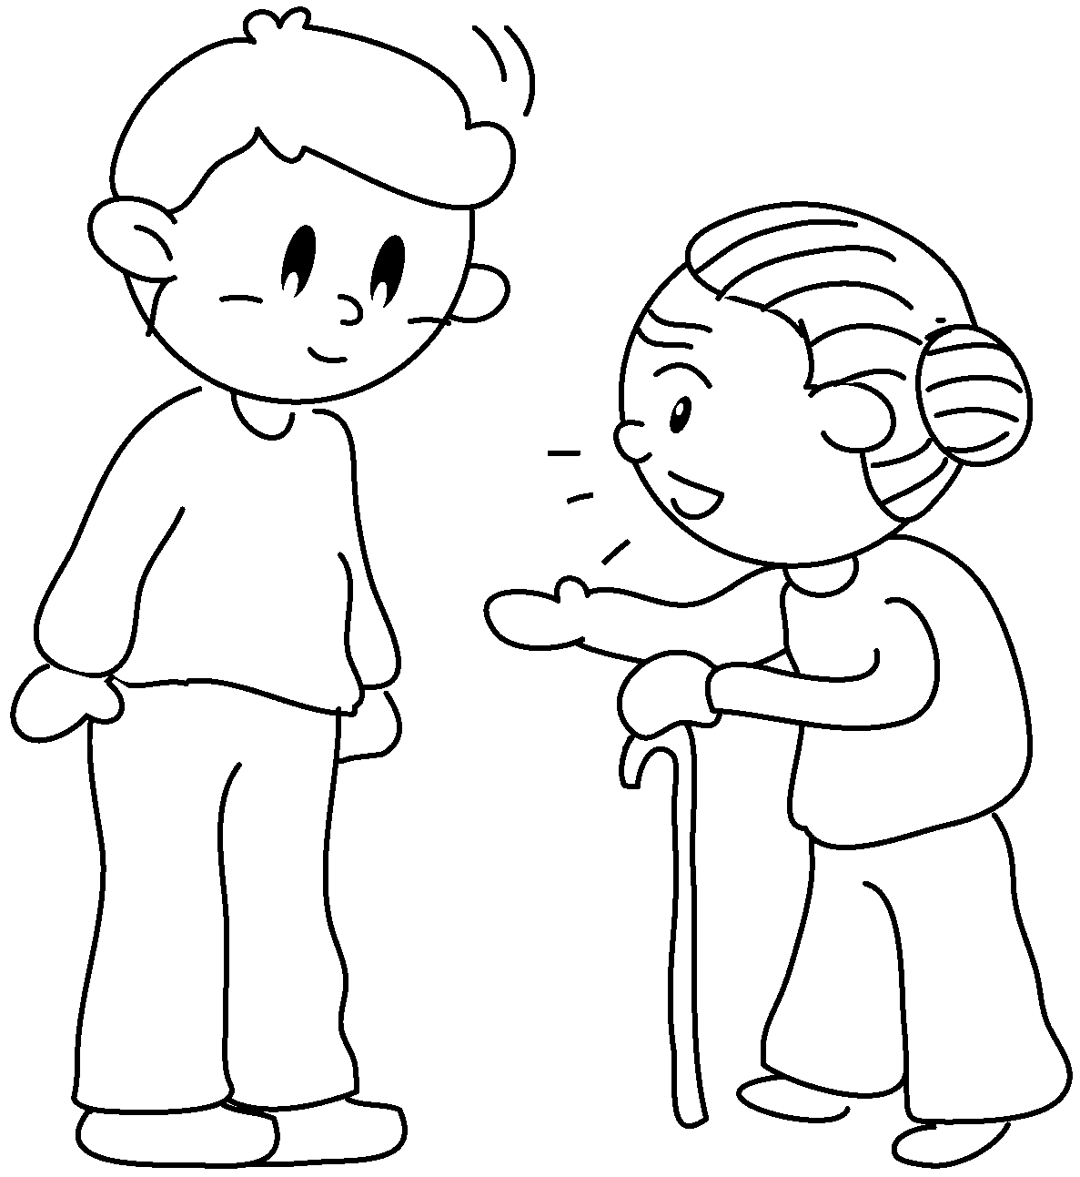  1 | 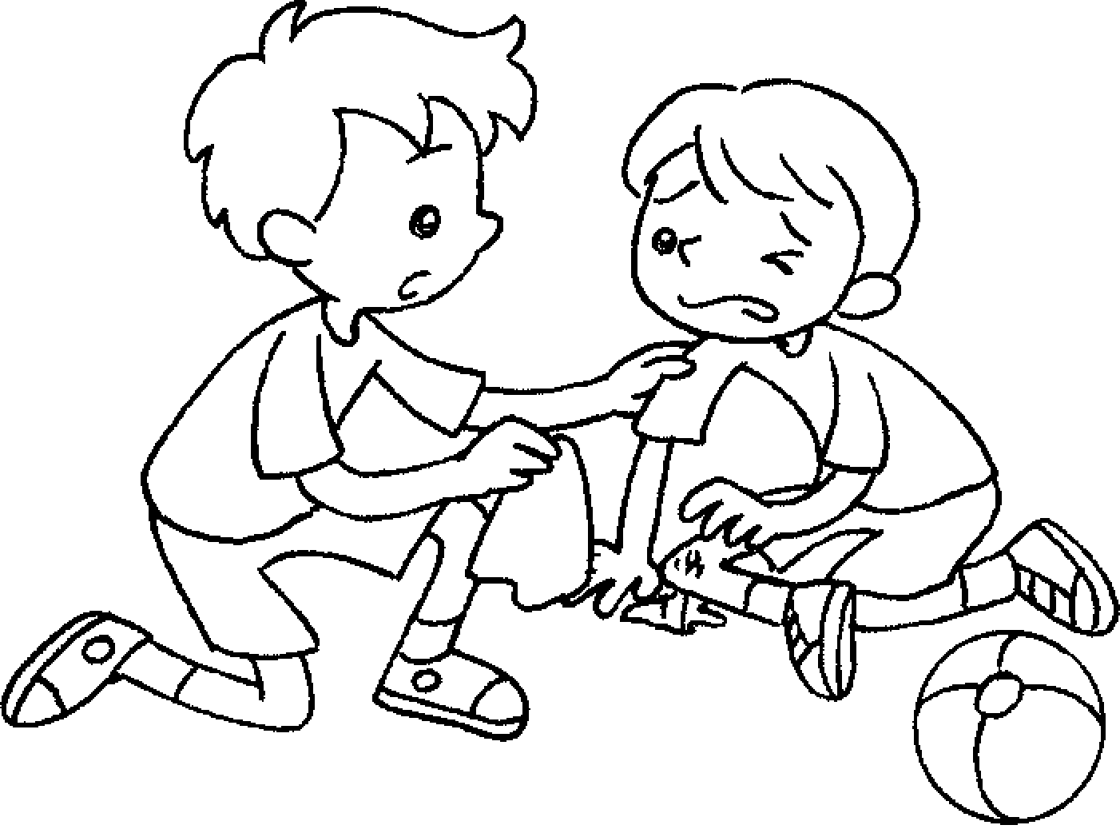  2 | 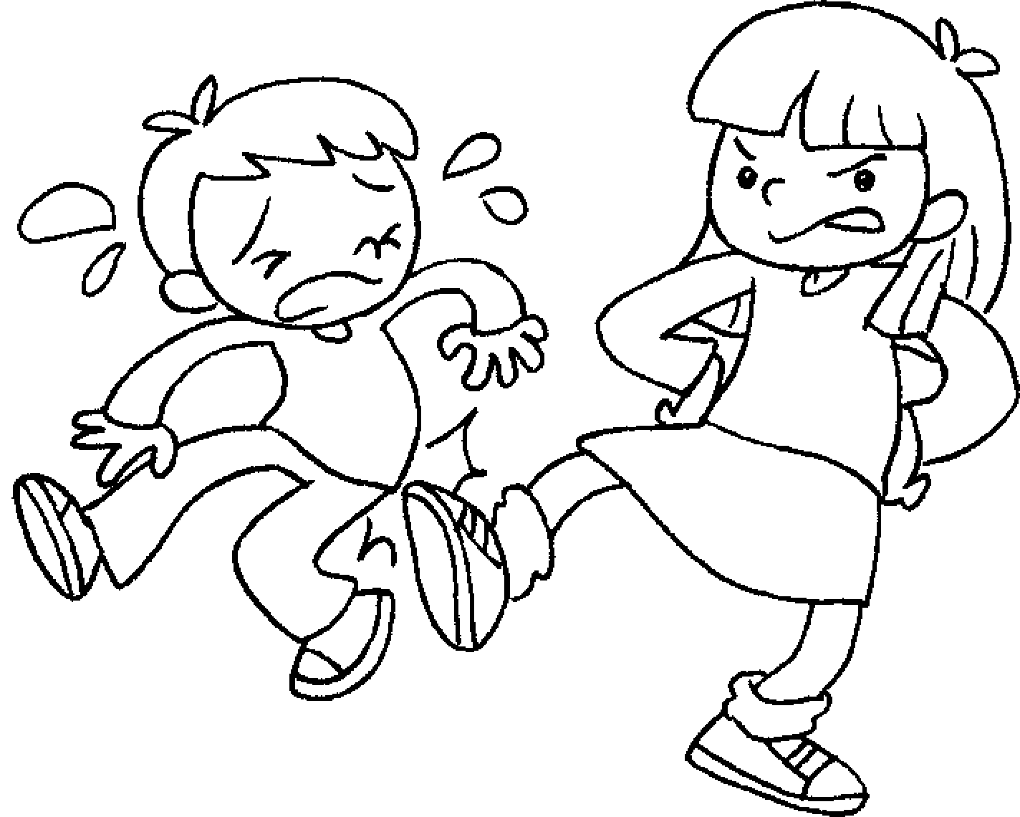  3 | 4
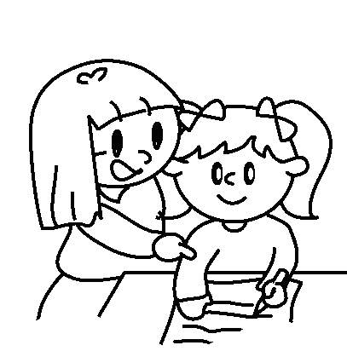  5 | 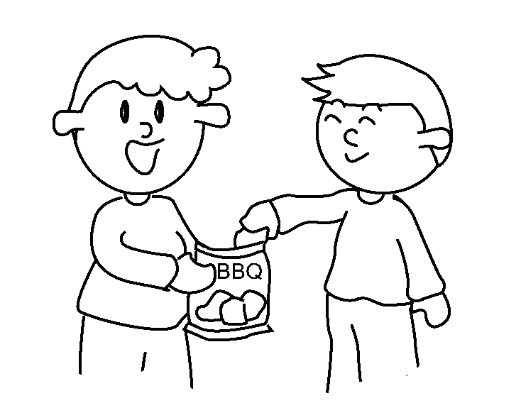  6 | 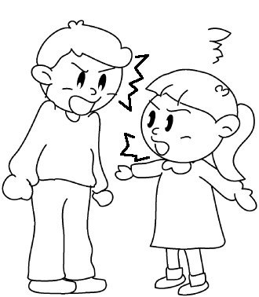  7 | 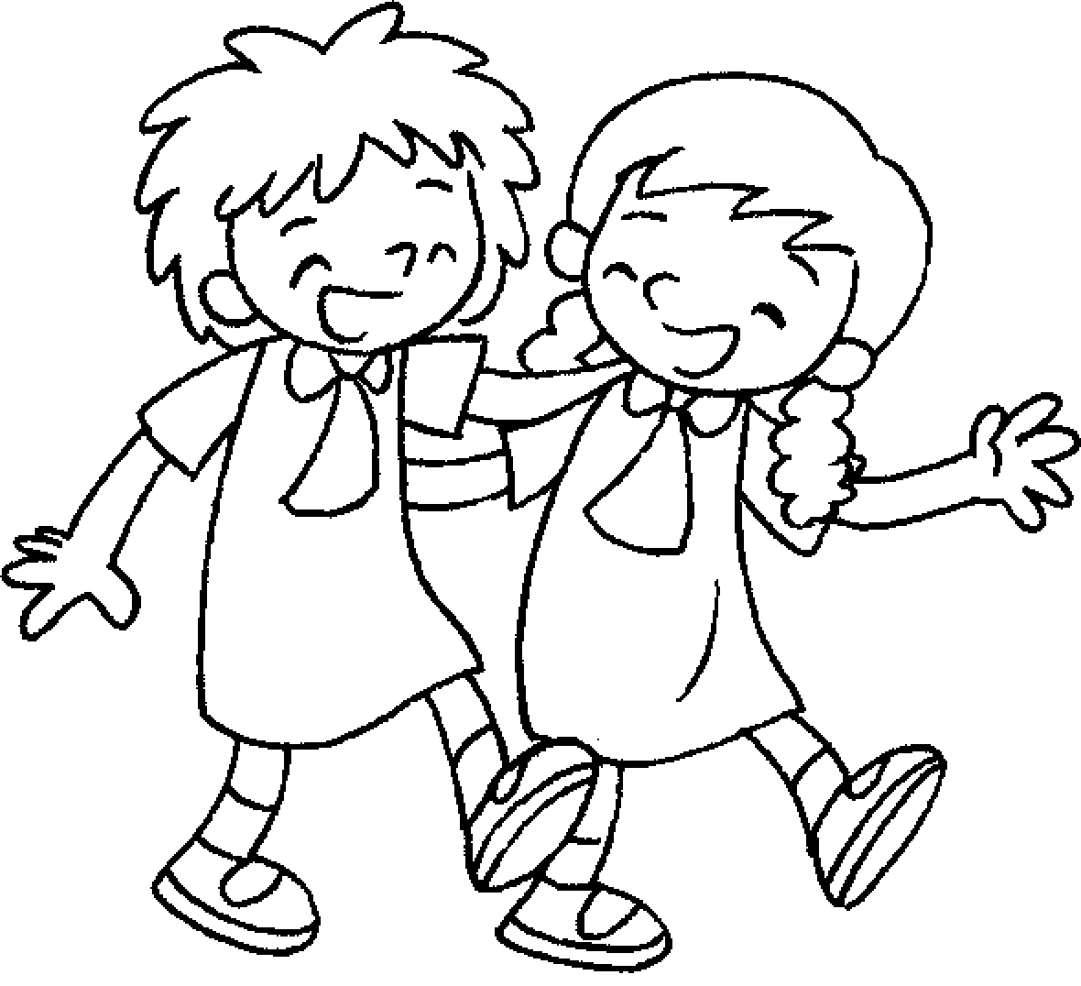  8
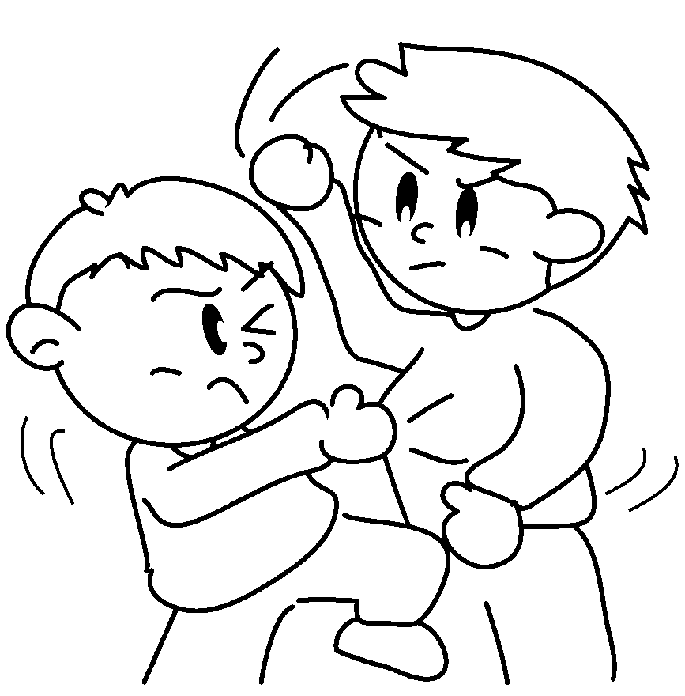  9 | 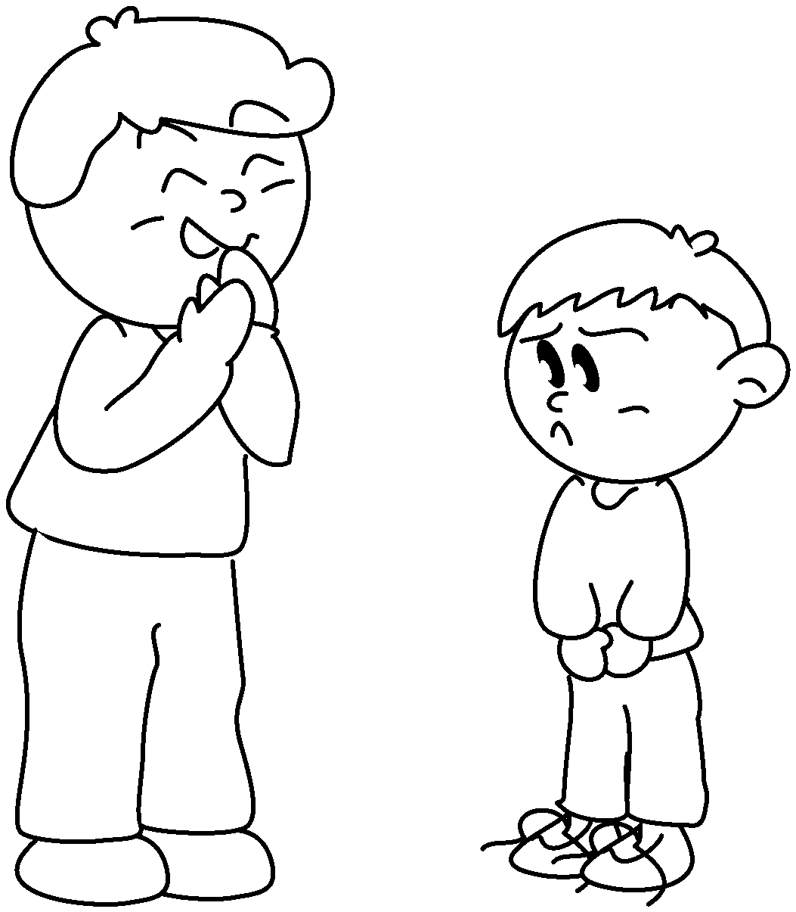  10 | 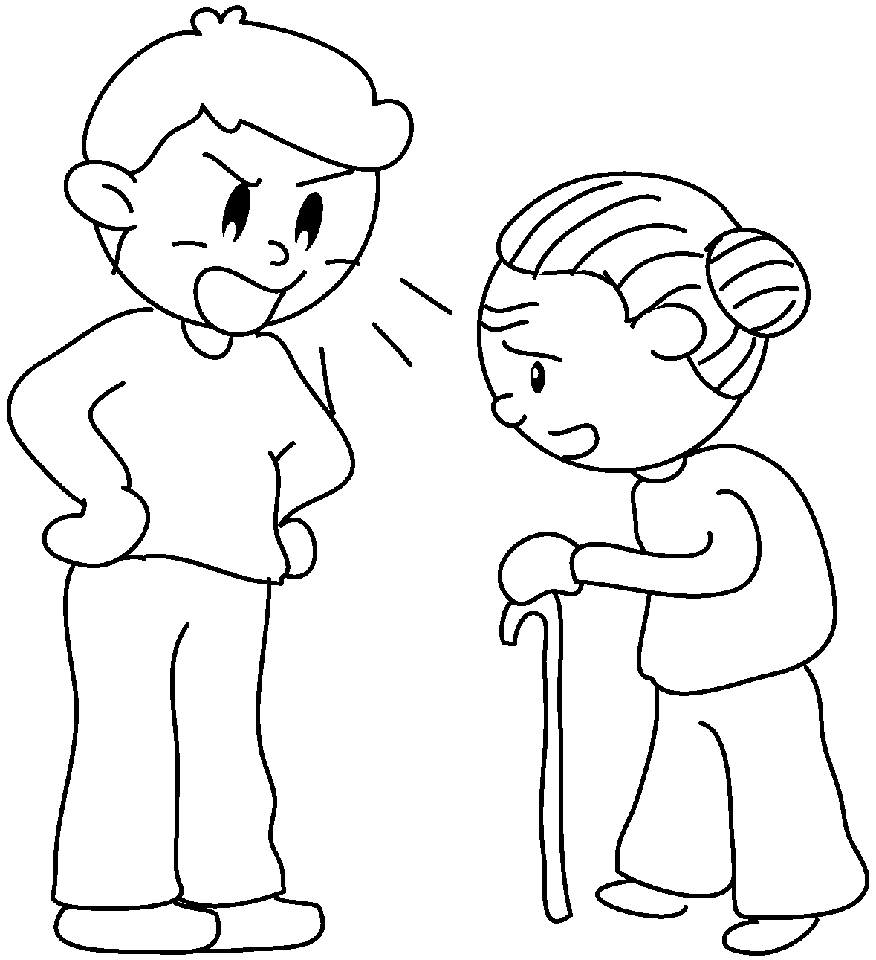  11 | 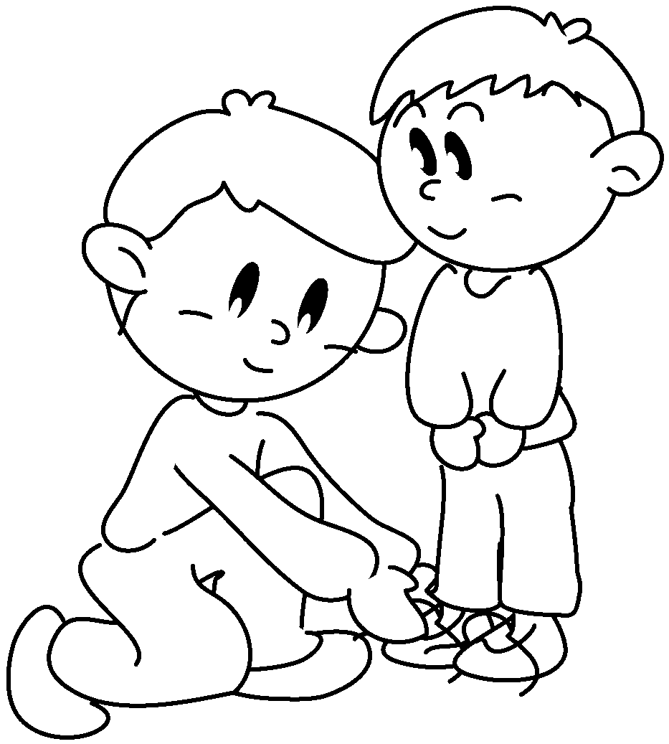  12

1 | ____________________ to | 2 | ____________________ to
3 | ____________________ to | 4 | ____________________ to
5 | ____________________ with | 6 | ____________________ with
7 | ____________________ with | 8 | ____________________ with
9 | ____________________ with | 10 | ____________________ at
11 | ____________________ at | 12 | ____________________ of



Book 5A Chapter 2 Graded Worksheets
Worksheet 1⬇⬇
1 talk 2 be nice
3 be mean 4 listen
5 help 6 share
7 quarrel 8 get on
9 fight 10 laugh
11 shout 12 take care

