Look at the pictures and fill in the blanks.

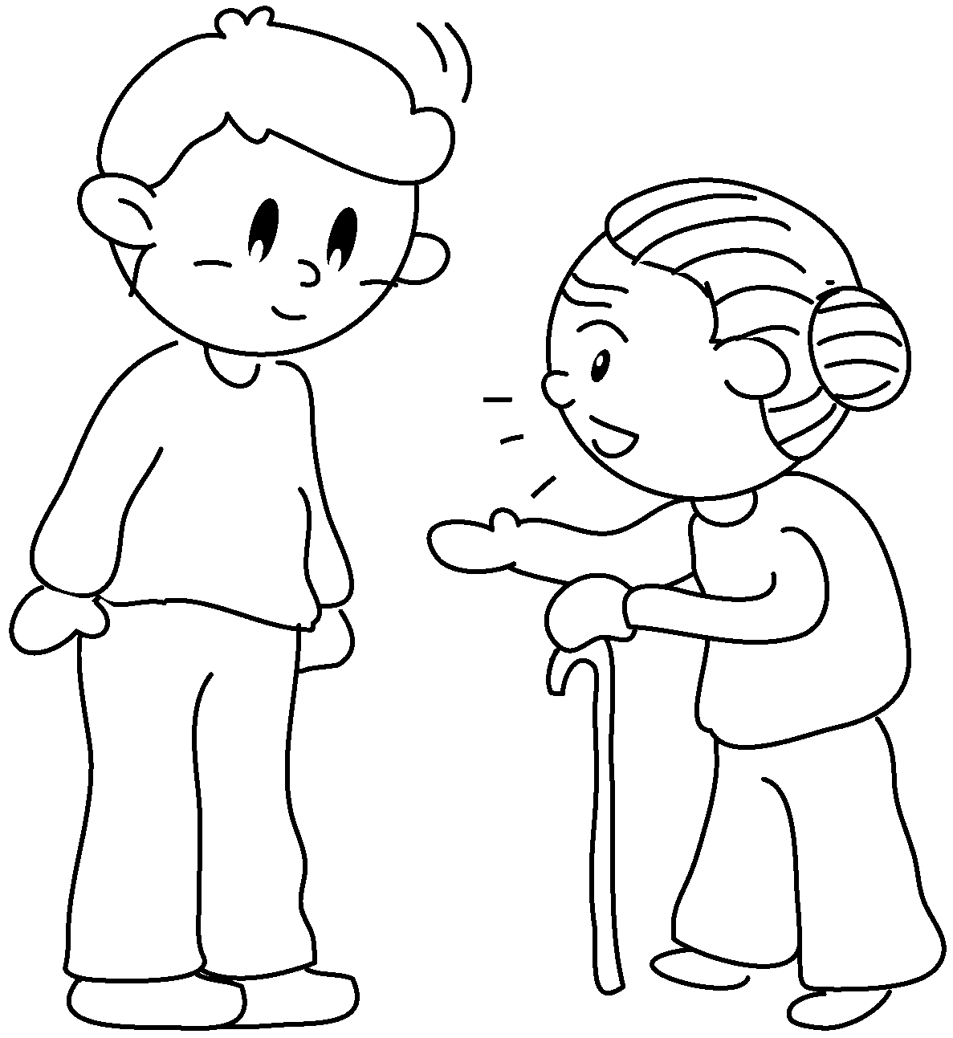  1 | 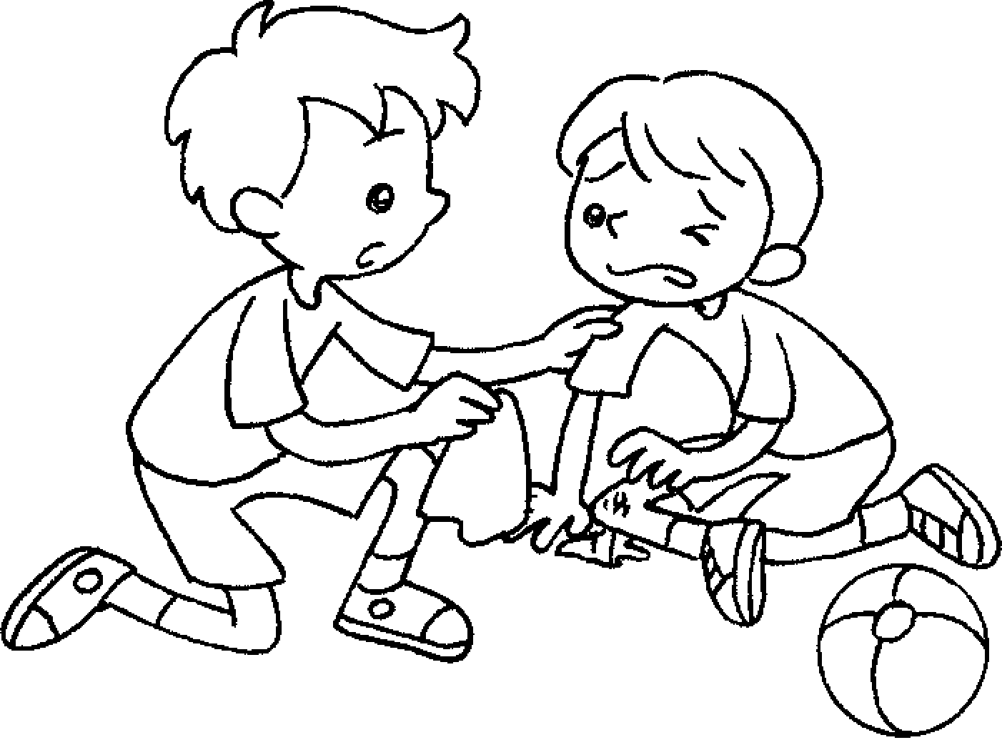  2 | 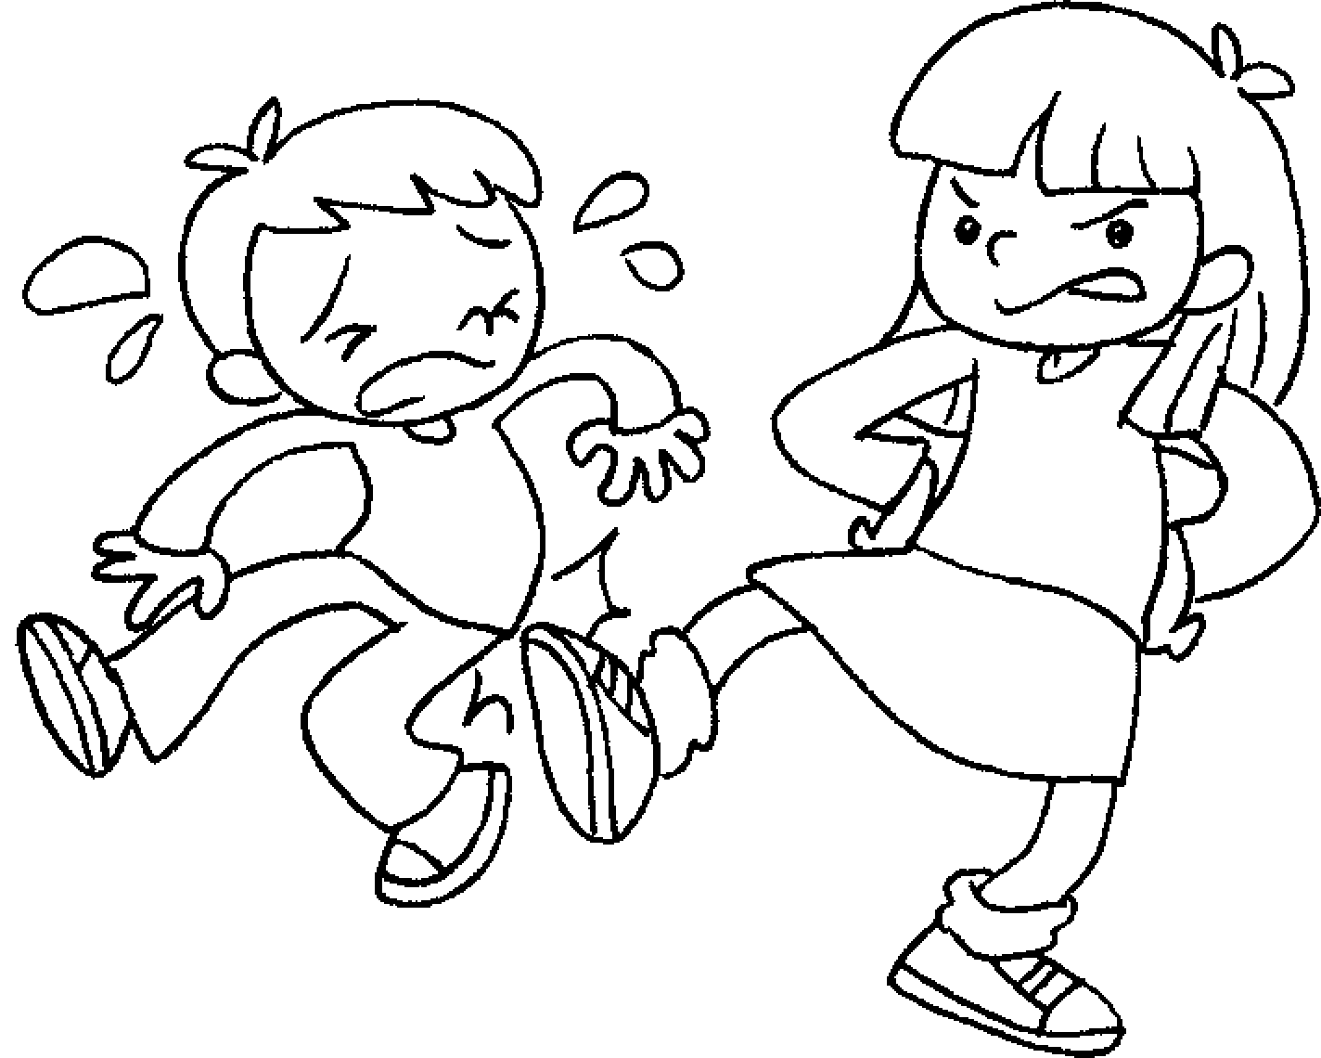  3 | 4
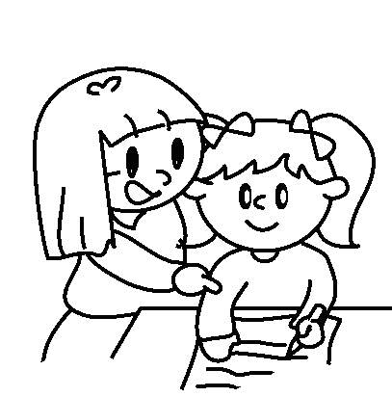  5 | 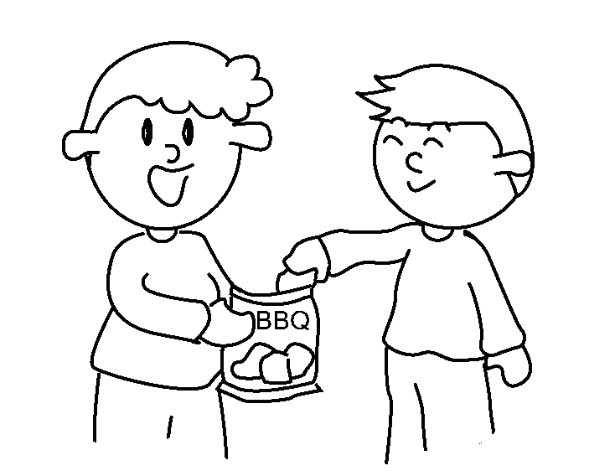  6 | 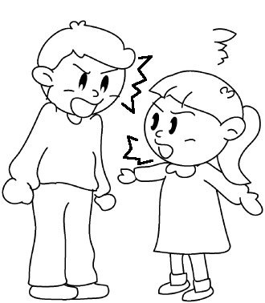  7 | 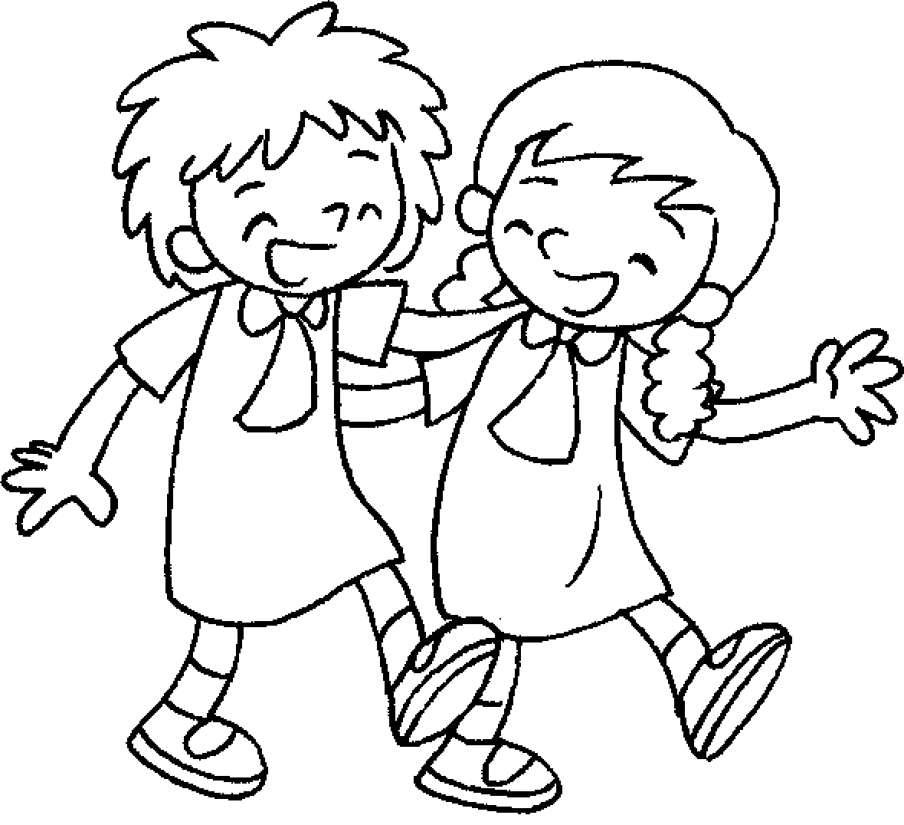  8
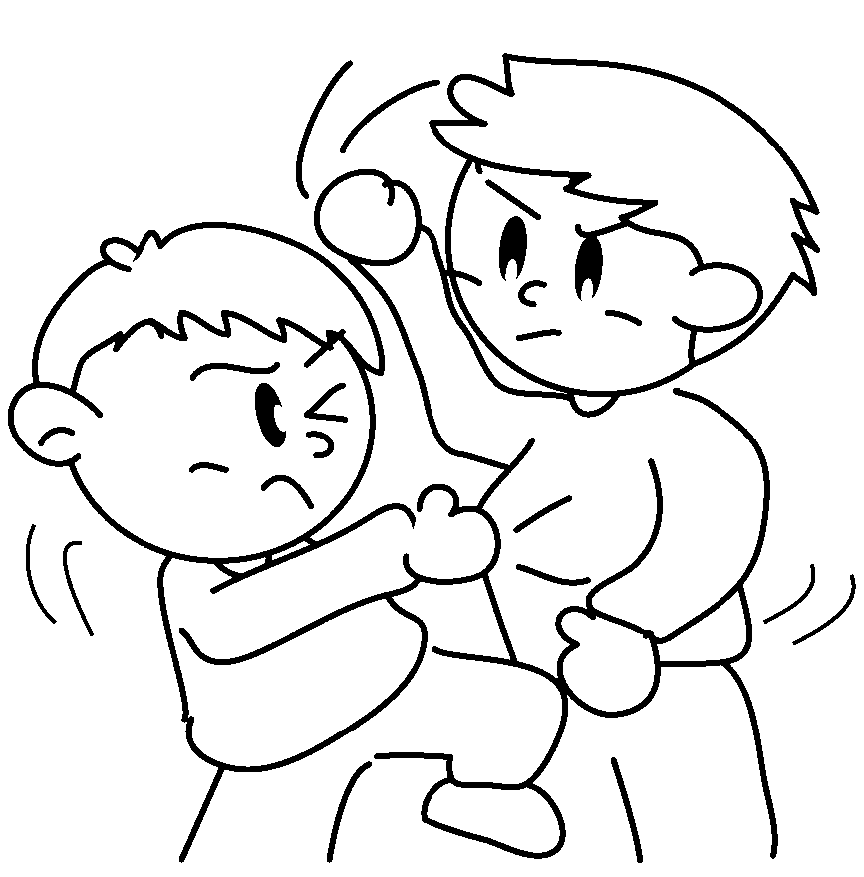  9 | 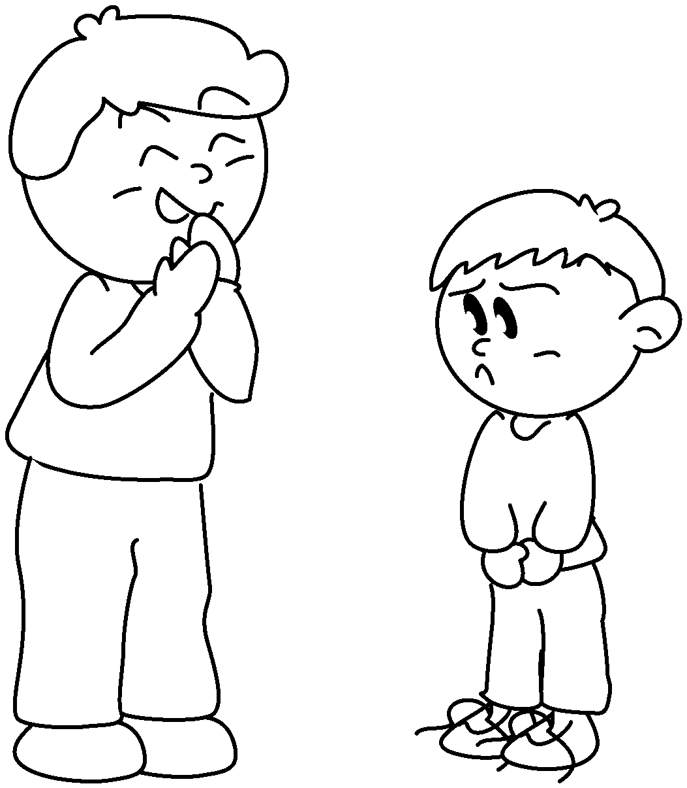  10 | 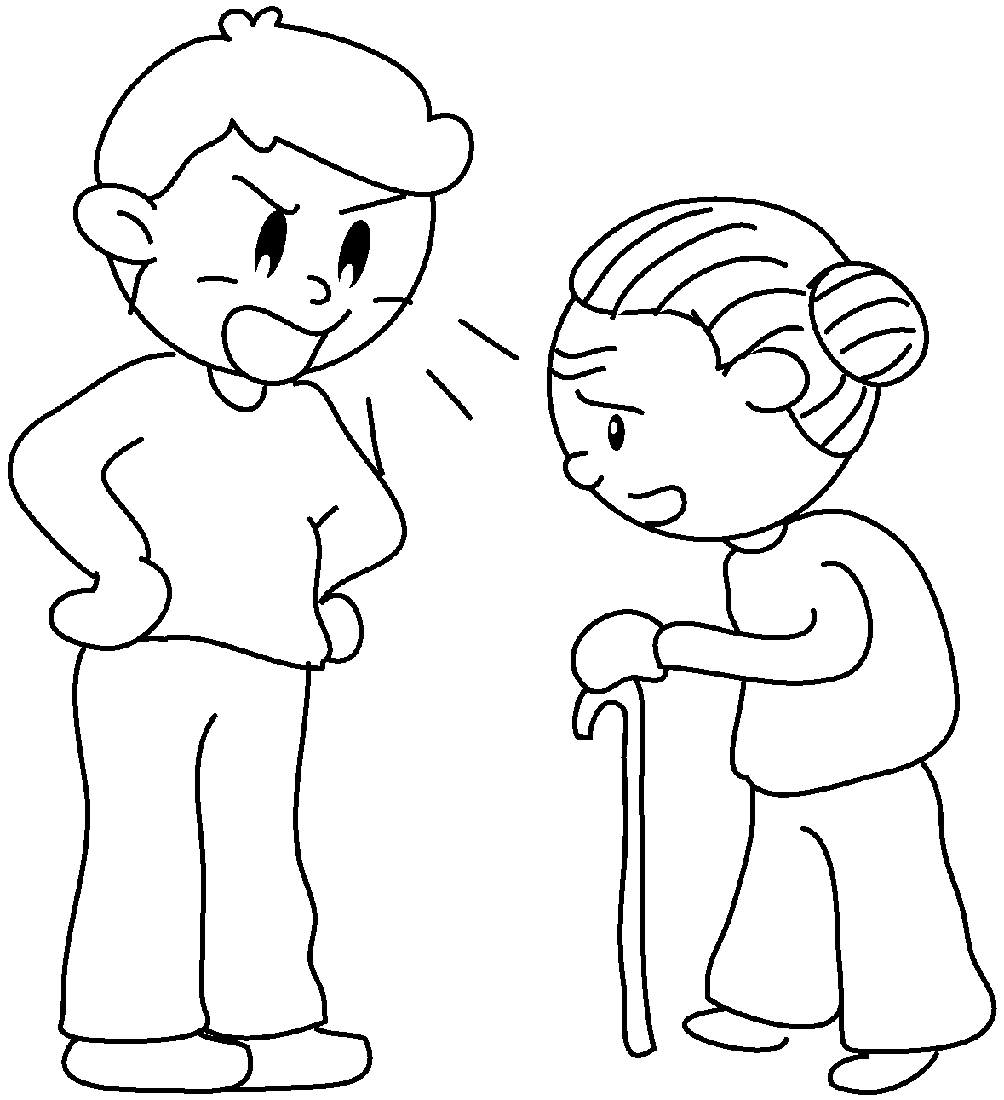  11 | 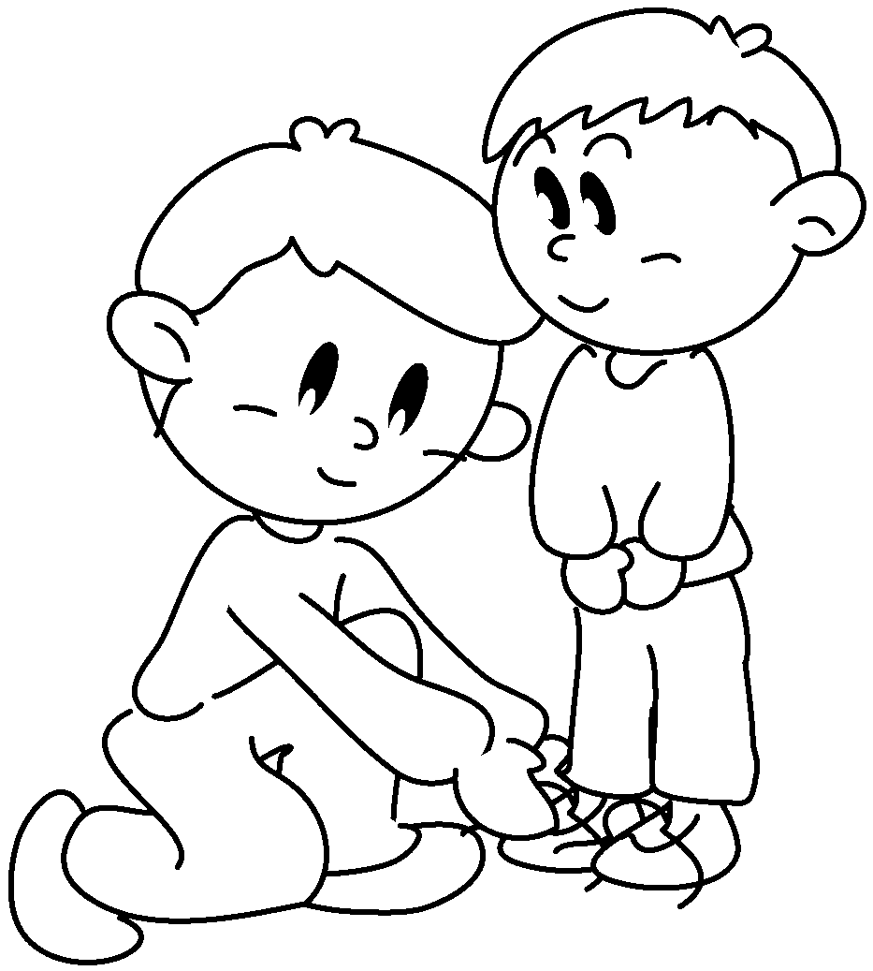  12

1 | _____________ to  talk | 2 | be _____________ to
3 | be _____________ to | 4 | _____________ to
5 | _____________ with | 6 | _____________ with
7 | _____________ with | 8 | ____________ ________ with
9 | _____________ with | 10 | _____________ at
11 | _____________ at | 12 | ____________ ________ of


Book 5A Chapter 2 Graded Worksheets
Worksheet 1⬇⬇⬇
2 nice
3 mean 4 listen
5 help 6 share
7 quarrel 8 get on
9 fight 10 laugh
11 shout 12 take care

