Choose and write.
at | with | to | of
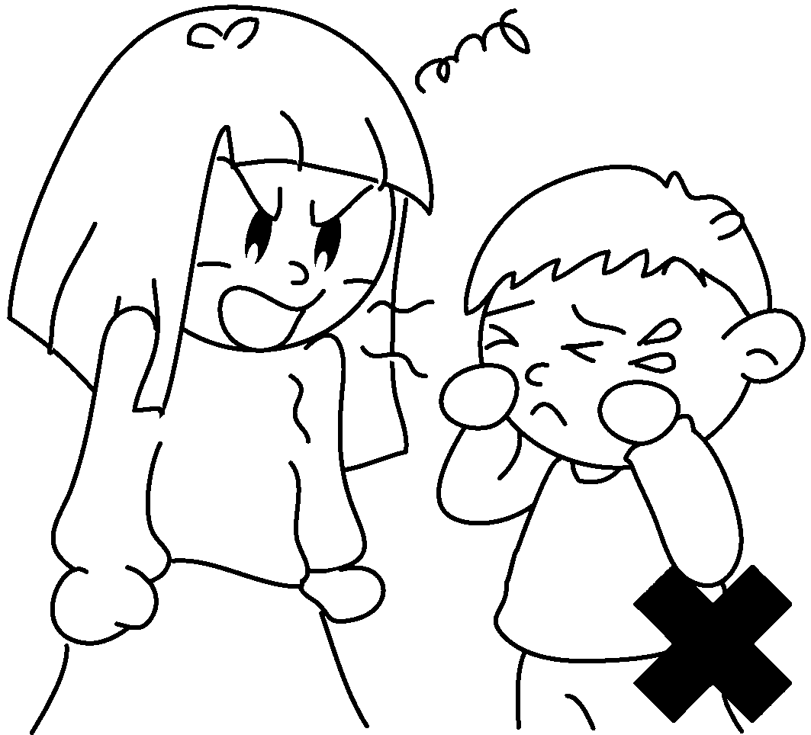
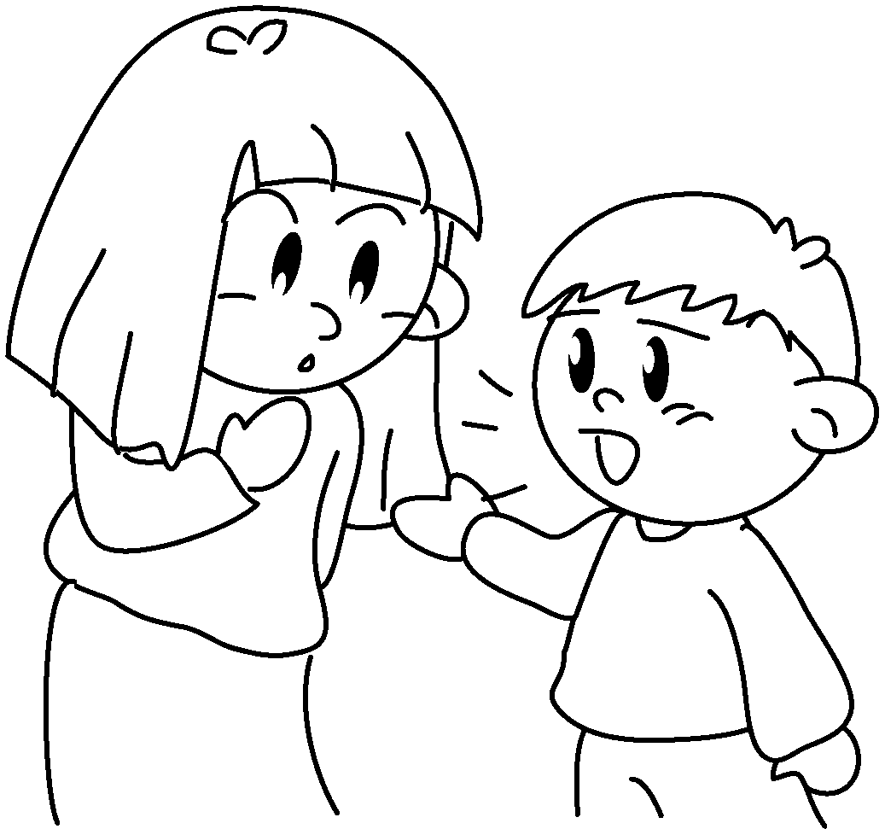
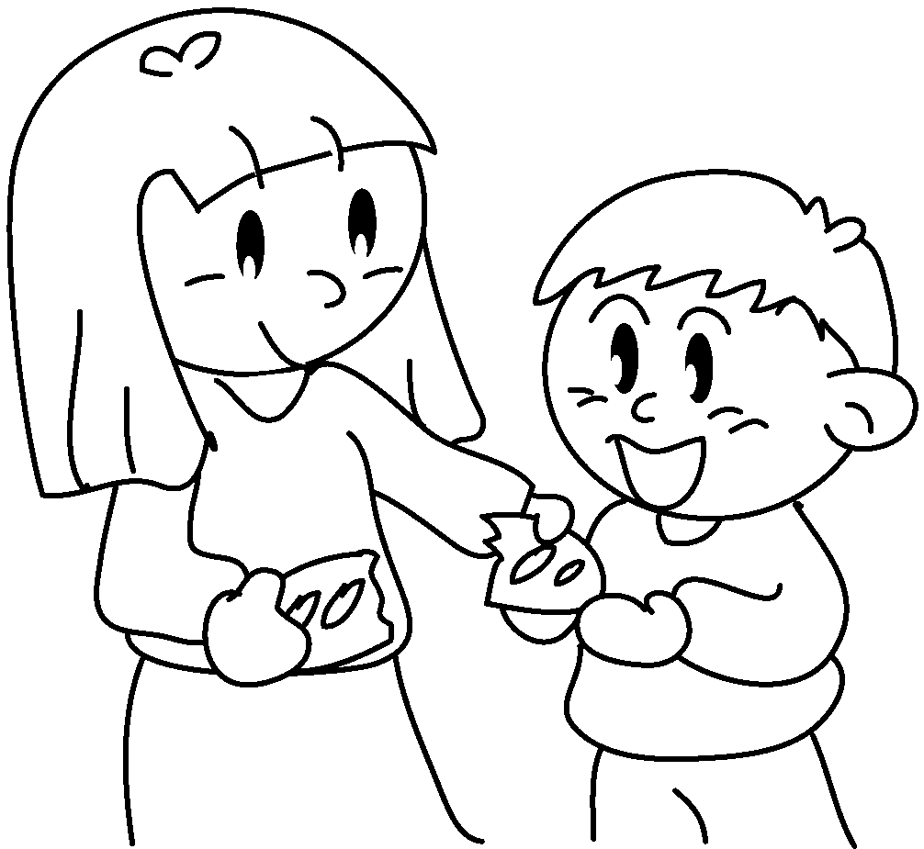


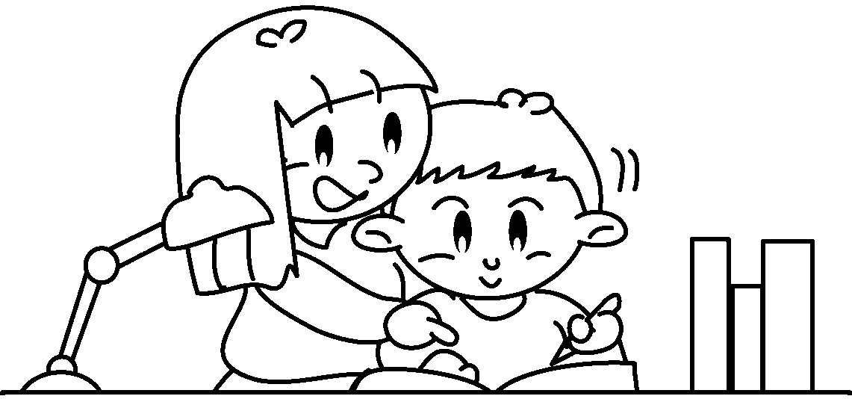
1
2
3
4
5
7
8
9
6
10
12
11

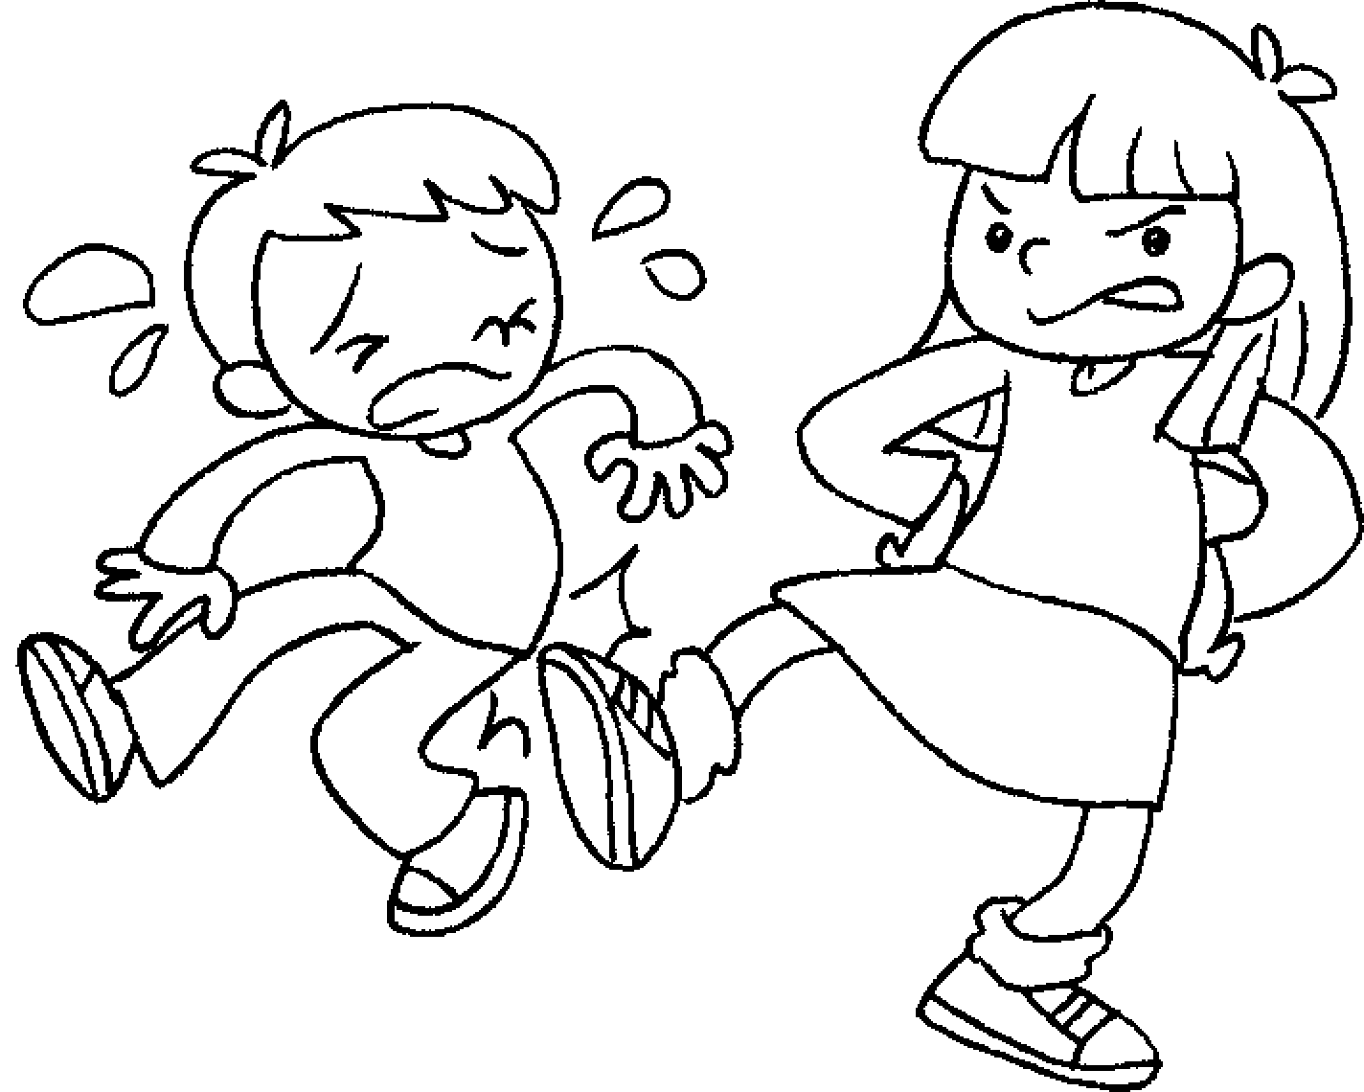

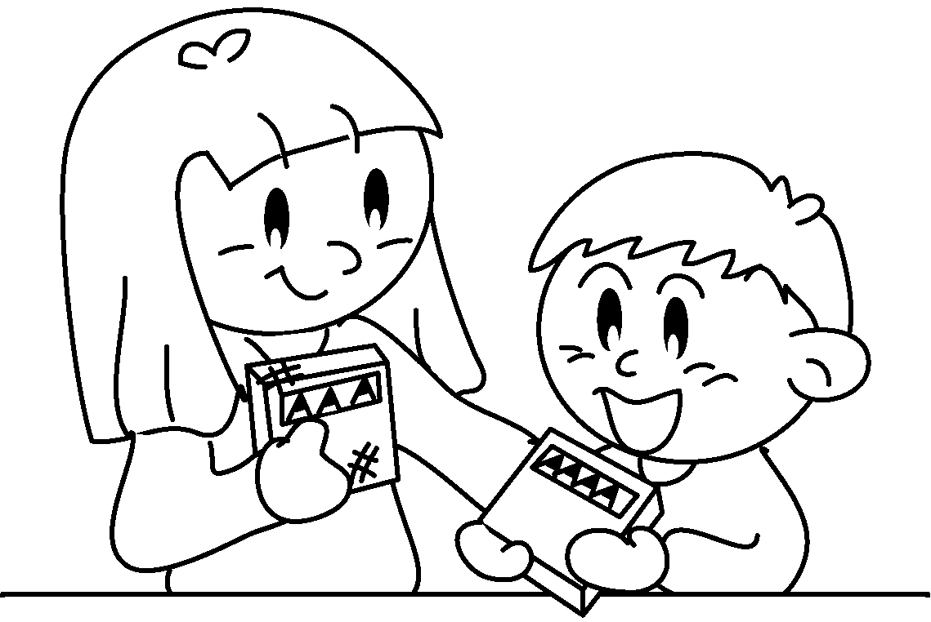
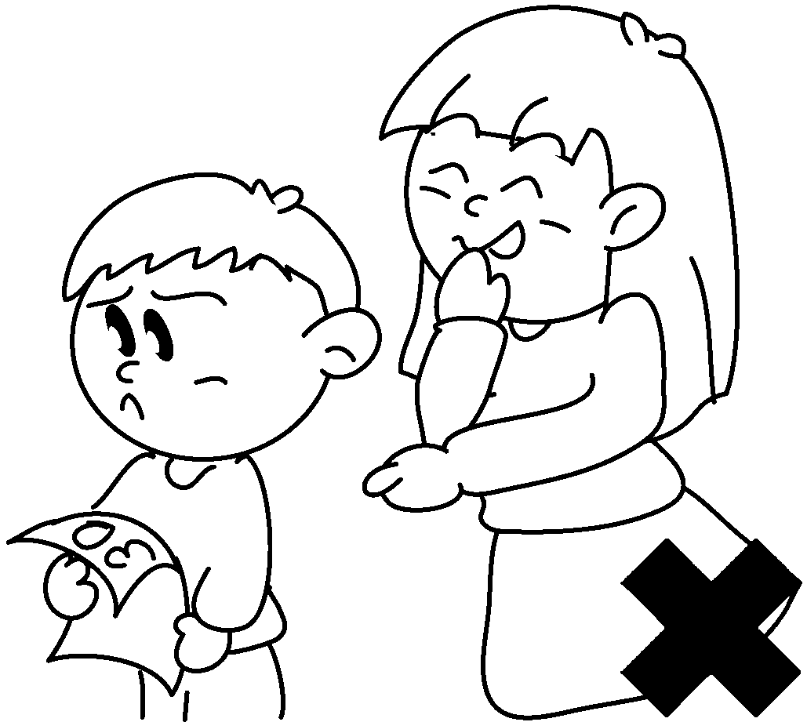
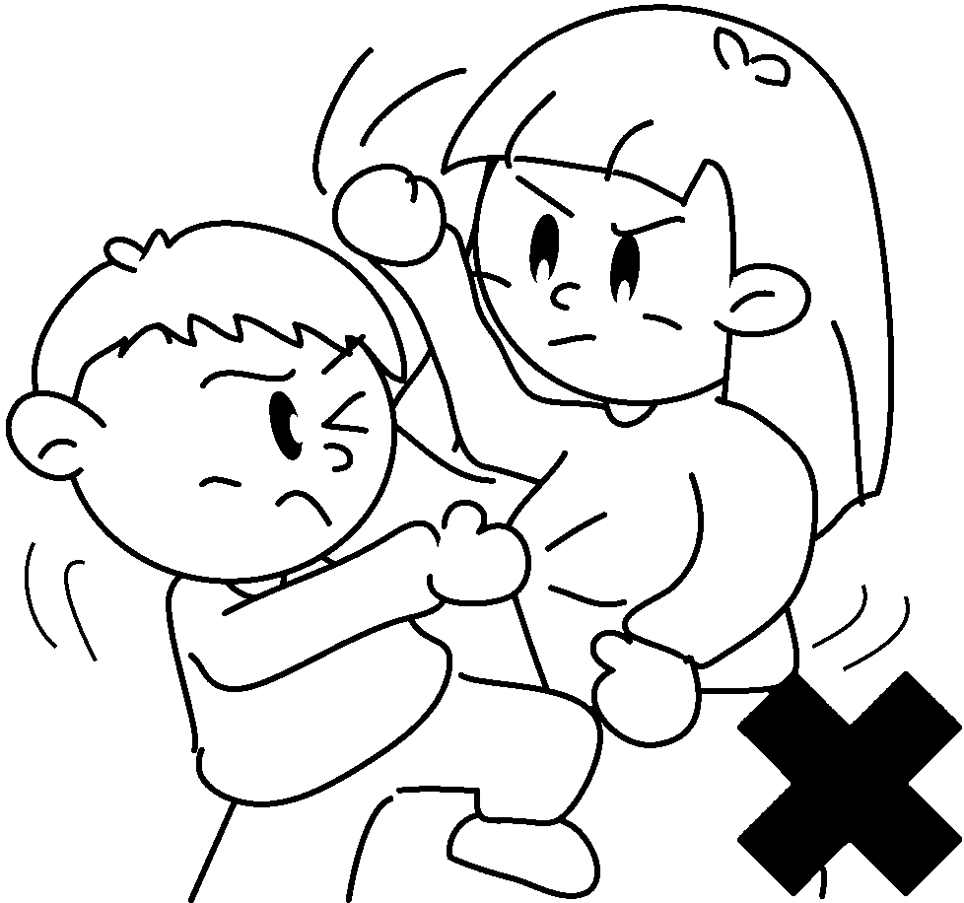
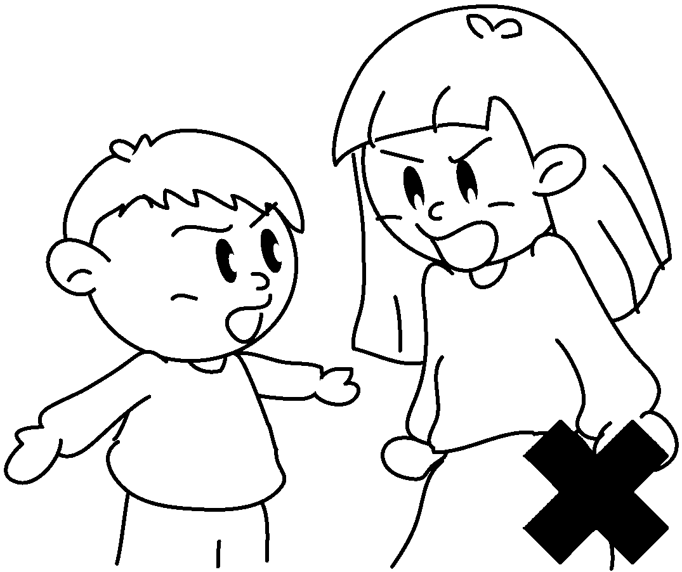

About my sister
Helen is my sister.
1She takes care me.
2She helps me my homework.
3She shares her food me.
4She listens me.
5She talks me.
6She doesn’t shout me.
7She doesn’t quarrel me.
8She doesn’t fight me.
9She doesn’t laugh me.
10She is nice me.
11She isn’t mean me.
12We get on well each other.
I love my sister!



Book 5A Chapter 2 Graded Worksheets
Worksheet 2⬇
- of
- with
- with
- to
- to
- at
- with
- with
- at
- to
- to
- with

