Fill in the blanks.
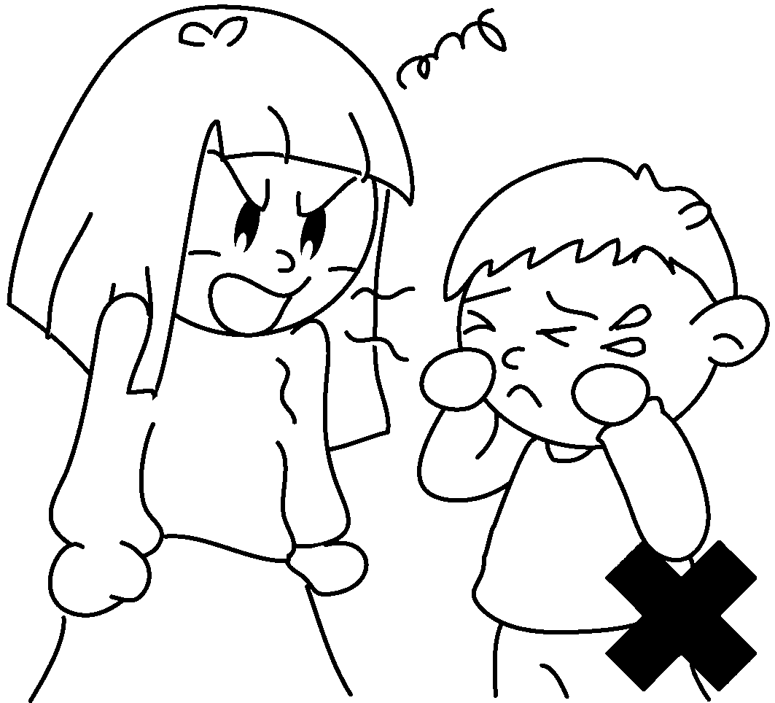
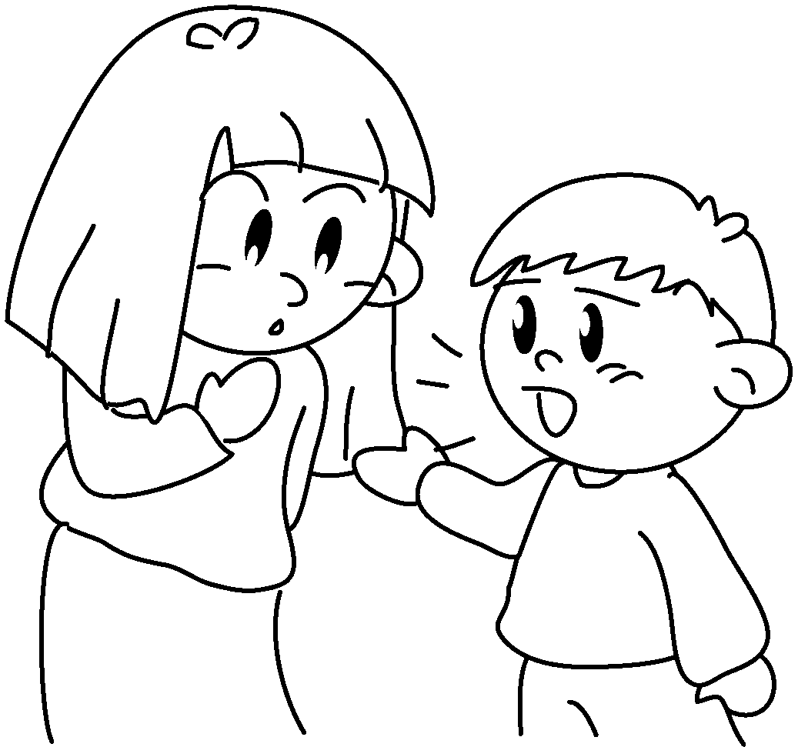
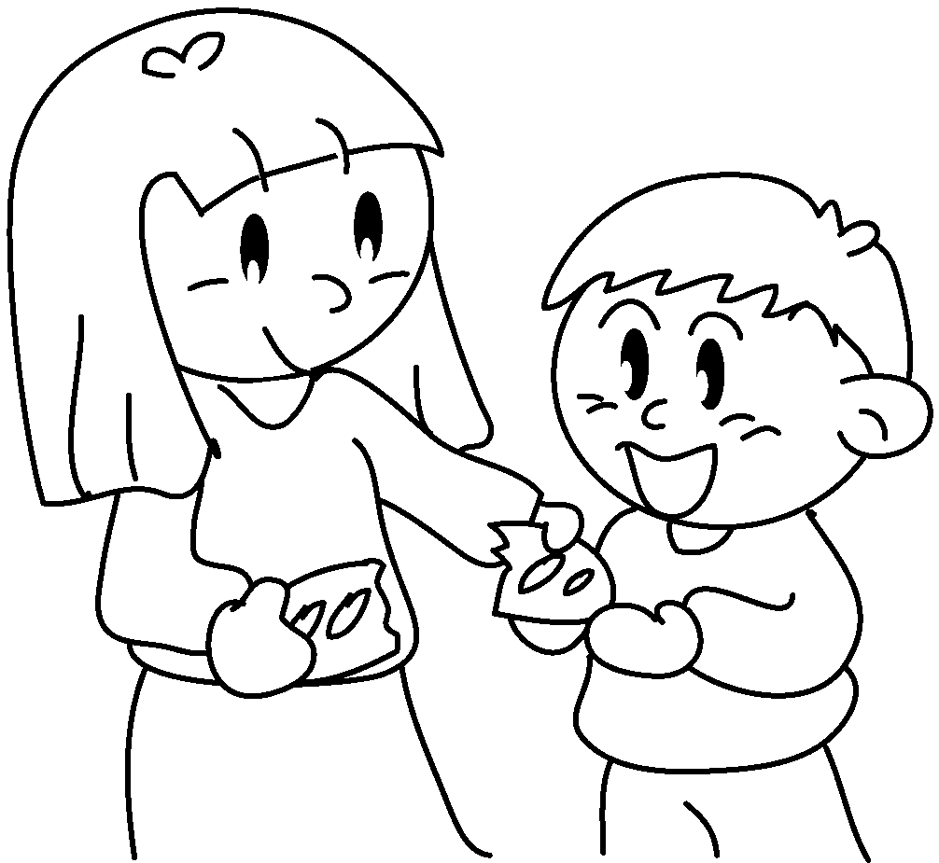
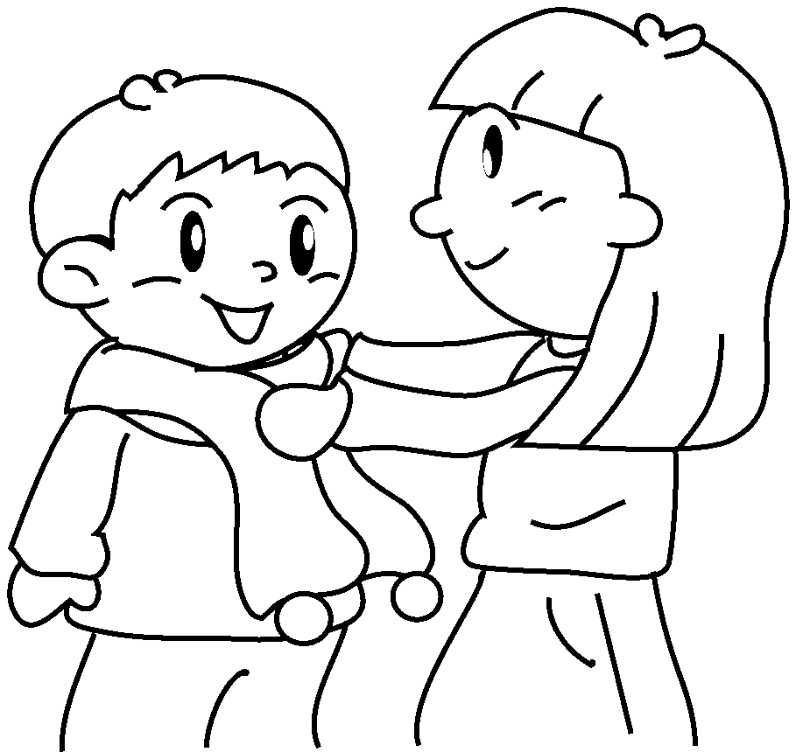
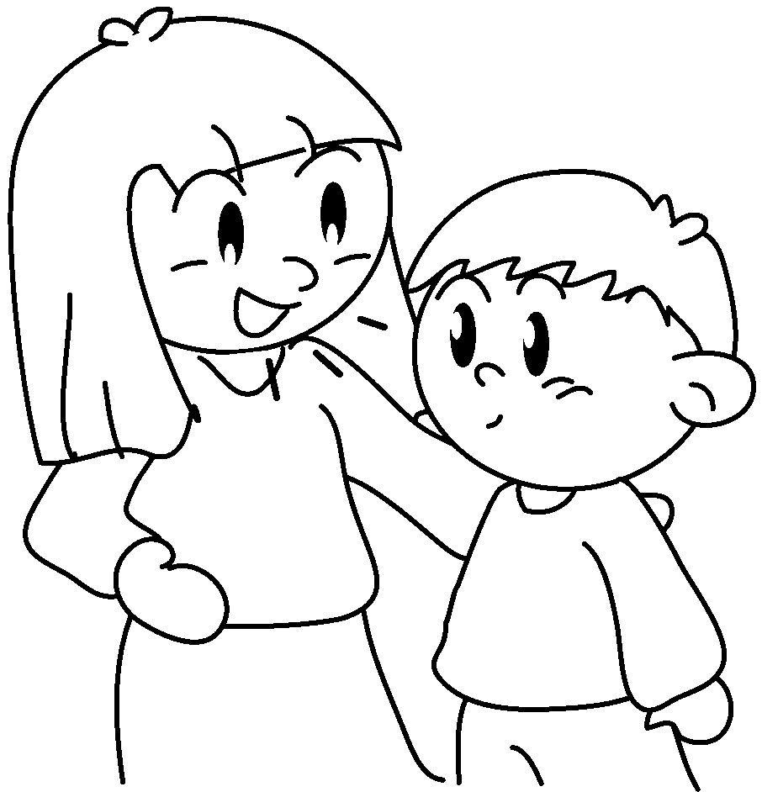
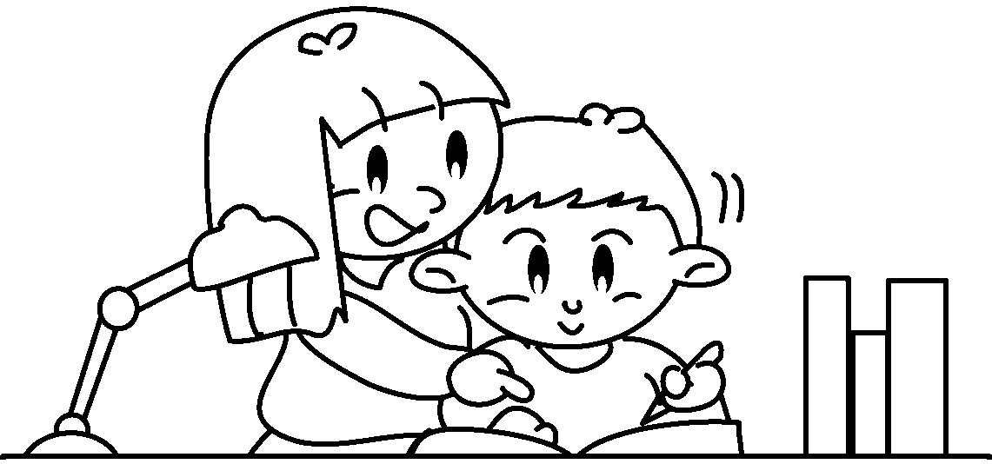
1
2
3
4
5
7
8
9
6
10
12
11

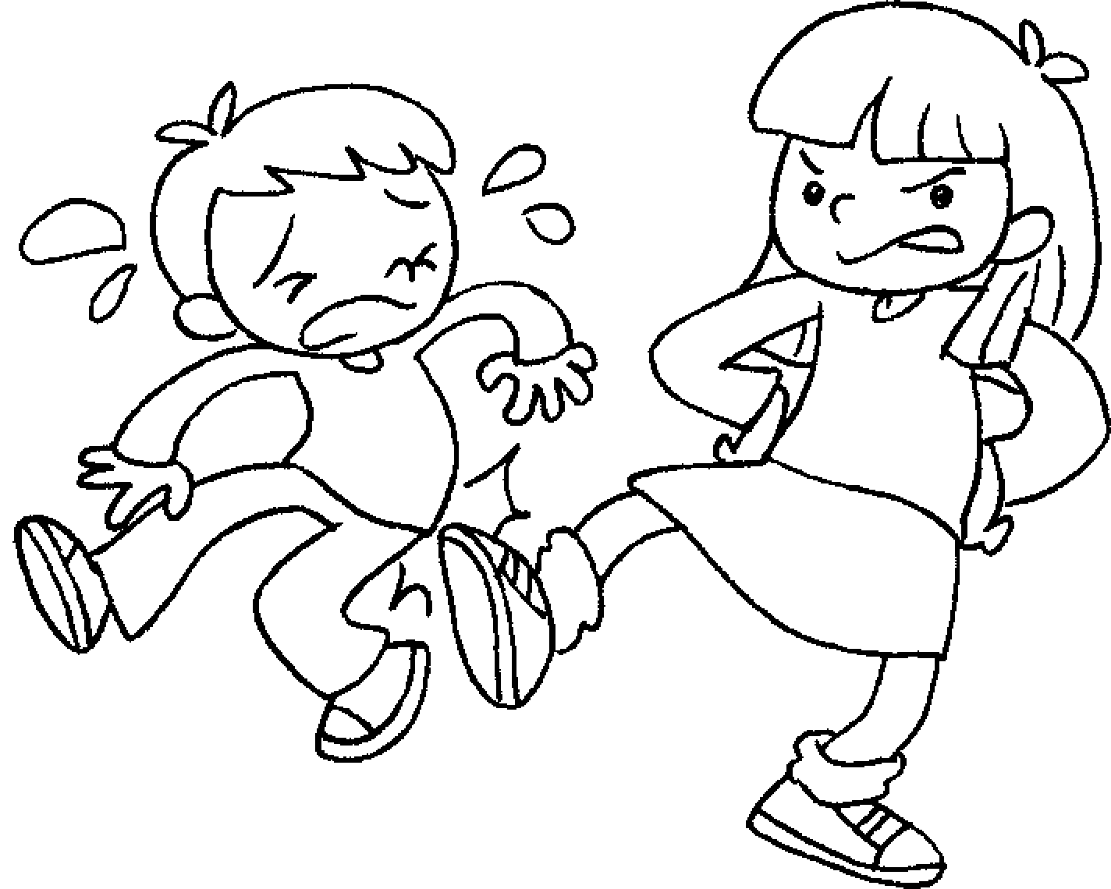

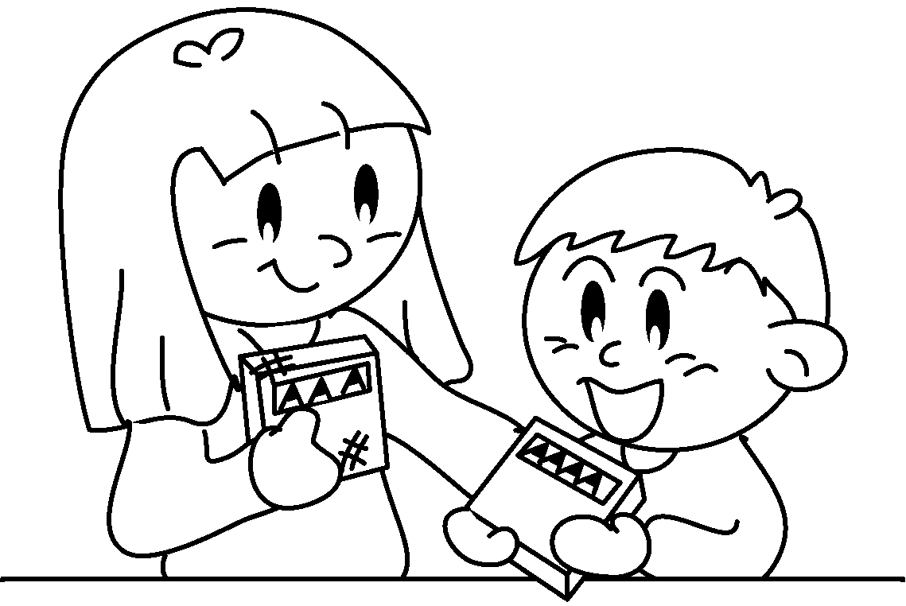
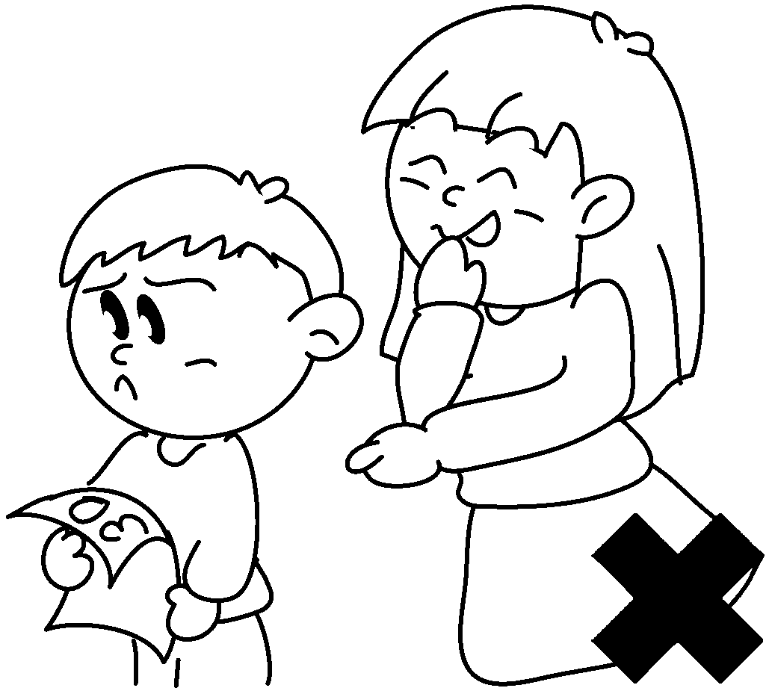
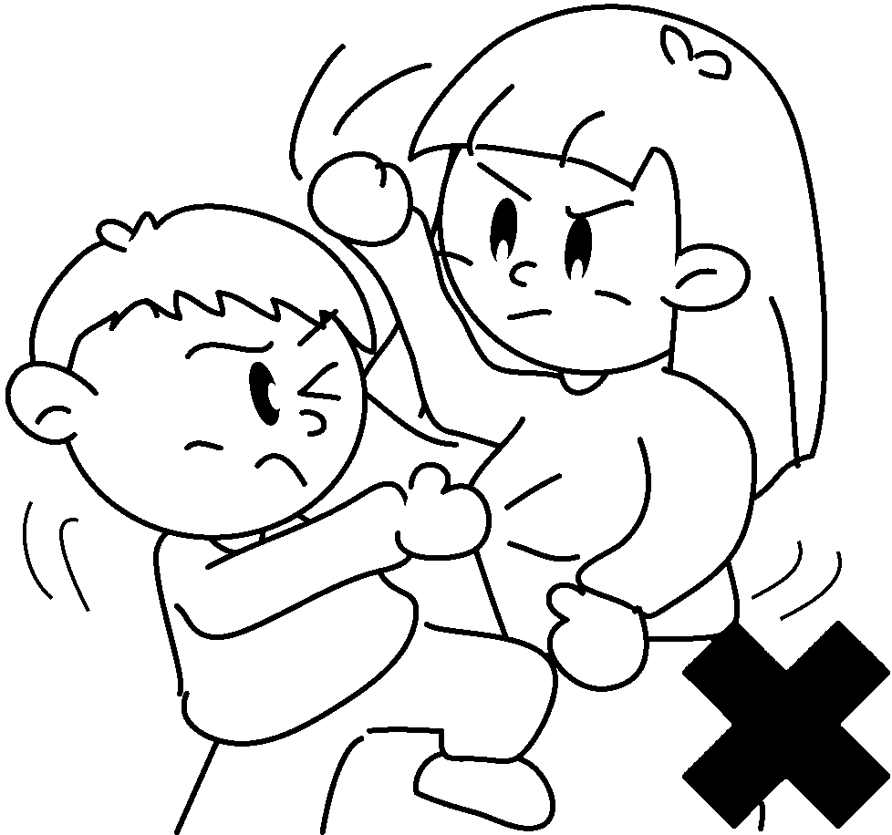
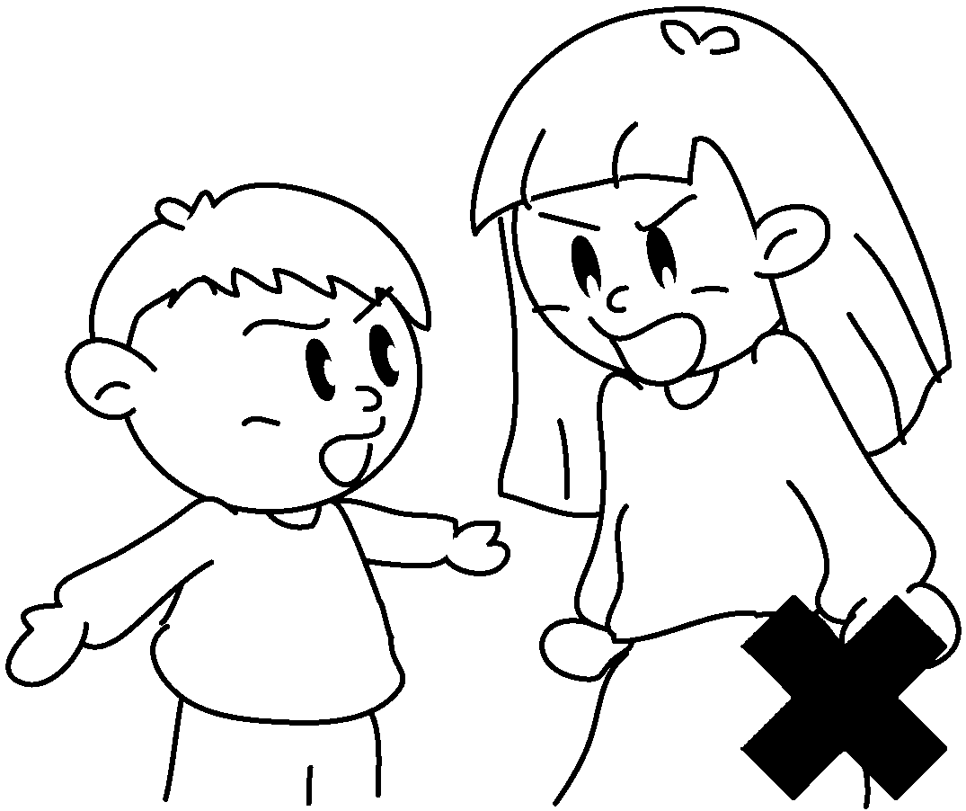

About my sister
Helen is my sister.
1She takes care me.
2She helps me my homework.
3She her food me.
4She me.
5She me.
6She doesn’t me.
7She doesn’t me.
8She doesn’t me.
9She doesn’t me.
10She is me.
11She isn’t me.
12We well each other.
I love my sister!



Book 5A Chapter 2 Graded Worksheets
Worksheet 2⬇⬇⬇
- of
- with
- shares with
- listens to
- talks to
- shout at
- quarrel with
- fight with
- laugh at
- nice to
- mean to
- get on with
(Accept any reasonable answers.)

