Choose and write.
one another
each other
1 Tina and Emma get on well with . | 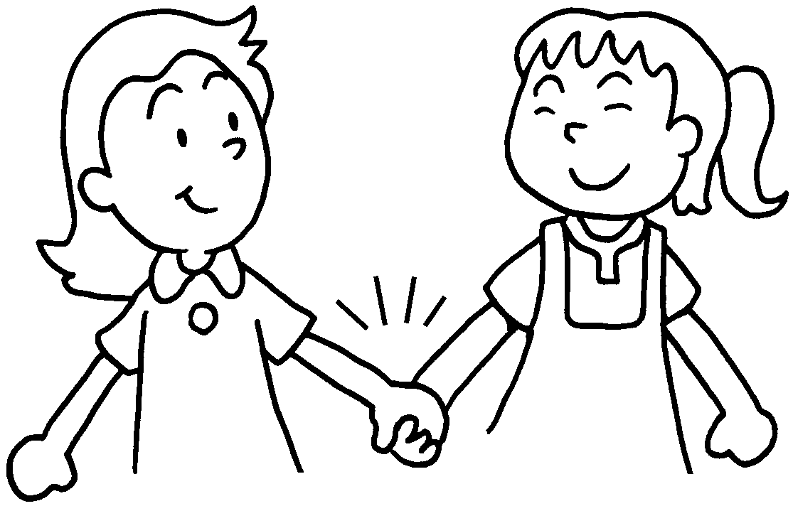
2 We should talk to and listen to . | 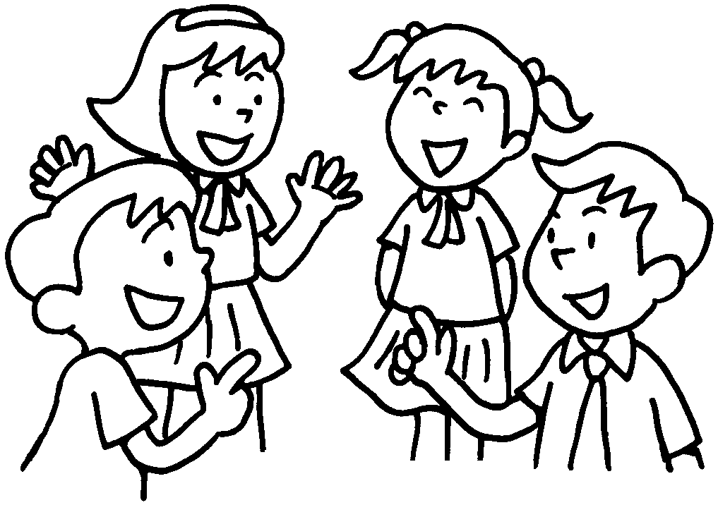
3 Mandy, Sarah and Kat shouldn’t shout at . | 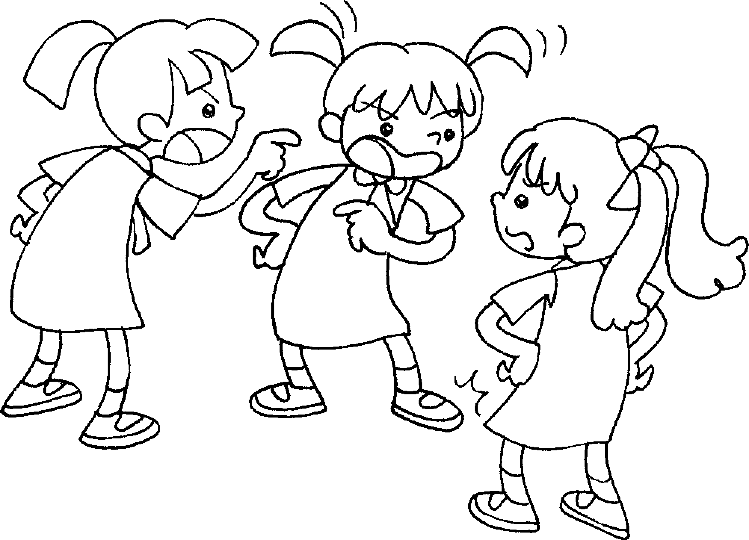
4 Jacky and Bobby shouldn’t fight with . | 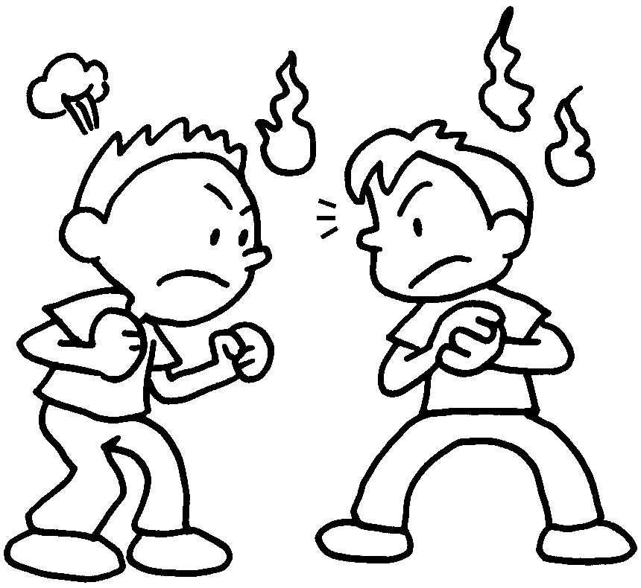
5 Sam and Joe shouldn’t quarrel with . | 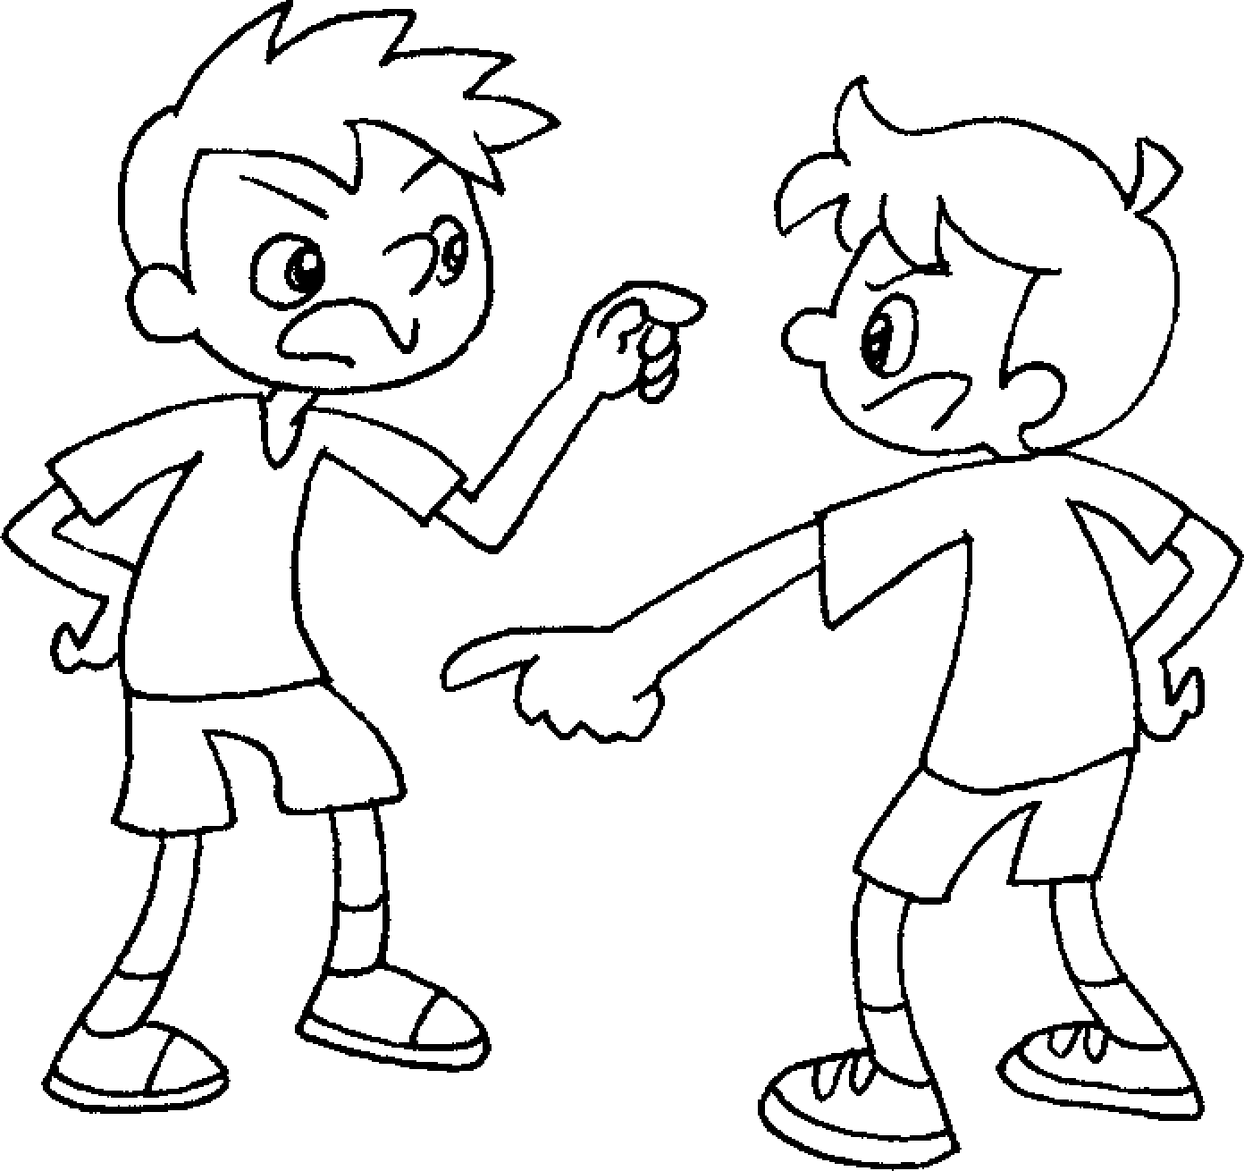  Joe
6 Helen, Sue and Penny shouldn’t be mean to .  They should share their food with . | 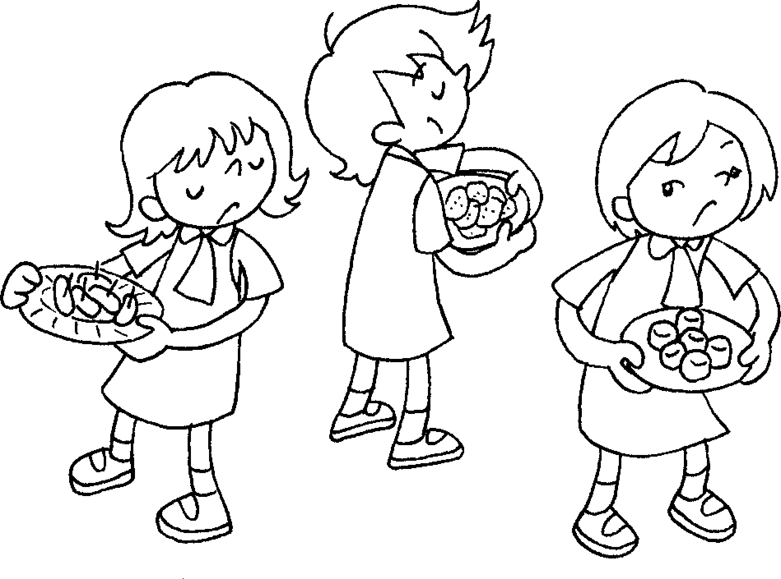

Book 5A Chapter 2
Remedial Worksheets
Worksheet 2
1 of 7 with
2 with 8 with
3 with 9 at
4 to 10 to
5 to 11 to
6 at 12 with
Book 5A Chapter 2
Remedial Worksheets
Worksheet 3
1 each other
2 each other
3 one another
4 one another
5 each other
6 one another
one another



Book 5A Chapter 2 Graded Worksheets
Worksheet 3⬇
- each other
- one another
- one another
- each other
- each other
- one another
one another

