Fill in the blanks.

1 Tina and Emma get on well with each . | 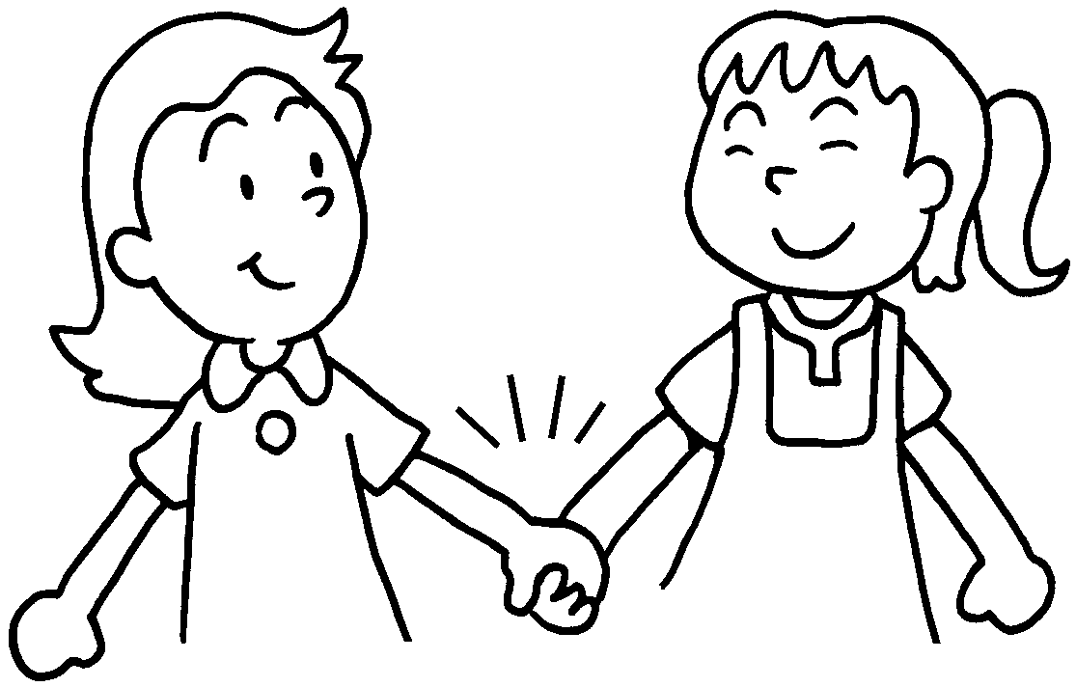
2 We should talk to and listen to one . | 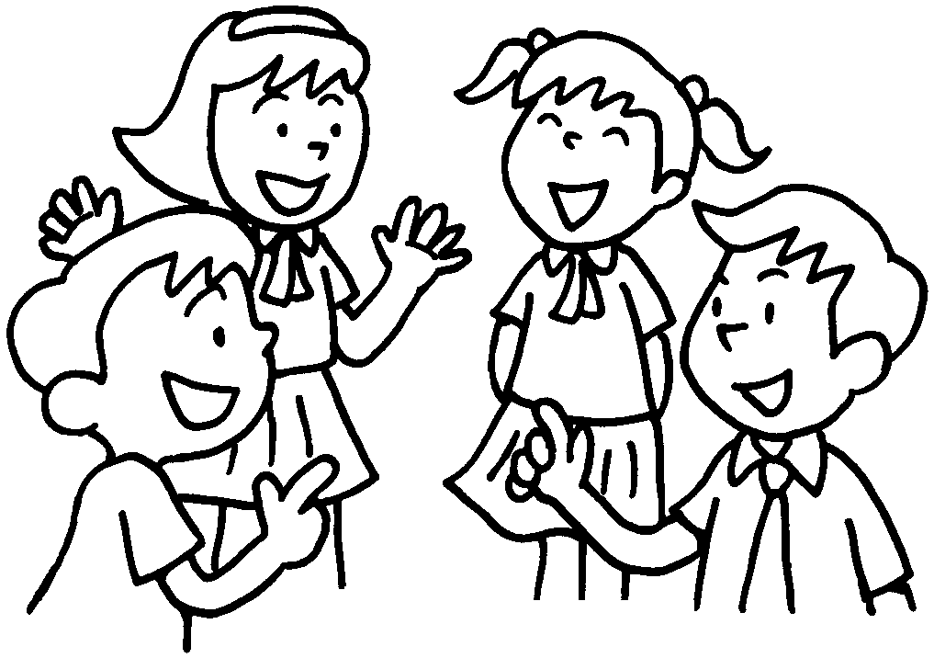
- Mandy, Sarah and Kat shouldn’t shout at  . | 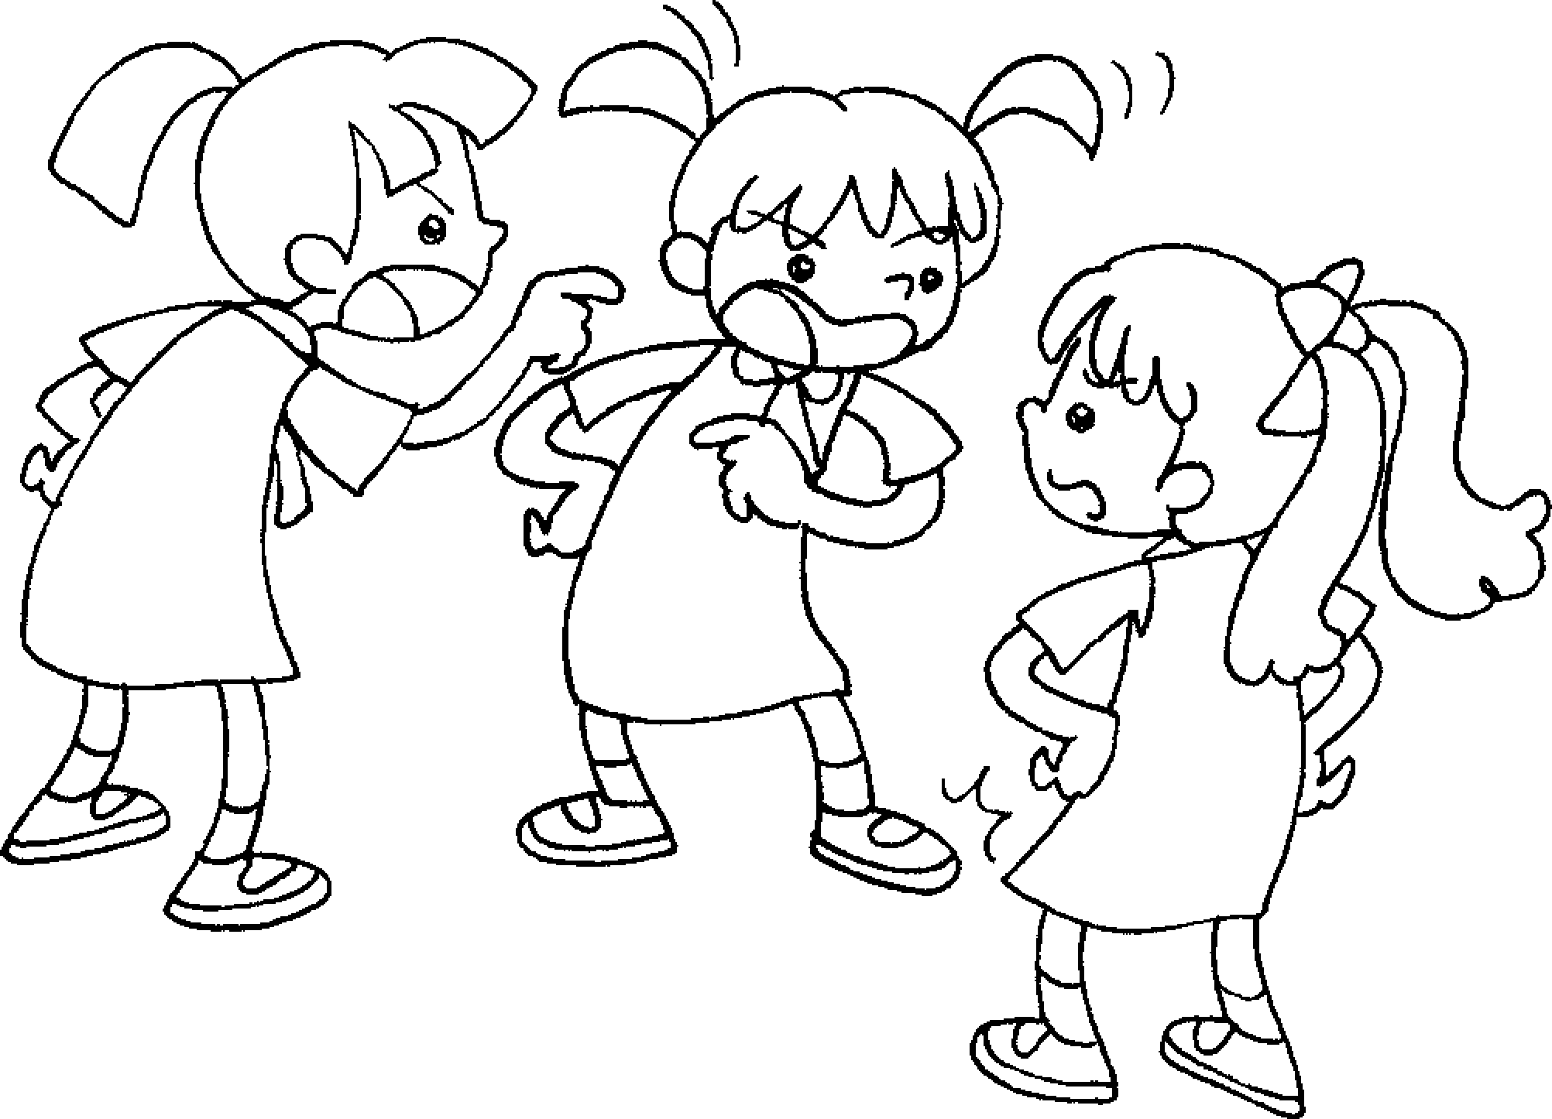
4 Jacky and Bobby shouldn’t fight with . | 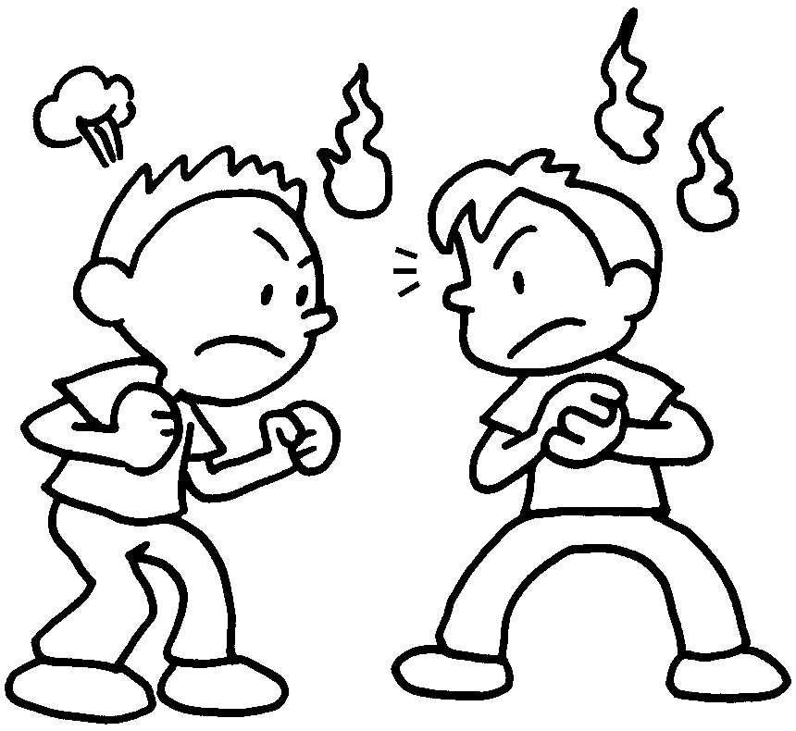
5 Sam and Joe shouldn’t quarrel with . | 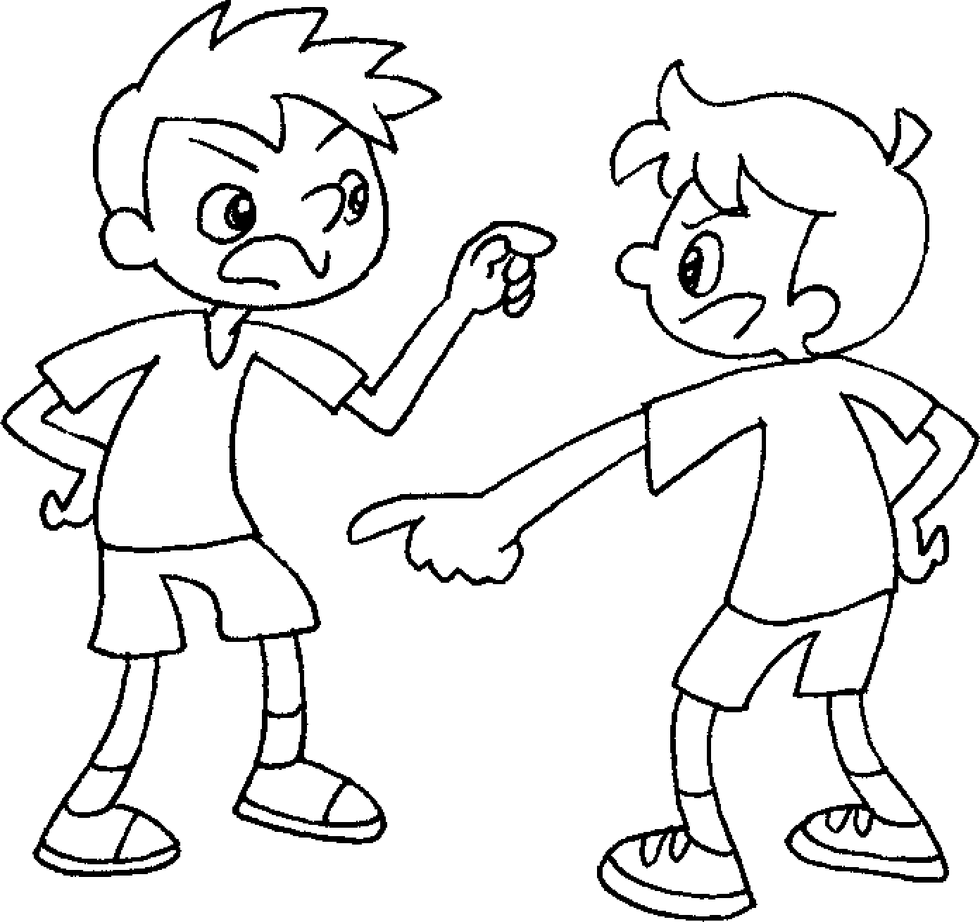
6 Helen, Sue and Penny shouldn’t be mean to .  They should share their food with . | 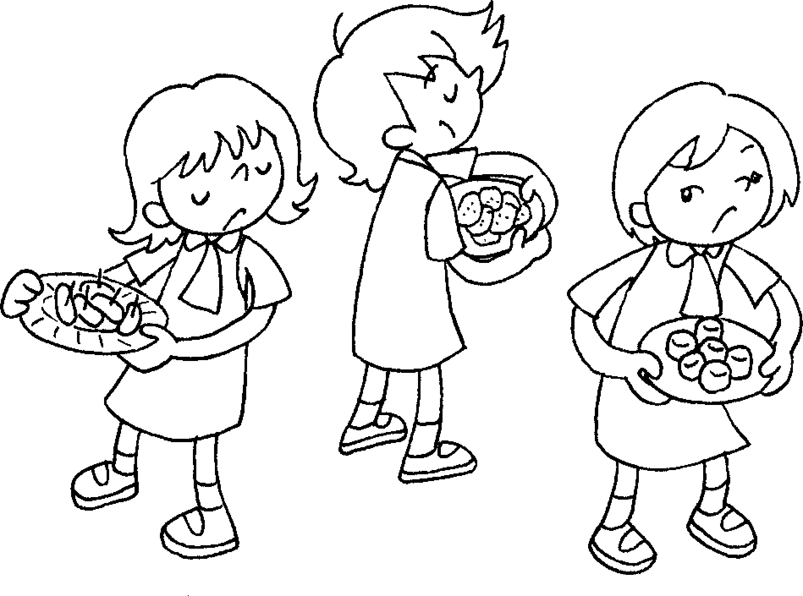


Book 5A Chapter 2 Graded Worksheets
Worksheet 3⬇⬇
- other
- another
- one another
- each other
- each other
- one another
one another

