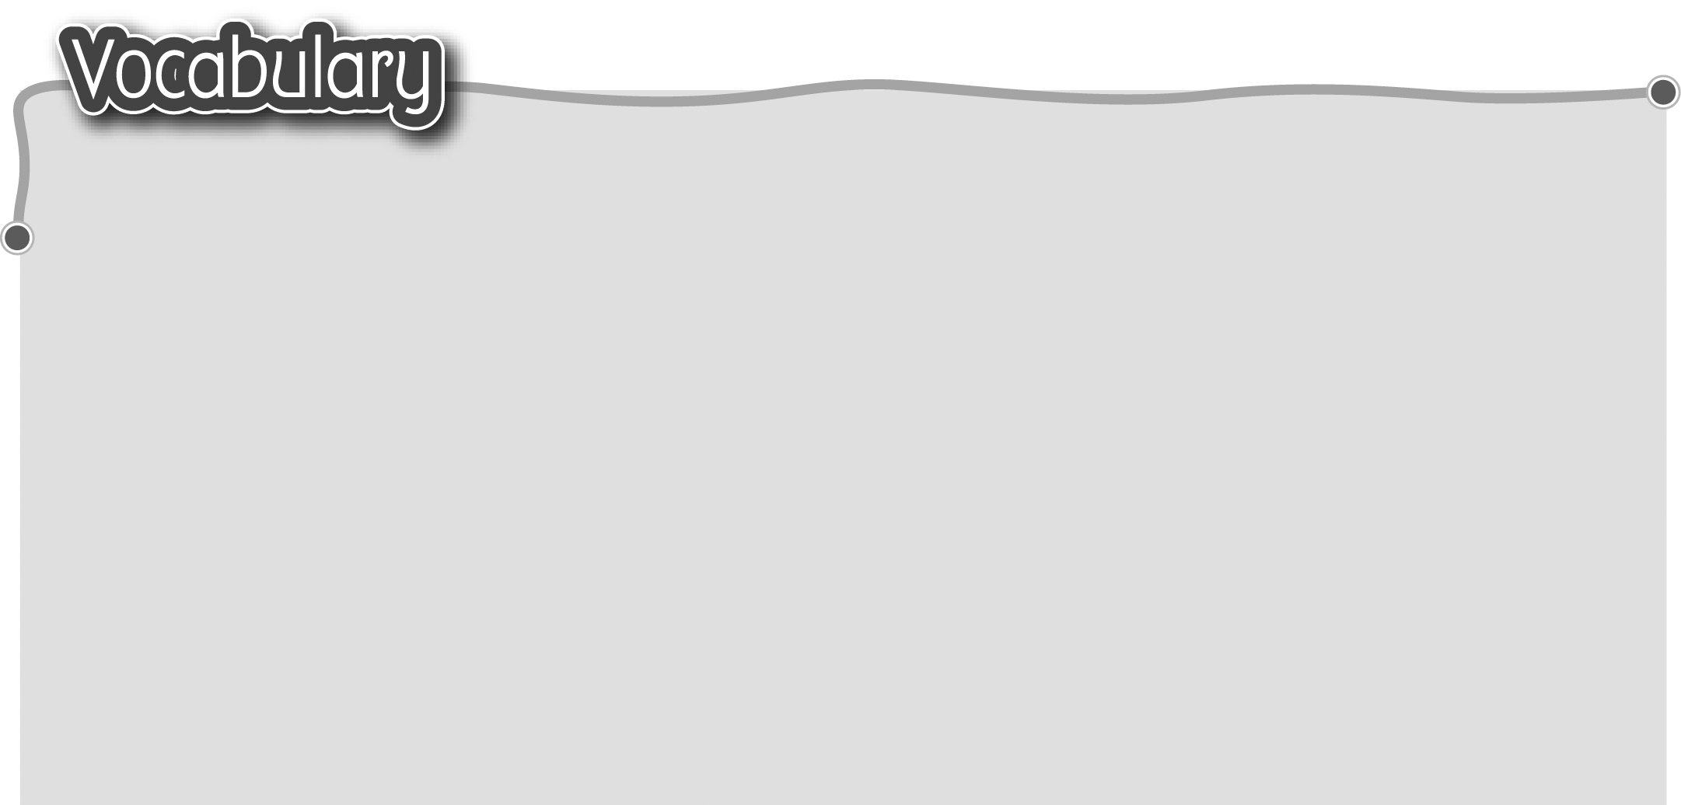
1 take care of 照顧 7 be mean to 對……刻薄
2 laugh at 取笑 8 help … with 幫忙
3 shout at 對……呼喝 9 share … with 跟……分享
4 listen to 聆聽 10 get on with 與……和睦相處
5 talk to 跟……交談 11 quarrel with 與……爭吵
6 be nice to 對……友好 12 fight with 與……打架

The words marked with * have different meanings in other
contexts. You can look up those meanings in a dictionary.
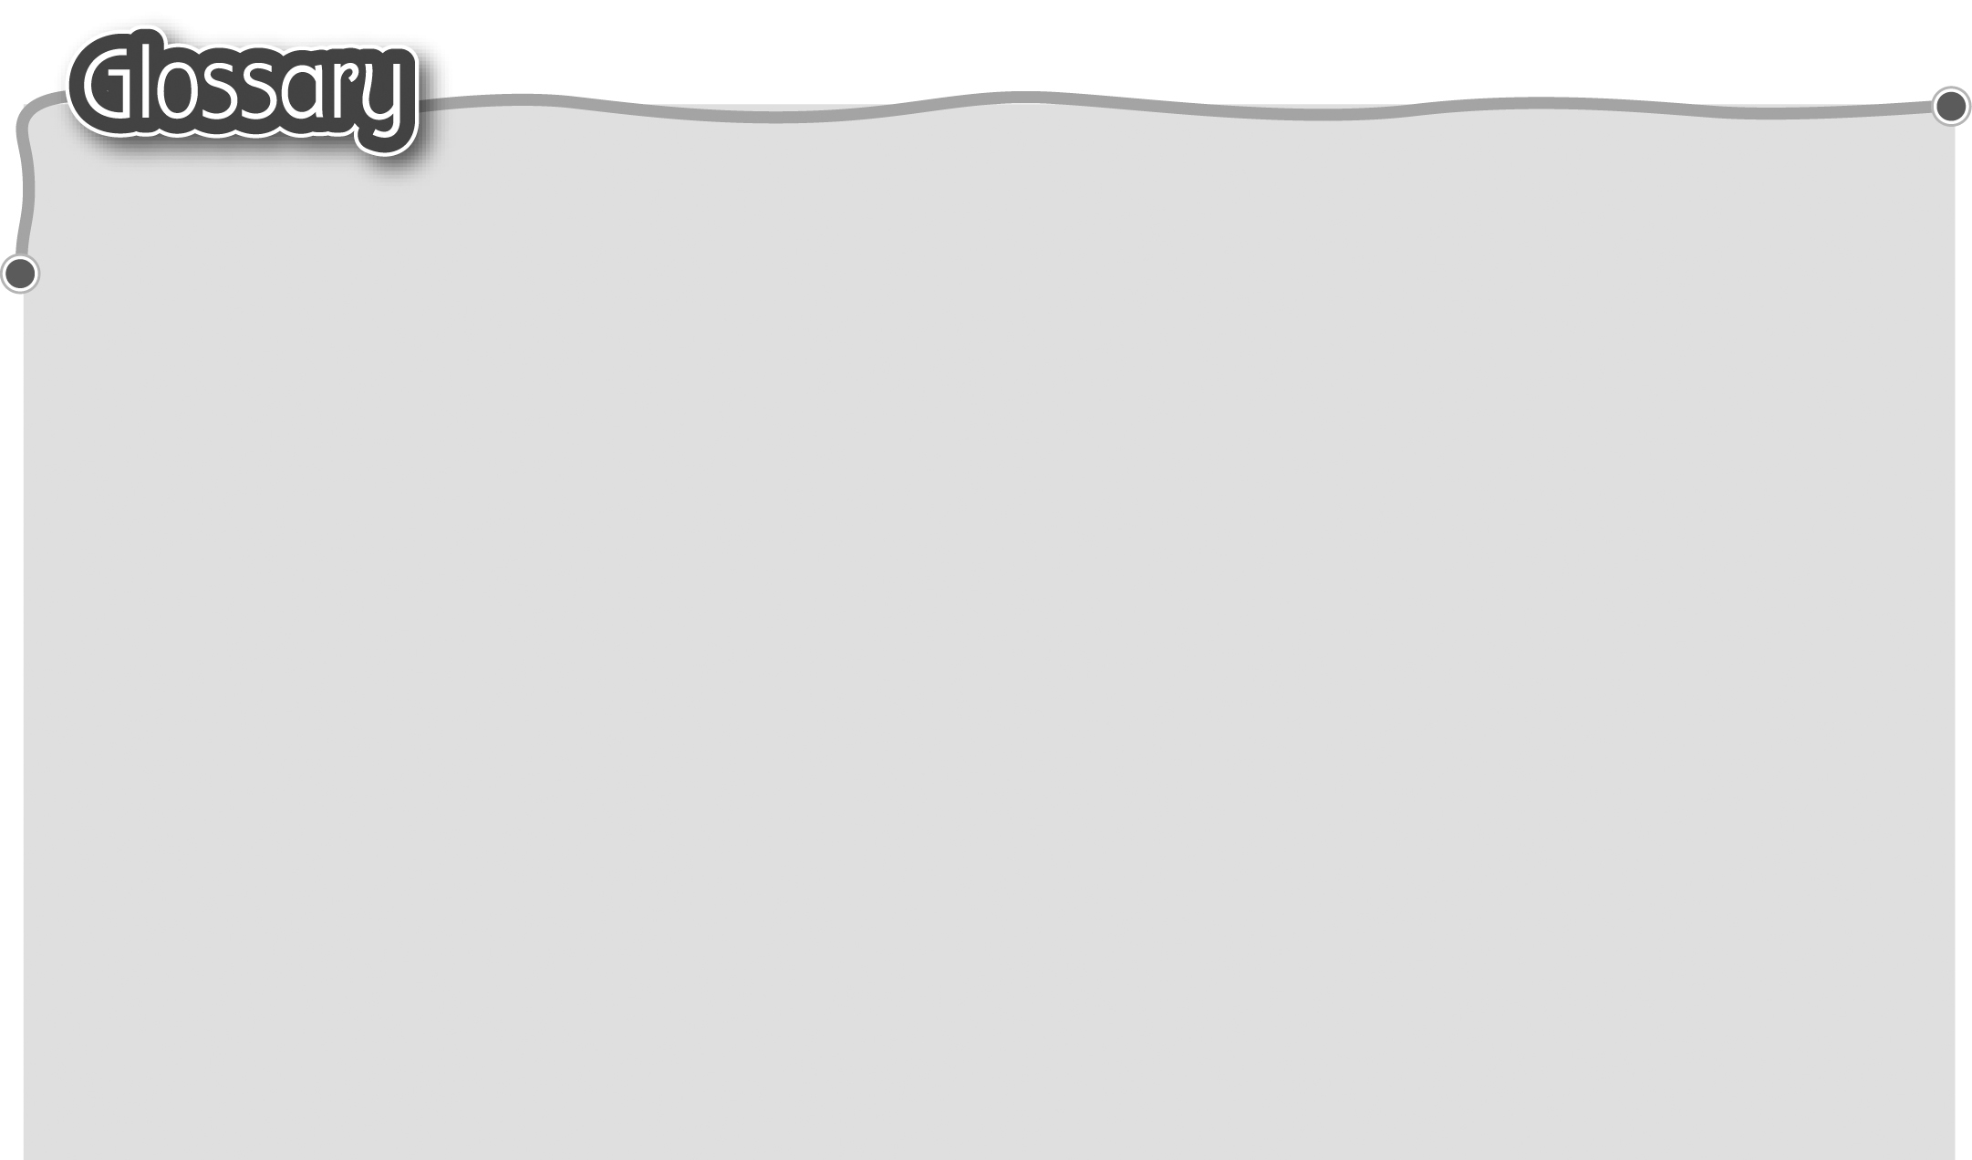
1 (be) afraid of (p.10) 感到害怕 9 ladder (p.11) 梯子
2 tame* (p.10) 溫馴（形容詞） 10 glad (p.11) 高興
3 mad* (p.10) 生氣 11 each other (p.11) 互相/彼此
4 the washing up (p.10) 洗碗碟 12 one another (p.13) 互相/彼此
5 unkind (p.11) 不仁慈 13 parents (p.14) 父母
6 (be) stuck (stick)* (p.11) 卡住 14 reader (p.17) 讀者
7 park keeper (p.11) 公園管理員 15 general idea (p.17) 概念
8 call* … (p.11) 叫……來（動詞） 16 mean* (p.17) 表示……的意思（動詞）

