RP no: Century Gothic 15pt
(所有圈號用15pt)
Choose and write.

glasses | watch | sunglasses | umbrella
2
1
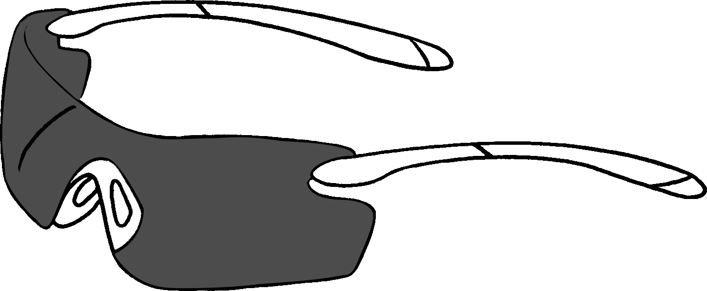  4  3 | 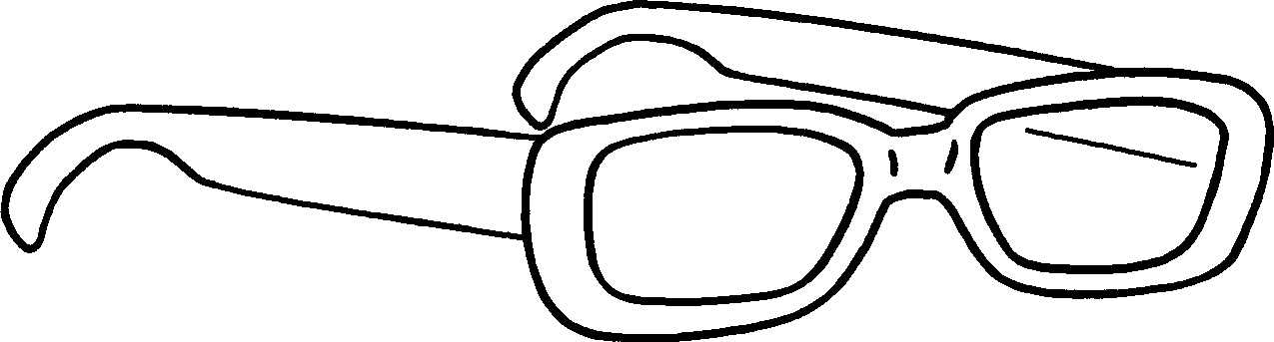 |  | 1
 |  |  | 2
 | 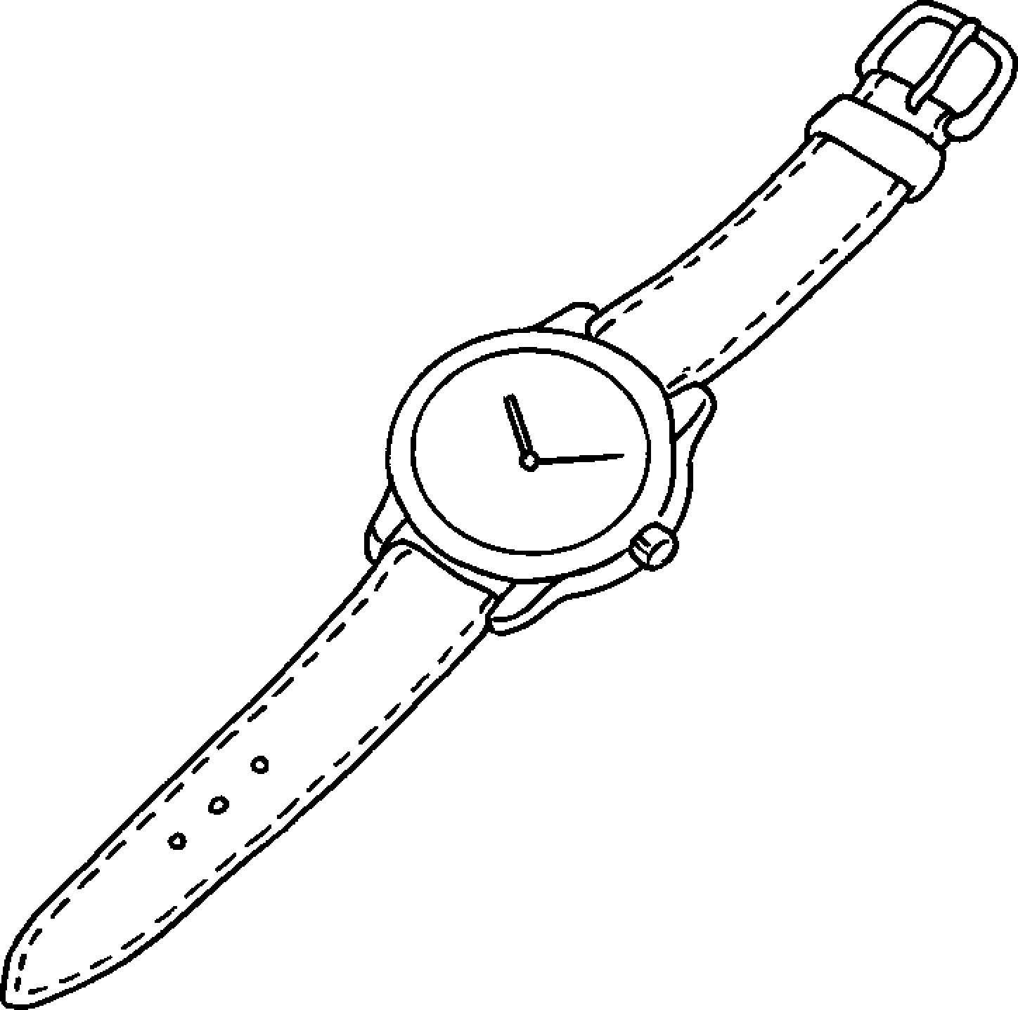 |  | 3 an
 |  |  | 4 a

gloves | jeans | mittens | sandals | suit | vest
6
5
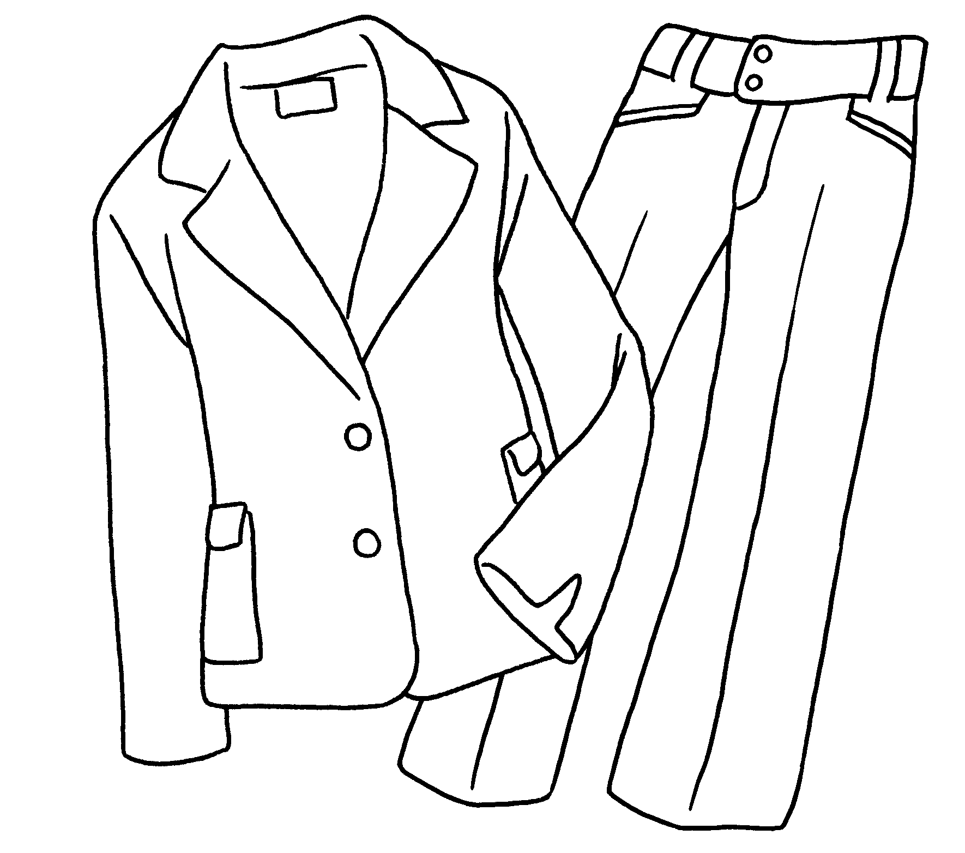  7 | 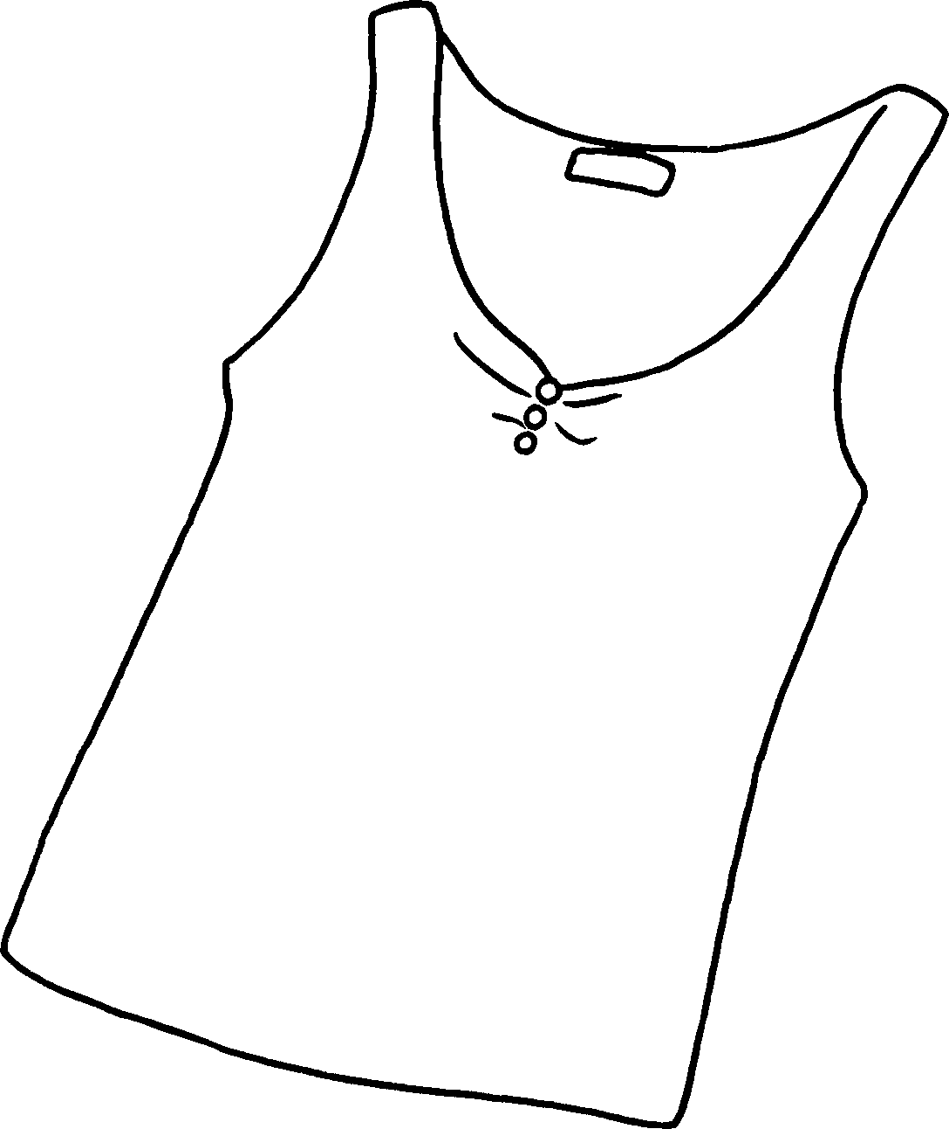  8 |  | 5 a
 |  |  | 6 a
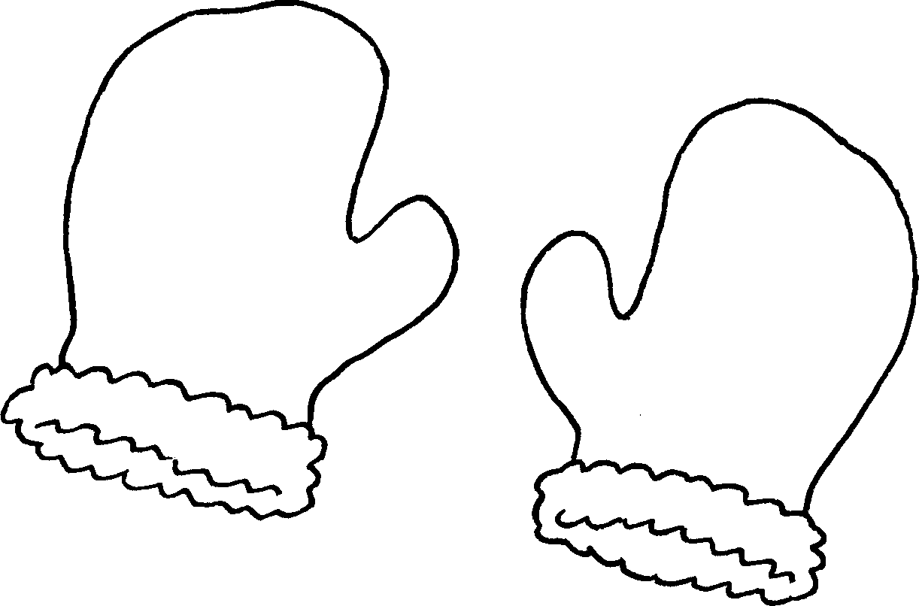  10  9 | 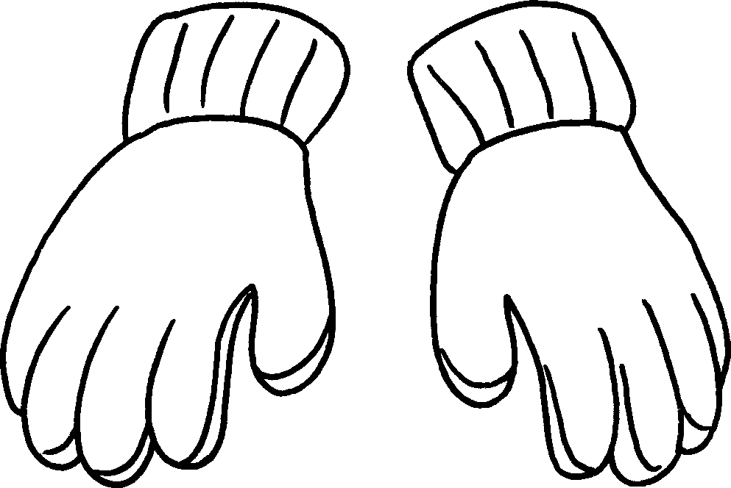 |  | 7
 |  |  | 8
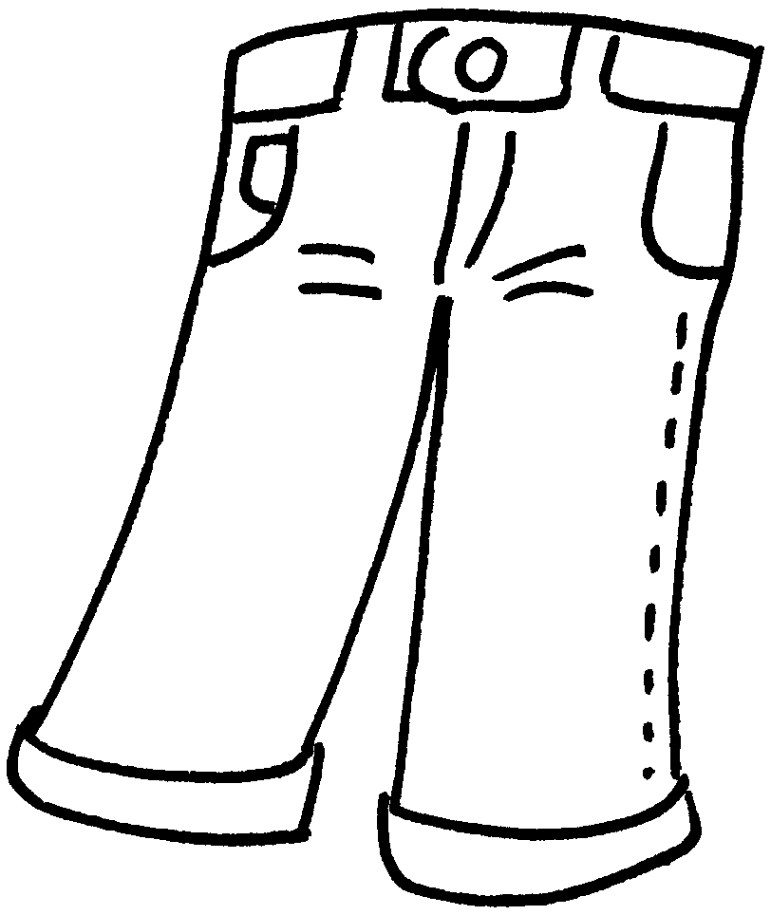 | 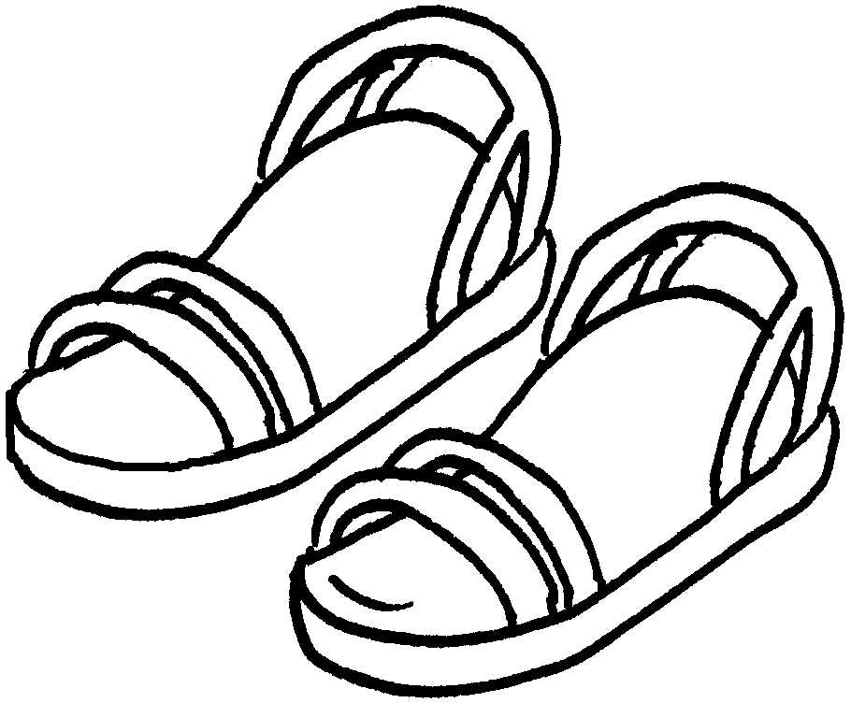 |  | 9
 |  |  | 10


RP no: Century Gothic 15pt
(所有圈號用15pt)

Book 5A Chapter 3 Graded Worksheets
Worksheet 1⬇
- sunglasses
- glasses
- umbrella
- watch
- suit
- vest
- mittens
- gloves
- jeans
- sandals

