RP no: Century Gothic 15pt
(所有圈號用15pt)
What are they? Write.
2
1
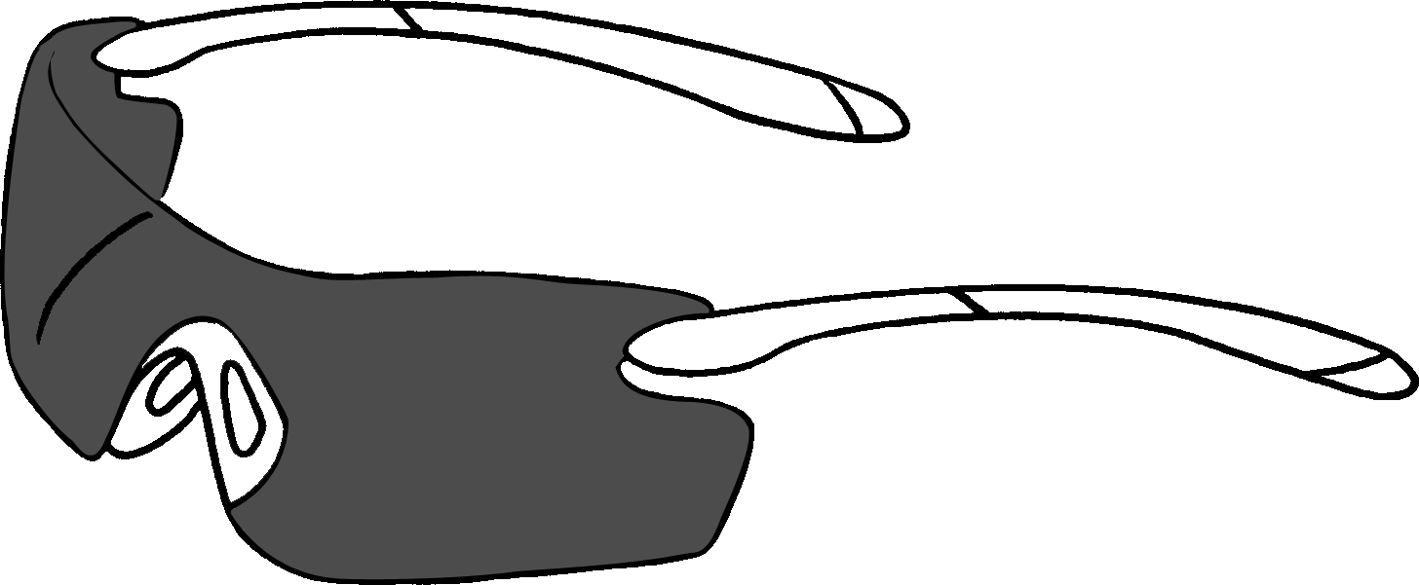 | 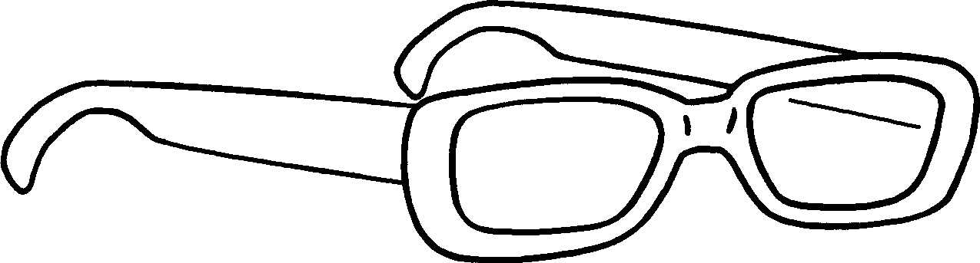 |  | 1 s
 |  |  | 2 g
4
3
 | 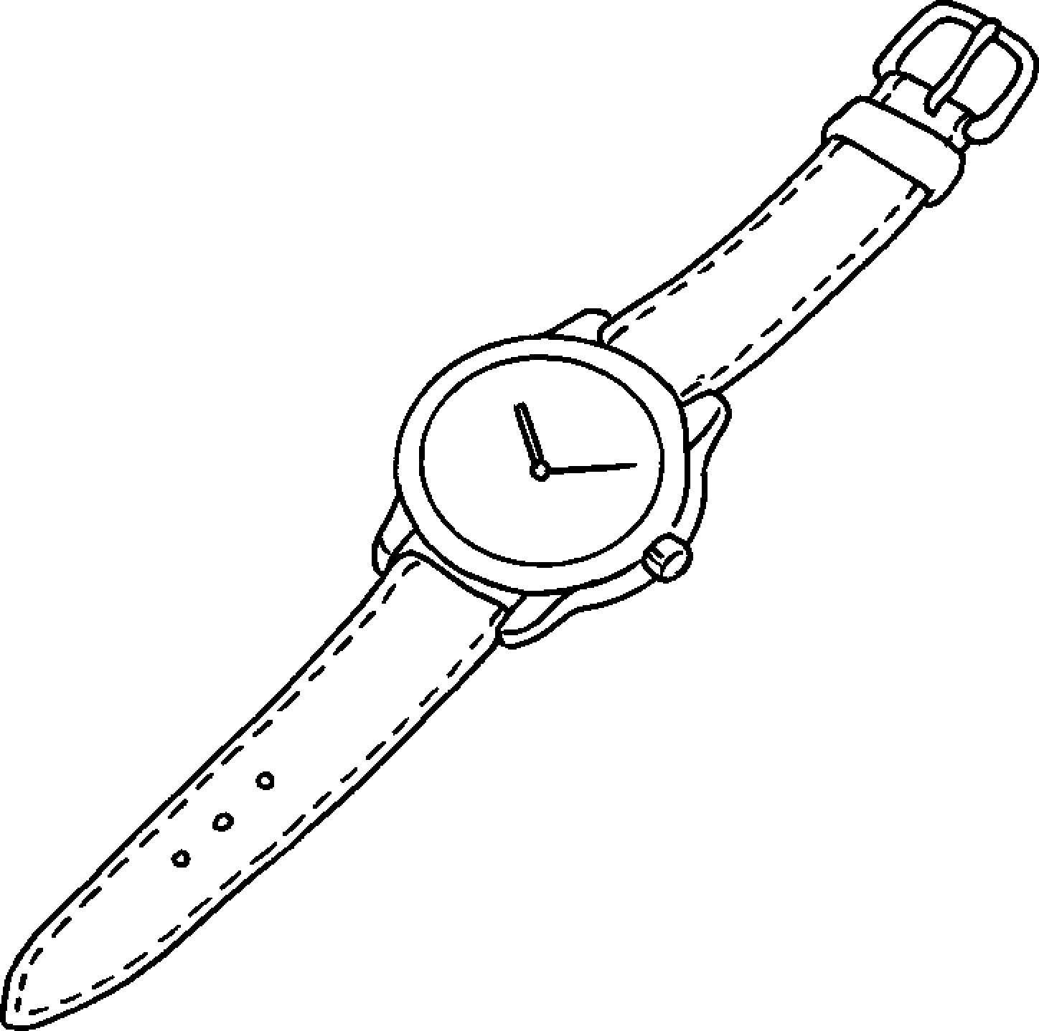 |  | 3 an u
 |  |  | 4 a w
6
5
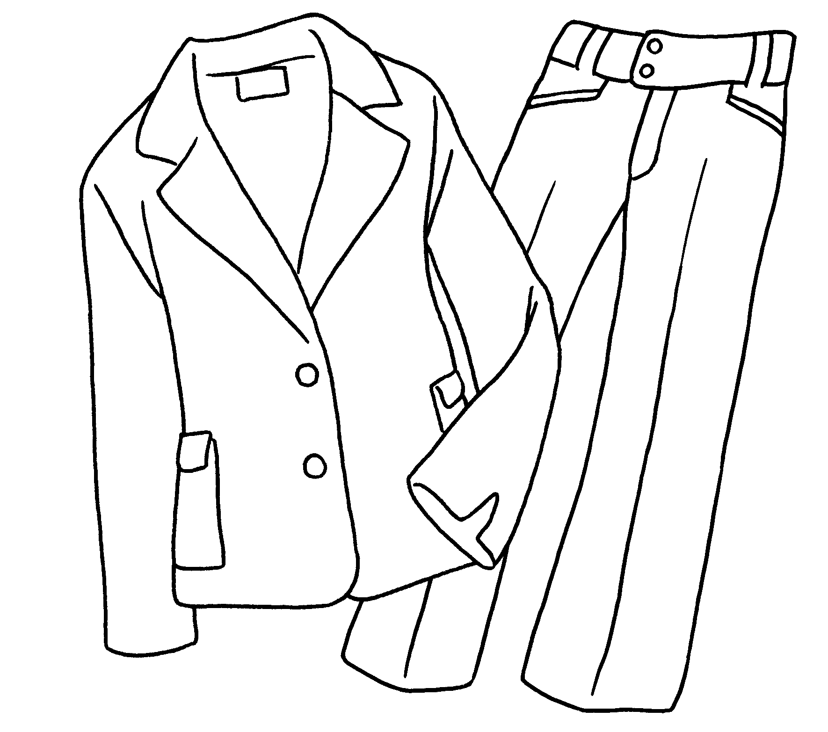 | 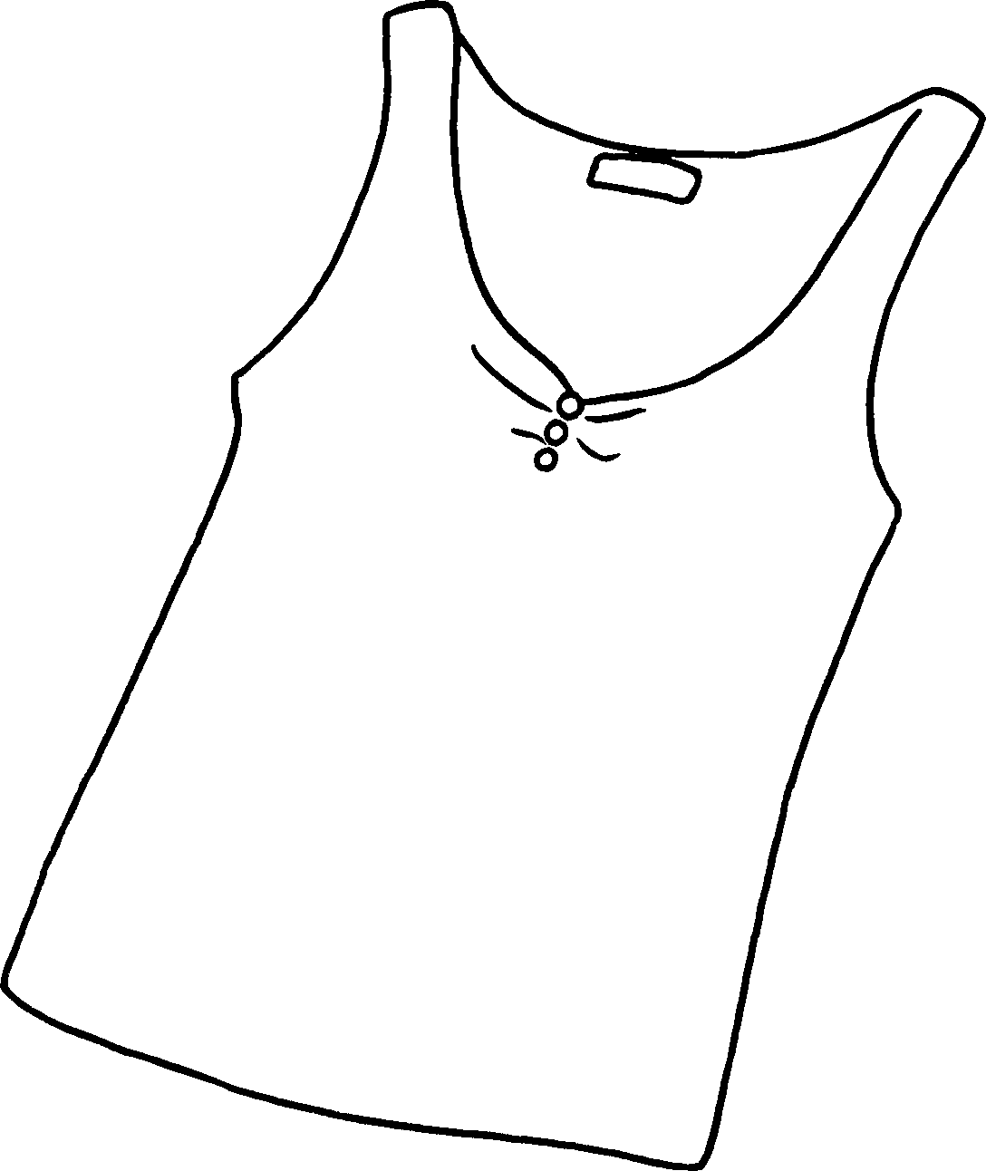 |  | 5 a s
 |  |  | 6 a v
8
7
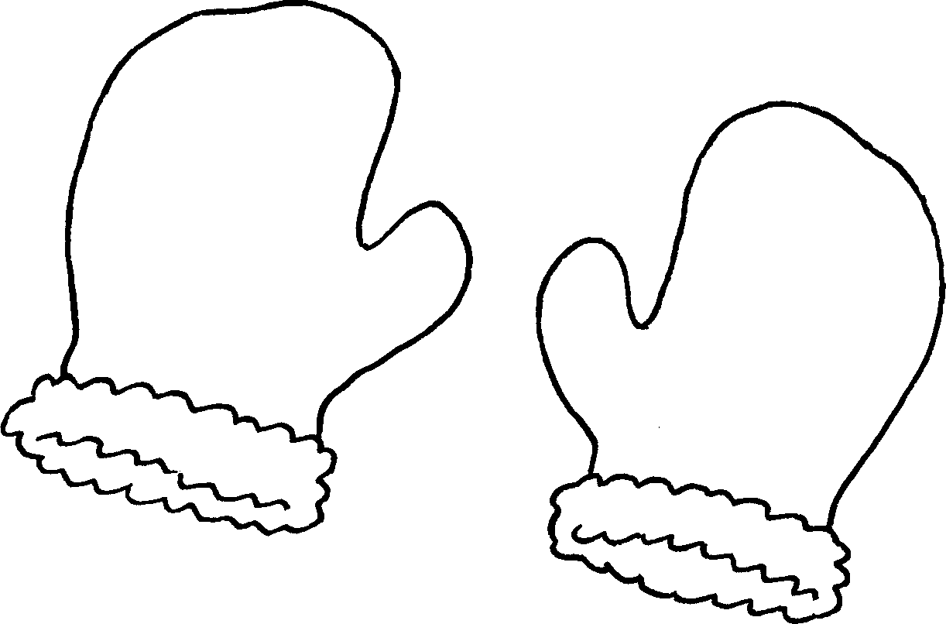 | 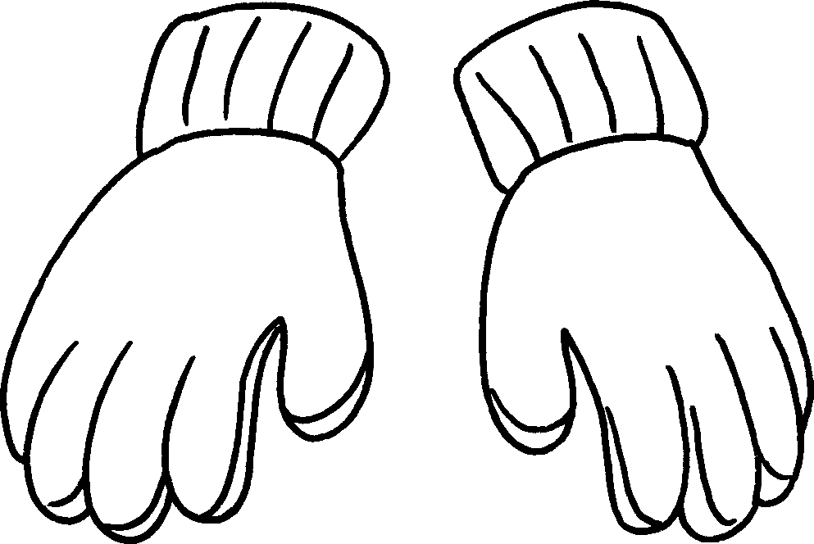 |  | 7 m
 |  |  | 8 g
10
9
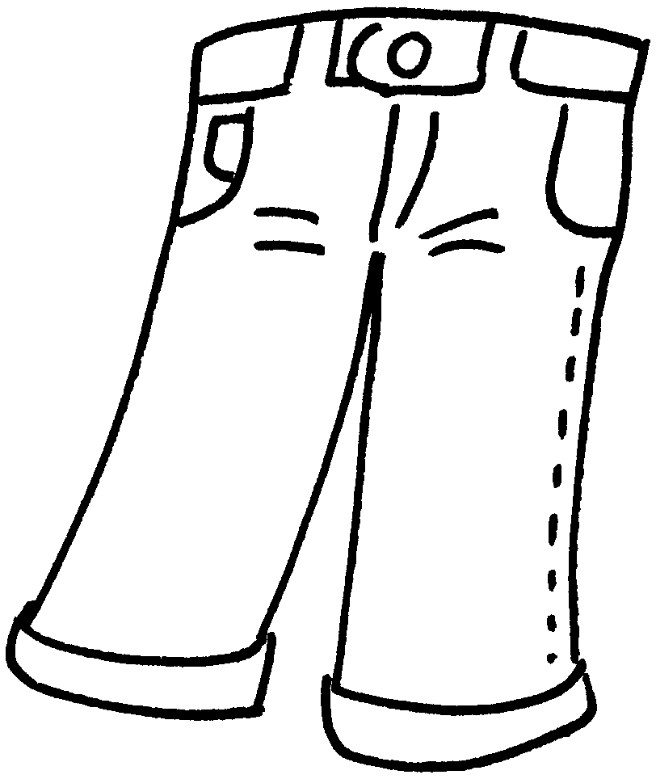 | 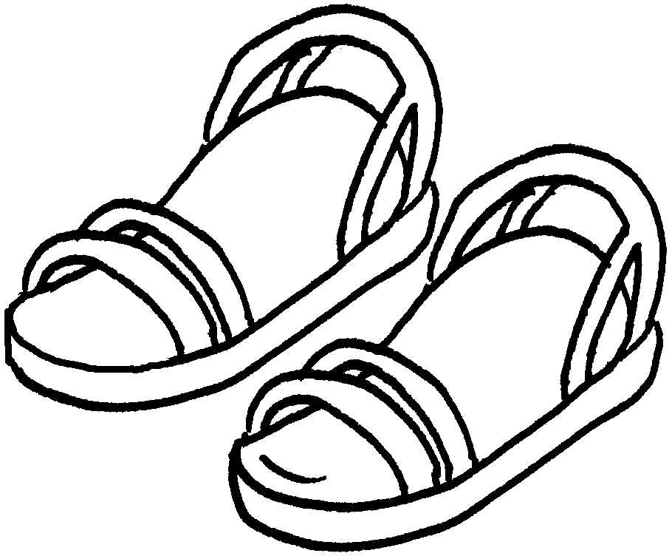 |  | 9 j
 |  |  | 10 s

Book 5A Chapter 3
Remedial Worksheets
Worksheet 3
1 who
2 who reading
3 who is skipping
4 who is looking
5 who is drawing
6 who is sleeping


Book 5A Chapter 3 Graded Worksheets
Worksheet 1⬇⬇
- sunglasses
- glasses
- umbrella
- watch
- suit
- vest
- mittens
- gloves
- jeans
- sandals

