What are they? Write.
2
1
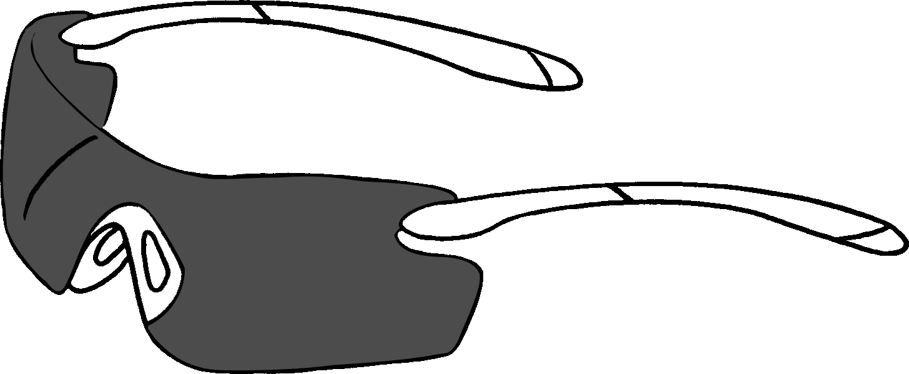 | 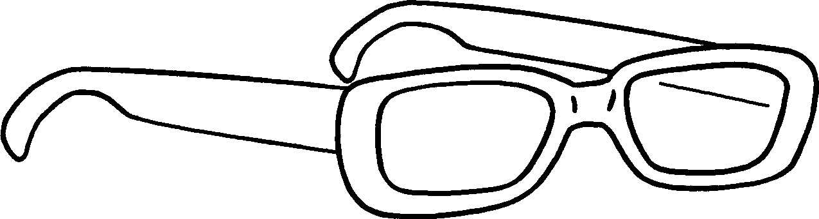 |  | 1
 |  |  | 2
4
3
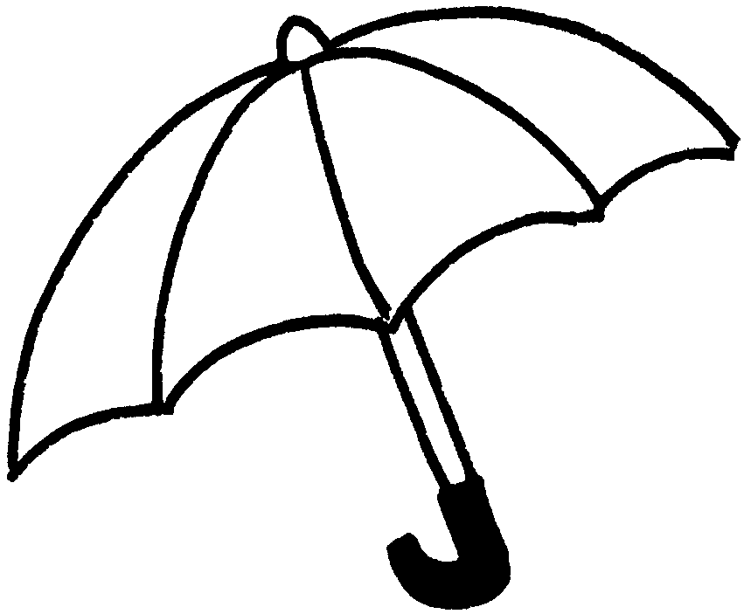 | 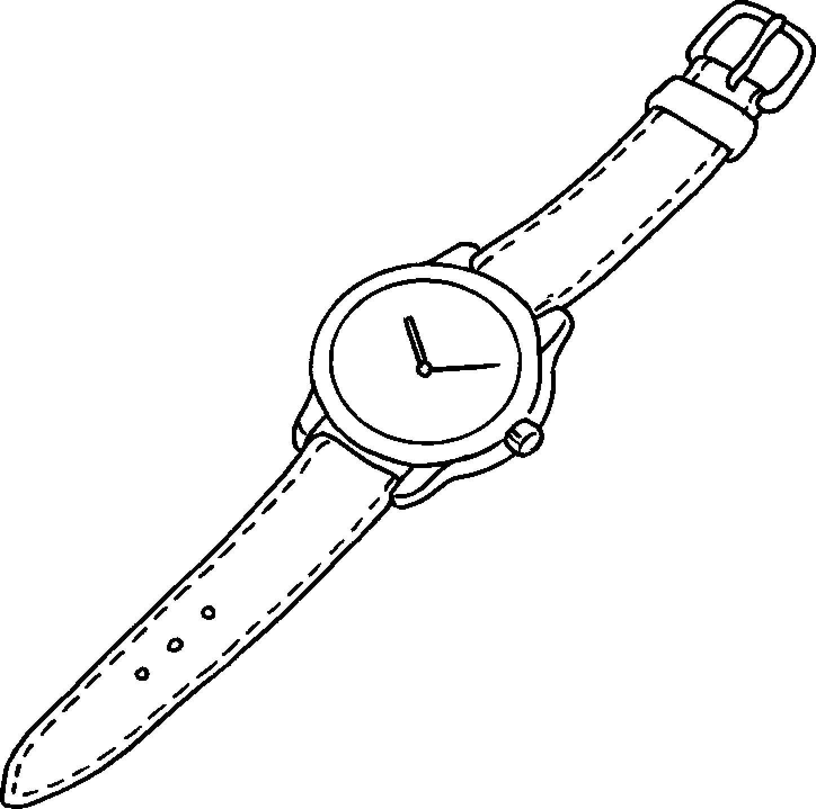 |  | 3
 |  |  | 4
6
5
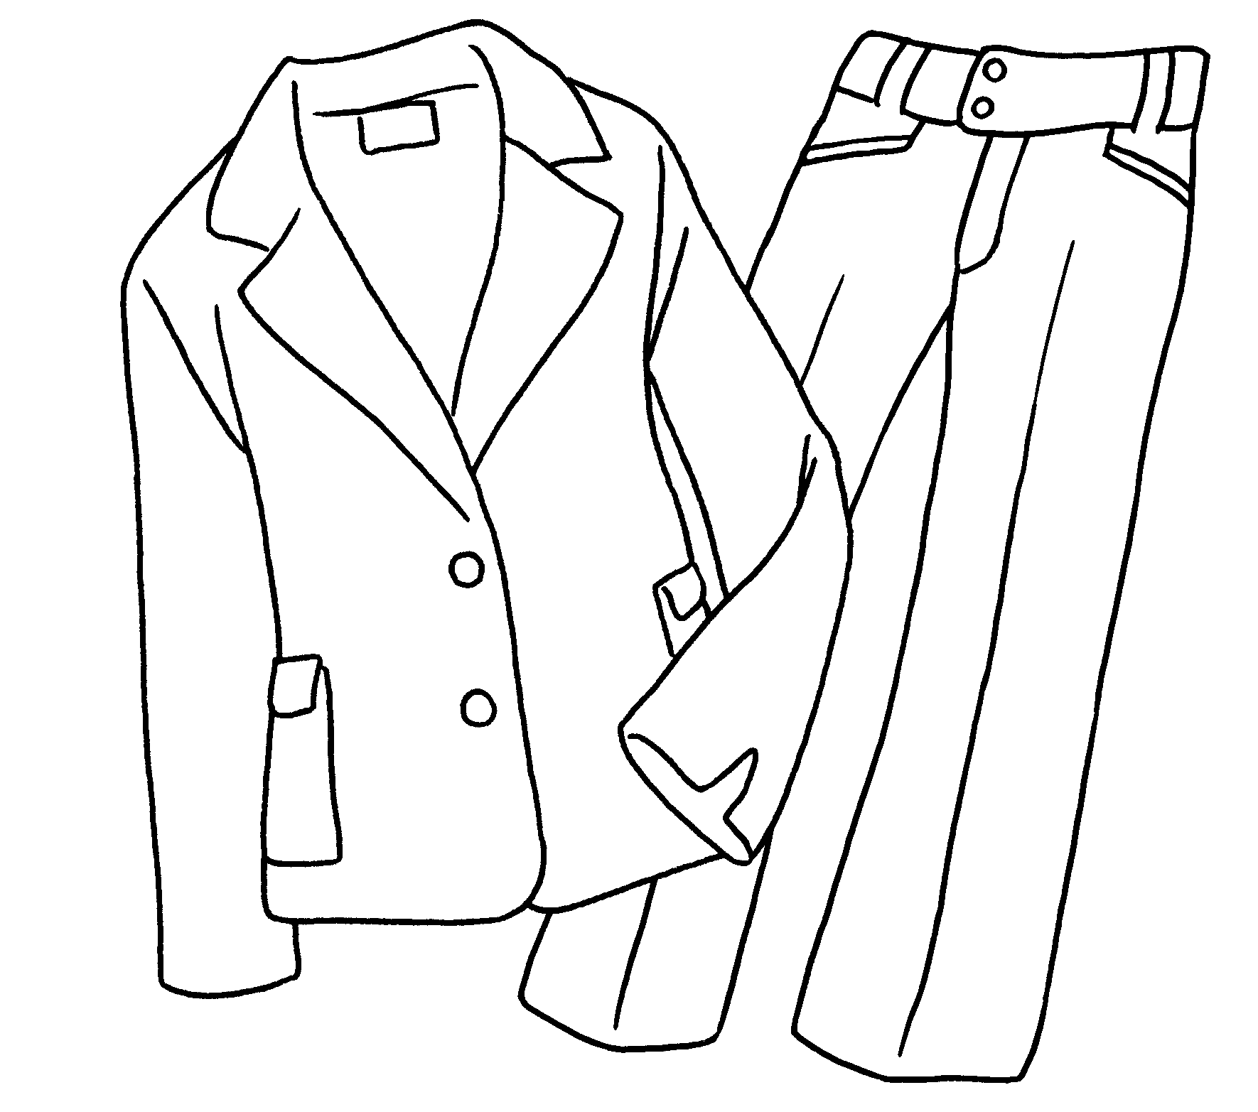 | 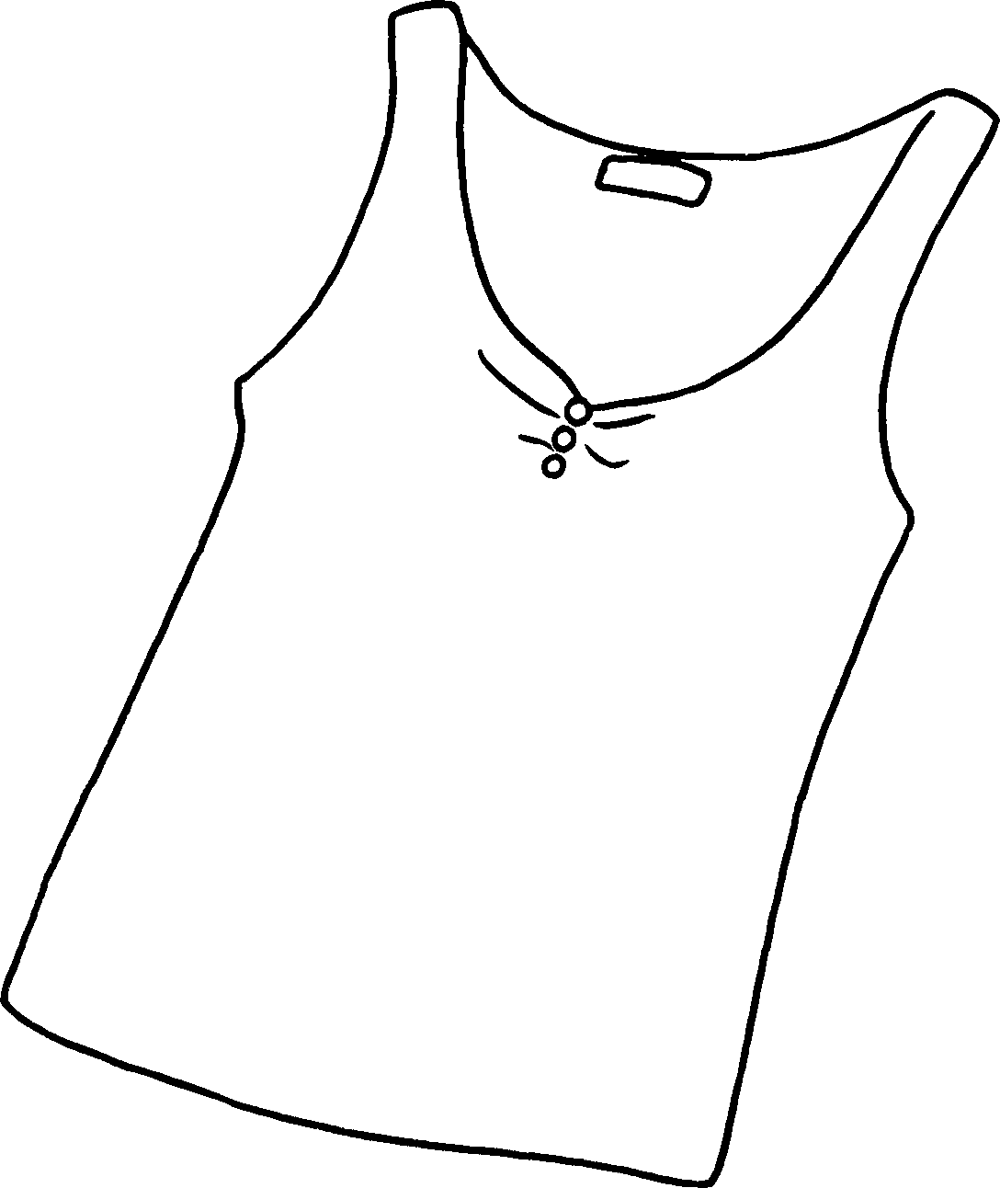 |  | 5
 |  |  | 6
8
7
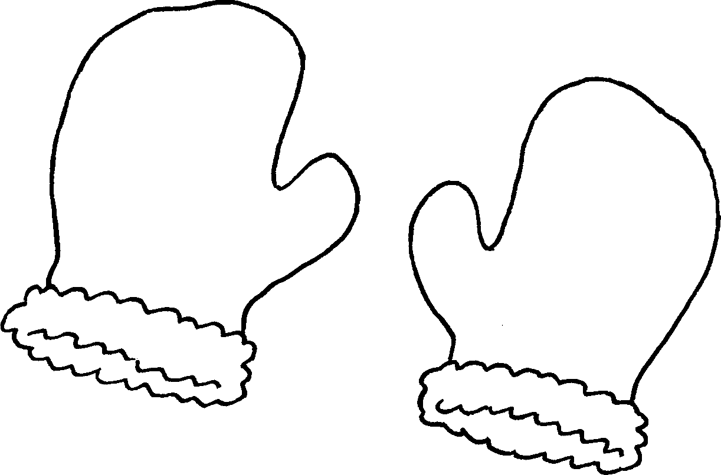 | 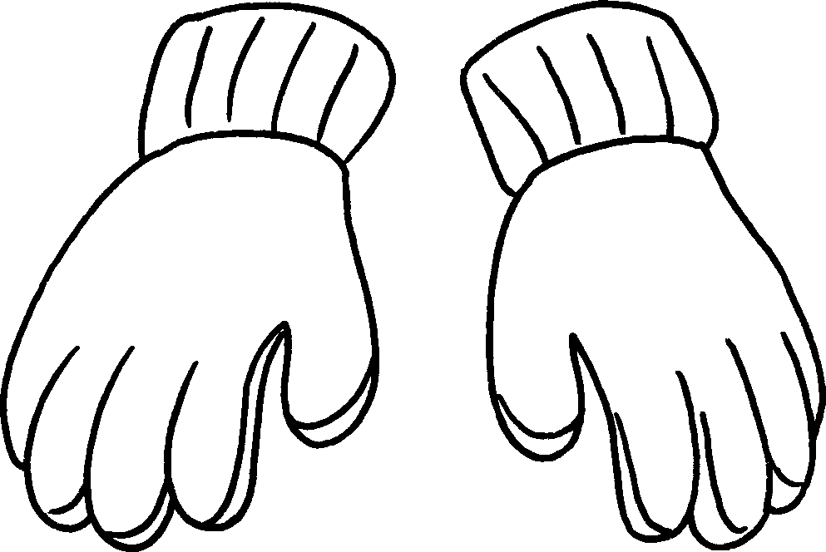 |  | 7
 |  |  | 8
10
9
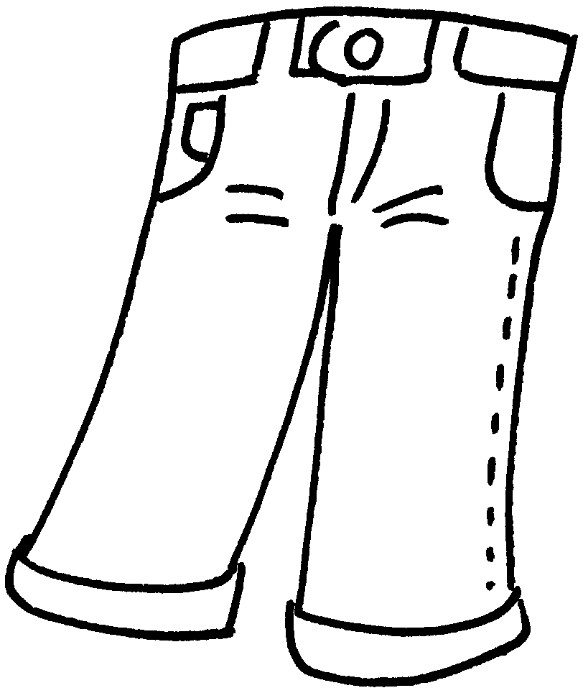 | 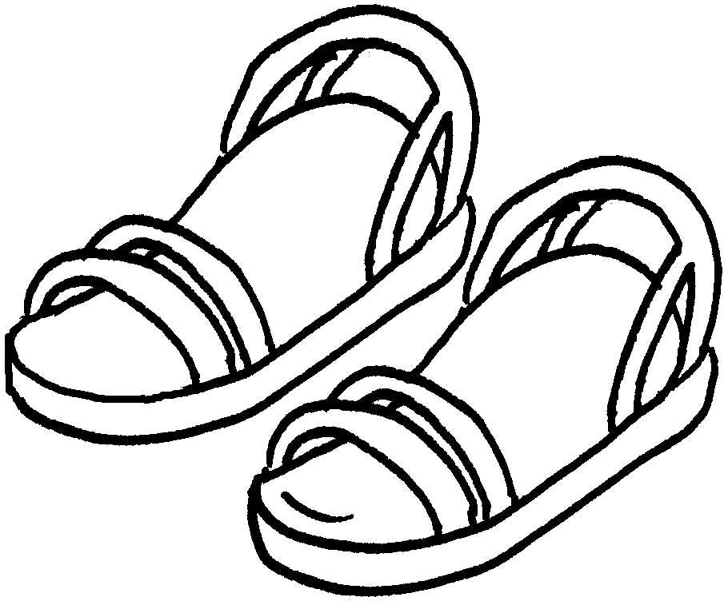 |  | 9
 |  |  | 10

Book 5A Chapter 3
Remedial Worksheets
Worksheet 3
1 who
2 who reading
3 who is skipping
4 who is looking
5 who is drawing
6 who is sleeping
Book 5A Chapter 3
Remedial Worksheets
Worksheet 3
1 who
2 who reading
3 who is skipping
4 who is looking
5 who is drawing
6 who is sleeping


Book 5A Chapter 3 Graded Worksheets
Worksheet 1⬇⬇⬇
- sunglasses
- glasses
- an umbrella
- a watch
- a suit
- a vest
- mittens
- gloves
- jeans
- sandals

