Choose and write.

in | with
B
B
B
B
B
A
A
A
A
A
1 | 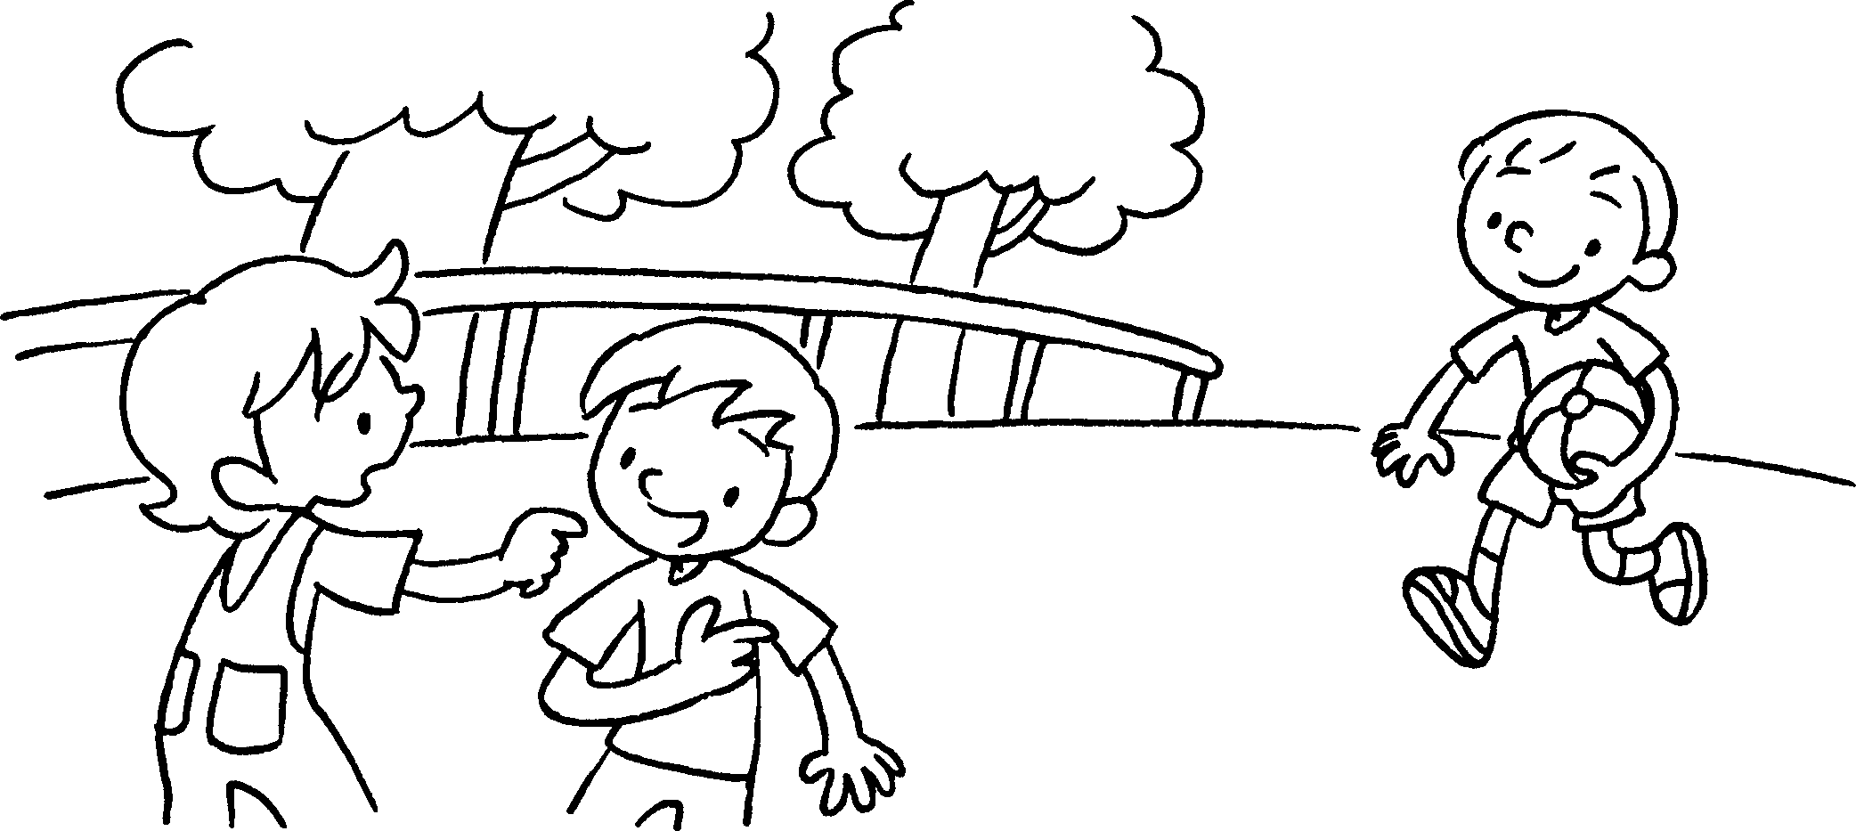 | A : Who’s the boy the round face?  B : That’s Danny.
2 | 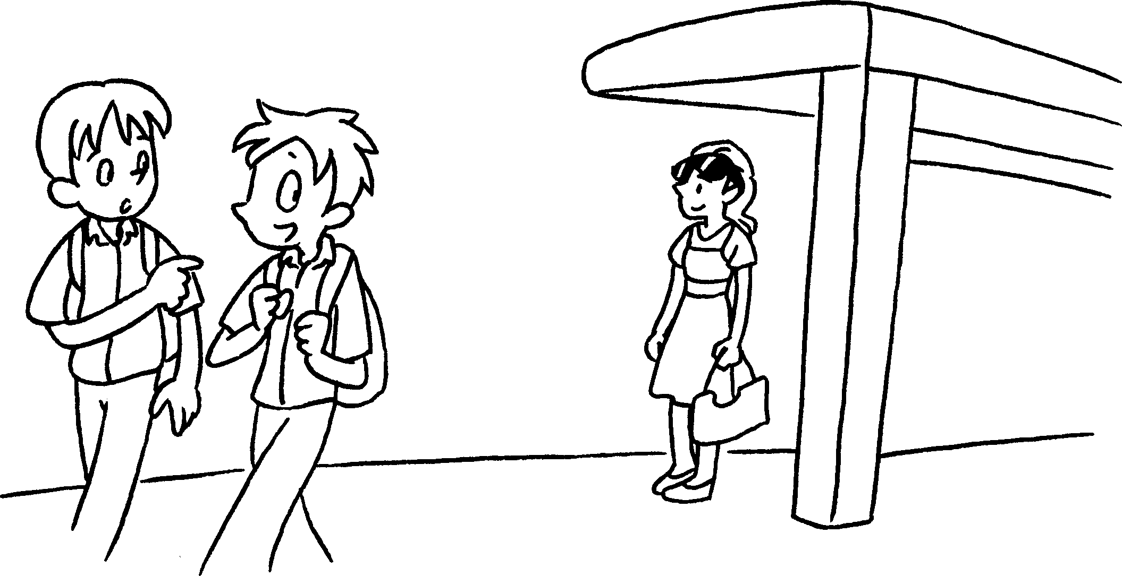 | A : Who’s the girl the sunglasses?  B : That’s Sue.
3 | 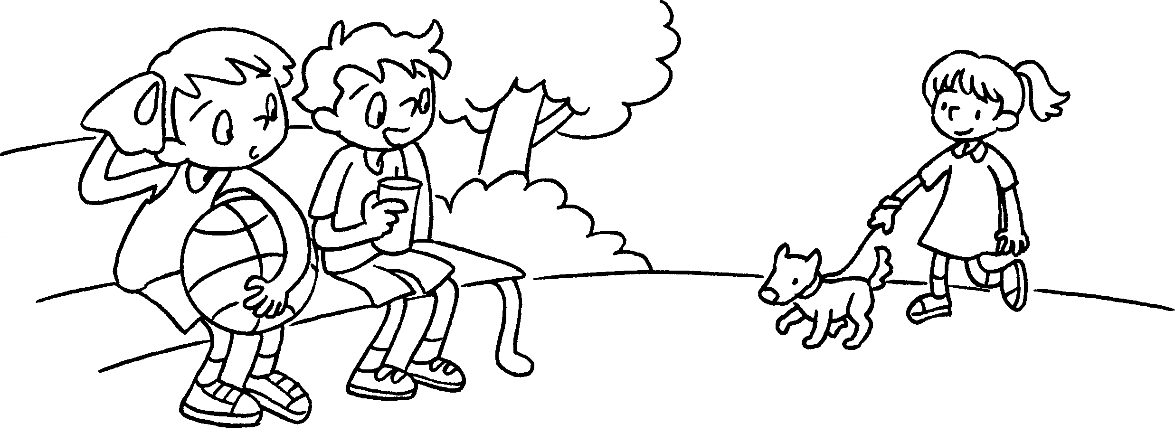 | A : Who’s the girl the dress?  B : That’s Kitty.
4 | 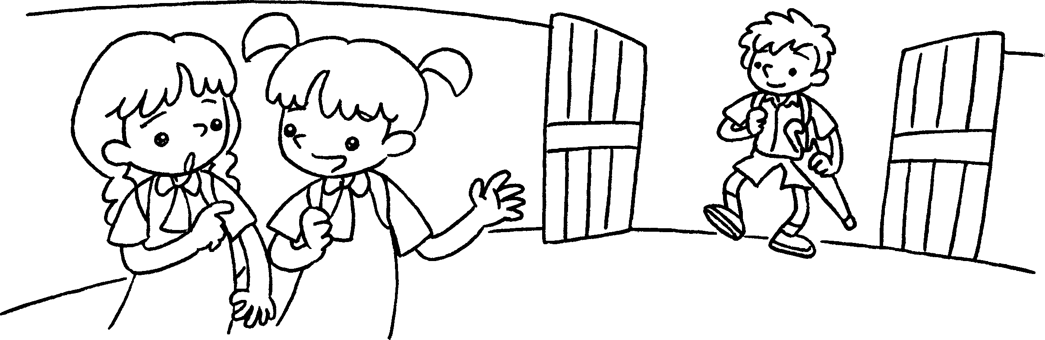 | A : Who’s the boy the umbrella?  B : That’s Jimmy.
5 | 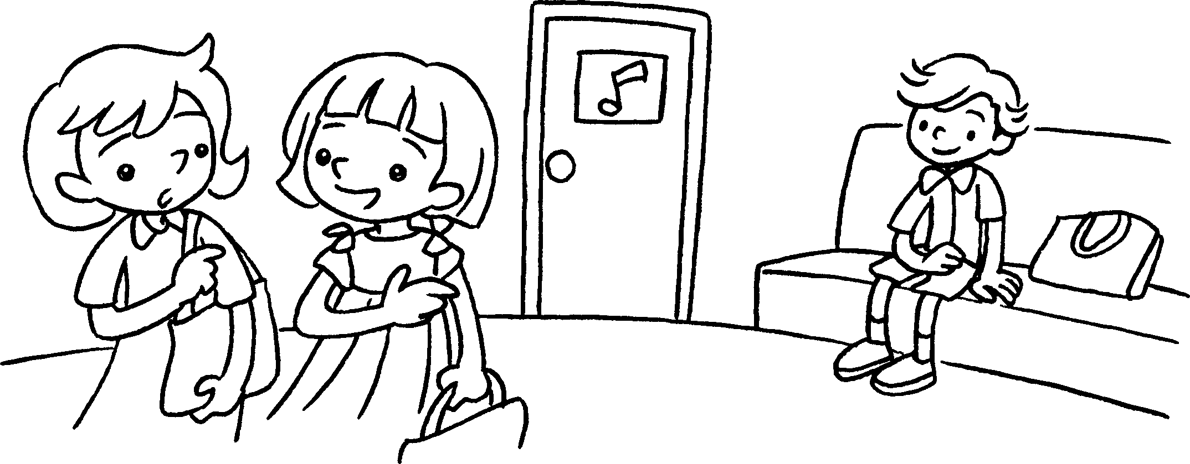 | A : Who’s the boy the bow tie?  B : That’s Donald.


Book 5A Chapter 3 Graded Worksheets
Worksheet 2⬇
- with
- with
- in
- with
- in (‘with’ is also acceptable)

