Finish the questions and answers.

1  B  B  B  B  B  A  A  A  A  A | 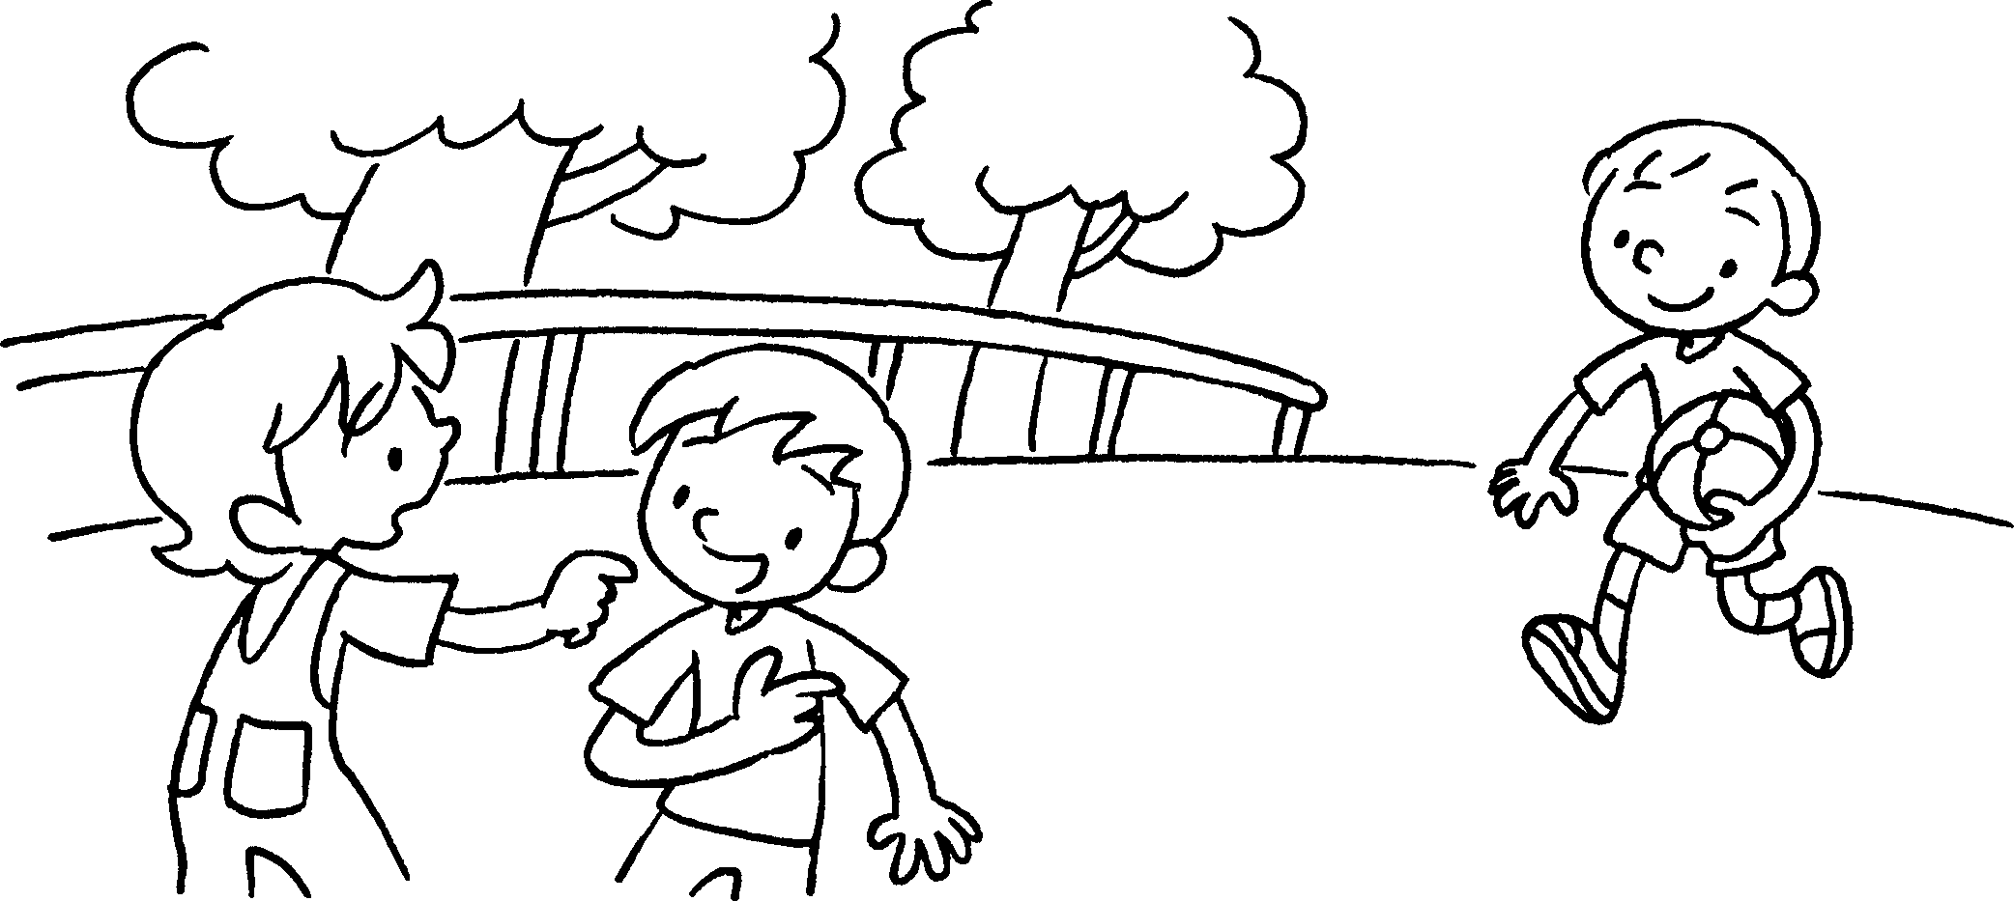 | A : Who’s the boy the round face?  B : That’s Danny.
2 | 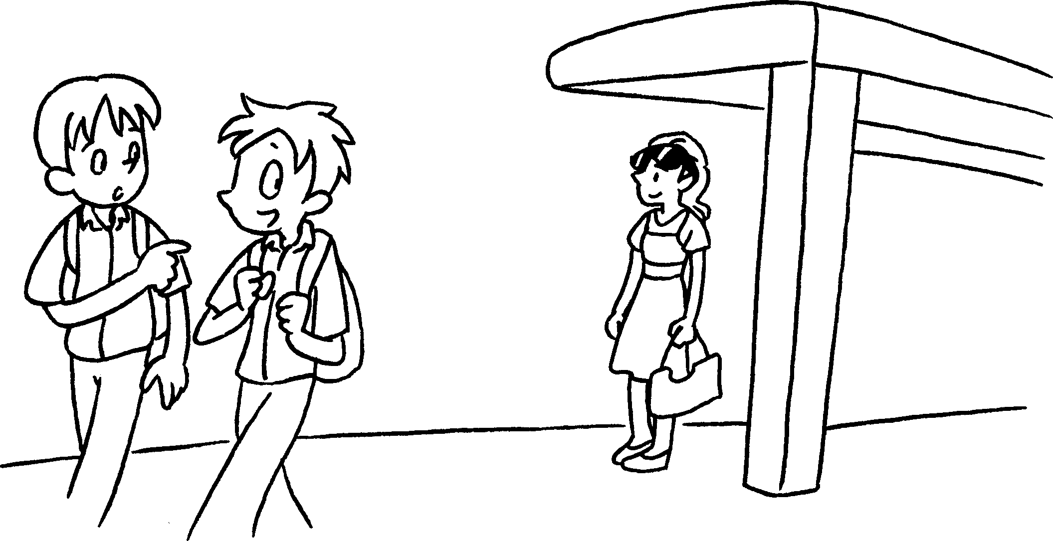 | A : Who’s the girl the sunglasses?  B : That’s Sue.
3 | 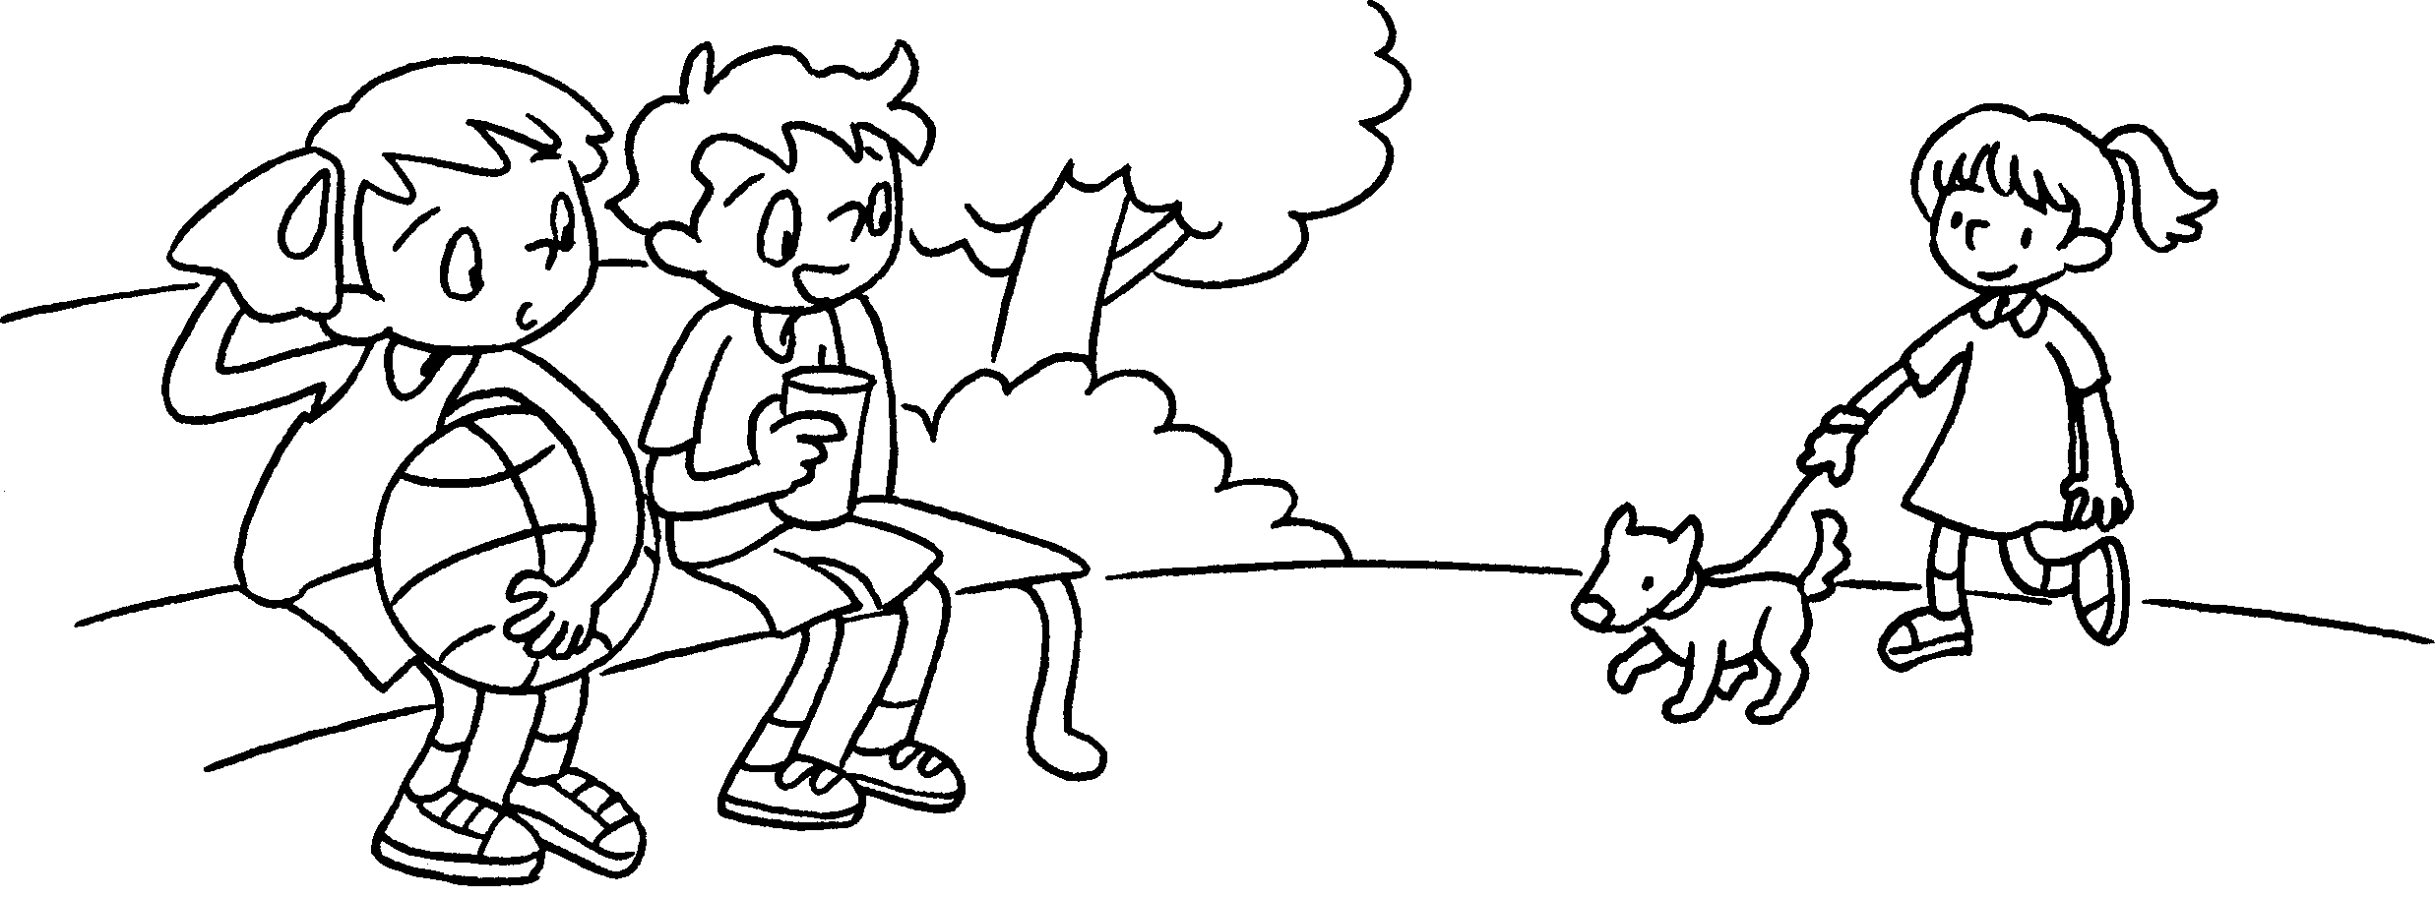 | A : the girl the dress?  B : Kitty.
4 | 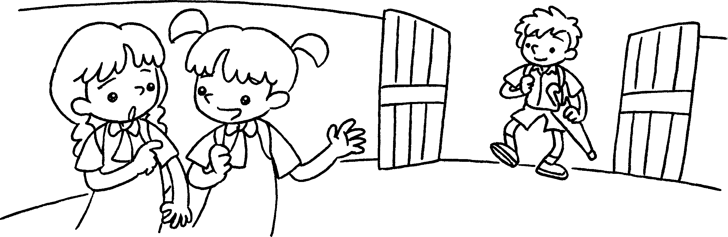 | A : the boy the umbrella?  B : Jimmy.
5 | 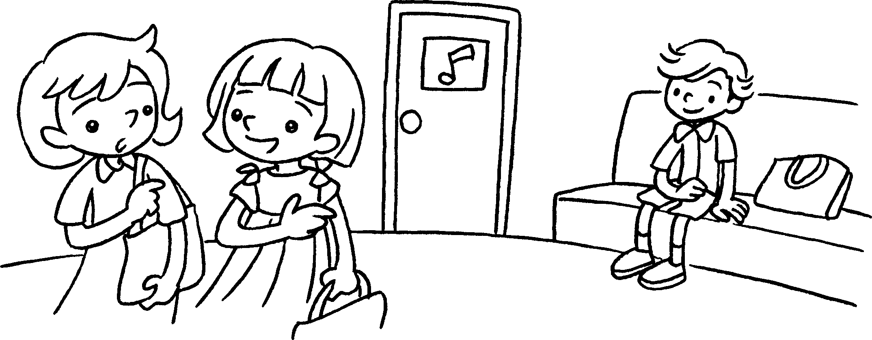 | A : the boy the bow tie?  B : Donald.


Book 5A Chapter 3 Graded Worksheets
Worksheet 2⬇⬇
- with
- with
- Who’s in
That’s
4 Who’s with
That’s
5 Who’s in (‘with’ is also acceptable)
That’s

