Finish the questions and answers.

1  B  B  B  B  B  A  A  A  A  A | 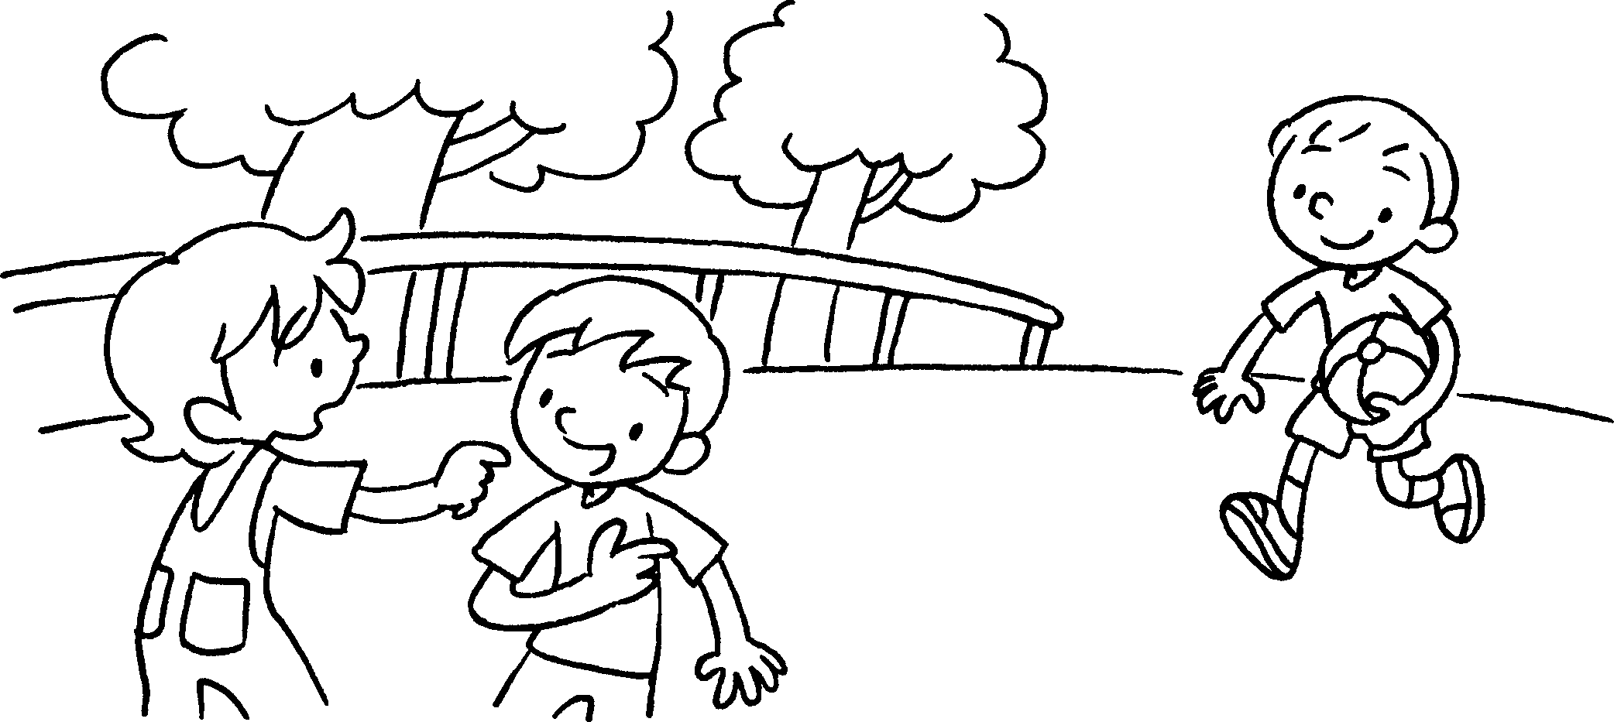 | A : Who’s the boy the round face?  B : That’s Danny.
2 | 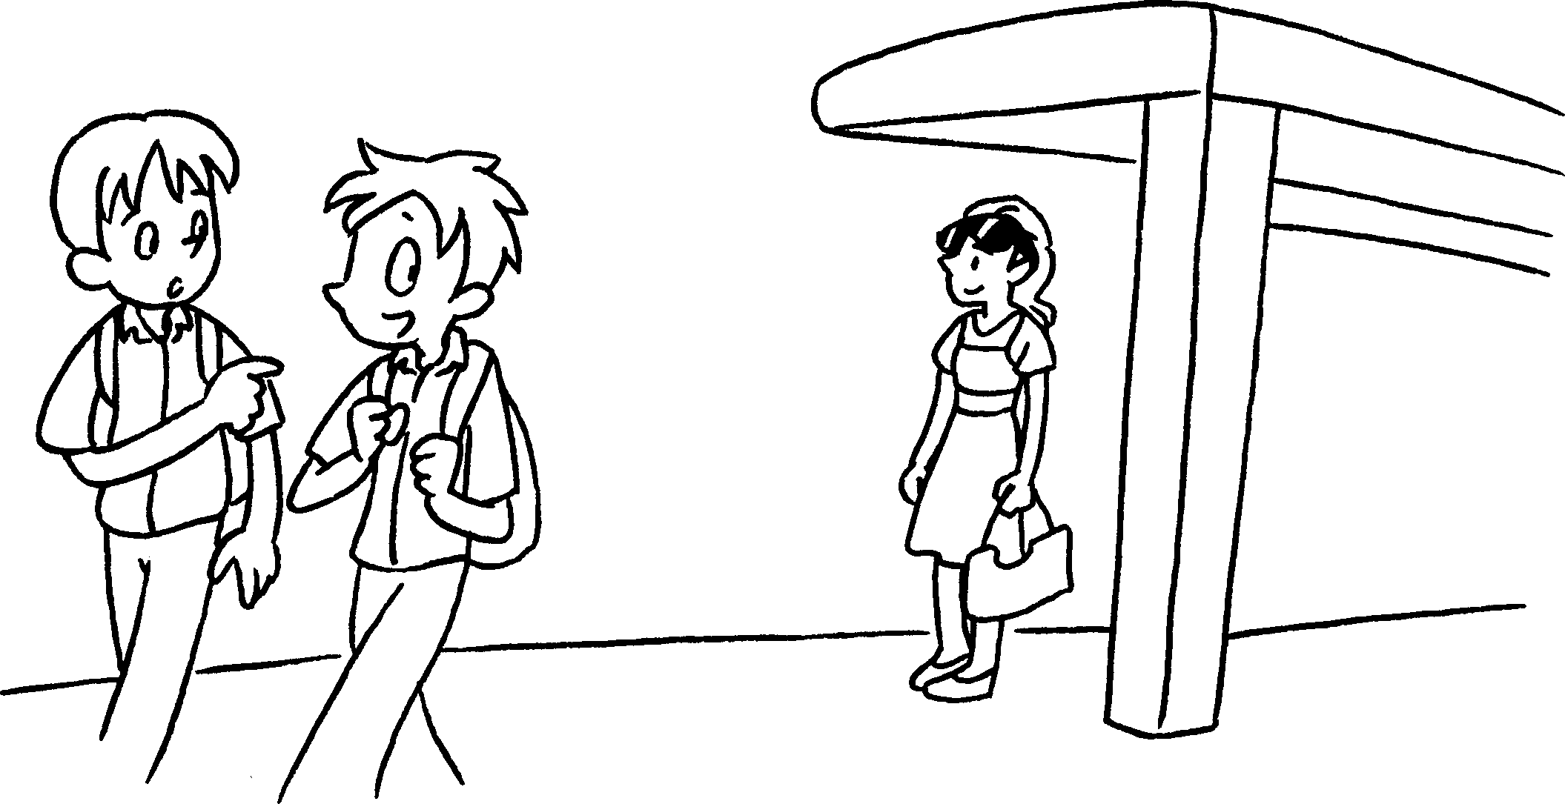 | A : Who’s the girl the sunglasses?  B : That’s Sue.
3 | Kitty  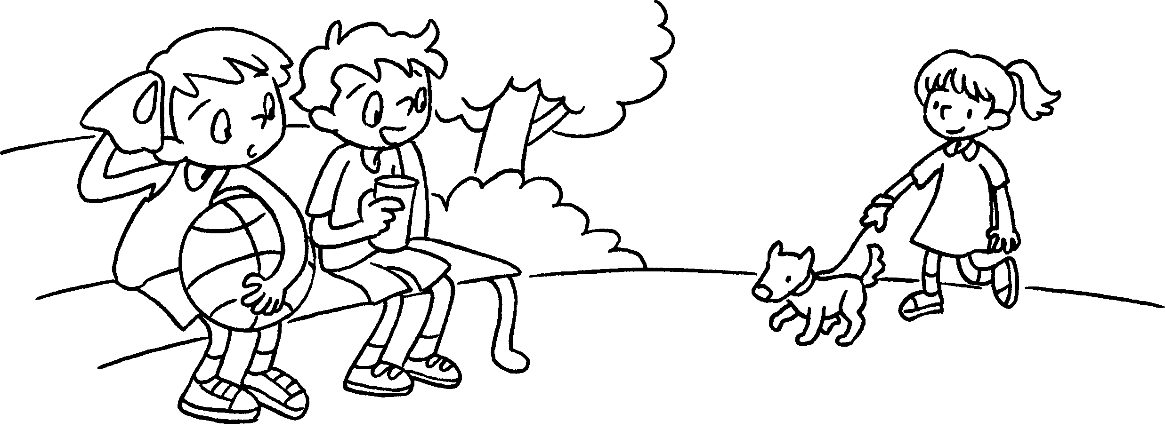 | A : the girl the dress?  B :
4 | Jimmy  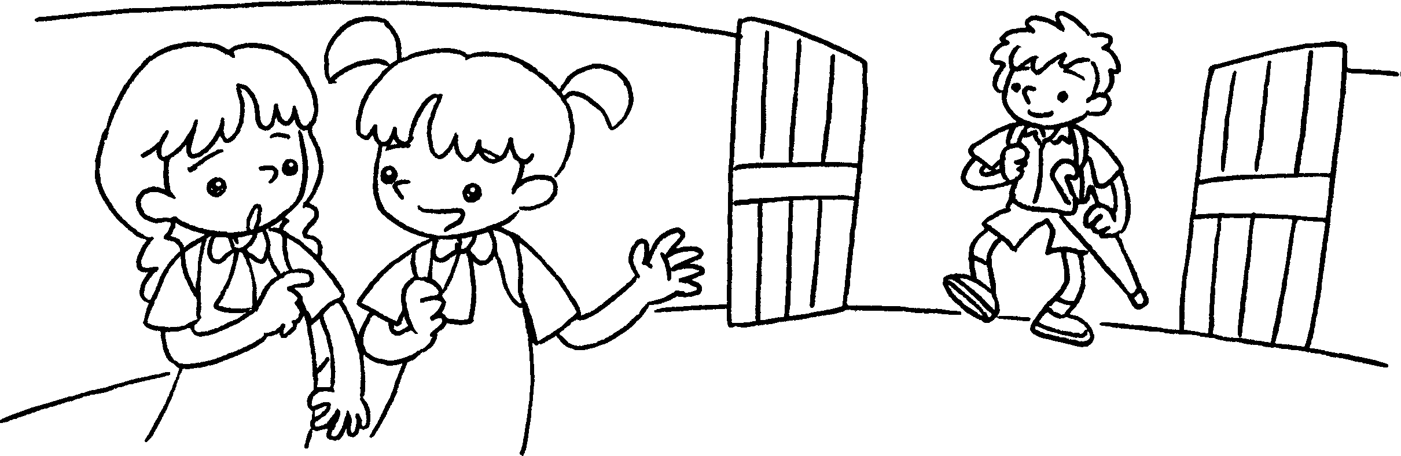 | A : ________________________________  ________________________________  B : ________________________________
5 | Donald  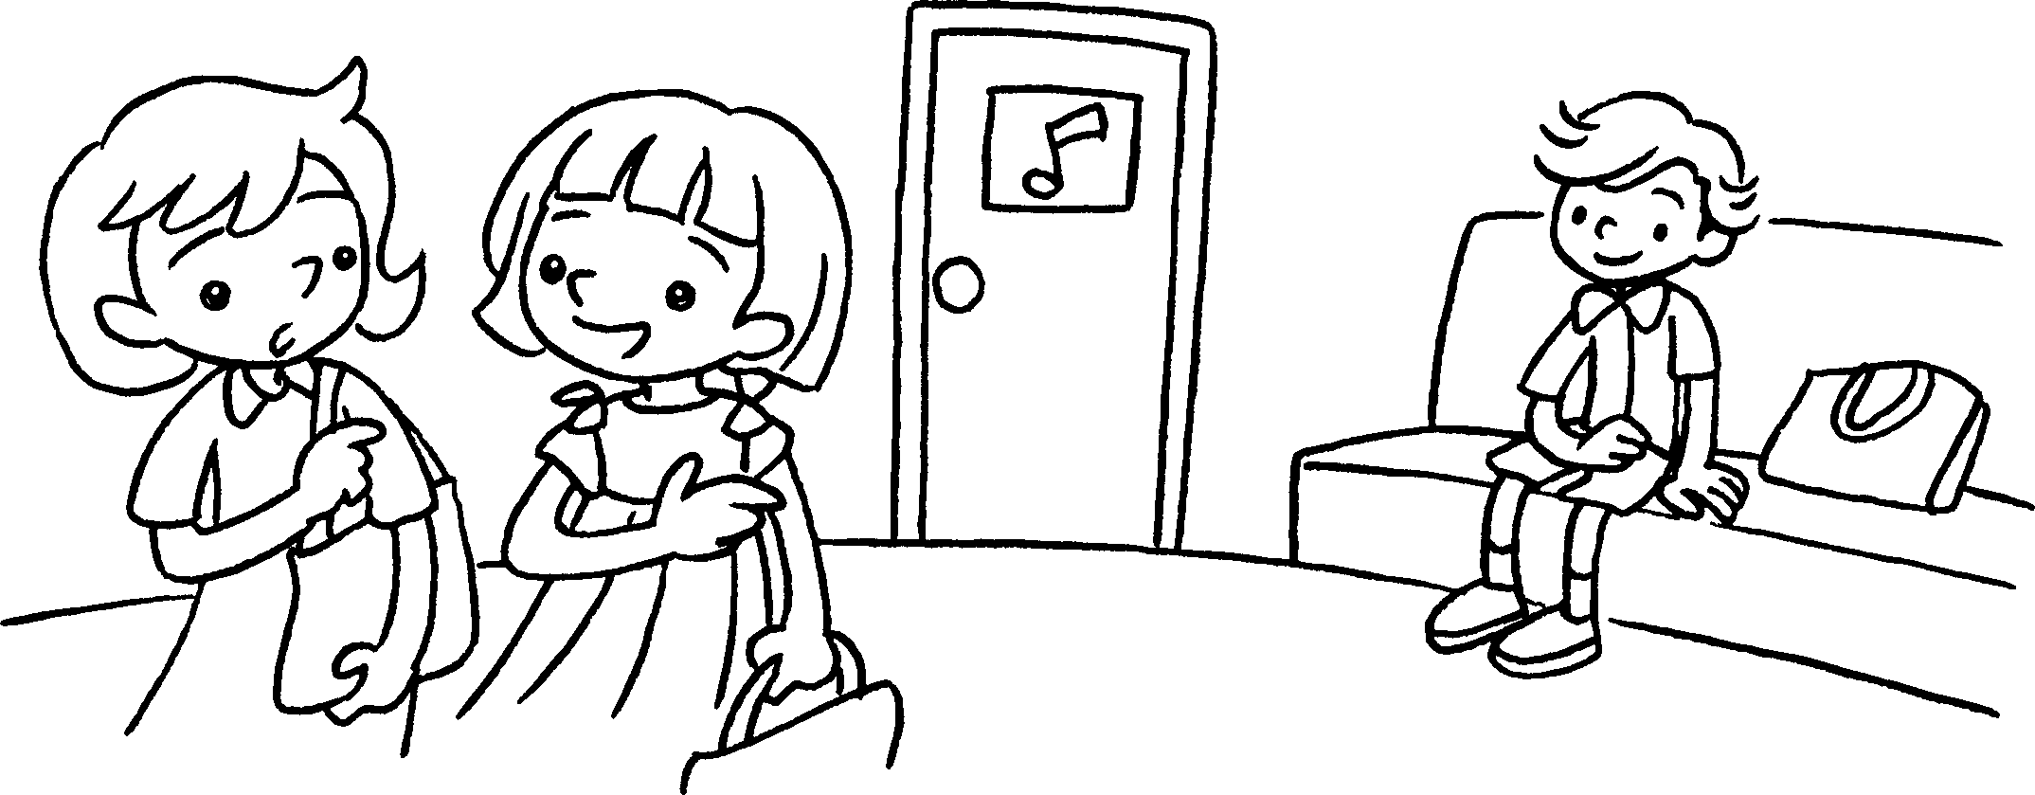 | A : ________________________________  ________________________________  B : ________________________________


Book 5A Chapter 3 Graded Worksheets
Worksheet 2⬇⬇⬇
- with
- with
- Who’s in
That’s Kitty.
- Who’s the boy with the umbrella?
That’s Jimmy.
5 Who’s the boy in / with the bow tie?
That’s Donald.

