Finish the sentences using ‘who’ and ‘is …ing’.

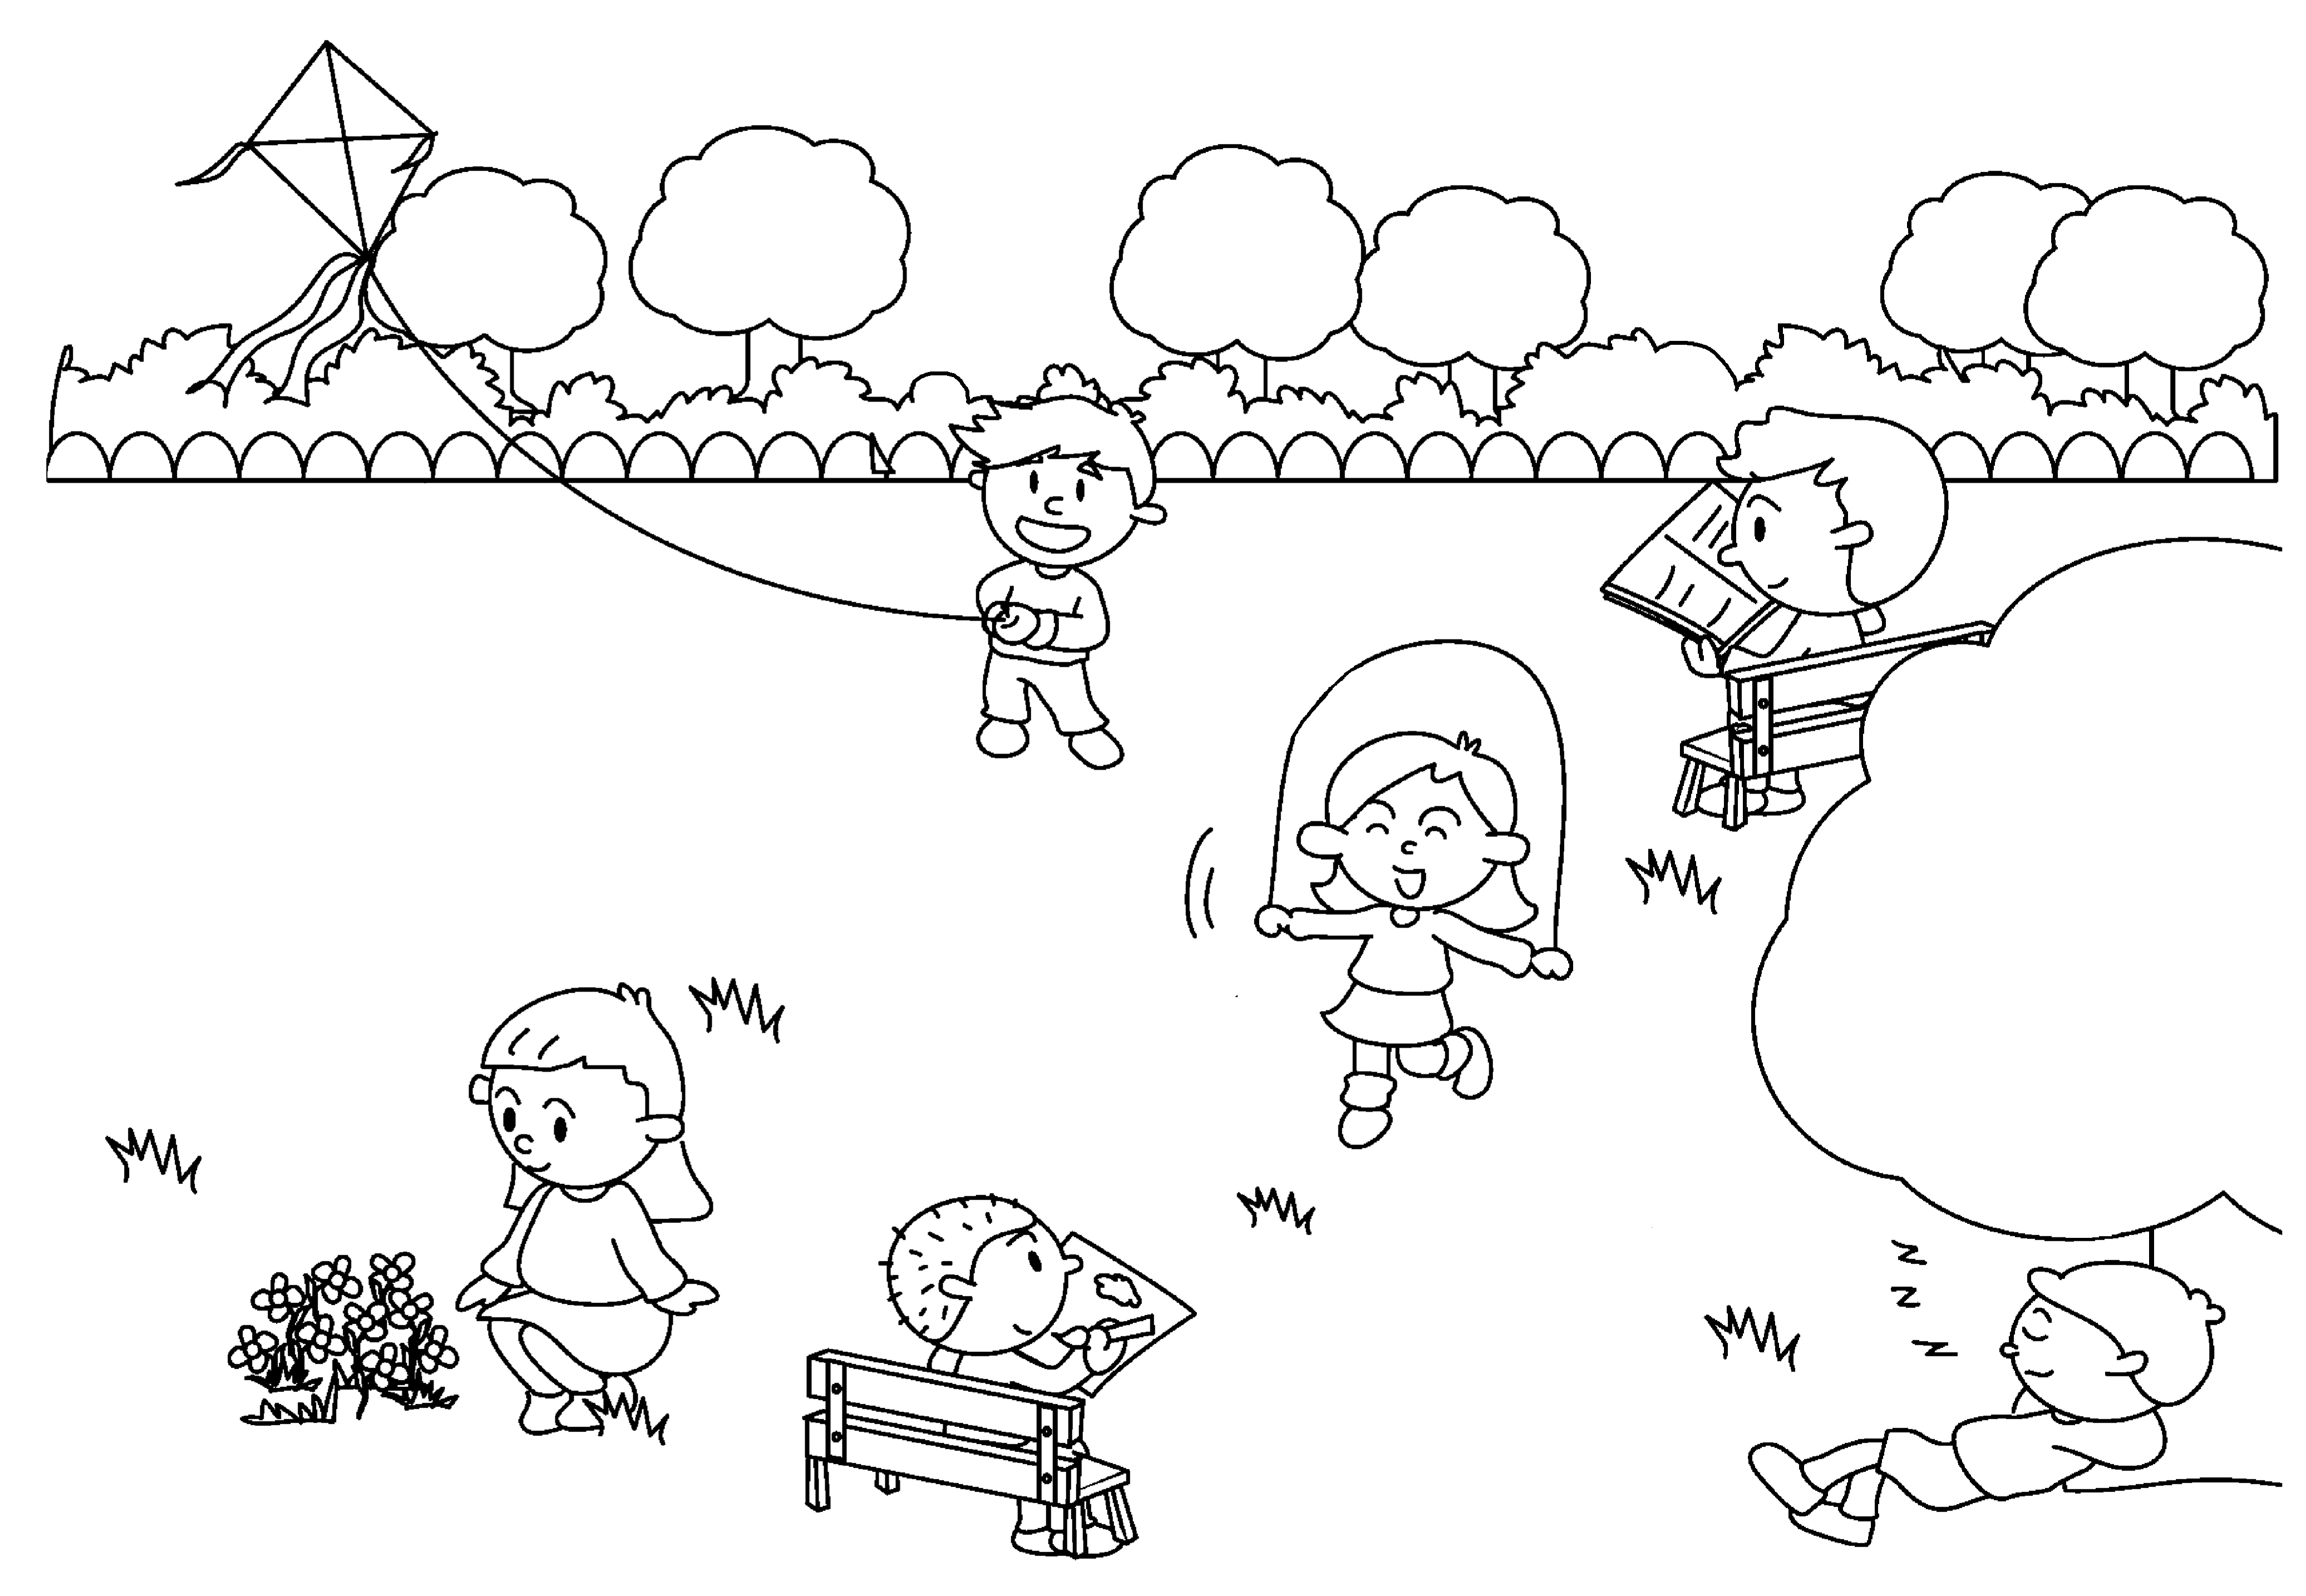
1
2
3
4
5
6
Mabel
John
Ruby
David
Ben
Simon

1 | Simon is the boy is flying a kite.
2 | John is the boy is ( read ).
3 | Mabel is the girl ( skip ).
4 | Ruby is the girl ( look ) at the flowers.
5 | David is the boy ( draw ).
6 | Ben is the boy ( sleep ).


Book 5A Chapter 3 Graded Worksheets
Worksheet 3⬇
- who
- who reading
- who is skipping
- who is looking
- who is drawing
- who is sleeping

