Finish the sentences using ‘who’ and ‘is …ing’.
sleep fly read
draw skip look at

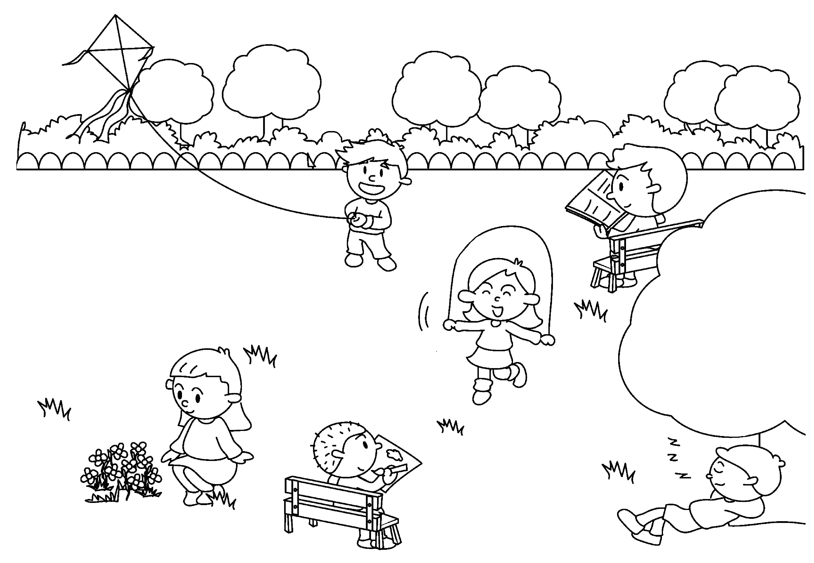
1
2
3
4
5
6
Mabel
John
Ruby
David
Ben
Simon

1 | Simon is the boy who is a kite.
2 | John is the boy is .
3 | Mabel is the girl .
4 | Ruby is the flowers.
5 | David is .
6 | Ben is .


Book 5A Chapter 3 Graded Worksheets
Worksheet 3⬇⬇
- flying
- who reading
- who is skipping
- the girl who is looking at
- the boy who is drawing
- the boy who is sleeping

