- The New Cinderella (Part 1)
Do you know the popular fairy tale* Cinderella? Read this play. How is it different from the Cinderella story you know?
* A fairy tale is a children’s story in which magical things can happen.

A list of people in the play
Characters
Cinderella (not his real name) ― a poor boy
Chris and Paul ― Cinderella’s rich step-brothers
‘Princess’ Peach ― a very rich girl
Fairy Godmother
Party guests

Setting – where the scene takes place
Act 1 Scene 1: In the hallway of a large house
Cinderella, dressed in dirty old clothes, is sweeping the floor. Enter Chris and Paul, laughing.
Chris : We’re going to ‘Princess’ Peach’s castle.
Stage direction – what the characters do and how they speak
Paul : Don’t forget to do the ironing.
Exit Chris and Paul.
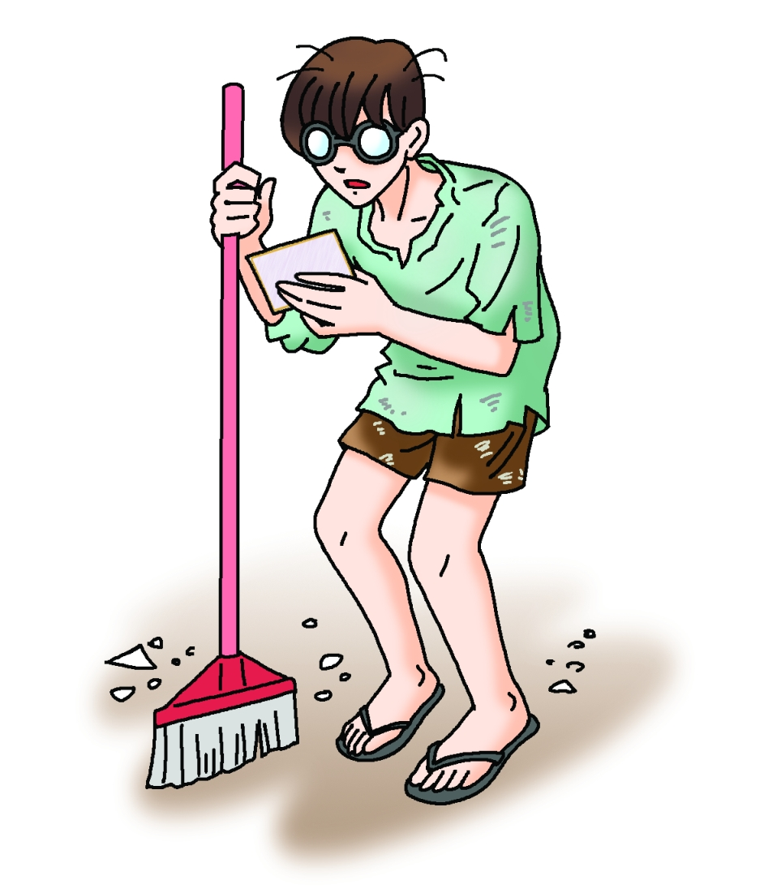
Cinderella : (sadly) My step-brothers always
make me do housework. They
call me Cinderella, like the girl in
the fairy tale. Today they’re
going to a pool party. Oh, here’s their invitation.

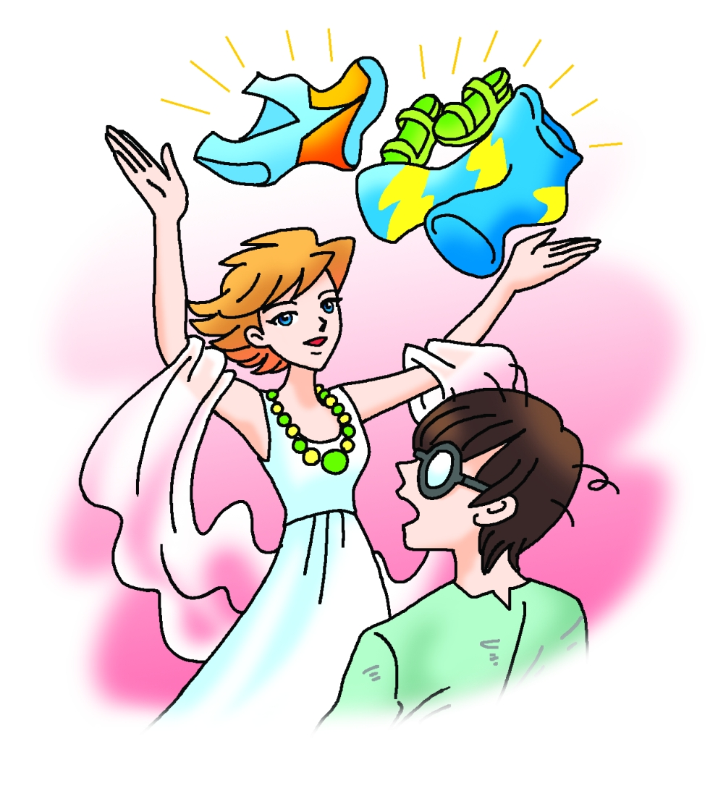
Enter a woman in a white dress.
Fairy : I’m your fairy godmother. You can go to the pool party now.
Book 5A Chapter 3
Simplified reading passage
Cinderella: (excitedly) Fantastic!
Fairy : Put on this beachwear. Let’s go!
Both exit quickly.

Act 1 Scene 2: At the pool party
People are dancing and chatting.
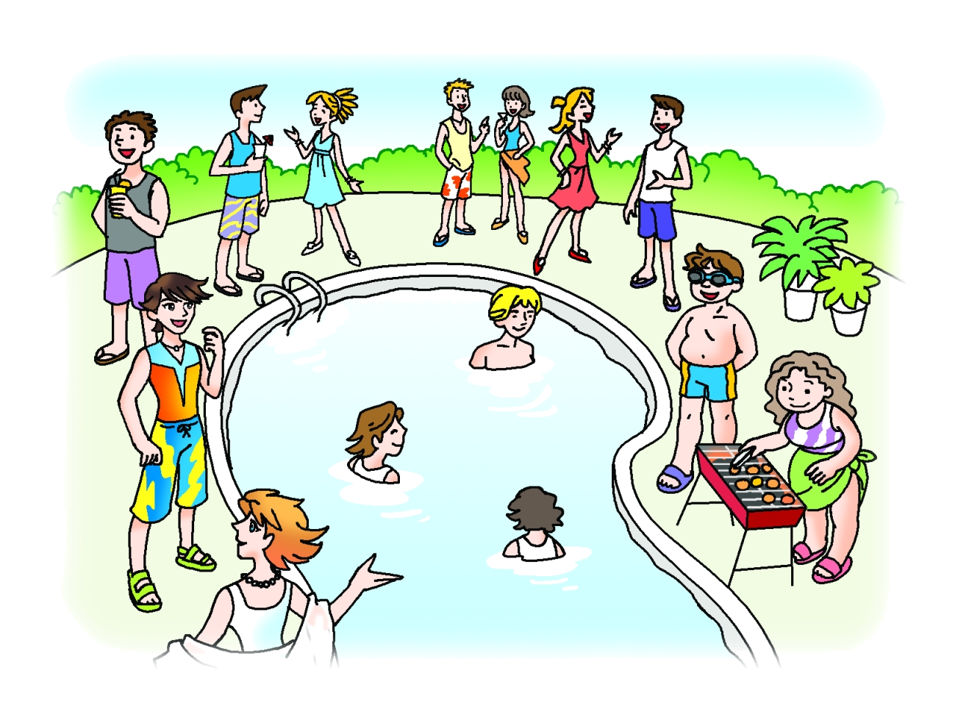
Enter Cinderella and Fairy Godmother.
Cinderella: (excitedly) There are a lot of people
here. Who’s the boy with the goggles?
Fairy : That’s Zhu. His father is very wealthy.
Zhu’s sister is the girl with the curly hair.
Cinderella: Where?
Fairy : Next to the barbecue. She’s the girl who
is cooking.
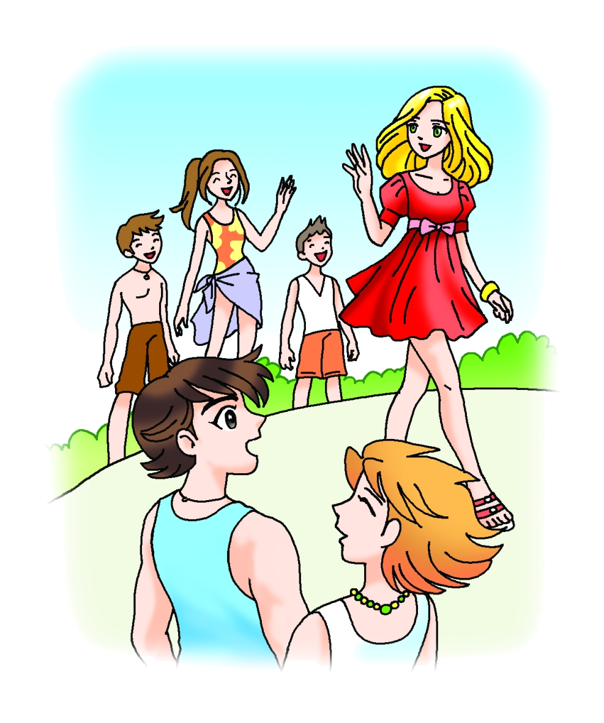
Enter ‘Princess’ Peach.
Cinderella: Who’s that?
Fairy : Who?
Cinderella: The girl in the red dress, the girl with
the lovely eyes, the girl with the
perfect face, the girl …
Fairy : That’s ‘Princess’ Peach.
Peach : Hello. Would you like to dance?
Cinderella: I, erm, I, well …
Fairy : Go on … (whispering in Cinderella’s ear)
Have fun, but you must leave before midnight.
Exit Cinderella and ‘Princess’ Peach dancing.

