Choose and write.
backpack | comb |  | hairbrush |  | mirror
earrings |  | necklace |  | ring

1 | 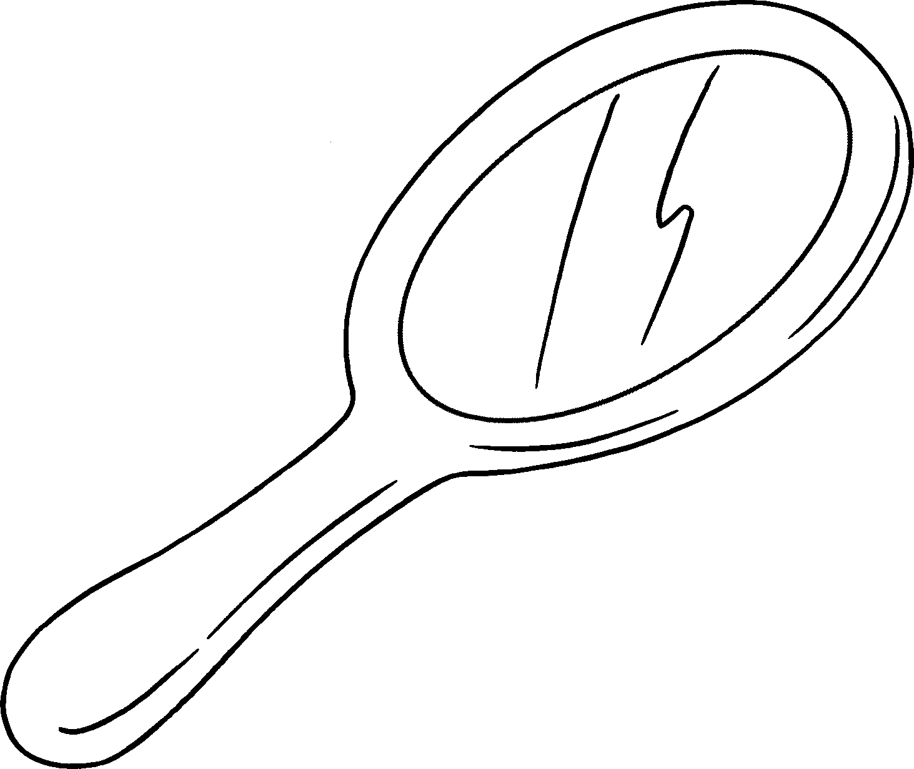 |  |  |  | 2 | 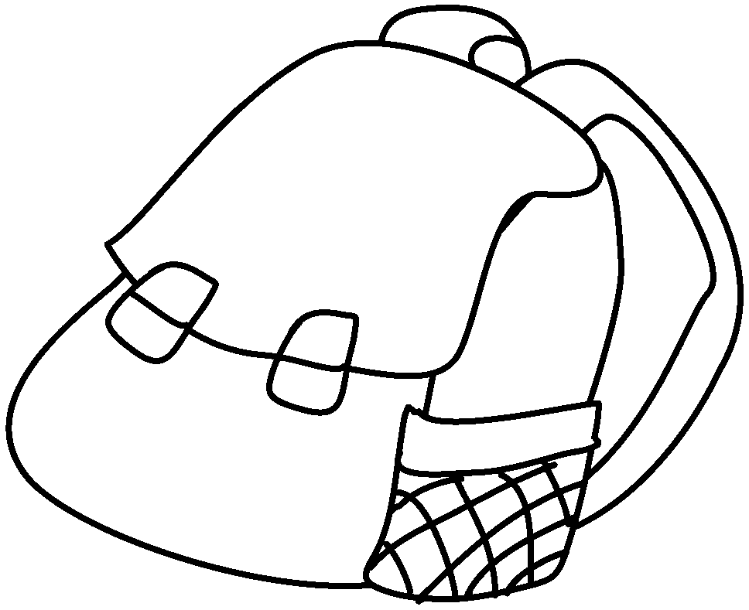
 | a |  |  |  |  | a
3 | 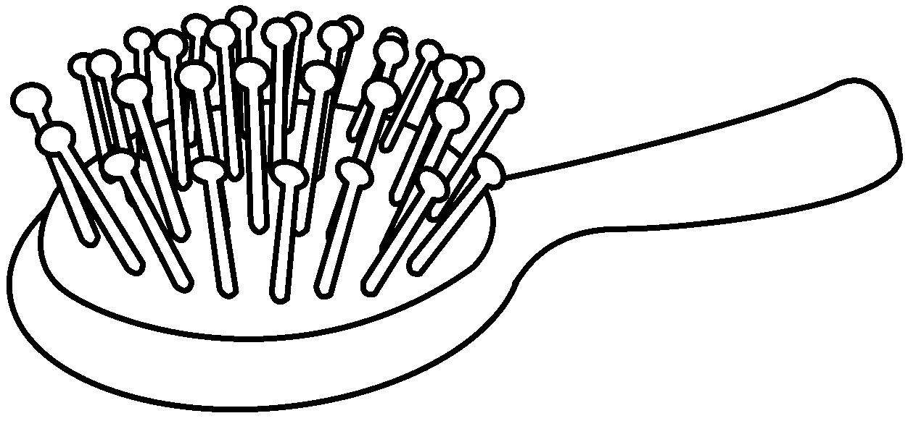 |  |  |  | 4 | 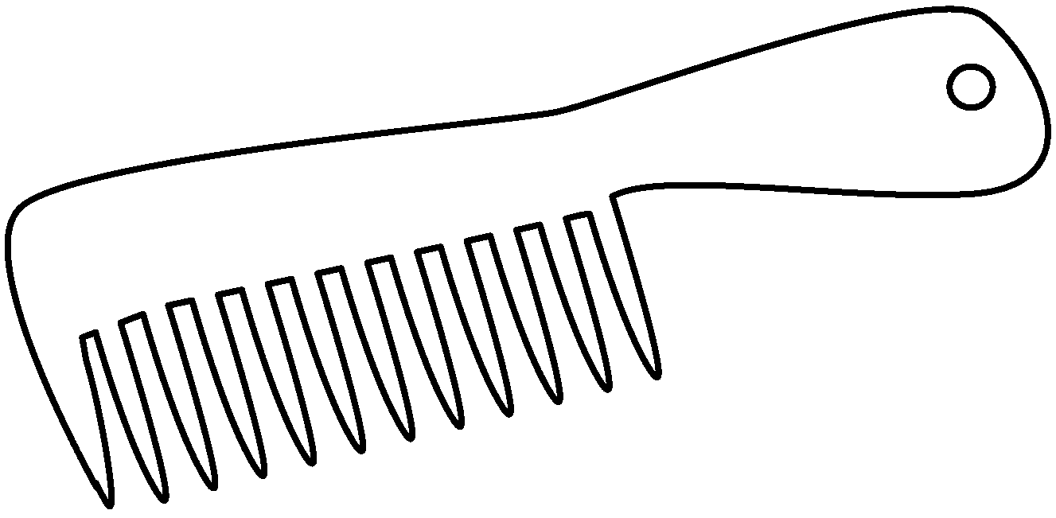
 | a |  |  |  |  | a
5 | 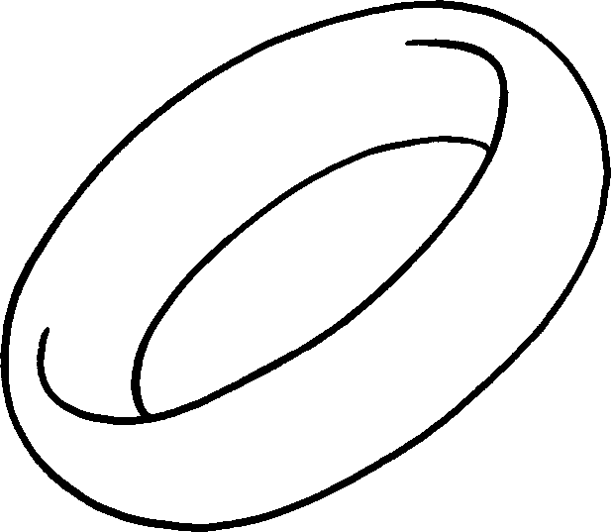 |  |  |  | 6 | 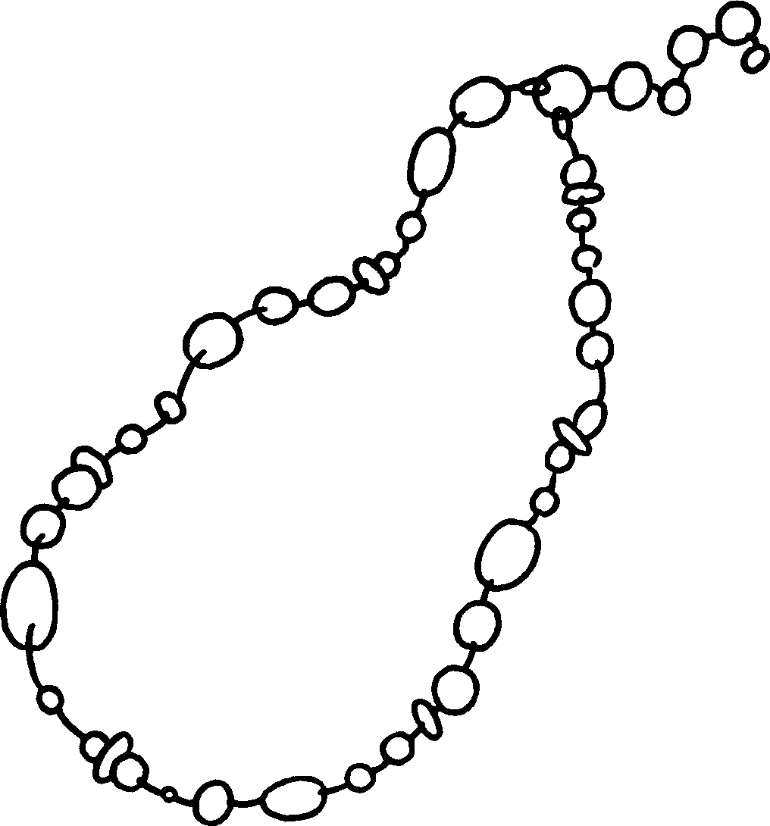
 | a |  |  |  |  | a
 |  | 7 | 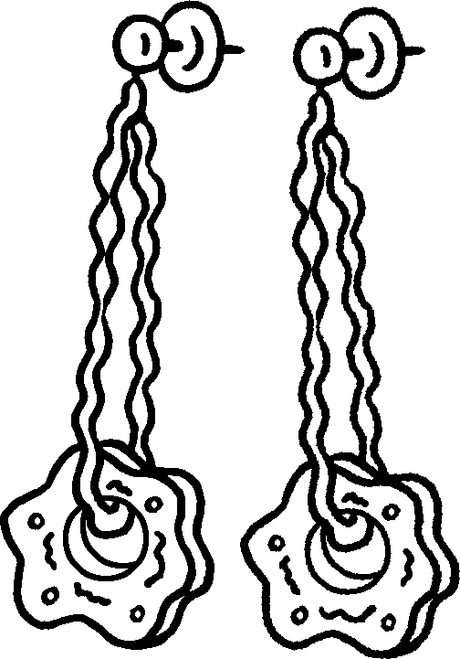


Book 5A Chapter 4 Graded Worksheets
Worksheet 1⬇
1 mirror 2 backpack
3 hairbrush 4 comb
5 ring 6 necklace
7 earrings

