What are they? Write.

1 | 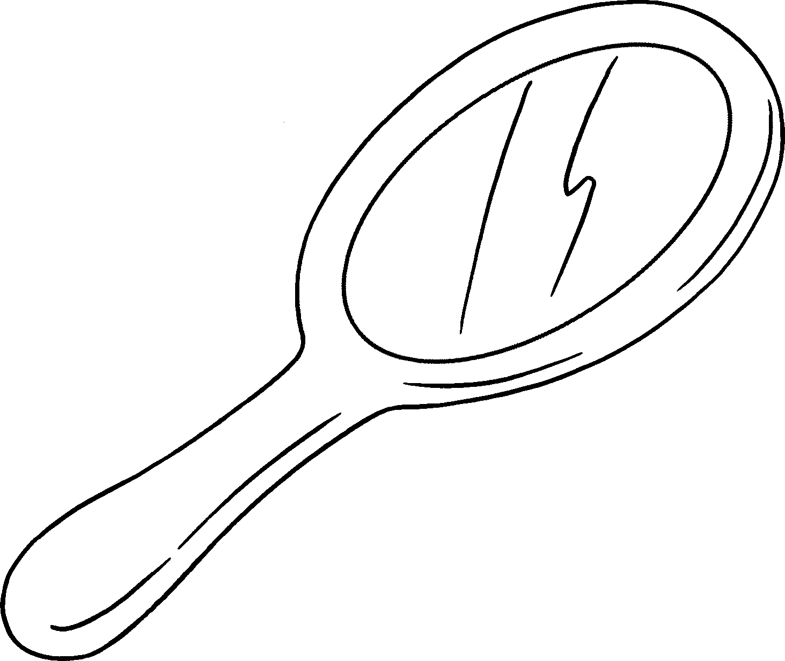 |  |  |  | 2 | 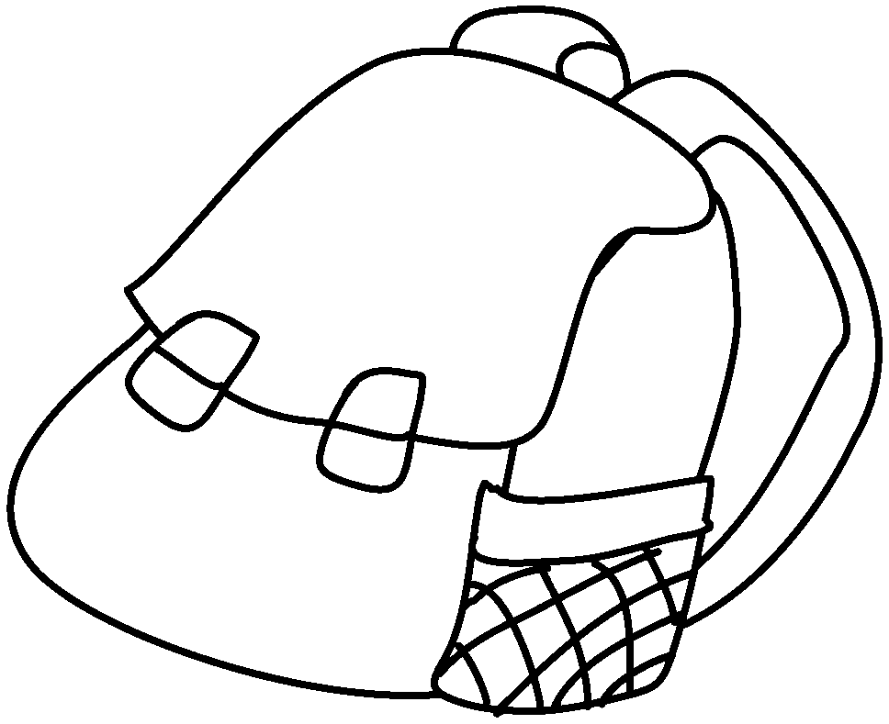
 | a m |  |  |  |  | a b
3 | 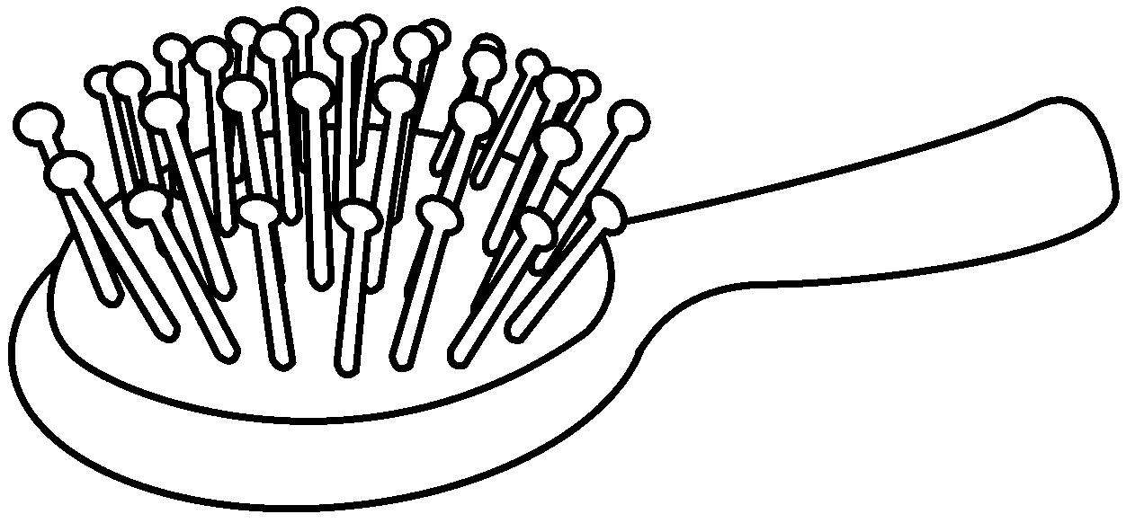 |  |  |  | 4 | 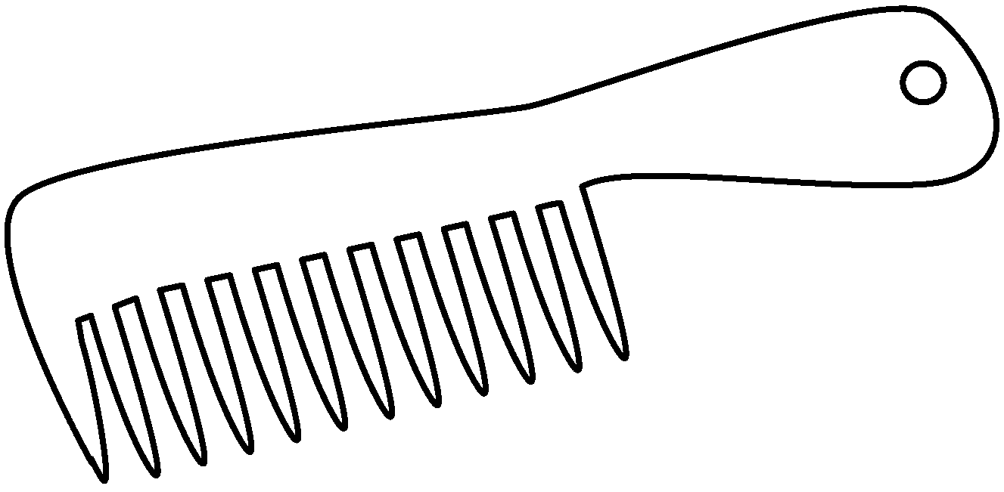
 | a h |  |  |  |  | a c
5 | 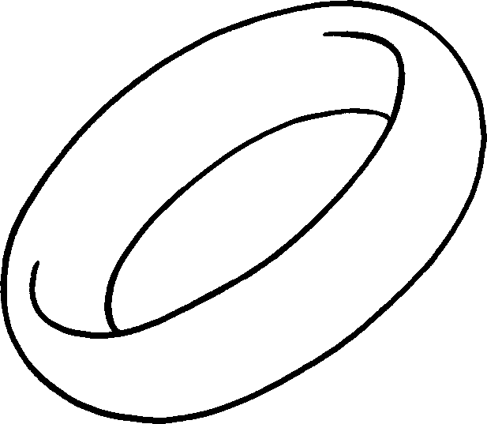 |  |  |  | 6 | 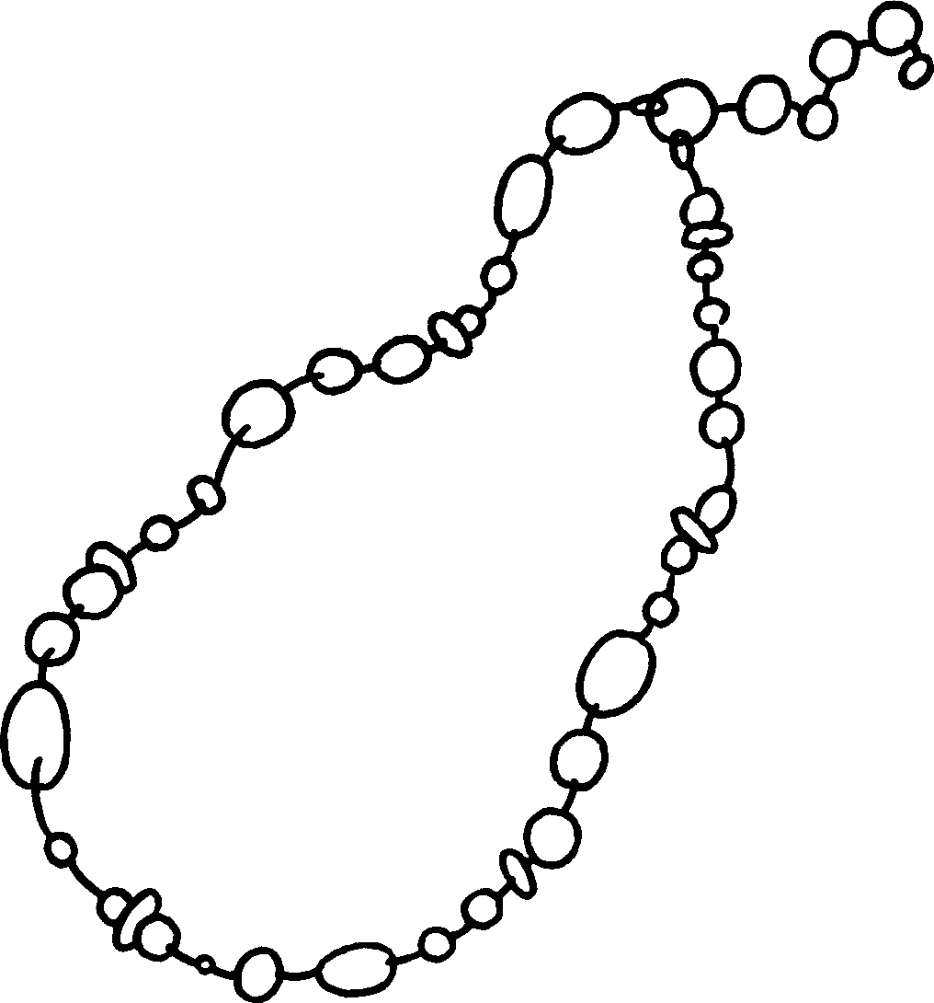
 | a r |  |  |  |  | a n
 |  | 7 | 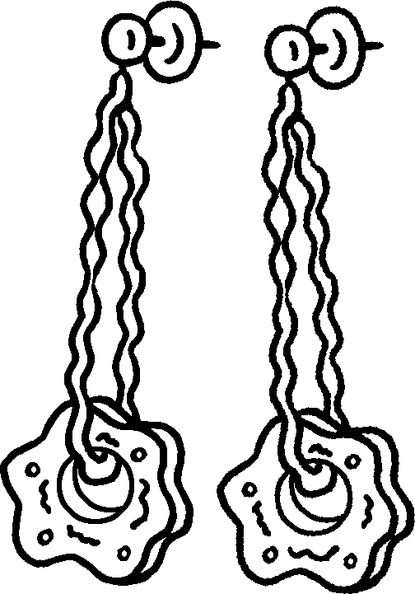
 |  |  | e


Book 5A Chapter 4 Graded Worksheets
Worksheet 1⬇⬇
1 mirror 2 backpack
3 hairbrush 4 comb
5 ring 6 necklace
7 earrings

