What are they? Write.

1 | 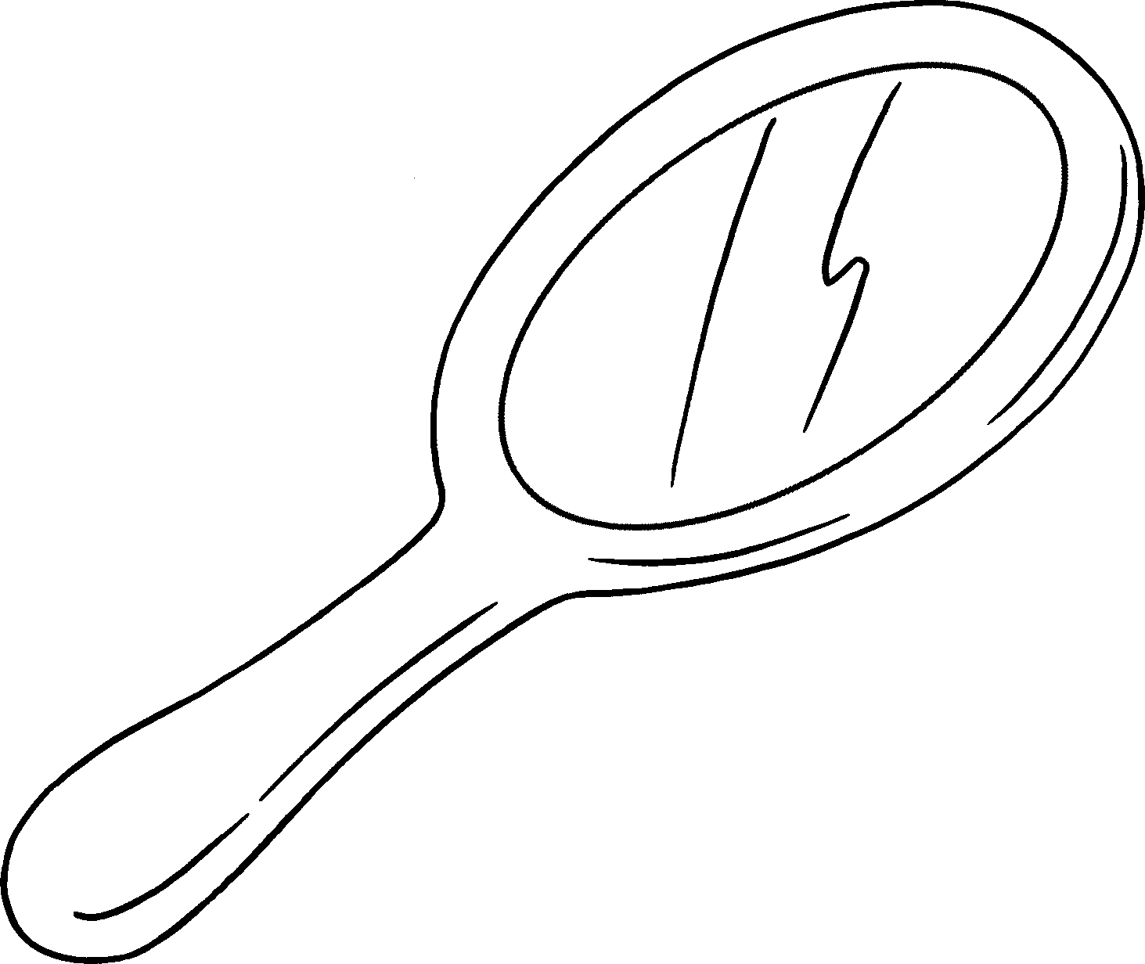 |  |  |  | 2 | 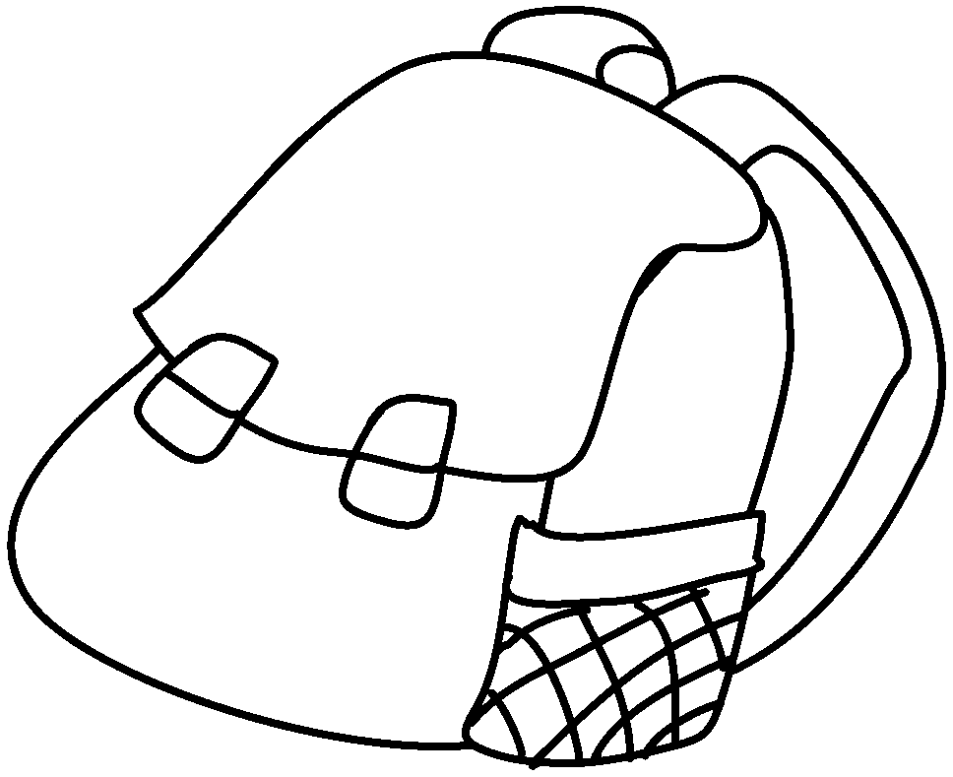
 | a |  |  |  |  | a
3 | 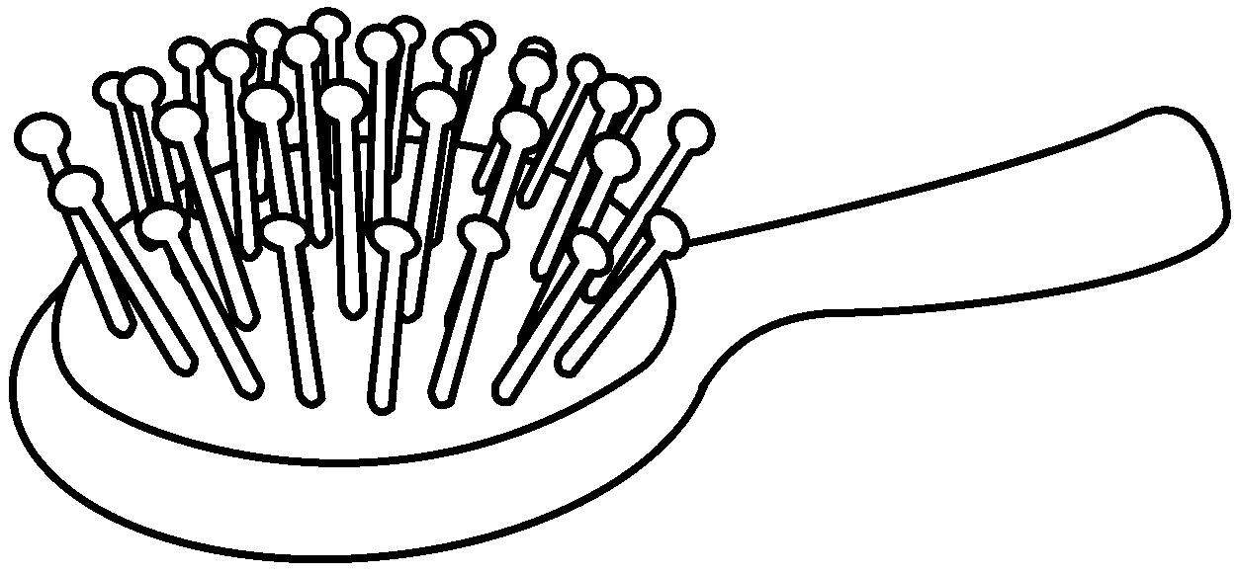 |  |  |  | 4 | 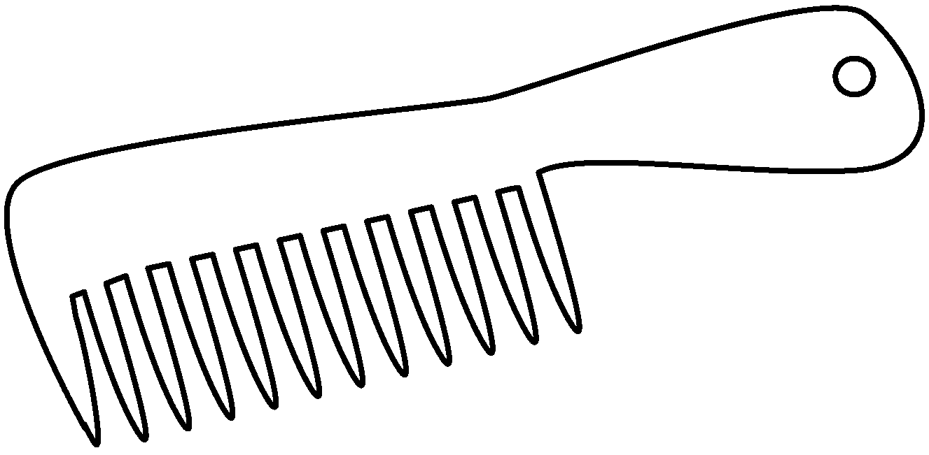
5 | 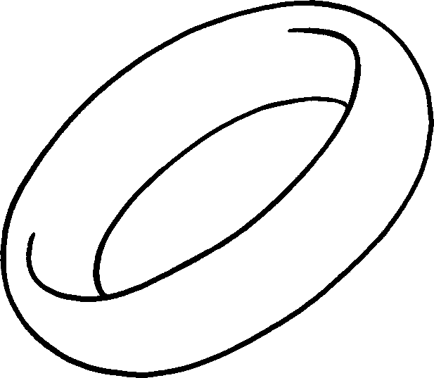 |  |  |  | 6 | 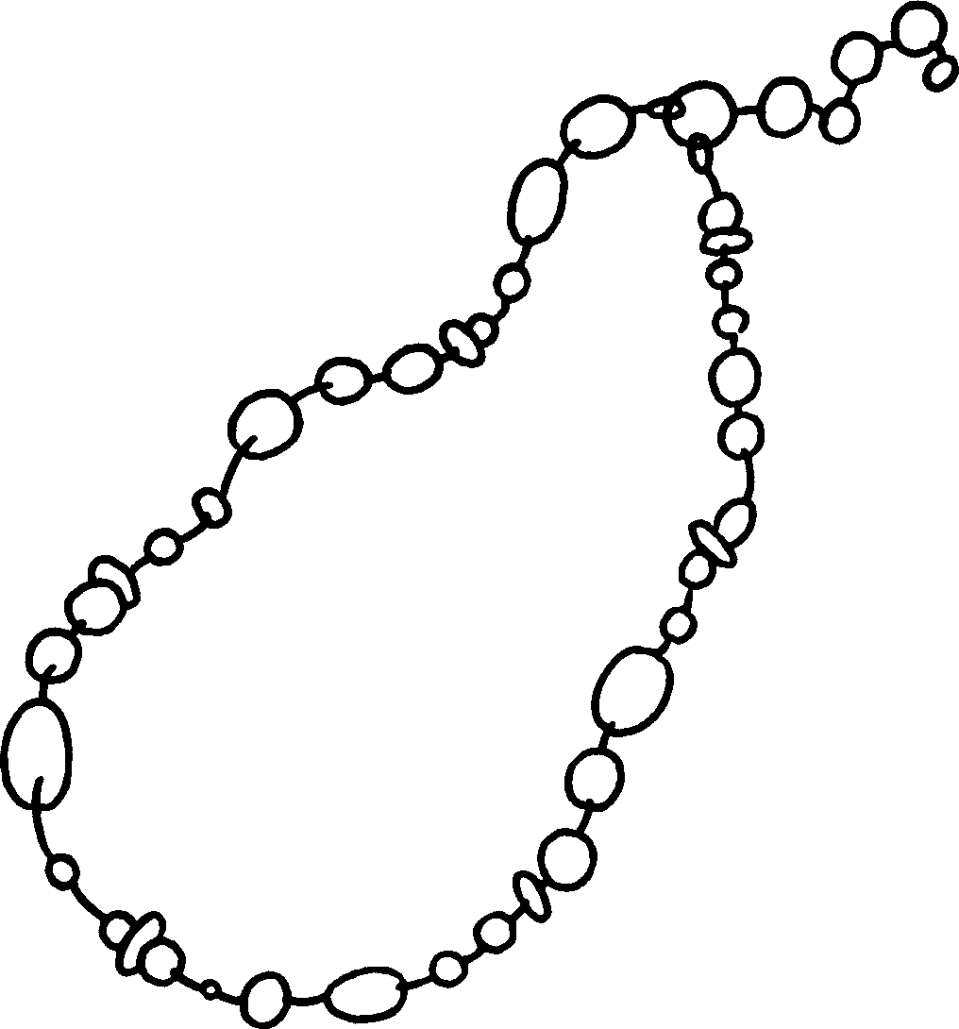
 |  | 7 | 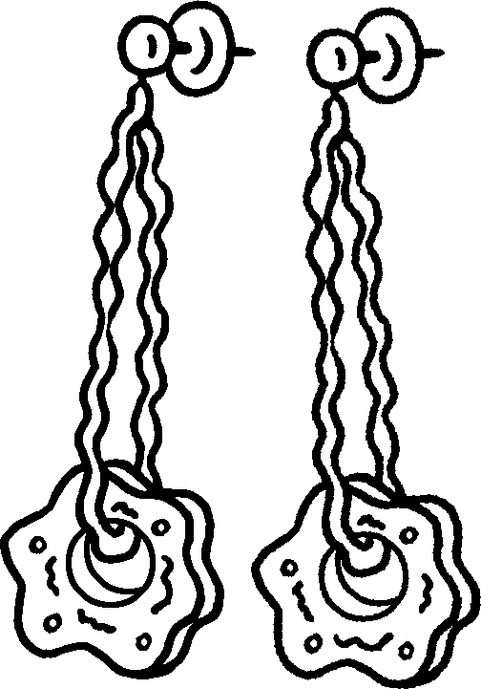


Book 5A Chapter 4 Graded Worksheets
Worksheet 1⬇⬇⬇
1 mirror 2 backpack
3 a hairbrush 4 a comb
5 a ring 6 a necklace
7 earrings
(Accept any reasonable answers.)

