Circle the correct answers.
✗
✓
A
A
A
A
A
B
C
C
B
B
B
B
1  ✓ | 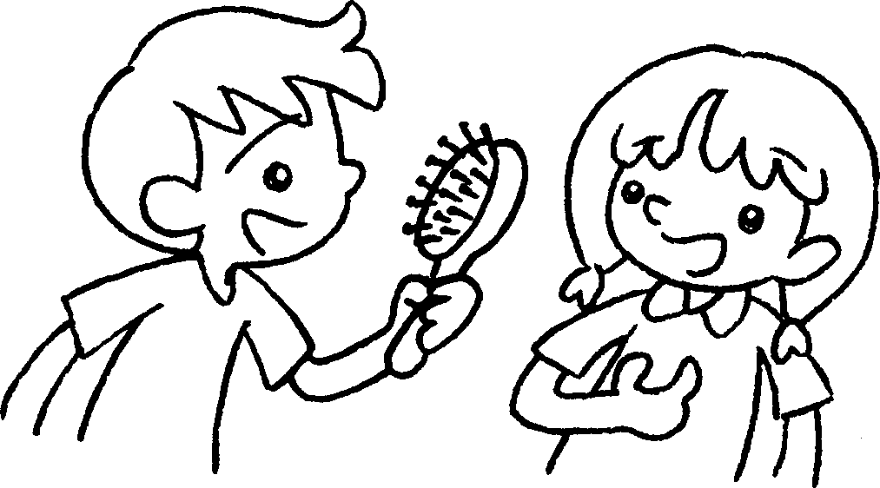 |  | A : Is this ( you / your / yours )?  B : Yes, it’s ( mine / my / ours ).
2 | 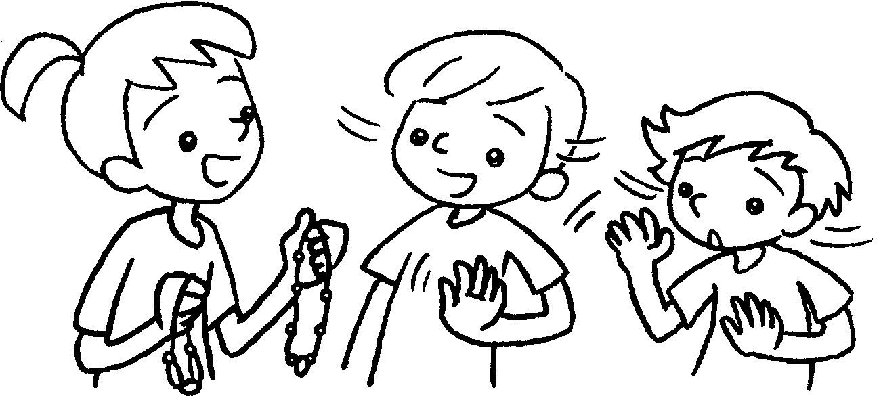 |  | A : Are these ( yours / your / you )?  B & C : No, they aren’t ( our / ours / my ).
3 | 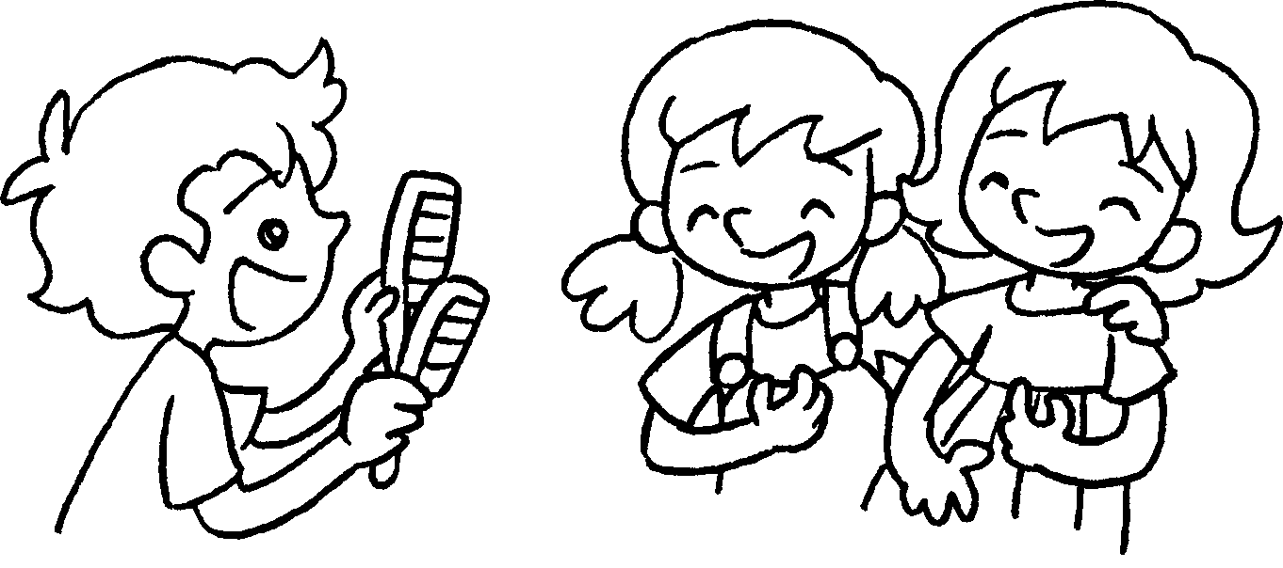 |  | A : Are these ( you / your / yours )?  B & C : Yes, they’re ( mine / our / ours ).
4  ✗ | 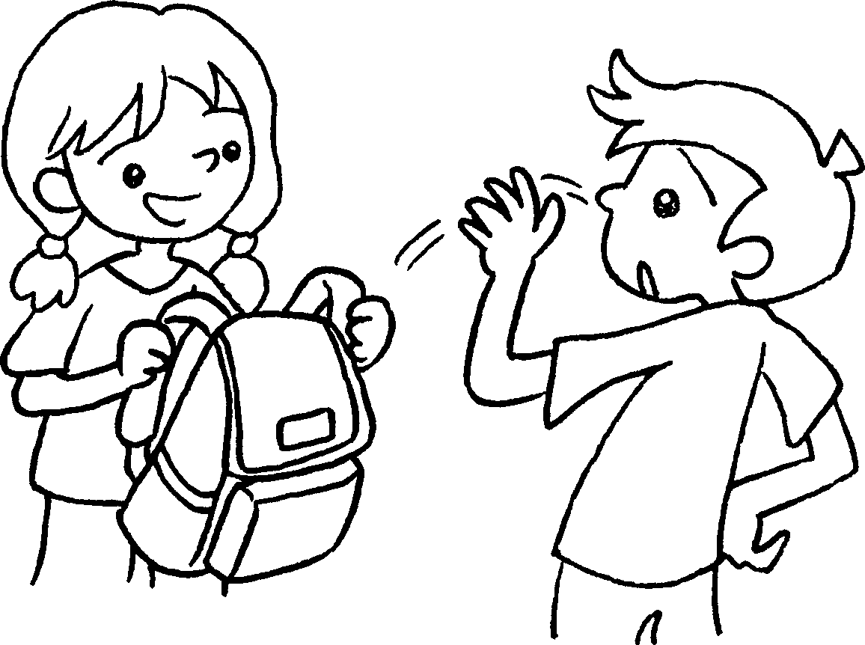 |  | A : Is this ( yours / you / your )?  B : No, it isn’t ( ours / mine / my ).
5  ✓ | 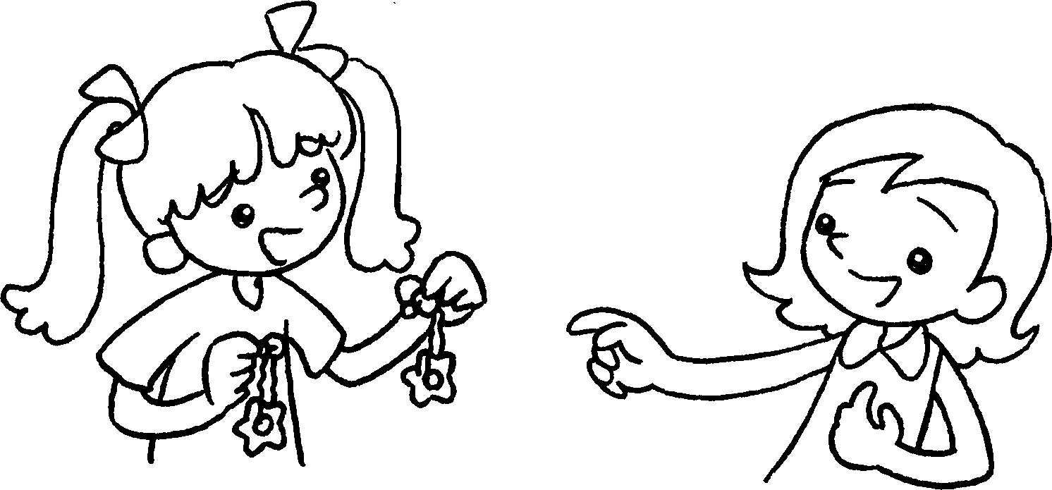 |  | A : Are these ( you / yours / your )?  B : Yes, they’re ( my / ours / mine ).


Book 5A Chapter 4 Graded Worksheets
Worksheet 2⬇
- ( you / your / yours )
( mine / my / ours )
- ( yours / your / you )
( our / ours / my )
- ( you / your / yours )
( mine / our / ours )
- ( yours / you / your )
( ours / mine / my )
- ( you / yours / your )
( my / ours / mine )

