Finish the questions and answers.

mine
yours
ours

✗
✓
A
A
A
A
A
B
C
C
B
B
B
B
1  ✓ | 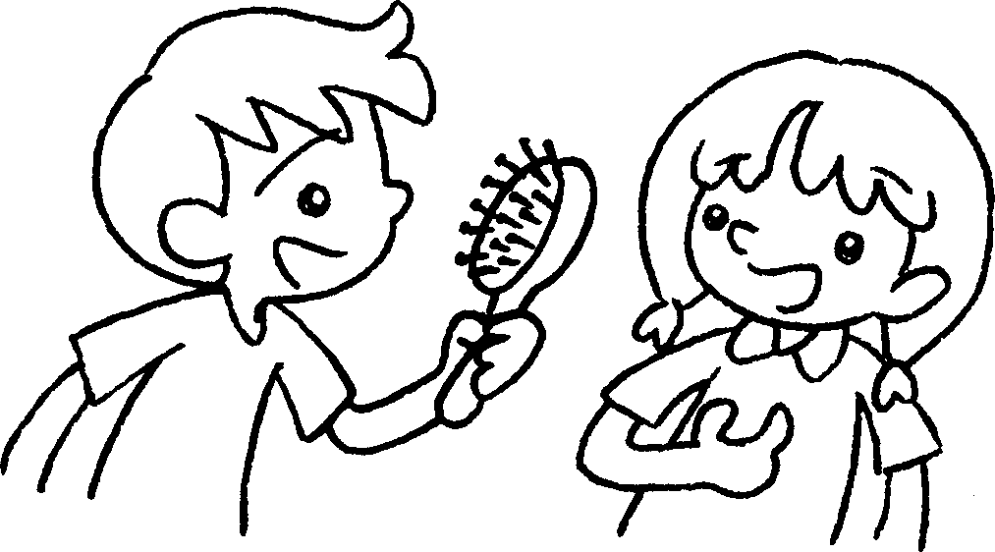 |  | A : Is this ?  B : Yes, it’s .
2 | 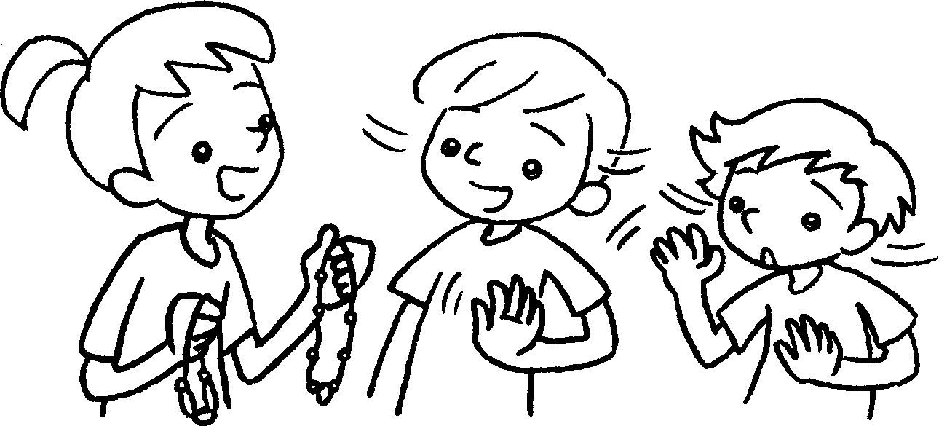 |  | A : Are these ?  B & C : No, they aren’t .
3 | 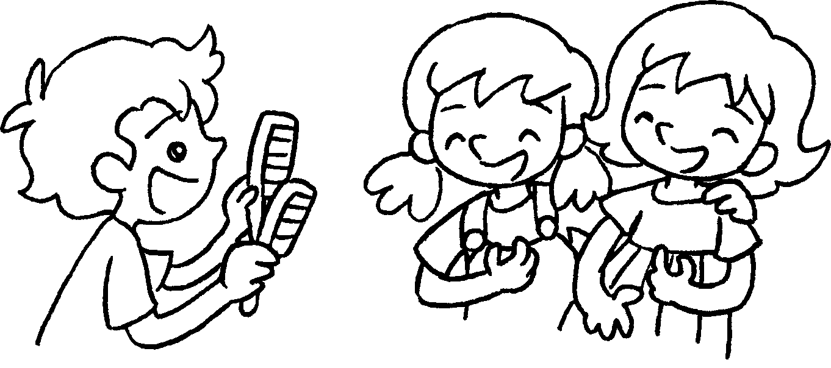 |  | A : Are these ?  B & C : Yes, they’re .
4  ✗ | 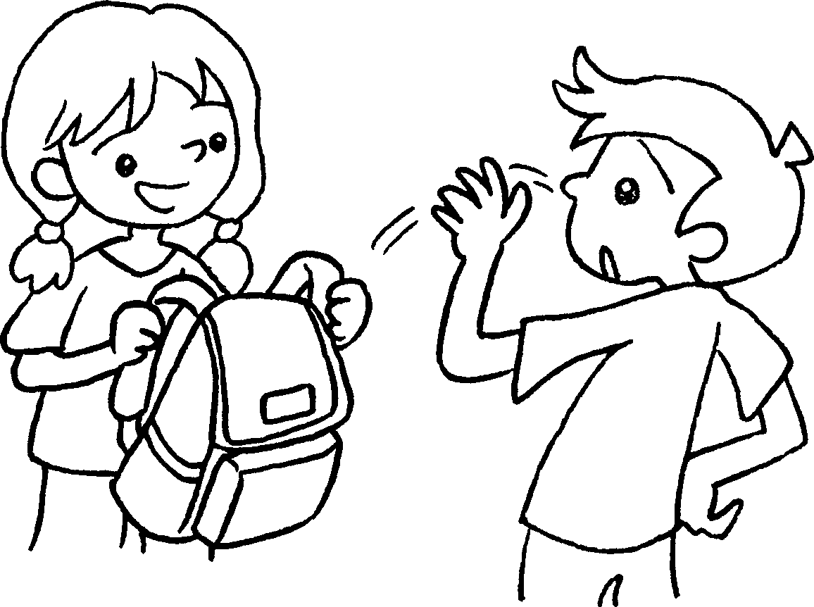 |  | A : this ?  B : No, .
5  ✓ | 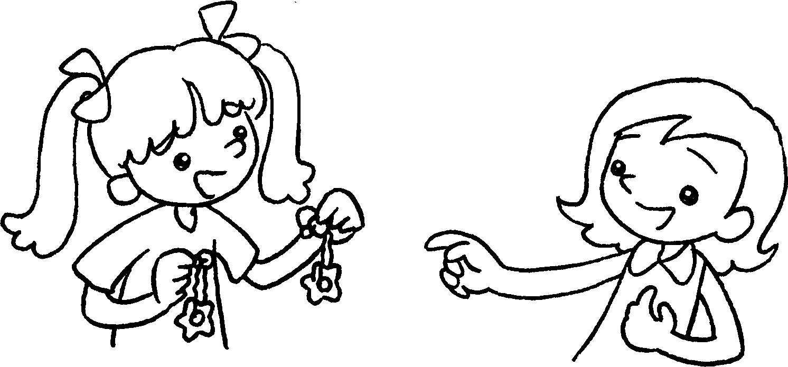 |  | A : these ?  B : Yes, .



Book 5A Chapter 4 Graded Worksheets
Worksheet 2⬇⬇
- yours
mine
- yours
ours
- yours
ours
4 Is yours
it isn’t mine
5 Are yours
they’re mine

