Finish the questions and answers.
✗
✓
A
A
A
A
A
B
C
C
B
B
B
B
1  ✓ | 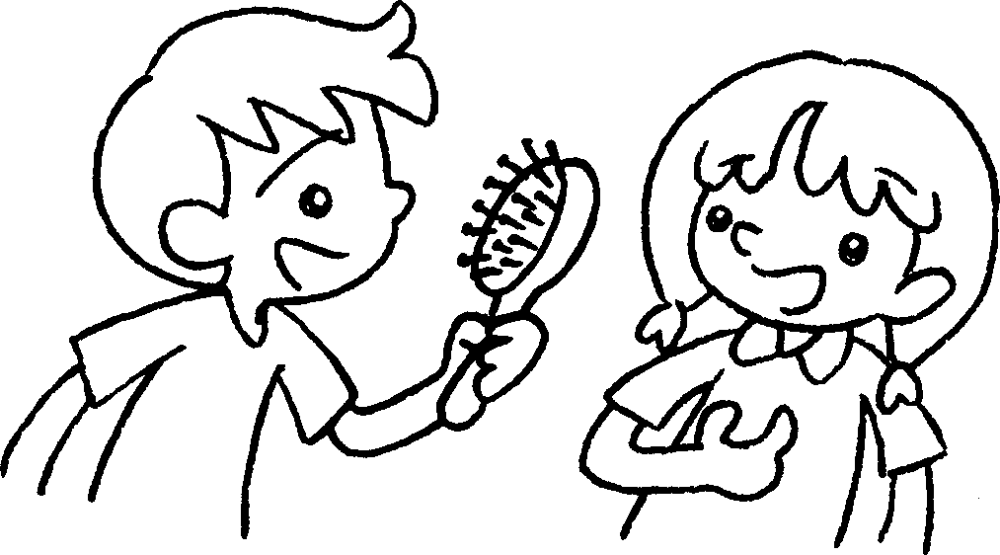 |  | yours  A : Is this ?  B : Yes, it’s m .
2 | 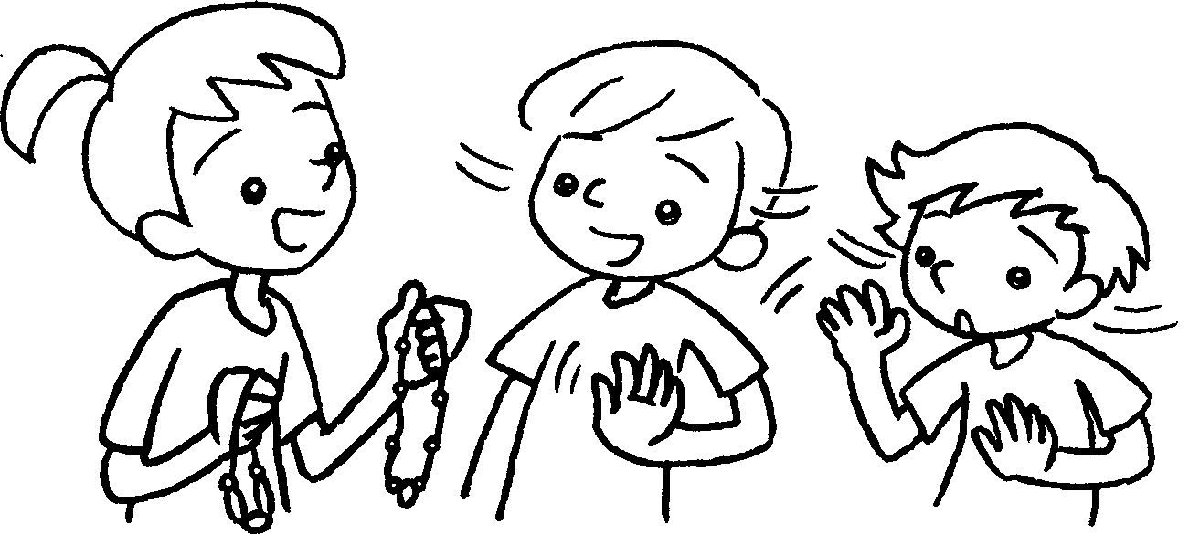 |  | A : Are these ?  B & C : No, they aren’t .
3 | 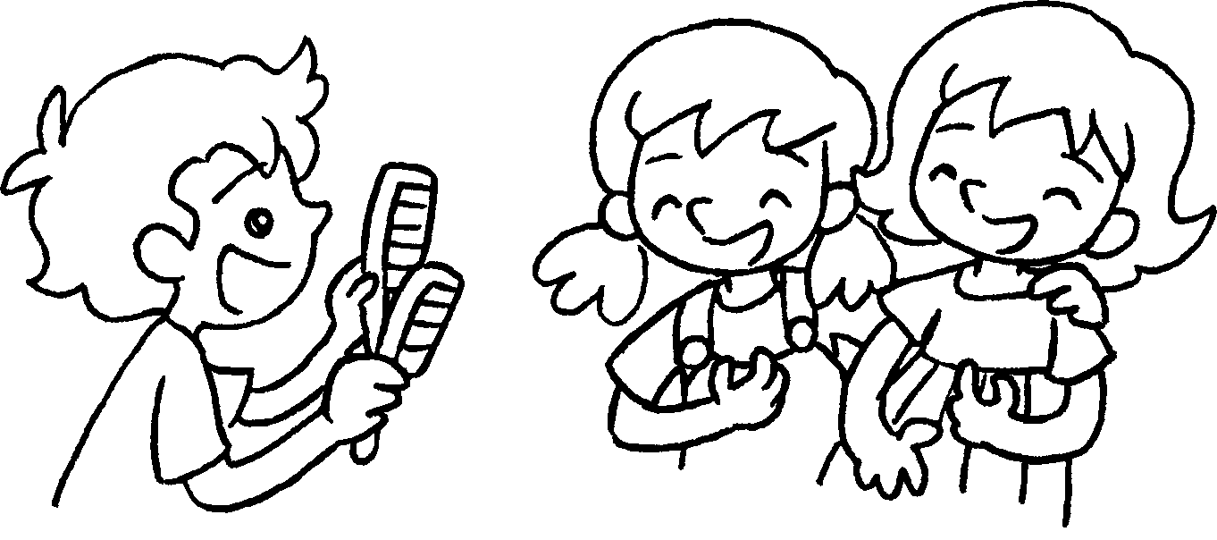 |  | A : Are these ?  B & C : Yes, .
4  ✗ | 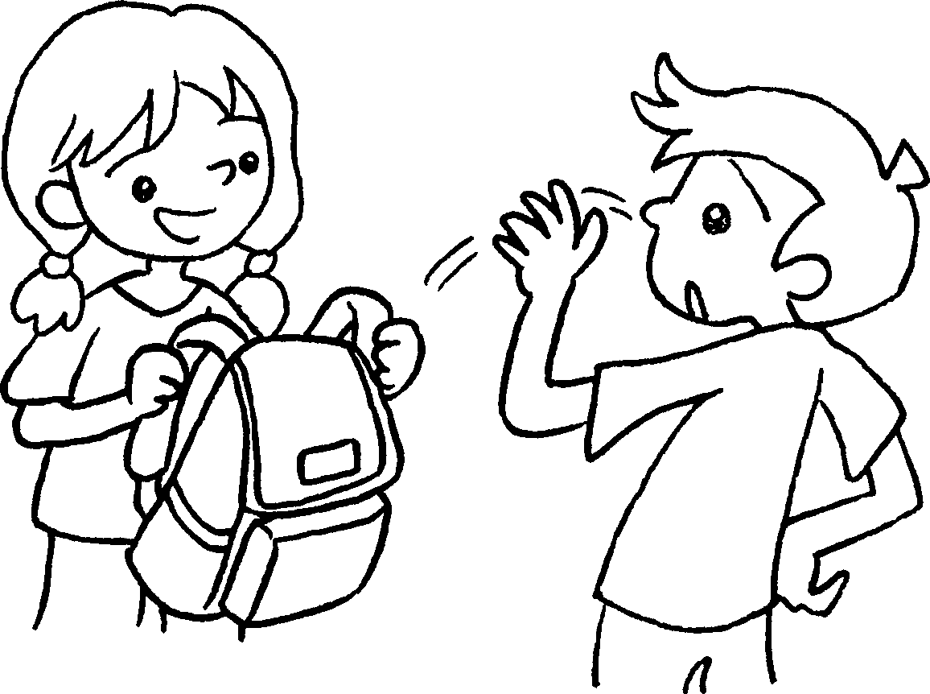 |  | A :  B :
5  ✓ | 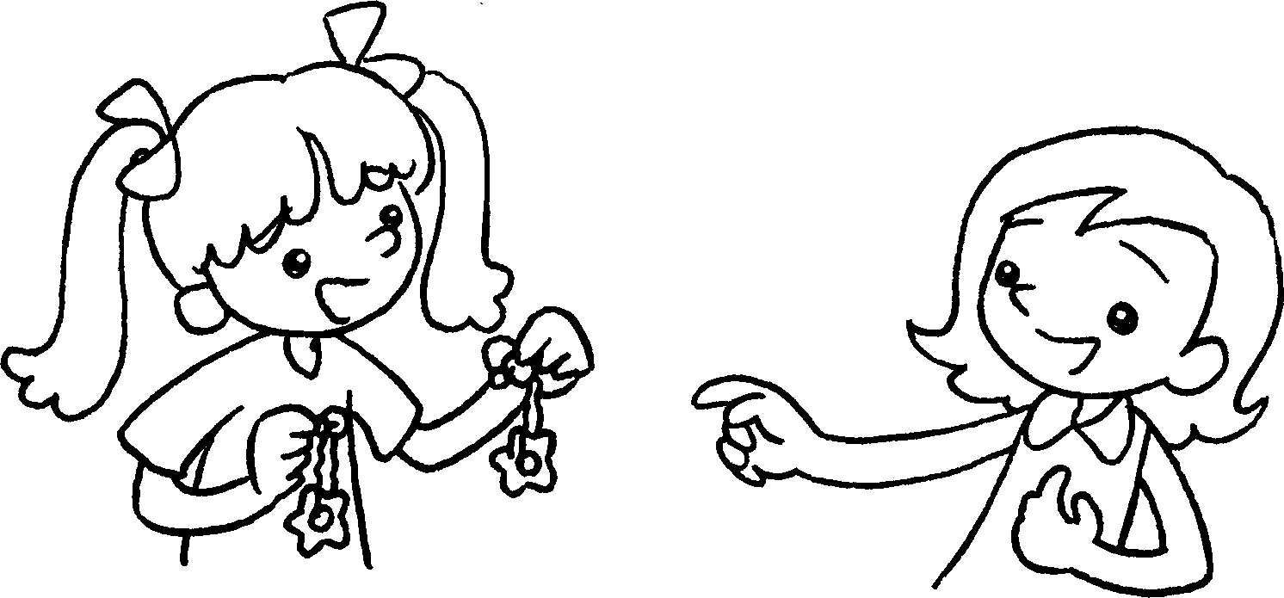 |  | A :  B :


Book 5A Chapter 4 Graded Worksheets
Worksheet 2⬇⬇⬇
- mine
- yours
ours
- yours
they’re ours
4 Is this yours?
No, it isn’t mine.
5 Are these yours?
Yes, they’re mine.

